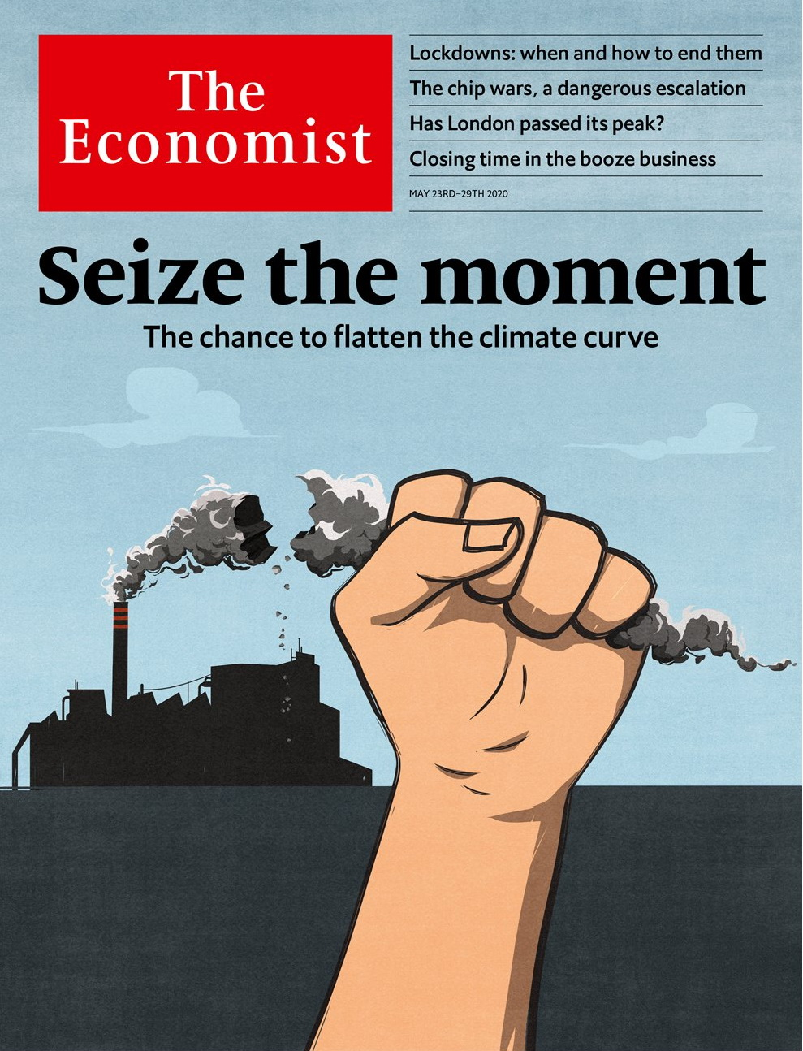

# Table of Contents

The world this week

Politics this week

Business this week

KAL’s cartoon

Leaders

Climate change and the pandemic: Seize the moment

After lockdowns: The cure and the disease

Uncle Sam v Huawei: Chip wars

Malaysia: No bail-outs without representation

Big pharma: Back in from the cold

Letters

Letters to the editor: On solitude, investors, electric cars, Yemen, Labour, Einstein, three points

Briefing

Covid and the climate: Flattening the other curve

Never let a crisis go to waste: A trillion-dollar question

Taxing carbon: The contentious and correct option

Emissions: If a tree falls

United States

The Centres for Disease Control and Prevention: Handcuffing an institution

Civil rights: Attention-deficit disorder

Congressional elections: Exit, pursued by a centrist?

Dechurching: The Sunday slump

Francis Collins: Jesus is not his vaccine

The extreme right: A boog’s life

Lexington: Joe Biden’s good pandemic

The Americas

Mexico: Betting on black

Women’s health: Birth pangs

Bello: In the valley of the shadow of death

Asia

India’s economy: Lockdown and out

Malaysian politics: Muhyiddin’s mess

Japanese politics: Unscathed but scathing

Power-sharing in Afghanistan: Titles all round

Australia’s trade with China: Barley barney and beef beef

Cruise ships in the Philippines: Floating confinement

Banyan: Sixty-somethings in a sack

China

Arms control: Be afraid, America

Coal-fired power: Brown elephants

Chaguan: Critical condition

Middle East & Africa

Egypt’s economy: Riders wanted

Iran’s bourse: A bizarre bazaar

Israel and the Palestinians: Nice while it lasted

Félicien Kabuga: The man who wasn’t there

The African School of Economics: Lessons from Leonard

Europe

Russia and covid-19: The anatomy of lies

Bailing out Europe: Not quite Hamiltonian

Tourism: We aren’t off to sunny Spain

Indigenous rights: Sami difference

Charlemagne: The wizards of Luxembourg

Britain

Peak London: The wheel turns

Grand houses: A palace of one’s own

Transport: The great land grab

Government finances: Not so burdensome

Health care: Now for the recovery

Politics: The pandemic goes partisan

International

Covid-19 and global poverty: The great reversal

Business

Chip wars: Immaculate misconceptions

SoftBank: Born again

Indian capitalism: Elephants in the room

Walmart: A nimble beast

Bartleby: Zoomers, zeros and Gen Z

Schumpeter: Closing time

Finance & economics

Sovereign-wealth funds: Raid on the piggy banks

The World Trade Organisation: Trading places

Buttonwood: Darcy and debt

All work and no play: Economic recovery

Banking in Africa: Borrower beware

Free exchange: The land down under

Schools brief

Energy transitions: Not-so-slow burn

Science & technology

Controlling covid-19: To each according to his need

Photovoltaics: Solar’s new power

Covid-19 in the young: Suffer the little children

Books & arts

Solidarity in reading: The lives of others

Instagram: The camera always lies

Crime fiction: Ice-cold cases

American history: The ballad of Malcolm and Martin

Home Entertainment: Discover trio sonatas

Home Entertainment: Travel in confinement

Economic & financial indicators

Economic data, commodities and markets

Graphic detail

Forecasting covid-19: A terrible toll

Obituary

Little Richard: Gonna have some fun tonight



### Friday, May 22, 2020

|  |  |
| --- | --- |
| The world this week | 3 |
| Leaders | 5 |
| Letters | 1 |
| Briefing | 4 |
| United States | 7 |
| The Americas | 3 |
| Asia | 7 |
| China | 3 |
| Middle East & Africa | 5 |
| Europe | 5 |
| Britain | 6 |
| International | 1 |
| Business | 6 |
| Finance & economics | 6 |
| Schools brief | 1 |
| Science & technology | 3 |
| Books & arts | 6 |
| Economic & financial indicators | 1 |
| Graphic detail | 1 |
| Obituary | 1 |

|  |  |  |
| --- | --- | --- |
|  | Sections | Leaders |

The world this week

Politics this week

.

Business this week

.

KAL’s cartoon

.

|  |  |  |
| --- | --- | --- |
|  | Sections | Leaders |

|  |  |  |  |
| --- | --- | --- | --- |
|  | Articles | Sections | Next |

# Politics this week

May 21st 2020 |

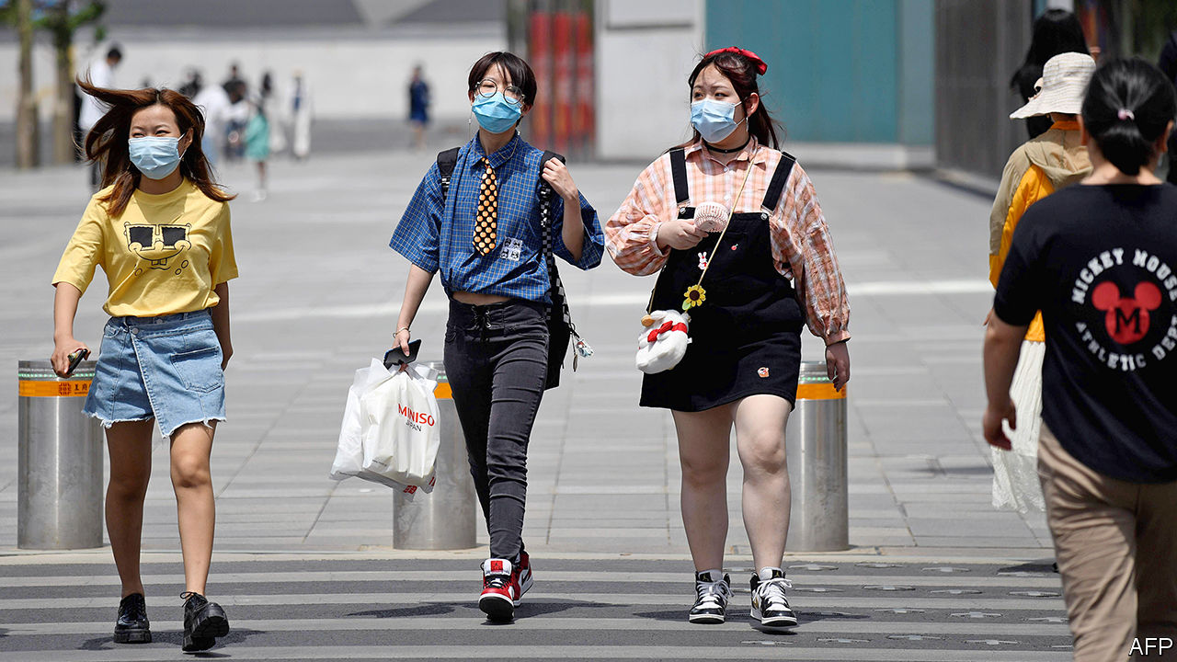

At the World Health Organisation’s annual summit (held remotely), China accepted an Australian-led motion calling for an inquiry into the origins of covid-19. This marked a climbdown by the Chinese government in the face of widespread demands for such a probe. Earlier, Donald Trump once again threatened to pull America out of the WHO unless it took unspecified steps to show “independence from China”. Despite its success in tackling the coronavirus, Taiwan was not invited to this year’s meeting.

China imposed tariffs on Australian barley on the day the WHO considered the Australian motion. China maintains that such tariffs have nothing to do with Australian criticism of its rulers. See article.

A police watchdog in Hong Kong issued a report on the force’s handling of protests last year. It found no serious problem with police tactics, which involved lots of rubber bullets. Opposition politicians called it a whitewash. In the territory’s legislature, pro-government politicians took control of an important committee. They are expected to put forward a bill making it a crime to insult the Chinese national anthem. Some pro-democracy legislators were evicted after scuffling with guards.

The two men who both claimed to be the president of Afghanistan after a disputed election in September, Ashraf Ghani and Abdullah Abdullah, struck a power-sharing deal. Mr Ghani will remain president, while Mr Abdullah will take charge of peace negotiations with the Taliban. See [article](https://www.economist.com/node/21786484).

Malaysia’s parliament met for the first time since Muhyiddin Yassin was appointed prime minister on March 1st. But it adjourned without voting on a no-confidence motion put forward by the prime minister whom Mr Muhyiddin replaced, Mahathir Mohamad. See article.

Cyclone Amphan, the most powerful storm to gather over the Bay of Bengal in 20 years, made landfall near the city of Kolkata in India. Initial reports suggested relatively few casualties, thanks to Indian and Bangladeshi efforts to evacuate people in its path.

Marco Rubio took over as chairman of the Senate Intelligence Committee, when Richard Burr stepped down amid an FBI inquiry into claims he benefited from a briefing about the emerging covid-19 threat in mid-February by selling stock.

Angela Merkel and Emmanuel Macron put forward a joint plan for a €500bn ($546bn) fund to help countries in the European Union recover from the pandemic. The money is to be provided as grants, not loans, and will be borrowed by the EU as a whole from markets. The “frugal four” (Austria, Denmark, the Netherlands and Sweden) are unhappy with the proposal, which requires unanimous agreement. See article.

Italy greatly eased its lockdown, allowing most shops, restaurants and even hairdressers to reopen, though with strict controls. To many people’s surprise, the government said it hopes to allow flights to and from the country to resume soon. Greece and Portugal also indicated they would reopen to tourists.

After a year of political deadlock Israel swore in a new government. Binyamin Netanyahu will continue to serve as prime minister for 18 months. His former rival, Benny Gantz, will be his deputy, before taking over the top job. As part of the coalition deal the government can seek approval for annexing parts of the West Bank. Mahmoud Abbas, the Palestinian president, responded by threatening to pull out of agreements and security arrangements with Israel. See article.

Forces aligned with the internationally recognised government in Libya captured an important air base from the forces of Khalifa Haftar, a rebellious general. General Haftar’s men then pulled out of parts of Tripoli, the capital, which they have tried to seize.

Police in the Democratic Republic of Congo killed 55 people in raids on a religious sect that had urged its followers, mostly ethnic Kongo, to drive members of other ethnicities from their homes.

The prime minister of Lesotho, Thomas Thabane, resigned after battling to stay in power despite claims he was involved in the murder of his ex-wife.

Nelson Teich quit as Brazil’s health minister after just one month in the job. The country’s president, Jair Bolsonaro, sacked the previous minister, who had pushed for stronger action against covid-19. The president and Mr Teich were also at odds. Brazil’s almost 300,000 confirmed cases are the third-highest number in the world.

El Salvador’s Supreme Court suspended an order from the president, Nayib Bukele, to extend a state of emergency, ruling that he must seek the approval of the Legislative Assembly. The legislature then passed a law to hasten the economy’s reopening, which Mr Bukele said he would veto.

Researchers in Argentina found fossils of an undiscovered type of megaraptor (large carnivorous dinosaur)in Patagonia. The dinosaur lived 70m years ago, was ten metres long and had 40cm claws. Megaraptors were slimmer than the Tyrannosaurus rex, and more prepared to race “with long tails to help them maintain balance”.

## Coronavirus briefs

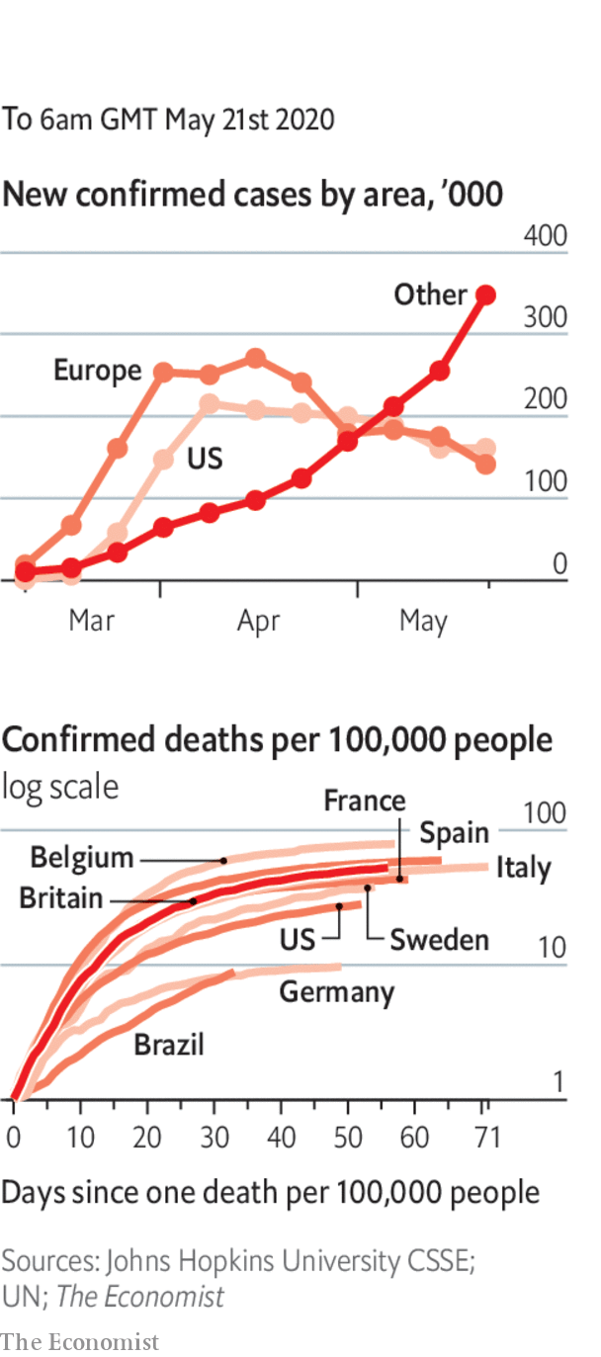

The Chinese city of Shulan was put under a strict lockdown after an outbreak of covid-19.

Infections in Russia surged to a cumulative total of 310,000. See article.

Protests erupted in a poor suburb of Santiago, Chile’s capital, over food shortages caused by the lockdown.

Donald Trump said he was taking hydroxychloroquine, a malaria drug, to ward off covid-19. Doctors warned that this is unsafe. See article.

America’s House of Representatives is to allow remote voting for the first time.

Captain Tom Moore, a war veteran who walked laps of his garden ahead of his 100th birthday to raise money for Britain’s health service, was awarded a knighthood. Captain Tom’s quest went viral, raising £32m ($39m), and cheering up a nation.

This article was downloaded by calibre from <https://www.economist.com/the-world-this-week/2020/05/21/politics-this-week>

|  |  |  |  |
| --- | --- | --- | --- |
|  | Articles | Sections | Next |

|  |  |  |  |
| --- | --- | --- | --- |
| Previous | Articles | Sections | Next |

# Business this week

May 21st 2020 |

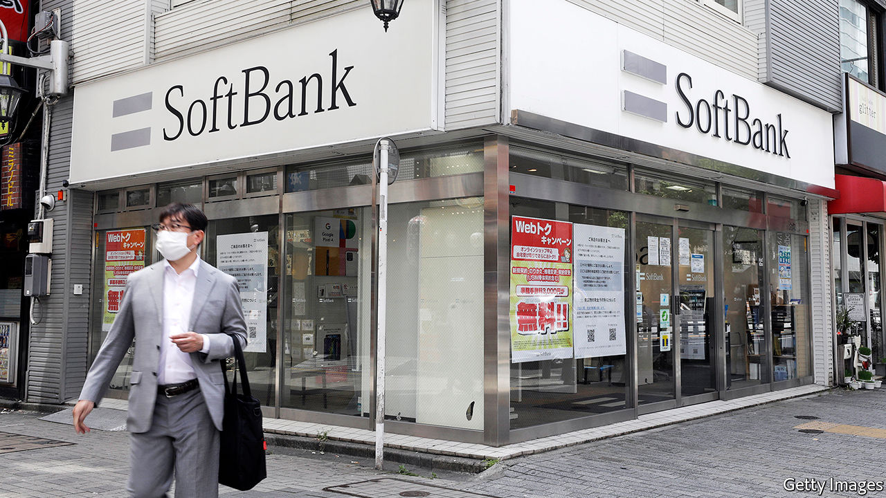

SoftBank reported an annual net loss of ¥962bn ($8.8bn), mostly because of bad investments its Vision Fund made in WeWork, Uber, Didi and other tech firms. The Japanese conglomerate might not pay a dividend to shareholders for the first time since becoming a public company in 1994. Jack Ma, the founder of Alibaba, a Chinese internet giant, is to step down from SoftBank’s board as a director, an unexpected departure from a position he held for 13 years. SoftBank was an early investor in Alibaba and may use its stake in the company to fund a share buy-back programme. See [article](https://www.economist.com/node/21786513).

Foxconn, the world’s biggest contract electronics manufacturer, which assembles products for Apple, Samsung and others, said it was over the worst of the covid-19 crisis and that all its factories in China have resumed normal operations. Net profit for the first three months of the year plunged by 90% compared with the same quarter last year.

A truce was called in a dispute between unions and Amazon in France, allowing the online retailer to reopen warehouses in the country that had been shut since mid-April. Amazon has made significant changes to allay workers’ fears that the buildings are unsafe during the covid-19 outbreak. Staff are having their temperatures checked, are required to wear masks, and their hours are being staggered in order to prevent crowding.

A surge in demand for food, fitness products and video games helped Walmart chalk up a 9% rise in sales for the three months ending April, year on year. The retailer said it had shifted some items over a few hours at a rate it normally sees in a few days. Target reported a similar rise in revenue, spurred by digital sales. The lockdown is producing winners and losers. J.C. Penney, a 118-year-old department-store chain, filed for bankruptcy protection, joining a list of collapsed businesses that includes J. Crew, Neiman Marcus and Gold’s Gym. See article.

In total, retail sales in America plummeted by 16.4% in April over March, worse than economists had expected and the biggest decline since the current data series began in 1992.

The World Bank appointed Carmen Reinhart, a professor at Harvard, as its new chief economist. Born in Cuba, Ms Reinhart moved to America aged ten and has written widely about financial crises, boom and bust, and contagion.

## Mind the gap

London’s public-transport operator was granted a £1.6bn ($2bn) bail-out after the mayor, Sadiq Khan, threatened to cut services if the government didn’t help. Transport for London has said it expects a funding gap of “over £4bn” in 2020-21 because of the fall in passenger revenue amid the pandemic. Meanwhile, as travel restrictions in the city were relaxed, TfL listed 20 Tube stations it said commuters should try to avoid because of overcrowding.

In a co-ordinated effort, several national regulators in Europe, including in France, lifted a ban on short-selling that had been introduced during the stockmarket rout in March.

Despite the uncertainty in stockmarkets, JAB Holding, a privately held German conglomerate, launched an IPO of its JDE Peet’s coffee business, which includes the Senseo and Kenco brands. The listing in Amsterdam could eventually raise up to €2bn ($2.2bn) in total, which would make it Europe’s biggest IPO this year.

The number of people claiming unemployment benefit in Britain rose by 69% in April to 2.1m, the highest monthly increase ever. The number in paid employment dropped by nearly half a million, while median monthly pay fell by 3%, down from a 0.75% drop in March. Annual inflation plunged to 0.8%, fuelling speculation that the Bank of England might introduce a negative interest rate for the first time when it next meets. See [article](https://www.economist.com/finance-and-economics/2020/05/21/should-the-fed-cut-rates-below-zero).

Rolls-Royce cut 9,000 jobs and predicted that it will take several years for demand for its aircraft engines to return to pre-pandemic levels. The number of job losses, a sixth of its workforce, is more drastic than had been expected.

Uber announced that another 3,000 jobs would go at its offices around the world on top of the 3,700 lay-offs it had made only recently. Together the redundancies account for a quarter of its staff. The company is to focus on its ride-hailing and food-delivery businesses and ditch its job-matching service and artificial-intelligence unit.

## TikTok, the lockdown clock

TikTok poached a senior executive from Disney to be its new boss. Kevin Mayer oversaw Disney’s thrust into streaming and had been in the running to replace Bob Iger as CEO (the job went to Bob Chapek). He joins TikTok amid a surge in users viewing its dance, comedy and other “talent” short videos. It reached 2bn downloads last month, as bored locked-down teenagers flocked to the app in droves.

This article was downloaded by calibre from <https://www.economist.com/the-world-this-week/2020/05/21/business-this-week>

|  |  |  |  |
| --- | --- | --- | --- |
| Previous | Articles | Sections | Next |

|  |  |  |  |
| --- | --- | --- | --- |
| Previous | Articles | Sections | Next |

# KAL’s cartoon

May 21st 2020 |

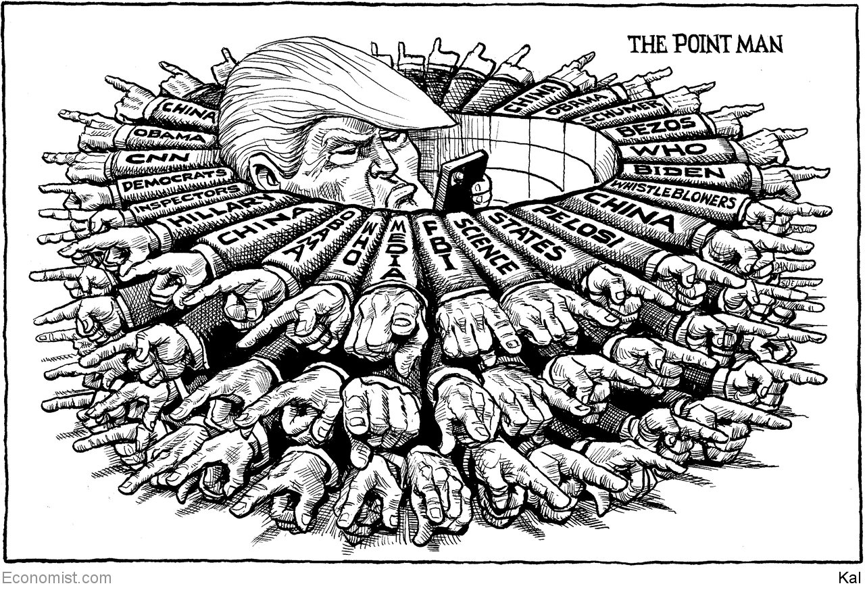

This article was downloaded by calibre from <https://www.economist.com/the-world-this-week/2020/05/21/kals-cartoon>

|  |  |  |  |
| --- | --- | --- | --- |
| Previous | Articles | Sections | Next |

|  |  |  |
| --- | --- | --- |
| The world this week | Sections | Letters |

Leaders

Climate change and the pandemic: Seize the moment

.

After lockdowns: The cure and the disease

.

Uncle Sam v Huawei: Chip wars

.

Malaysia: No bail-outs without representation

.

Big pharma: Back in from the cold

.

|  |  |  |
| --- | --- | --- |
| The world this week | Sections | Letters |

|  |  |  |  |
| --- | --- | --- | --- |
|  | Articles | Sections | Next |

#### A new opportunity to tackle climate change

# The covid and climate crises are connected

The pandemic shows how hard it will be to decarbonise—and creates an opportunity

May 21st 2020 |

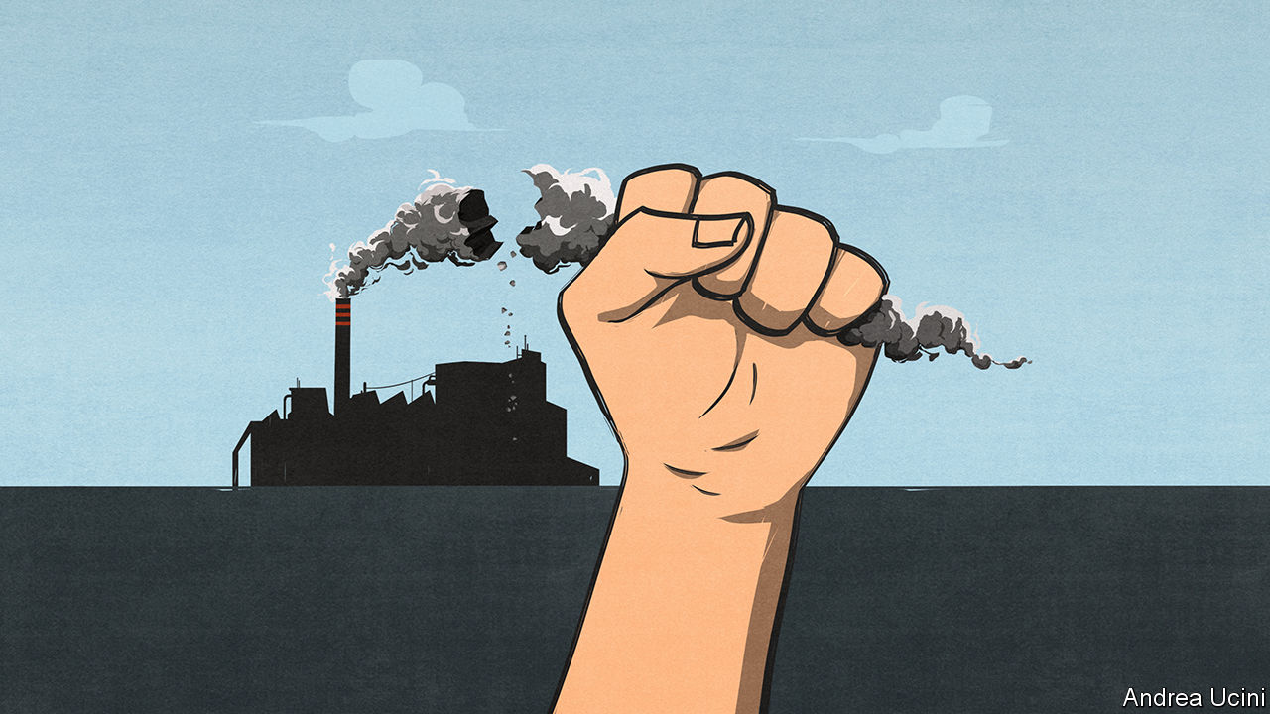

Editor’s note: Some of our covid-19 coverage is free for readers of The Economist Today, our daily [newsletter](https://my.economist.com/user#newsletter). For more stories and our pandemic tracker, see our [hub](https://www.economist.com/news/2020/03/11/the-economists-coverage-of-the-coronavirus)

FOLLOWING THE pandemic is like watching the climate crisis with your finger jammed on the fast-forward button. Neither the virus nor greenhouse gases care much for borders, making both scourges global. Both put the poor and vulnerable at greater risk than wealthy elites and demand government action on a scale hardly ever seen in peacetime. And with China’s leadership focused only on its own advantage and America’s as scornful of the World Health Organisation as it is of the Paris climate agreement, neither calamity is getting the co-ordinated international response it deserves.

The two crises do not just resemble each other. They interact. Shutting down swathes of the economy has led to huge cuts in greenhouse-gas emissions. In the first week of April, daily emissions worldwide were 17% below what they were last year. The International Energy Agency expects global industrial greenhouse-gas emissions to be about 8% lower in 2020 than they were in 2019, the largest annual drop since the second world war.

That drop reveals a crucial truth about the climate crisis. It is much too large to be solved by the abandonment of planes, trains and automobiles. Even if people endure huge changes in how they lead their lives, this sad experiment has shown, the world would still have more than 90% of the necessary decarbonisation left to do to get on track for the Paris agreement’s most ambitious goal, of a climate only 1.5°C warmer than it was before the Industrial Revolution.

But as we explain this week (see article) the pandemic both reveals the size of the challenge ahead and also creates a unique chance to enact government policies that steer the economy away from carbon at a lower financial, social and political cost than might otherwise have been the case. Rock-bottom energy prices make it easier to cut subsidies for fossil fuels and to introduce a tax on carbon. The revenues from that tax over the next decade can help repair battered government finances. The businesses at the heart of the fossil-fuel economy—oil and gas firms, steel producers, carmakers—are already going through the agony of shrinking their long-term capacity and employment. Getting economies in medically induced comas back on their feet is a circumstance tailor-made for investment in climate-friendly infrastructure that boosts growth and creates new jobs. Low interest rates make the bill smaller than ever.

Take carbon-pricing first. Long cherished by economists (and The Economist), such schemes use the power of the market to incentivise consumers and firms to cut their emissions, thus ensuring that the shift from carbon happens in the most efficient way possible. The timing is particularly propitious because such prices have the most immediate effects when they tip the balance between two already available technologies. In the past it was possible to argue that, although prices might entrench an advantage for cleaner gas over dirtier coal, renewable technologies were too immature to benefit. But over the past decade the costs of wind and solar power have tumbled. A relatively small push from a carbon price could give renewables a decisive advantage—one which would become permanent as wider deployment made them cheaper still. There may never have been a time when carbon prices could achieve so much so quickly.

Carbon prices are not as popular with politicians as they are with economists, which is why too few of them exist. But even before covid-19 there were hints their time was coming. Europe is planning an expansion of its carbon-pricing scheme, the largest in the world; China is instituting a brand new one. Joe Biden, who backed carbon prices when he was vice-president, will do so again in the coming election campaign—and at least some on the right will agree with that. The proceeds from a carbon tax could raise over 1% of GDP early on and would then taper away over several decades. This money could either be paid as a dividend to the public or, as is more likely now, help lower government debts, which are already forecast to reach an average of 122% of GDP in the rich world this year, and will rise further if green investments are debt-financed.

Carbon pricing is only part of the big-bang response now possible. By itself, it is unlikely to create a network of electric-vehicle charging-points, more nuclear power plants to underpin the cheap but intermittent electricity supplied by renewables, programmes to retrofit inefficient buildings and to develop technologies aimed at reducing emissions that cannot simply be electrified away, such as those from large aircraft and some farms. In these areas subsidies and direct government investment are needed to ensure that tomorrow’s consumers and firms have the technologies which carbon prices will encourage.

Some governments have put their efforts into greening their covid-19 bail-outs. Air France has been told either to scrap domestic routes that compete with high-speed trains, powered by nuclear electricity, or to forfeit taxpayer assistance. But dirigisme disguised as a helping hand could have dangerous consequences: better to focus on insisting that governments must not skew their bail-outs towards fossil fuels. In other countries the risk is of climate-damaging policies. America has been relaxing its environmental rules further during the pandemic. China—whose stimulus for heavy industry sent global emissions soaring after the global financial crisis—continues to build new coal plants (see article).

## Carpe covid

The covid-19 pause is not inherently climate-friendly. Countries must make it so. Their aim should be to show by 2021, when they gather to take stock of progress made since the Paris agreement and commit themselves to raising their game, that the pandemic has been a catalyst for a breakthrough on the environment.

Covid-19 has demonstrated that the foundations of prosperity are precarious. Disasters long talked about, and long ignored, can come upon you with no warning, turning life inside out and shaking all that seemed stable. The harm from climate change will be slower than the pandemic but more massive and longer-lasting. If there is a moment for leaders to show bravery in heading off that disaster, this is it. They will never have a more attentive audience. ■

This article was downloaded by calibre from <https://www.economist.com/leaders/2020/05/21/the-covid-and-climate-crises-are-connected>

|  |  |  |  |
| --- | --- | --- | --- |
|  | Articles | Sections | Next |

|  |  |  |  |
| --- | --- | --- | --- |
| Previous | Articles | Sections | Next |

#### The next stage of covid-19

# Lifting lockdowns: the when, why and how

They are blunt instruments that can cause immense harm. Time to be more discriminating

May 23rd 2020 |

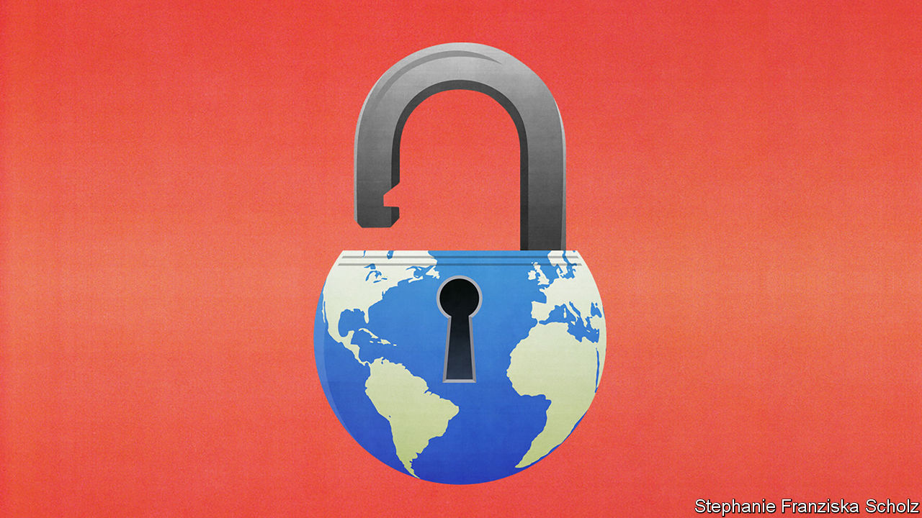

SINCE CHINA locked down the city of Wuhan on January 23rd, over a third of the world’s population has at one time or another been shut away at home. It is hard to think of any policy ever having been imposed so widely with such little preparation or debate. But then closing down society was not a thought-out response, so much as a desperate measure for a desperate time. It has slowed the pandemic, but at a terrible price. As they seek to put lockdowns behind them, governments are not thinking hard enough about the costs and benefits of what comes next.

Although social distancing may have to be sustained for months or years, lockdowns can only ever be temporary. That is because it is becoming clear how costly they are, especially in poor countries. Part of the price is economic. Goldman Sachs this week predicted that India’s GDP would fall in the second quarter at an annualised quarterly rate of 45%, and would rebound by 20% in the third quarter if lockdowns were lifted. Absa, a bank, reckons South Africa’s economy could shrink at an annualised rate of 23.5% in the second quarter.

The poorest are hit very hard, because they have nothing to fall back on. In sub-Saharan Africa an individual in the lowest income quintile has only a 4% chance of receiving social assistance from the government in normal times. The combination of covid-19 and lockdowns could drive up to 420m people into absolute poverty—defined as having to live on less than $1.90 a day. That would increase the total by two-thirds and set back progress against penury by a decade (see article).

The consequences will be far-reaching. Hunger permanently stunts children. Lockdowns that block normal services cost lives. The World Health Organisation has warned that covid-19 threatens vaccination programmes. If they stop in Africa, 140 children could die for each covid death averted. A three-month lockdown, followed by a ten-month interruption of tuberculosis treatment, could cause 1.4m deaths in 2020-25. It is the same for malaria and AIDS. The longer lockdowns continue, the likelier it is that they will cost more lives than they save.

The picture in rich countries is less dramatic, but still worrying. America’s unemployment rate increased from 3.5% in February to 14.7% in April. In Britain a third of new graduates had a job offer withdrawn or delayed. Bond markets in America are signalling a wave of defaults, especially in hospitality, raw materials, carmaking and utilities. The scarring in the labour market could last for years. Rich-world services are vulnerable, too. One study concluded that delaying cancer consultations in England by six months would offset 40% of the life-years gained from treating an equivalent number of covid-19 patients. Vaccination rates have fallen, risking outbreaks of diseases like measles.

Lifting lockdowns risks a second wave. Iran reopened in April to save the economy, but last week designated the capital, Tehran, and eight provinces as “red zones”, because the virus is spreading there again. Some American states, such as Georgia, that never suppressed the initial outbreak will soon find whether they lifted lockdowns too hastily. Some African countries are going ahead even though their case loads are rising.

To limit the risk requires an epidemiological approach that focuses on the places and people most likely to spread the disease. An example is care homes, which in Canada have seen 80% of all the country’s deaths even though they house only 1% of the population. In Sweden refugees turn out to be high-risk, perhaps because several generations may be packed into a household. So are security guards, who are often elderly and are exposed to many people in their work (see article).

For this approach to succeed at scale, you need data from tests to provide a fine-grained picture of how the disease spreads. Testing let Germany rapidly spot that it had a problem in its slaughterhouses, where the virus persists longer than expected on cold surfaces. Likewise, South Korea identified a super-spreader in Seoul’s gay bars. Without testing, a country is blind.

Armed with data, governments can continuously refine their policies. Some are universal. Masks were once thought ineffective, but in fact help stop the spread of the disease. Like handwashing, they are cheap and do not impose hidden costs. However, closing schools harms children and stops parents from working. In contrast with flu, it turns out, the benefits to health are not especially great. Schools should reopen, under conditions that lower the risk to teachers and vulnerable pupils.

As a rule, the balance of costs and benefits favours narrow local policies over blanket national ones. In Britain agency workers carry the virus between care homes: they should work at only one. Gibraltar has a Golden Hour, when open spaces are set aside for the over-70s to exercise while everyone else stays at home. Stockholm is moving vulnerable people into their own flats. Liberty University, run by Jerry Falwell, a supporter of President Donald Trump, was condemned for keeping its campus open. But thanks to social distancing, it has logged no cases of covid-19.

Poor countries will not be able to afford all these approaches. However, Vietnam and the Indian state of Kerala have shown that good primary-health systems can devise and disseminate sensible adaptations. Poor countries have more experience of infectious diseases than rich ones. Epidemiologists talk of “smart containment” that all can practise. Rwanda has put foot-operated handwashing stations in busy places such as bus depots. Slums need clean water for handwashing and to cut queues. Local leaders can spread health messages and designate areas where suspected cases can be isolated. Markets must remain open, but limit social contact. If people can earn some money, millions who would otherwise go hungry could feed themselves.

The emergency phase of the pandemic is drawing to a close. Too many governments failed to spot what was coming, but then did what they could. In the much longer second phase they will have no such excuse. They must identify groups at risk; devise and enact policies for them; explain these so that vulnerable people change their behaviour without becoming scapegoats; provide vital infrastructure; and be ready to adapt as new data come in. This will sort countries where the government works from those where it does not. The stakes could not be higher. ■

This article was downloaded by calibre from <https://www.economist.com/leaders/2020/05/23/lifting-lockdowns-the-when-why-and-how>

|  |  |  |  |
| --- | --- | --- | --- |
| Previous | Articles | Sections | Next |

|  |  |  |  |
| --- | --- | --- | --- |
| Previous | Articles | Sections | Next |

#### Semiconductors

# America is determined to sink Huawei

A new escalation in the tech conflict illustrates the limits of American power

May 23rd 2020 |

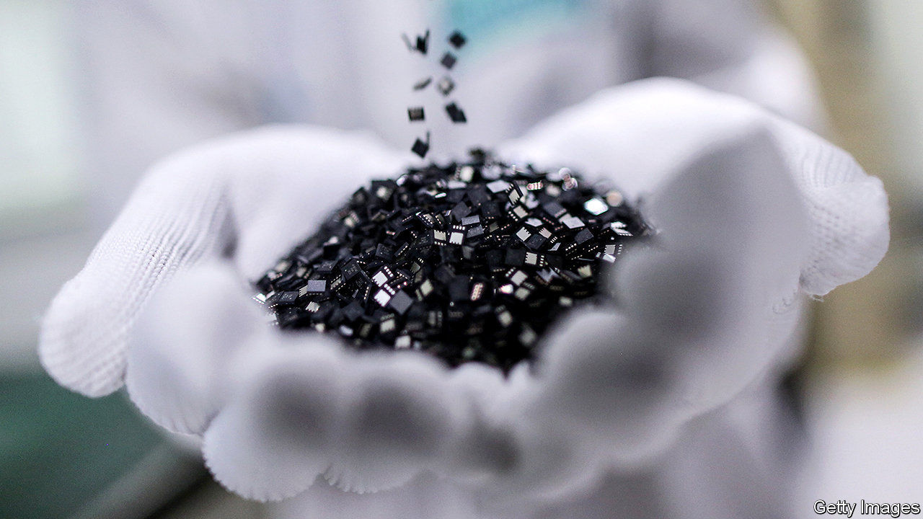

IF AT FIRST you don’t succeed, try again. A year ago America forbade its high-tech companies from selling to Huawei, a Chinese maker of smartphones and mobile-network infrastructure. American officials worry that Huawei-powered phone networks could aid Chinese spying (something the firm denies), and about China’s growing technological prowess more generally. But the embargo turned out to be puny. Loopholes allowed American firms to carry on supplying Huawei from overseas factories. The Chinese firm’s revenues rose by 19% in 2019, to $123bn. Thanks to its efforts to stockpile parts, its purchases from American suppliers rose by 70%, to $19bn.

On May 15th America tried a different tack. It announced new rules that target Huawei’s in-house microchips, which power many of the firm’s products. The rules are aimed at the factories that take such designs and turn them into working silicon, such as those owned by TSMC in Taiwan and SMIC in China. They specify that no American tools can be used to make Huawei’s products. Since every big chipmaker uses some American tools, the effect is to freeze Huawei out completely. The Chinese giant denounced a “pernicious” decision that “threatens to undermine the entire industry worldwide”.

The microchip is an American invention. But the chipmaking business has gone global. These days the dozen biggest semiconductor firms make only 27% of their sales in America. Just 20% of their plant is physically based there. Huawei evaded the worst effects of America’s original blacklist by switching suppliers and buying from non-American factories. The new measures focus on a bottleneck instead: a cohort of American-based chip-equipment firms whose products lack substitutes.

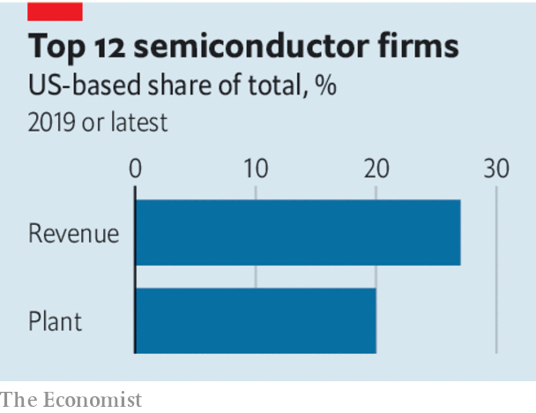

Huawei has said its survival is at stake. Markets are more sanguine. The price of its bonds, which are traded in Hong Kong, barely dipped. It has spent the past year beefing up its large cash buffers and inventories. Now a hunt will begin for a new way to sidestep the rules. China’s long-term project to build up its own chip industry, of which Huawei is a vital part, will be seen as more important than ever. On May 15th SMIC, which is China’s biggest chipmaker, said it had raised $2bn from state investors and planned to increase its capacity in China six-fold.

The episode will have broader consequences for the tech industry. China could retaliate by hobbling American tech firms that make money on the mainland, including Apple. And as the decoupling of America and China accelerates, tech firms that straddle the two are experimenting with ways to try to keep both sides happy. On May 15th TSMC said it would build a $12bn chip plant in Arizona. Four days later ByteDance, a Chinese social-media giant, said that it had appointed Kevin Mayer, a Disney executive, to run TikTok, its most popular app. Having an American in charge may ease worries in Washington about a Chinese app that is installed on millions of American smartphones.

The tech war is guaranteed to make the chip industry less efficient. The big question is whether using technological clout ends up undermining the very American dominance that gives rise to it. No one knows how vital American chipmaking technology really is, because until now there has been no reason to find out. Many governments are wary of China’s power. But they may chafe at American policies that tell their firms who they are allowed to do business with. They may even conclude that wriggling out from under such restrictions by shunning American suppliers is worth a try.

This has, after all, happened before. The aerospace industry is another high-tech business that America jealously guards. The hassle of complying with draconian export rules has proved a selling-point for products that contain no American technology—“ITAR-free”, in the jargon. America’s hawks plainly think that the chance to spike Huawei’s guns, and to slow China’s technological development, is worth that long-term risk. ■

This article was downloaded by calibre from <https://www.economist.com/leaders/2020/05/23/america-is-determined-to-sink-huawei>

|  |  |  |  |
| --- | --- | --- | --- |
| Previous | Articles | Sections | Next |

|  |  |  |  |
| --- | --- | --- | --- |
| Previous | Articles | Sections | Next |

#### No bail-outs without representation

# Malaysia needs a legitimate government to fight covid-19

Prime Minister Muhyiddin Yassin must prove he has a majority

May 23rd 2020 |

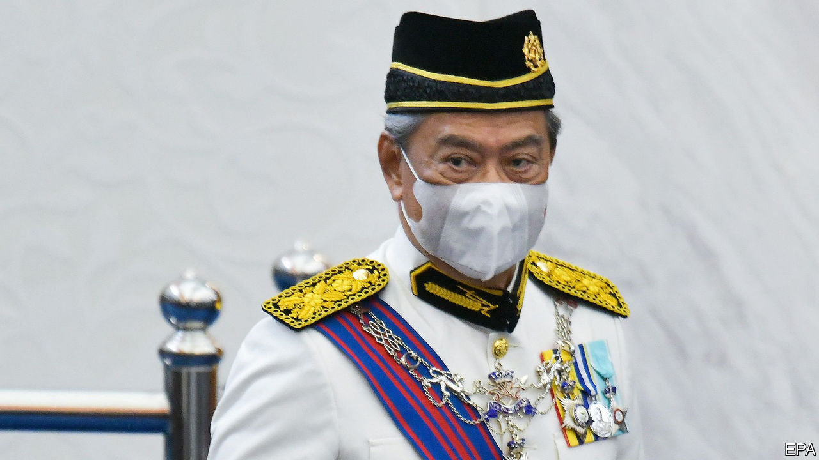

“DO NOT DRAG the country again into political uncertainty,” Malaysia’s king, Sultan Abdullah, admonished the country’s parliament this week. It is too late, unfortunately. Ever since Mahathir Mohamad resigned as prime minister in February, politics has been in flux. In theory, the king’s decision to appoint Muhyiddin Yassin to head a new government on March 1st should have put an end to the turmoil. But because Mr Muhyiddin has spent two and a half months in office without proving he has a majority in parliament, the politicking has continued (see [article](https://www.economist.com/node/21786476)). Indeed, many speculate that the prime minister is avoiding a vote because he might lose it. The only way to stem the scheming is for Mr Muhyiddin to prove them wrong.

The parliamentary arithmetic is opaque because Mr Muhyiddin’s government was born out of a splintering of several parties in Dr Mahathir’s coalition. Defectors from both Bersatu, the party of the two prime ministers, and Keadilan, the biggest component of Dr Mahathir’s government, have joined forces with the opposition in what amounted to a parliamentary coup. The king, having consulted all MPs, believed that the turncoats, led by Mr Muhyiddin, had a majority. But the balance of power is held by fickle and mercenary regional parties. And it has only gradually become apparent where the loyalties of the 37 MPs from Bersatu, in particular, lie. Thirty-two of them support the government.

Parliament met this week, and could have set the record straight. But a no-confidence motion put forward by Dr Mahathir was postponed; instead, MPs listened only to the king’s speech before adjourning. As things stand, they will not meet again until July. The ostensible reason for the delay was covid-19. Malaysia has suffered more than 7,000 cases. It has closed its borders, restricted citizens’ movement and banned religious gatherings—a bold step in a country with a Muslim majority. How could MPs even consider repaying the sacrifices ordinary citizens are making by descending into another bout of infighting, critics ask? Worse still, what if no government is able to drum up a majority? How irresponsible would it be of MPs to pitch Malaysia into an election in the middle of a pandemic?

But politicking will not go away. The wobblier Mr Muhyiddin appears, the weightier the incentives he must dangle before wavering lawmakers to keep their backing. Already he has dished out more than 60 jobs as ministers or deputies—in a parliament of just 222 members. Castigating allies for insubordination is impossible. Squabbles between supposedly friendly parties within the government plague state politics.

Moreover, a government of dubious legitimacy is making unprecedented and sweeping decisions whose effects will be felt for years. As in many countries, the lockdown to curb covid-19 is bludgeoning the economy. The government has adopted a relief package with a notional value of 16% of GDP. It will soon have to decide whether to restrict Malaysians’ freedoms yet longer, and whether to spend even more money it does not have to mitigate the consequences. Decisions of such magnitude should be made only by a government that a majority of MPs and, by extension, a majority of Malaysians, support.

A vote of confidence may also be a way to force awkward MPs to behave. Would they really want to precipitate an election now? Some may be induced to support Mr Muhyiddin by their conscience—imagine!—rather than by bribes. And if an election really is the only way out, so be it. It would have to be conducted safely, of course, ideally with lots of postal voting or over several days, to allow social distancing. But it is when difficult decisions are being made that democracy is most needed—not when the going is smooth. ■

This article was downloaded by calibre from <https://www.economist.com/leaders/2020/05/23/malaysia-needs-a-legitimate-government-to-fight-covid-19>

|  |  |  |  |
| --- | --- | --- | --- |
| Previous | Articles | Sections | Next |

|  |  |  |  |
| --- | --- | --- | --- |
| Previous | Articles | Sections | Next |

#### Big pharma is having a good crisis

# Drug innovation is back in fashion

Big pharma is no longer the villain

May 23rd 2020 |

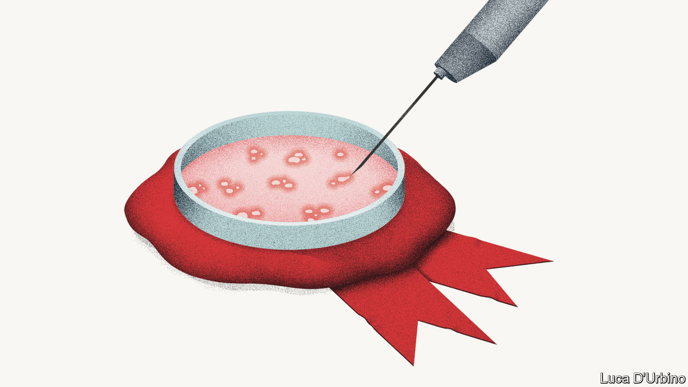

Editor’s note: Some of our covid-19 coverage is free for readers of The Economist Today, our daily [newsletter](https://my.economist.com/user#newsletter). For more stories and our pandemic tracker, see our [hub](https://www.economist.com/news/2020/03/11/the-economists-coverage-of-the-coronavirus)

FOR MUCH of the past two decades big pharma has been a lost cause. Despised by the public, it became notorious for price-gouging, secretiveness and its neglect of global health problems. Big pharma also lost its lustre with investors, despite its bumper profits. They worried that a business model that relied too much on rent-seeking and too little on innovation was unsustainable, and that citizens would eventually revolt and demand more regulation—or even rip up the patent system that gives drugs firms a temporary monopoly over new medicines. As a result, in the five years before the covid crisis the pharmaceutical sector lagged behind America’s S&P 500 index.

The pandemic has reminded the world of the industry’s strengths—its capacity to innovate and provide drugs on a vast scale. Many of the big firms, such as Johnson & Johnson and Sanofi, are working on covid-19 vaccines and therapies. Scores of smaller companies are at work, too. On May 18th Moderna, an American biotech firm, said that its much-anticipated vaccine has shown positive early results (although some analysts questioned the validity of its tests). AstraZeneca, a big British firm that invests heavily in research and development (R&D), is working on a vaccine with scientists at Oxford University, helped by $1bn of new funding from America’s government. Even before the virus, the industry had started to invest more heavily. In the most recent quarter America’s 30 biggest firms boosted their R&D by a median of 6% year on year. Now medical innovation is back in fashion.

It looks like big pharma’s moment to shine. However, the pandemic has also created new ethical and political dilemmas. Vaccine nationalism is spreading as governments panic that others may get their hands on crucial drugs first. France’s Sanofi has found itself embroiled in a transatlantic row over who will be first to get any covid-19 vaccine it develops. Paul Hudson, the firm’s boss, stated last week that because the American government invested in his firm’s risky scientific efforts, the United States would have early access. This led to a political explosion in France and a dressing-down from Emmanuel Macron, France’s president. And there is mounting pressure to suspend elements of the patent system. A gathering of the World Health Organisation this week passed a resolution urging drugs firms to pool patent rights. Several dozen current and former world leaders released an open letter demanding that any successful covid-19 vaccine should be made available patent-free.

There is an alternative to beggar-thy-neighbour nationalism and taking a sledgehammer to the intellectual-property regime. First, a global agreement is needed to govern the manufacture and distribution of a potential vaccine. It could take several years to vaccinate the world’s population; global co-operation will mean that the vaccine is deployed first where it brings most benefit.

Second, the patent system should be preserved because, correctly designed, it incentivises investment in new treatments. The big drugs firms have already said they will make any vaccine available at cost-plus prices. Arrangements exist for tiered pricing of medicines and free vaccinations for diseases afflicting the world’s poor that should be extended to covid-19 treatments. If a smaller drugs firm tried to price-gouge, governments in the West and elsewhere have the powers to pass compulsory licensing orders in an emergency. When the pandemic passes, there must be no going back to the bad old days. Governments should seek to authorise new drug patents faster, as the best way to balance innovation and lower prices. And big pharma needs to keep investing. That will help shareholders and global public health, too.■

This article was downloaded by calibre from <https://www.economist.com/leaders/2020/05/23/drug-innovation-is-back-in-fashion>

|  |  |  |  |
| --- | --- | --- | --- |
| Previous | Articles | Sections | Next |

|  |  |  |
| --- | --- | --- |
| Leaders | Sections | Briefing |

Letters

Letters to the editor: On solitude, investors, electric cars, Yemen, Labour, Einstein, three points

.

|  |  |  |
| --- | --- | --- |
| Leaders | Sections | Briefing |

|  |  |  |  |
| --- | --- | --- | --- |
|  | Articles | Sections | Next |

#### On solitude, investors, electric cars, Yemen, Labour, Einstein, three points

# Letters to the editor

A selection of correspondence

May 23rd 2020 |



## All by myself

Loneliness can indeed arise from the extremes of solitude, but solitude is not about being physically distant from others (“[All the lonely people](https://www.economist.com/books-and-arts/2020/04/30/solitude-has-always-been-both-a-blessing-and-a-curse)”, May 2nd). Solitude is giving your mind repose from the incessant stream of distraction in the external world: music, TV, instant communication, endless scrolling. Solitude is allowing yourself the time and space to become comfortable with the wondrous ongoing of your mind without wishing for an immediate suppressant.

Loneliness, by contrast, comes from the endless desire to seek out connection, in which one struggles to find anything real or profound.

PIERRE MASON-PEREZ  
Durham

I recall David Foster Wallace remarking once that loneliness does not come from being alone. Sadly, from a man who probably knew all too well.

CHRIS STILLNashville

I am reminded of what Amartya Sen said about the difference between voluntarily eating 1,000 calories a day on a diet and having to stick to that limit because you cannot afford food. Choosing solitude is one thing; imposed solitary confinement quite another.

ARNOLD PACKERFormer assistant secretary of labour  
La Jolla, California

Alex Honnold did indeed climb El Capitan in Yosemite “with neither companions nor crampons”. That’s because crampons are used for ice and snow in alpine environments. El Capitan is a granite monolith and is never climbed with crampons but rather with rock-climbing shoes.

JOSHUA COOK  
Bogotá

You said that “Sherlock Holmes preferred an opium pipe to ignite his solitary reveries.” Poppycock I say! He smoked tobacco in his pipe. True, Watson did find the great detective in an opium den in “The Man with the Twisted Lip”, but Holmes assured him it was all for cover and he did not inhale.

The real vice for Holmes was cocaine, a stimulant that enhanced frenetic thinking until a solution emerged.

ANDREW WILSON  
Portland, Oregon

“Leslie Stephen and G.M. Trevelyan thought nothing of walking from Cambridge to London for dinner”, you wrote. However, I wonder if they did think during their 50-mile hike that their 6am departure was cutting it a bit fine.

ADRIAN WILLIAMS  
Headington, Oxford

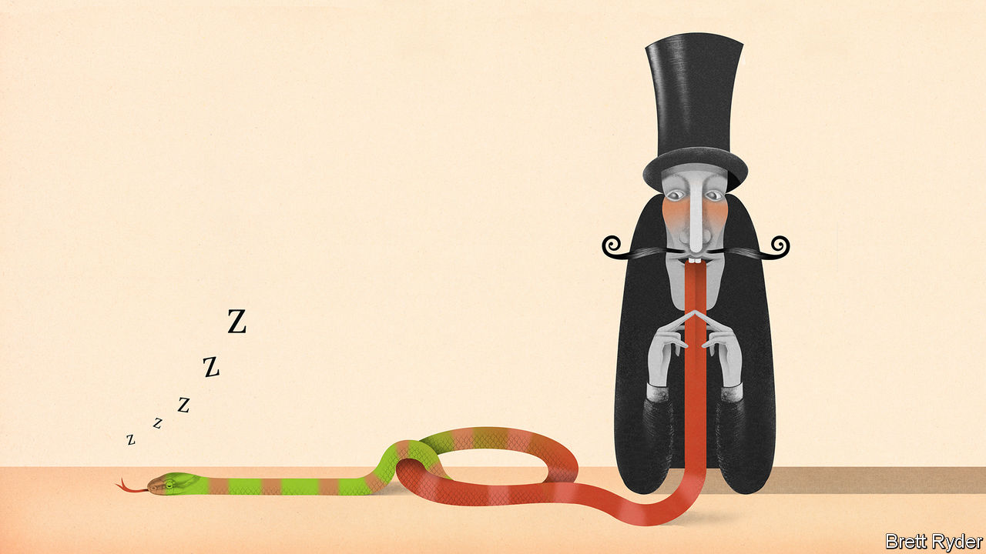

## Animal spirits

May I respectfully question Schumpeter’s imagery of activist investors as soon-to-be awakened serpents ([April 18th](https://www.economist.com/business/2020/04/18/activist-investors-have-gone-quiet-during-the-pandemic)). The extreme disruption for business being wrought by this dreadful virus will indeed expose the weaker performers to scrutiny from activists and institutional investors alike. Warren Buffett’s line that “only when the tide goes out do you discover who’s been swimming naked” comes to mind.

Emboldened by a market hungry for yield and with little patience for underperformance, energised from a flush of capital and bearing the stripes of lessons learned, perhaps the image of the activist as a prowling tiger would be more appropriate. Continuing with that imagery, the boards of any companies targeted by such activists should hope that they are more “The Tiger Who Came To Tea” than the one that bares its claws. I, however, am expecting more of the latter.

MALCOLM MCKENZIEManaging director  
Alvarez & Marsal  
London

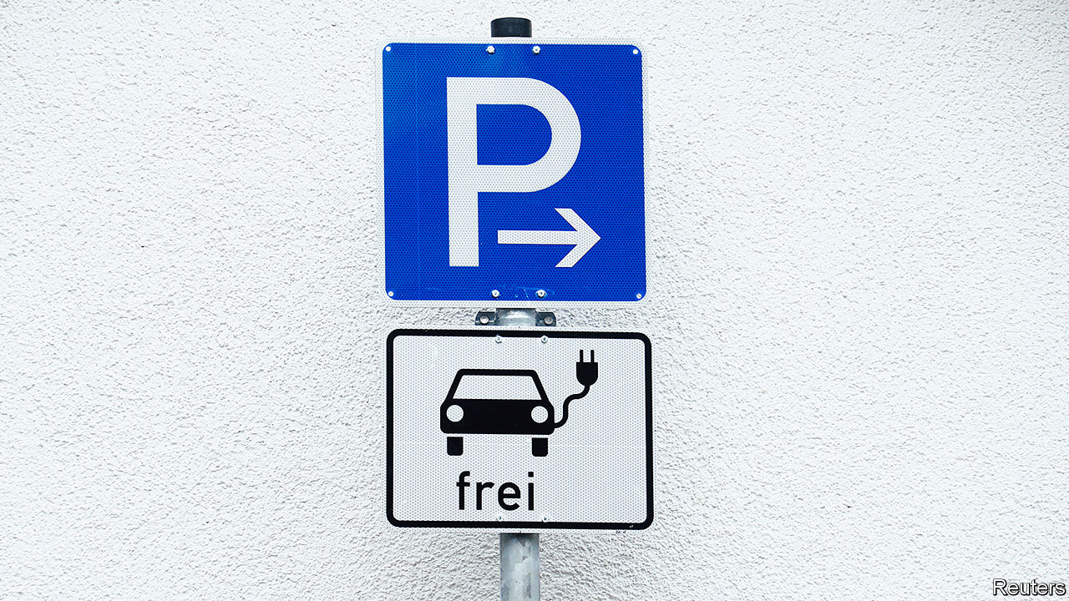

## Recharge needed

You suggested that we may soon reach the $100 per kWh price for lithium-ion batteries to make electric vehicles competitive (“[Charging up for a long ride](https://www.economist.com/briefing/2020/04/25/lithium-remains-the-car-battery-material-of-choice)”, April 25th). However, research from MIT finds that once we account for price floors set by materials cost, battery prices will probably fall to only $124 per kWh by 2030. This, coupled with cheaper fuel for cars from lower oil prices, means that government interventions in the form of subsidies, fuel taxes and emission rules are still necessary if EVs are to compete.

KARAN BHUWALKA  
Cambridge, Massachusetts

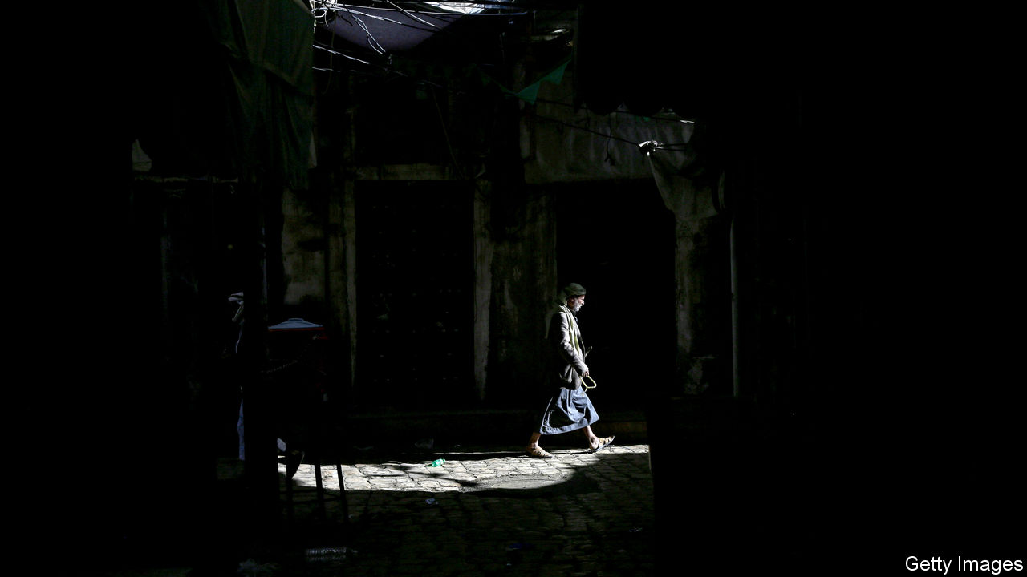

## Trapped in a war zone

“[Looking for an exit](https://www.economist.com/middle-east-and-africa/2020/04/18/saudi-arabia-looks-for-an-exit-to-the-war-in-yemen)” (April 18th) discussed the prospects for an end to the war in Yemen. Many Yemenis are also looking for an exit, but they have few opportunities for migration. Only 33 countries allow Yemenis visa-free access, according to the Henley Passport Index. Oman is even building a wall. Instead of offering protection, Saudi Arabia has been sending Yemenis back across the border. Djibouti has granted refugee status to those who survive the dangerous sea crossing, but it is a poor country. Europe is all but inaccessible. Clandestine journeys can cost as much as $26,000.

These restrictive migration policies mean that Yemenis are forced to move internally to stay safe. At least 3.6m people in a population of 28m are internally displaced; many have been forced to move more than once. These repeated displacements undermine the prospects for lasting stability.

CHLOE SYDNEY  
Internal Displacement  
Monitoring Centre  
Geneva

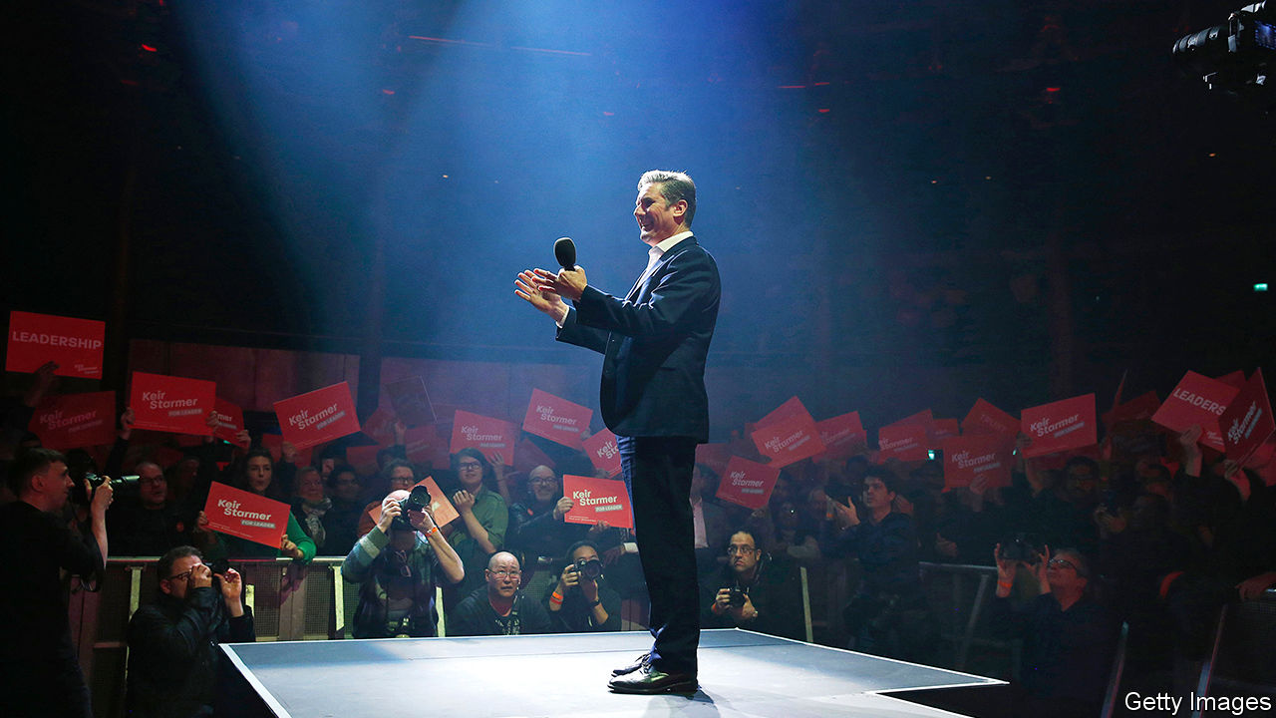

## A good start for Starmer

The parallel between Neil Kinnock and Sir Keir Starmer in their respective ascension to the leadership of Britain’s Labour Party is striking (“[Socialism with a barrister’s face](https://www.economist.com/britain/2020/04/11/keir-starmer-labours-electable-new-leader)”, April 11th). Jeremy Corbyn’s manifesto at last year’s election brought to mind Michael Foot’s in 1983, described as the longest suicide-note in history. Mr Kinnock replaced Foot, giving Labour credibility and holding the Thatcher government to account far more eloquently than Foot ever had.

Sir Keir will also flourish in both these aspects. His great challenge, however, lies in convincing voters to rid Boris Johnson of his majority, something which Mr Kinnock never managed to achieve with Margaret Thatcher or even John Major. The cold truth in British politics, that oppositions don’t win elections but government’s lose them, may come to haunt Sir Keir.

KARDO BECK  
London

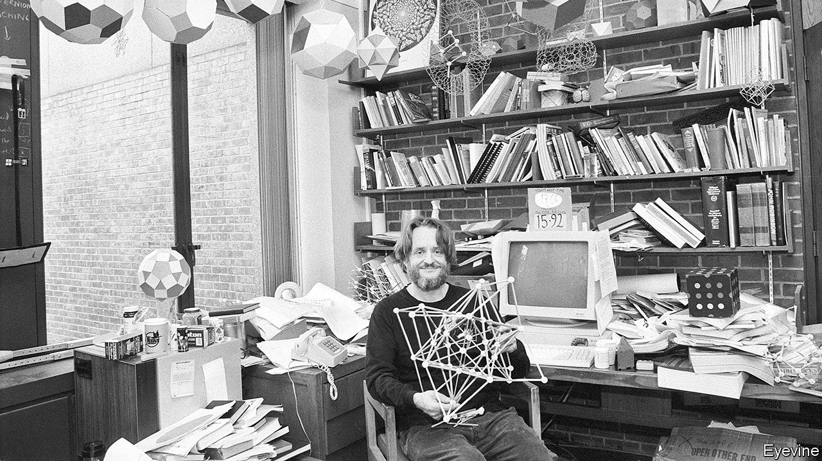

## Missing signature

Your obituary of John Conway ([April 25th](https://www.economist.com/obituary/2020/04/23/john-conway-died-on-april-11th)) states that he earned fellowship of the Royal Society “in the same big book as Newton and Einstein”. If you are referring to the Charter Book of the Royal Society, which all fellows sign, it is worth mentioning that one notable omission is Albert Einstein. Although elected as a Foreign Member in 1921, he never signed the book.

SEMIR ZEKI  
Professor of neuroesthetics  
University College London

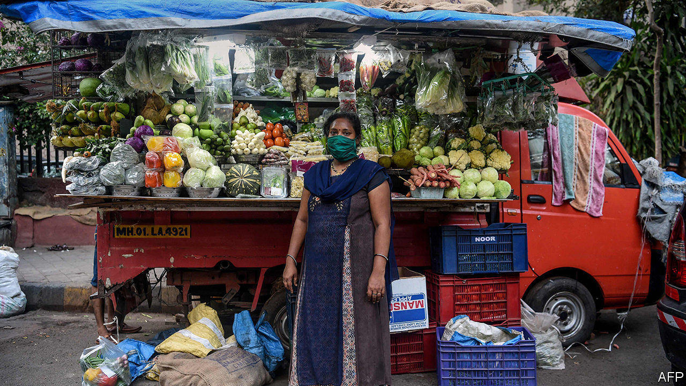

## We're all in this together

* I understand your article (“[For microfinance lenders, covid-19 is an existential threat](https://www.economist.com/finance-and-economics/2020/05/05/for-microfinance-lenders-covid-19-is-an-existential-threat)”, May 5th) as a call to action to prevent a reversal in progress towards financial inclusion. However, the title of the piece suggests that the very existence of the financial inclusion sector is at stake which is clearly not true. The demand and need for financial services for low income populations will be greater than ever in the future. You highlighted one of the elements to succeed: a boost in digitalisation.

You also rightly note the liquidity stress that the financial institutions lending to MSMEs are experiencing due to the impact of lockdowns and payment holidays. One of the key initiatives to support the sector was not mentioned, namely the extraordinary actions of solidarity from the firms that fund these institutions: impact investors. Our priority as impact investors has been to continue to fund bankable institutions through the refinancing of existing debt or additional financing in a responsible manner. We have recently published a memorandum to provide a framework for efficient coordination among leading impact investors. Indeed, MSMEs form a vital basis for future social and economic recovery post-covid-19.

It is critical not to fan a flame of panic, but to foster the communal approach that impact investors and development banks have taken—continued support for the financial institutions that reach out to MSMEs in order to support the informal economy and all income-generating activities for the most vulnerable among us.

MARTIN HEIMES  
Co-head, Financial Institutions Debt  
responsAbility Investments  
Zurich

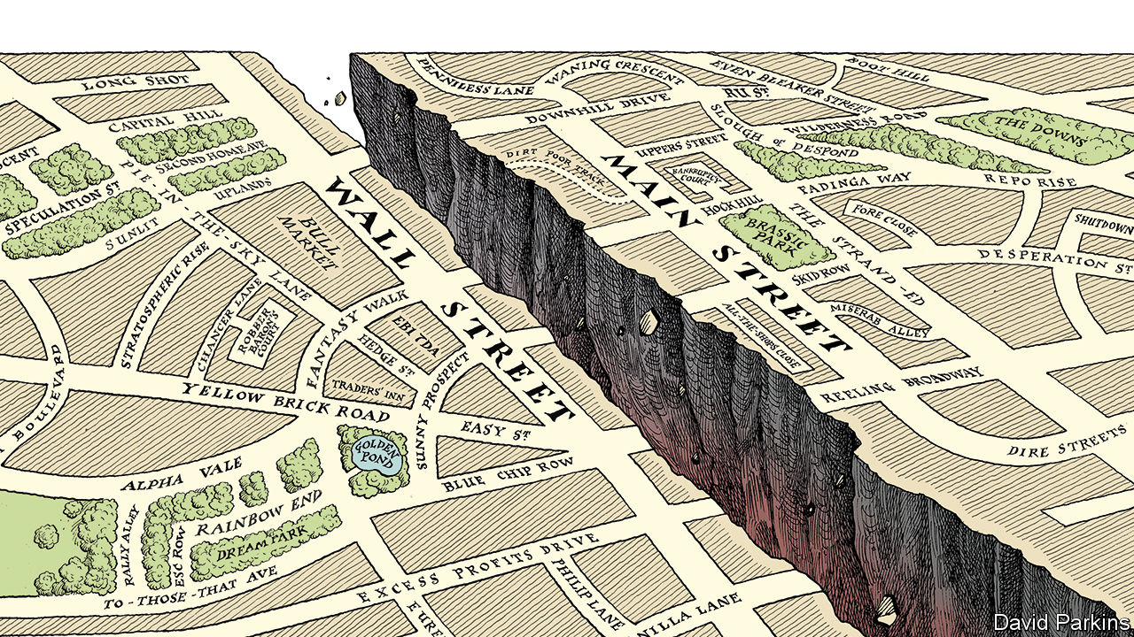

## The holy trinity

I am a big fan of The Economist, but I do have one pet peeve. Why must lists always be in sets of three? In several articles in just one issue ([May 9th](https://www.economist.com/printedition/2020-05-09)), for example, we had: “There are countless threats to such a prospect, but three stand out”; “But three dangers loom”; “Three things are driving change”; “There are three types of benefits to the issuers of a reserve currency”; and “Nevertheless it brings three dangers”. Do challenges or opportunities never come in sets of two or four?

SEAN LEIMBACH  
New York  
* Letters appear online only

This article was downloaded by calibre from <https://www.economist.com/letters/2020/05/23/letters-to-the-editor>

|  |  |  |  |
| --- | --- | --- | --- |
|  | Articles | Sections | Next |

|  |  |  |
| --- | --- | --- |
| Letters | Sections | United States |

Briefing

Covid and the climate: Flattening the other curve

.

Never let a crisis go to waste: A trillion-dollar question

.

Taxing carbon: The contentious and correct option

.

Emissions: If a tree falls

.

|  |  |  |
| --- | --- | --- |
| Letters | Sections | United States |

|  |  |  |  |
| --- | --- | --- | --- |
|  | Articles | Sections | Next |

#### The other crisis

# Can covid help flatten the climate curve?

Arriving at a time of change, the pandemic could bring forward the fossil-fuel peak

May 21st 2020 | NEW YORK

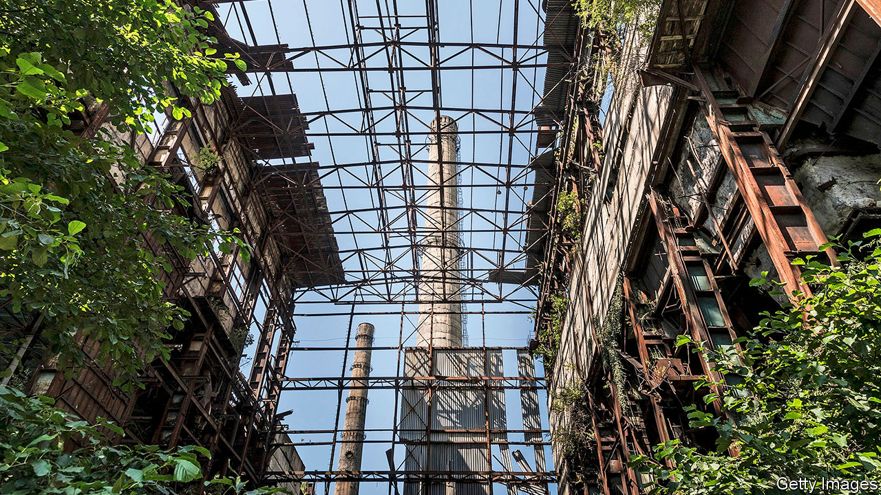

Editor’s note: Some of our covid-19 coverage is free for readers of The Economist Today, our daily [newsletter](https://my.economist.com/user#newsletter). For more stories and our pandemic tracker, see our [hub](https://www.economist.com/news/2020/03/11/the-economists-coverage-of-the-coronavirus)

AMID COVID-19’s sweeping devastation, its effect on greenhouse gases has emerged as something of a bright spot. Between January and March demand for coal dropped by 8% and oil by 5%, compared with the same period in 2019. By the end of the year energy demand may be 6% down overall, according to the International Energy Agency (IEA), an intergovernmental forecaster, amounting to the largest drop it has ever seen.

Because less energy use means less burning of fossil fuels, greenhouse-gas emissions are tumbling, too. According to an analysis by the Global Carbon Project, a consortium of scientists, 2020’s emissions will be 2-7% lower than 2019’s if the world gets back to prepandemic conditions by mid-June; if restrictions stay in place all year, the estimated drop is 3-13% depending on how strict they are. The IEA’s best guess for the drop is 8%.

That is not enough to make any difference to the total warming the world can expect. Warming depends on the cumulative emissions to date; a fraction of one year’s toll makes no appreciable difference. But returning the world to the emission levels of 2010—for a 7% drop—raises the tantalising prospect of crossing a psychologically significant boundary. The peak in carbon-dioxide emissions from fossil fuels may be a lot closer than many assume. It might, just possibly, turn out to lie in the past.

That emissions from fossil fuels have to peak, and soon, is a central tenet of climate policy. Precisely when they might do so, though, is so policy-dependent that many forecasters decline to give a straight answer. The IEA makes a range of projections depending on whether governments keep on with today’s policies or enact new ones. In the scenario which assumes that current policies stay in place, fossil-fuel demand rises by nearly 30% from 2018 to 2040, with no peak in sight.

The IEA, though, has persistently underestimated the renewable-energy sector. Others are more bullish. Carbon Tracker, a financial think-tank, predicted in 2018 that with impressive but plausible growth in renewable deployment and relatively slow growth in overall demand, even under current policy fossil-fuel emissions should peak in the 2020s—perhaps as early as 2023. Michael Liebreich, who founded BloombergNEF, an energy-data outfit, has also written about a possible peak in the mid 2020s. Depending on how the pandemic pans out he now thinks that it may be in 2023—or may have been in 2019.

Previously, drops in emissions caused by economic downturns have proved only temporary setbacks to the ongoing rise in fossil-fuel use. The collapse of the Soviet Union in 1991, the Asian financial crash in 1997 and the financial crisis of 2007-09 all saw emissions stumble briefly before beginning to rise again (see chart). But if a peak really was a near-term prospect before the pandemic, almost a decade’s worth of setback could mean that, though emissions will rise over the next few years, they never again reach the level they stood at last year.

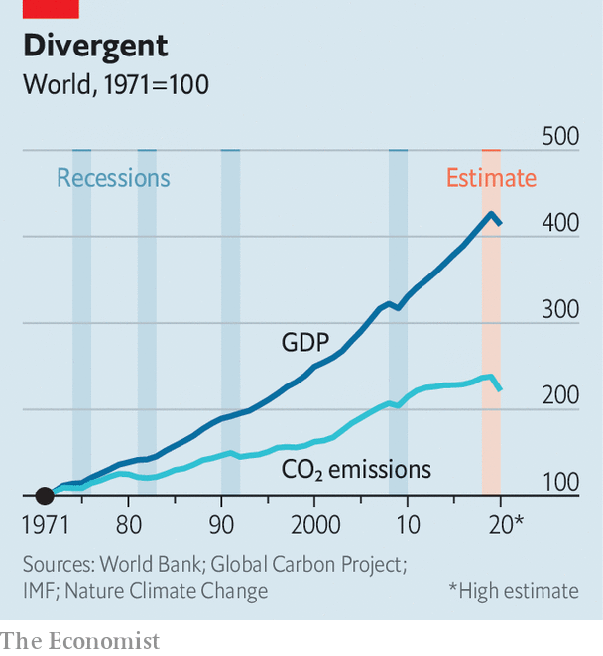

The alternative, more orthodox pre-covid view was that the peak was both further off and destined to be higher. On this view, emissions will regain their pre-pandemic level within a few years and will climb right on past it. Covid’s damage to the economy probably means that the peak, when it arrives, will be lower than it might have been, says Roman Kramarchuk of S&P Global Platts Analytics, a data and research firm. But an economic dip is unlikely to bring it on sooner.

What, though, if covid does not merely knock demand back, but reshapes it? This shock, unlike prior ones, comes upon an energy sector already in the throes of change. The cost of renewables is dipping below that of new fossil-fuel plants in much of the world. After years of development, electric vehicles are at last poised for the mass market. In such circumstances covid-19 may spur decisions—by individuals, firms, investors and governments—that hasten fossil fuels’ decline.

So far, renewables have had a pretty good pandemic, despite some disruptions to supply chains. With no fuel costs and the preferential access to electricity grids granted by some governments, renewables demand jumped 1.5% in the first quarter, even as demand for all other forms of energy sank. America’s Energy Information Administration expects renewables to surpass coal’s share of power generation in America for the first time this year.

Coal prices have fallen, given the low demand, which may position it well post-pandemic in some places. Even before covid, China was building new coal-fired plants (see article). But the cost of borrowing is also low, and likely to stay that way, which means installing renewables should stay cheap for longer. Renewable developers such as Iberdrola and Orsted, both of which have weathered covid-19 rather well so far, are keen to replace coal on an ever larger scale.

Those who see demand for fossil fuels continuing to climb as populations and economies grow have assumed demand for oil will be much more persistent than that for coal. Coal is almost entirely a source of electricity, which makes it ripe for replacement by renewables. Oil is harder to shift. Electric vehicles are sure to eat into some of its demand; but a rising appetite for petrochemicals and jet fuel, to which lithium-ion batteries offer no competition, was thought likely to offset the loss.

## Breaking bounds

Now oil’s future looks much more murky, depending as it does on a gallimaufry of newly questionable assumptions about commuting, airline routes, government intervention, capital spending and price recovery. In the future more people may work from home, and commuting accounts for about 8% of oil demand. But those who do commute may prefer to do so alone in their cars, offsetting some of those gains. Chinese demand for oil has picked up again quickly in part because of reticence about buses and trains.

As to planes, Jeff Currie of Goldman Sachs estimates that demand for oil will recover to pre-crisis levels by the middle of 2022, but that demand for jet fuel may well stay 1.7m barrels a day below what it was as business travel declines. That is equivalent to nearly 2% of oil demand.

Such uncertainty means more trouble for the oil sector, whose poor returns and climate risks have been repelling investors for a while. Companies are slashing spending on new projects. By the mid-2020s today’s underinvestment in oil may boost crude prices—making demand for electric vehicles grow all the faster.

Natural gas, the fossil fuel for which analysts have long predicted continued growth, has weathered the pandemic better than its two older siblings. But it, too, faces accelerating competition. One of gas’s niches is powering the “peaker” plants which provide quick influxes of energy when demand outstrips a grid’s supply. It looks increasingly possible for batteries to take a good chunk of that business.

Those hoping for fossil fuels’ imminent demise should not be overconfident. As lockdowns around the world end, use of dirty fuels will tick back up, as they have in China. Energy emissions no longer rise in lockstep with economic growth, but demand for fossil fuels remains tied to it. Mr Currie of Goldman Sachs, for one, is wary of declaring a permanent decoupling: “I’m not willing to say there is a structural shift in oil demand to GDP.” Even so, a peak of fossil fuels in the 2020s looks less and less farfetched—depending on what governments do next in their struggle with the pandemic. Of all the uncertainties in energy markets, none currently looms larger than that. ■

This article was downloaded by calibre from <https://www.economist.com/briefing/2020/05/21/can-covid-help-flatten-the-climate-curve>

|  |  |  |  |
| --- | --- | --- | --- |
|  | Articles | Sections | Next |

|  |  |  |  |
| --- | --- | --- | --- |
| Previous | Articles | Sections | Next |

#### Never let a crisis go to waste

# The pressure to make the post-covid rebound green

A matter of opportunities and costs

May 23rd 2020 |

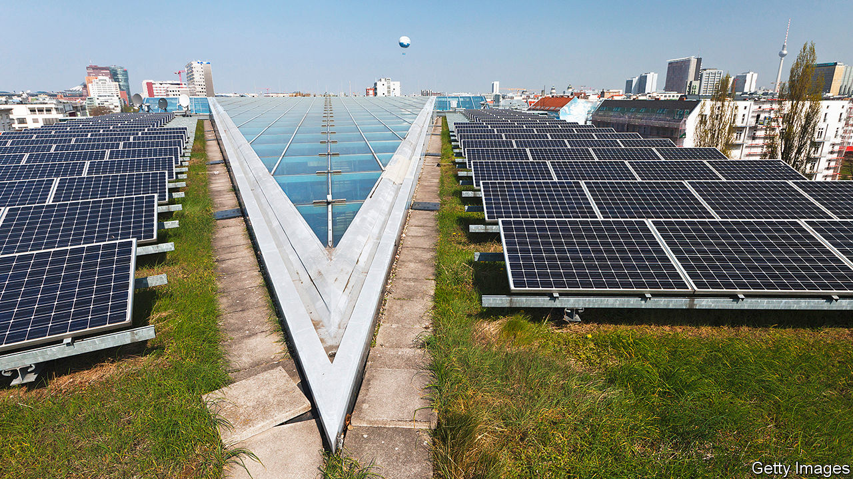

Editor’s note: Some of our covid-19 coverage is free for readers of The Economist Today, our daily [newsletter](https://my.economist.com/user#newsletter). For more stories and our pandemic tracker, see our [hub](https://www.economist.com/news/2020/03/11/the-economists-coverage-of-the-coronavirus)

IN THE SIMULTANEOUSLY global, parochial and precise view of the scientists of the Global Carbon Project (GCP), it was April 7th which marked peak lockdown. The parts of the world where there was some sort of confinement order in place on that day would normally have accounted for 89% of the world’s greenhouse-gas emissions, the highest such percentage of the whole pandemic: the day before, less of America was locked down; the day after, more of China had gone back to work. The amount of carbon dioxide emitted on that peak day was, the GCP calculates, 17% lower than 2019’s daily average.

That is a huge difference: more than 11m tonnes of carbon dioxide. It is also a small one. For years, environmentalists have been calling on people to change their lifestyles in order to protect the planet. In the face of covid-19, governments have made some of their strictures official policy. The world now knows what can be achieved by closing a vast number of shops, as well as offices and factories, and stopping a great many people from travelling: a reduction in emissions which, though striking, is not enough to fundamentally change things, gained at an enormous price in terms of liberty and the pursuit of happiness.

The measures governments have taken against covid-19 are entirely unsuited to a campaign against climate change that has to last for decades, rather than days. But the financial muscle brought to bear and the willingness to use the full force of the state is nevertheless suggestive. Climate-minded academics, public intellectuals and think-tankers have worked themselves into a lather over the benefits which action on such a scale could provide if effects on climate were actually part of the remit.

As Fatih Birol, the head of the International Energy Agency, an intergovernmental think-tank, points out, government decisions guide about 70% of the world’s spending on energy. “In a very short period of time,” he says, “governments will make enormously consequential decisions.” Total stimulus spending will be in the trillions. If a decent fraction of that is earmarked for climate action, it could be world changing.

This idea is not new. Similar pleas were heard—from some of the same people—a decade ago, when policymakers were trying to get the world out of the slump brought on by the financial crisis of 2007-09. Roughly an eighth of the stimulus money disbursed by the American Recovery and Reinvestment Act (ARRA)—some $90bn—went into clean-energy loans and investments.

This greenery is remembered in political circles mainly because the first loan issued under the scheme—for a meaty $535m—went to Solyndra, a company devoted to cylindrical solar cells which went bust soon afterwards. The overwhelming majority of its loans, though, were repaid. One of them helped to finance Tesla’s first car factory.

Defenders of those clean-energy investments argue that they drew in $150bn of private and non-federal investment in clean energy—2009 and 2012 proved to be bumper years in America’s wind-energy sector—and paved the way for great progress over the subsequent decade. They did not, though, have any prompt appreciable effect on the global emissions trajectory. That was dominated by China’s post-crisis stimulus, which relied on ramping up coal-fired power stations. If American emissions did not rise as fast as they might have, it had more to do with cheap natural gas from the fracking boom providing a profitable alternative to coal-fired electricity than to any effects of ARRA.

Whatever ARRA’s role in the matter, though, renewables did start to have an appreciable effect in later years. They helped global emissions plateau in 2014-16, and again in 2018-19, even as the economy expanded. Renewables are now often cheaper than fossil fuels in large parts of the world. This is one of the reasons why today’s calls for a green stimulus are not carbon copies of those made ten years ago. They have less stress on renewable-energy R&D and fewer calls for demonstration projects. There is more emphasis on deploying technologies for types of decarbonisation not easily achieved with electricity, and on energy-storage systems and greatly improved electric grids that will open the way to much needed further expansion of renewables.

In America, the precise details of what is on the stimulus menu seem immaterial; President Donald Trump’s administration is much more interested in helping coal and oil companies than it is the renewable sector. That said, a block of Republican senators from states with significant clean-energy industries—including wind farms of the sort that blossomed after the financial crisis—has convinced the Treasury to consider extending tax-incentive schemes for renewable developments which have been stalled by the response to the epidemic.

The fact that renewables now have lobbying power is one demonstration that things are different this time. Another is that politics have changed, too. The Paris agreement of 2015 required its signatories to develop plans for emissions reduction, and to stand ready to increase their ambition at another big UN summit, co-hosted by Britain and Italy, which was originally planned for this year but has now been deferred to 2021. Polling suggests that citizens would be happy to see them take that commitment seriously. In April Ipsos MORI asked people from 14 countries whether they thought climate change was as serious a threat as covid-19. The greatest assent was in China, where 87% agreed that it was; but even in America, where the assent was lowest, 59% agreed. Nearly two-thirds of respondents, including 57% of Americans, went on to say that it was important that government actions aimed at economic recovery prioritise action on climate change.

## Gizza job

Green boosters have always been keen to claim that strong climate policies have the added advantage of producing copious jobs; the Obama administration credited clean-energy investments under ARRA with supporting 900,000 job-years of employment. In recent years of low unemployment such claims have come to seem somewhat beside the point. With joblessness now having bounced back above Great Depression levels in many places, green jobs have again become a selling point.

Some see mass unemployment not just as a symptom to assuage, but as a unique opportunity to get things done which, if everyone had a job, would be much harder. Such ideas fit with the growing need for large-scale infrastructure that gets the most out of private investments. With renewable energy growing fast, getting it to the places where it can do the most to edge out fossil fuels—for example, the batteries of electric vehicles—is an obvious next step. The British government is one of those considering rolling out a huge network of car-charging facilities.

Many economists might prefer to see governments simply provide incentives for endeavours they think worthwhile, leaving industry to meet those goals with whatever number of workers seems most efficient, rather than how many the government wants off the dole. This is particularly true given that much covid-related unemployment has fallen on the service sector; the jobs that need doing and the people who need jobs might be a poor fit.

Against that needs to be considered the problem of the “90% economy”. Some service-sector jobs will come back quite slowly, if at all. If governments incentivise, say, home insulation and offer training and certification, all sorts of local companies might provide the actual service, and they would be quite labour intensive.

In Pakistan the unemployed are being released from lockdown to work on a tree-planting programme that predates the crisis. The climate impact may not be that high; but refugees from service sectors around the world might rather enjoy similar opportunities, at least for a while. And they would not need all that much training. As Cameron Hepburn of the University of Oxford points out, you can go from pulling pints to planting pines pretty quickly. ■

This article was downloaded by calibre from <https://www.economist.com/briefing/2020/05/23/the-pressure-to-make-the-post-covid-rebound-green>

|  |  |  |  |
| --- | --- | --- | --- |
| Previous | Articles | Sections | Next |

|  |  |  |  |
| --- | --- | --- | --- |
| Previous | Articles | Sections | Next |

#### Fighting climate change

# The world urgently needs to expand its use of carbon prices

But doing so could provoke another trade war

May 23rd 2020 |

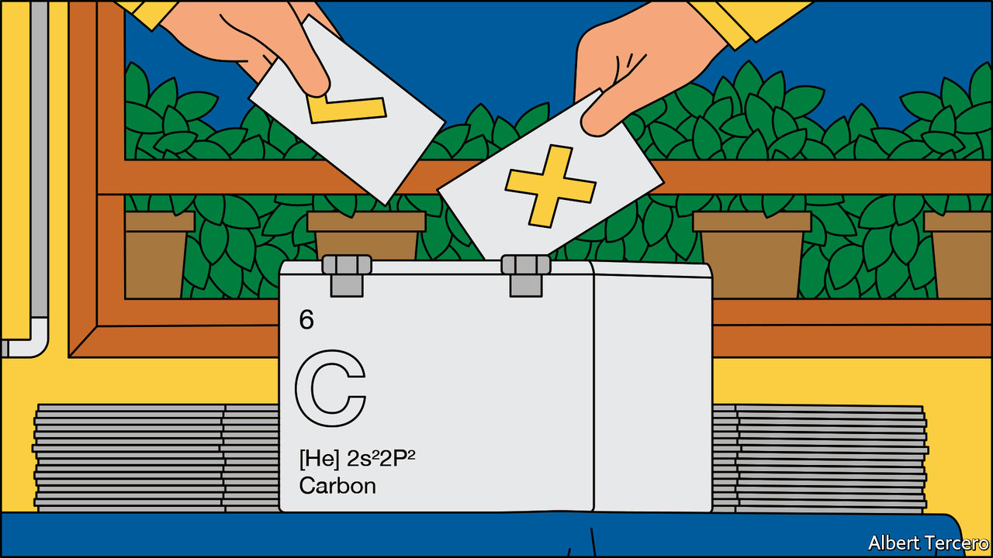

IF ECONOMISTS ruled the world, carbon prices would drive most of the action on climate change. Polluters would pay for the negative externality their emissions inflict on the planet. There might be differences on the method of payment—some might lean more towards taxes, others towards the permits used in “cap and trade” schemes. But the idea that some sort of price would help people find an efficient means of reducing emissions is a given.

In the absence of a global econocracy, the policy has fared less well. Take the experience of Yoram Bauman. He is unusual, among those with doctorates in economics, in earning his living as a stand-up comedian. But he is in line with the professional mainstream on carbon prices. In 2016 he led an attempt to get the state of Washington to raise a new tax on emissions of carbon dioxide and use the revenues mostly to cut sales taxes. The ballot measure gained some support from politicians of both parties, but it was opposed by environmental groups on the left who wanted its revenues spent on clean energy investments and redistribution, not tax cuts. It was defeated 41% to 59%.

In 2018 a second proposal for a carbon tax was put to the ballot. This one followed what Mr Bauman calls a “unite the left” approach; any cash raised was to go on green investments and communities affected by climate change. The “yes” side, whose financial backers included Bill Gates and Michael Bloomberg, spent $15m, much more than in 2016. The “no” side, backed mainly by fossil-fuel interests such as the Western States Petroleum Association, spent about twice that. This time the carbon tax attracted the support of 43%.

## Out of the ruins

The vast majority of humankind’s carbon emissions are currently unpriced. This is not simply a snub to the dismal science. As Mr Bauman’s experience shows, other factors are at play. One is that when asked to pay a new tax, people by and large demur; when told that they will, as a result, pay less in old taxes, they tend to scoff. Another is that companies which depend on their, or their customers’, greenhouse-gas emissions for their livelihood do not want to see those emissions discouraged—especially if companies elsewhere do not have to play by the same rules. A third is that, in some places, the green left, which plays a decisive role in climate politics, has come to distrust the idea.

As a result only 20% of global emissions are currently subject to a pricing scheme or soon to become so (see chart 1). And the prices in these plans are too low. The Paris agreement, adopted in 2015, commits its signatories to keeping the rise in global temperature, compared to that of the preindustrial climate, “well below 2°C”. A serious attempt to use carbon prices to that end, according to Nicholas Stern and Joseph Stiglitz, two noted economists, would require a price in the range of $40-80 to be levied on all the world’s industrial greenhouse-gas emissions (as well as some other interventions). In existing schemes the median tonne of carbon emissions is priced at only $15. Nowhere is there a carbon price that is both above $40 and applies to more than half a country’s greenhouse-gas emissions.

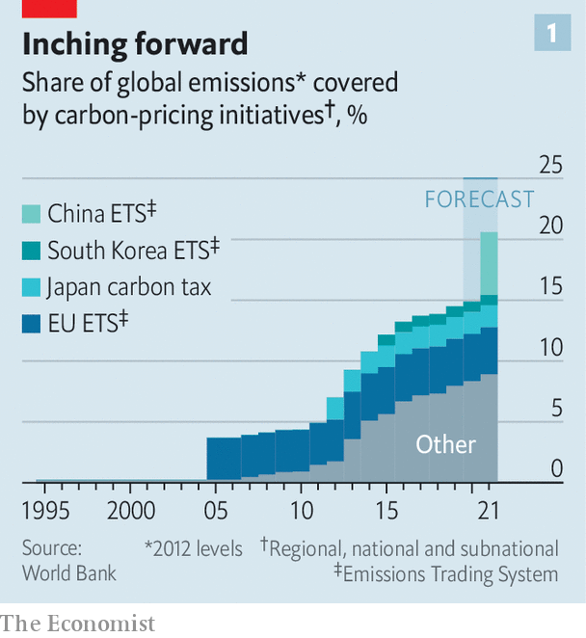

Despite such limited progress, advocates for a carbon price remain committed to the cause. Before the advent of covid-19, they also seemed to be on something of a roll. Since January carbon emissions have been priced at a minimum of C$20 ($14) per tonne across Canada. By 2022 that will rise to C$50. In 2021 70% of global aviation emissions were scheduled to enter a UN emissions-trading programme which aims to cap them at 2020 levels. China was going to launch a nationwide carbon market for its notoriously dirty power sector at the end of the year. And as part of its “green deal”, the European Commission had announced plans for the expansion of its Emissions Trading Scheme (ETS), already the largest carbon-pricing system in the world (see chart 2). Its carbon price, stuck in the single digits in the 2010s, rose to around €25 ($27).

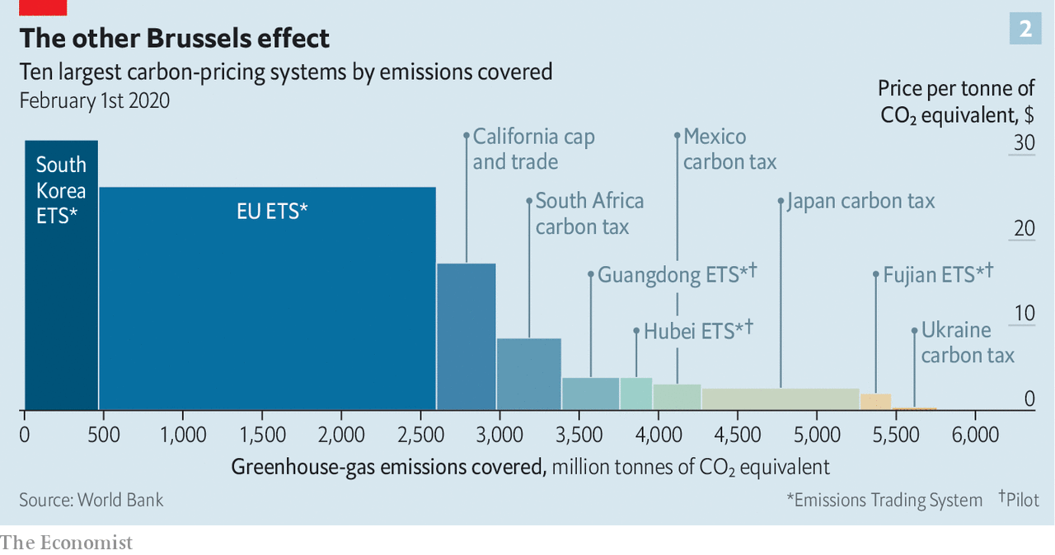

The pandemic has derailed many of these plans. If aviation emissions were capped at the levels likely to be seen in 2020, the industry would be doomed. Climate change is no longer the top priority of the commission, which has an economic and political crisis to fight. And the ETS carbon price has fallen by about a fifth in 2020 as the world economy has suffered.

The need to decarbonise the economy, though, remains as urgent as ever. Indeed, the pandemic demonstrates the scale of the climate challenge. Although entire sectors of the economy, including aviation, have shut down, emissions this year will still remain too high. What is now needed is a way around various political barriers to a carbon price as well as at least one economic one: the effect that prices imposed piecemeal might have on trade.

Making it expensive to use fossil fuels can change behaviour quickly if there are easy and cheap alternatives available. In a history of carbon pricing published in 2018, Barry Rabe of the University of Michigan points to the experience of America’s sulphur dioxide permit scheme in the 1990s. It reduced the sulphur emissions from power plants largely because power companies had access both to sources of low-sulphur coal and technology to “scrub” sulphur dioxide from their smokestacks. The companies best placed to make the shift sold the allowances to emit sulphur that they had received from the government to those finding it harder.

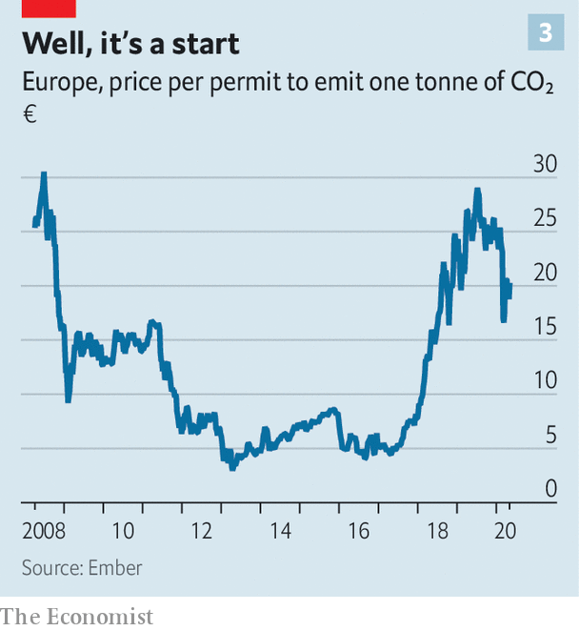

The effect that the ETS has had on European emissions is based on a similar sort of substitution. After years of low prices following the global financial crisis, in 2018 prices started to rise as the EU reduced the number of permits in circulation (see chart 3). This had the effect of beginning to price coal—which releases twice as much carbon dioxide per watt as gas—out of the market. In 2019, for the first time, renewables produced more of the electricity consumed in Europe than coal.

## Out from the wreckage

Prices change behaviour less when there are few immediate alternatives to emitting carbon. Cars are taxed heavily in many places, for example. In 2018 a study by the OECD, a club of mostly rich countries, found that in 34 of 42 countries at least 90% of road transport emissions incurred taxes equivalent to a carbon price of more than €60 per tonne. Yet in the absence of readily available alternatives many people pay these taxes and drive lots.

In principle, faced with a price on carbon companies will invest in the development of alternatives that are not yet competitive. But only if they believe that the carbon price will be high enough in the future to make this worthwhile. And there is nothing to stop governments scrapping carbon-pricing schemes. That is what Australia did in 2014 after a campaign to “axe the tax” helped to swing an election. Britain, while in the ETS, imposed a carbon-price floor that drove a decisive shift away from coal, but in 2014 the government reneged on a commitment to raise that floor. When an oil giant such as ExxonMobil supports a carbon-pricing plan such as that touted by America’s Climate Leadership Council (CLC), a campaign group, sceptical observers may well have a point in thinking that the company imagines either that the scheme will not survive or that lobbying will keep the price low.

How can high prices be made credible? Ben Caldecott of Oxford University points out that it is possible for governments to strike contracts that will cost them money if the price underperforms. His example is Britain’s Woodland Carbon Guarantee (WCaG). One of the purported charms of cap-and-trade carbon markets is that those who can see no alternative but to emit greenhouse gases can buy permission to do so from those businesses which are more flexible, or who make it their business to suck carbon out of the air (see article).

The WCaG encourages people to plant trees which could be used as offsets in this way. As it is inevitably a long-term commitment, the British government guarantees a floor price for the carbon stored in the wood until 2056. If, when the planter sells the credit, the carbon stored in the trees is worth more on the offset market than the government is obliged to pay it will be off the hook. If not it is obliged to cough up. That gives the government an incentive to see the value of carbon on such offset markets remain high.

The result is elegant but only really feasible on a smallish scale—the WCaG scheme is valued at £50m ($61m). The ultimate guarantor of prices that can be relied on to persist, or increase, is public and political support. There are two ways to make this more likely. One is to simultaneously commit to public investments that will make compliance with carbon taxes less onerous as those investments bear fruit—in effect doing what the private sector deems too risky. The other is to use the revenues from carbon-pricing schemes to create a political lobby in favour of keeping and expanding them.

Economists have historically wanted to use carbon-tax revenue to cut other taxes—the logic behind the first of the two Washington state initiatives. This is held to have two benefits. It reduces the economic drag those other taxes impose, thus helping the economy at large and compensating households for having to pay the tax. The world has just one example of full revenue recycling: British Columbia’s carbon levy. This funds lower taxes and some transfers to households and affected firms. It is popular with the public. Prices have risen substantially since its launch in 2008, despite a big fossil-fuel industry.

Recycling through the tax system is efficient. David Victor, a political scientist at the University of California San Diego, points out that it can also be politically efficacious if the tax benefits favour interests otherwise likely to oppose the scheme. But it is not the norm. In other jurisdictions the revenues are spent on environmental measures. That is how most of the money from Europe’s ETS is spent. An alternative approach, favoured by the CLC in America, is to give the money straight back to the people in a “fee-and-dividend”. It may lack efficiency and targetability, but a monthly cheque offers a nice, clear incentive to the voters—and, in theory, increasing the size of that cheque means that carbon prices can be increased, too.

Getting a pricing scheme started is not enough; it also has to have scope. When the ETS was being set up, according to Jos Delbeke, a former commission official who was heavily involved in the process, the politicians wanted it up and running quickly. The easiest way to do so was to impose a price just on the sectors where emissions were large and easily monitored: electricity generation and heavy industry.

The ETS has since been expanded. It now includes flights within Europe, and covers just under half of emissions from the EU. As part of the green deal, Ursula von der Leyen, the president of the commission, wants to expand the ETS once more to include emissions from transport, shipping and heating buildings, to increase its coverage to over 90% of emissions. But that brings up the issue of trade.

## Looking for something to rely on

In the economists’ utopia there exists a single global carbon market. Any polluter or offsetter could participate in it. In this ideal world the pay-off from emissions trading is greatest when it takes place between countries that are dissimilar. (In the rich world, emissions are most valuable, whereas in the poor world measures to reduce them are cheap.) According to modelling by the Environmental Defence Fund, a campaign group, a global carbon market could reduce the total cost of fulfilling the Paris agreement by 79% compared with relying on local markets alone. Existing carbon markets like the ETS, or the regional greenhouse-gas initiative in the north-eastern states of America, tend towards homogeneity.

Such a market would also not merely be more efficient; it would also be less gameable. No firm would be placed at a disadvantage by having to compete with rivals outside the scheme, and thus free of its costs; no firm would be tempted to move its factories beyond the scheme’s reach.

In the absence of the ideal scenario, both energy-intensive, trade-exposed companies worried about competition and governments anxious about factories moving beyond their reach seek protection in the form of so-called “border carbon adjustment” (BCA) mechanisms. The adjustment is in effect a tariff on countries which are not members of the carbon-pricing scheme. Through such tweaking it allows schemes to reach emissions otherwise hidden from them: those “embedded” in imported goods.

The EU says it will propose a BCA mechanism next year as part of the expansion of the ETS. In America the CLC’s fee-and-dividend proposal includes both an exemption for exporters and a carbon tariff on imports. Joe Biden, the Democratic presidential nominee, has promised border adjustments to stop his climate plans hurting competitiveness. Both the carbon-pricing bills recently tabled in Congress offer some form of BCA.

In advanced economies that have outsourced a lot of heavy industrial production, a BCA would capture quite a lot of carbon. In America and Europe the emissions associated with all goods consumed, including imports, is 15% higher than the emissions associated with all production, including that which is exported. What is more, BCAs should also make carbon prices more attractive to countries which have yet to impose them. Better to impose the price internally, and thus see revenues at home, than to let some other government get those revenues at the border.

## There’s got to be something better

As appealing as BCAs may be, they also throw up a large number of practical and political problems. For all but the most basic commodities the process of determining the right levy would be nightmarishly complicated. In 2018 a report by the European Commission said that an ideal BCA would depend on “the sources of energy used by each producer...and the effectiveness of the climate policies of the country of production”. Such a system “would be clearly unmanageable at this stage”.

The only existing BCA bears this out. It applies to electricity imports into California, which has a state wide cap-and-trade programme. Companies importing electricity into the state can either specify its source, and hence the emissions with which it is associated, or be treated as if the electricity was generated by a relatively efficient natural-gas power plant.

This system is clearly imperfect, because the imports may in fact be dirtier than that. But if it were tougher, the incentive to game the system—by exporting the cleanest electricity to California while using the dirtiest elsewhere—would get even stronger. If such compromises have to be made when there are only electrons involved, imagine the complexities involved for an object made of many components from many jurisdictions.

Then there is the question of whether other countries might retaliate against a BCA. Rough alculations by The Economist using OECD data on the carbon emissions embodied in international trade suggest that a BCA of €30 per tonne levied on all goods coming into Europe would amount to €10bn on imports from China and €3bn on imports from the United States, equivalent to tariffs of 2.8% and 1.2% respectively. On imports from India the price would be €2bn, equivalent to a 5.1% tariff. In all three cases it is roughly equivalent to doubling existing average tariffs.

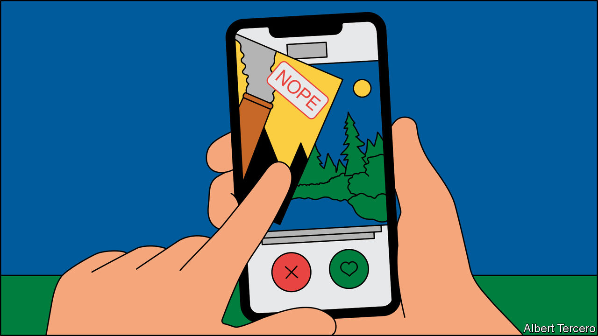

In 2012 a far less ambitious attempt to level carbon-emission playing fields inside and outside the EU quickly came to grief. The EU wanted to include emissions from flights to and from countries beyond the EU in the ETS; both some of its own airlines and its trading partners protested, the latter threatening action through the World Trade Organisation (WTO) and reviews of bilateral air-service agreements.

Ms von der Leyen has insisted that any BCA would need to be consistent with the rules of the WTO. But although it might be allowed if it were equivalent to a domestic tax, or if it were applied to protect the environment, nobody knows quite how a BCA would have to be crafted in order to qualify.

The more complicated and overlapping BCAs get, the greater the risk they would be captured or gamed. There will be pressure to exempt some of the EU’s trading partners, such as poor developing countries, who often depend on dirty exports for growth. The more bespoke the carve-outs, the greater the risk that the EU will be accused of unfair discrimination.

The difficulties and dangers of BCAs explain why Europe, and California, have until now used a different tool to placate industries made less competitive by carbon pricing: giving out permits to emit carbon at no charge. The idea is that free permits preserve the firms’ profits, allowing them to compete on international markets and removing the incentive for them to go overseas. The incentive to cut emissions remains, because cleaner production would allow them to sell their surplus permits.

The EU prefers not to award freebies to polluting sectors, arguing that they reduce the urgency of cutting emissions. The free permits currently issued to sectors including wine making, textile weaving and tools manufacturing are due to be phased out of the ETS by 2030, though sectors such as steel and cement will get to keep theirs. Part of the impetus for BCAs is that they could replace free permits, though the generosity of the existing scheme means that some firms are better off with free permits than they would be under a BCA. California rejected a BCA for trade in cement in part because its producers preferred subsidies. Because overcoming all these issues is hard, any EU carbon border charges are probably six or seven years away.

## All else are castles built on air

The environmental argument for a BCA ultimately rests on the idea that countries like China and India would respond by pricing carbon-dioxide emissions adequately. Some countries might even want to join the ETS, edging towards the global carbon market which economists have long dreamed of. But it is also possible that BCAs could undermine the international co-operation on which the fight against climate change depends—say by provoking a trading partner to withdraw from the Paris agreement. Ensuring that carbon emissions carry a high price everywhere is vital, and increasingly so. But rarely is so stark a contrast found between the simplicity of the theory and that of the practice. ■

This article was downloaded by calibre from <https://www.economist.com/briefing/2020/05/23/the-world-urgently-needs-to-expand-its-use-of-carbon-prices>

|  |  |  |  |
| --- | --- | --- | --- |
| Previous | Articles | Sections | Next |

|  |  |  |  |
| --- | --- | --- | --- |
| Previous | Articles | Sections | Next |

#### If a tree falls

# Carbon offsetting is essential to tackling climate change

If the world is to achieve net-zero emissions, then offsets are part of the plan

May 23rd 2020 |



WHEN COMPANIES that depend on emissions, such as easyJet, an airline, use offsets sold on private “over the counter” markets to claim carbon neutrality it is hard not to be reminded of the indulgences sold by the medieval Catholic church that helped sinners to go on sinning guilt-free. But the recent emphasis on “net zero” economies has made offsets central to climate-change plans. In a net-zero economy adding carbon dioxide, or another greenhouse gas, to the atmosphere is only allowed if an equivalent amount of greenhouse gas is removed from it.

Offsets already play a role in some international agreements and government-backed programmes. But the idea of including them in emissions-trading schemes triggers bad memories in Europe. Credits for dodgy offsets helped to undermine the credibility of the Emissions Trading Scheme (ETS) in its early years. International offsets are in the process of being expunged from the ETS, though they are still traded on the Californian emissions market.

Despite this rocky start, offset-trading could still work. Indeed, the 2015 Paris agreement already includes rules for how to account properly for offsets, according to Kelley Kizzier of the Environmental Defence Fund, a campaign group. Many of the issues with monitoring offsets come from the fact that offsetting takes place in remote places where the rule of law is weaker, because planting trees and plants requires a lot of cheap land.

But it is likely to become easier. Ben Caldecott of Oxford University points out that technology used to monitor offsets has improved. The use of high-resolution satellite imagery means that it is possible to know exactly when a tree is cut down. In theory offset contracts could also be auctioned on mobile phones with payments sent via mobile banking. “We can create smart contracts between a smallholder farmer and a funder where the payment is unlocked if the tree is still there,” he says.

If the world is to achieve net-zero emissions, the only permissible offsets will need to be genuine negative emissions (rather than schemes that simply reduce emissions). This may mean sucking carbon out of the air using machines. A nascent industry aims to do this, but the costs are big. An estimate in 2018 by researchers at Carbon Engineering, a Canadian firm, put the cost of direct air capture between $94 and $232, many times the carbon price in most places.

It is possible that with sufficient investment those costs could fall as carbon prices rise, allowing a “direct air capture” industry to make money by selling credits into emissions-trading schemes. Direct-capture machines are much more efficient in terms of land. Mr Caledcott hopes that Britain, which has said it will leave the ETS now it is no longer in the EU, will pioneer the first net-zero emissions trading system including such offsets.

This article was downloaded by calibre from <https://www.economist.com/briefing/2020/05/23/carbon-offsetting-is-essential-to-tackling-climate-change>

|  |  |  |  |
| --- | --- | --- | --- |
| Previous | Articles | Sections | Next |

|  |  |  |
| --- | --- | --- |
| Briefing | Sections | The Americas |

United States

The Centres for Disease Control and Prevention: Handcuffing an institution

.

Civil rights: Attention-deficit disorder

.

Congressional elections: Exit, pursued by a centrist?

.

Dechurching: The Sunday slump

.

Francis Collins: Jesus is not his vaccine

.

The extreme right: A boog’s life

.

Lexington: Joe Biden’s good pandemic

.

|  |  |  |
| --- | --- | --- |
| Briefing | Sections | The Americas |

|  |  |  |  |
| --- | --- | --- | --- |
|  | Articles | Sections | Next |

#### To hell with experts

# How the world’s premier public-health agency was handcuffed

The CDC has been absent with leave during the spread of covid-19

May 23rd 2020 |

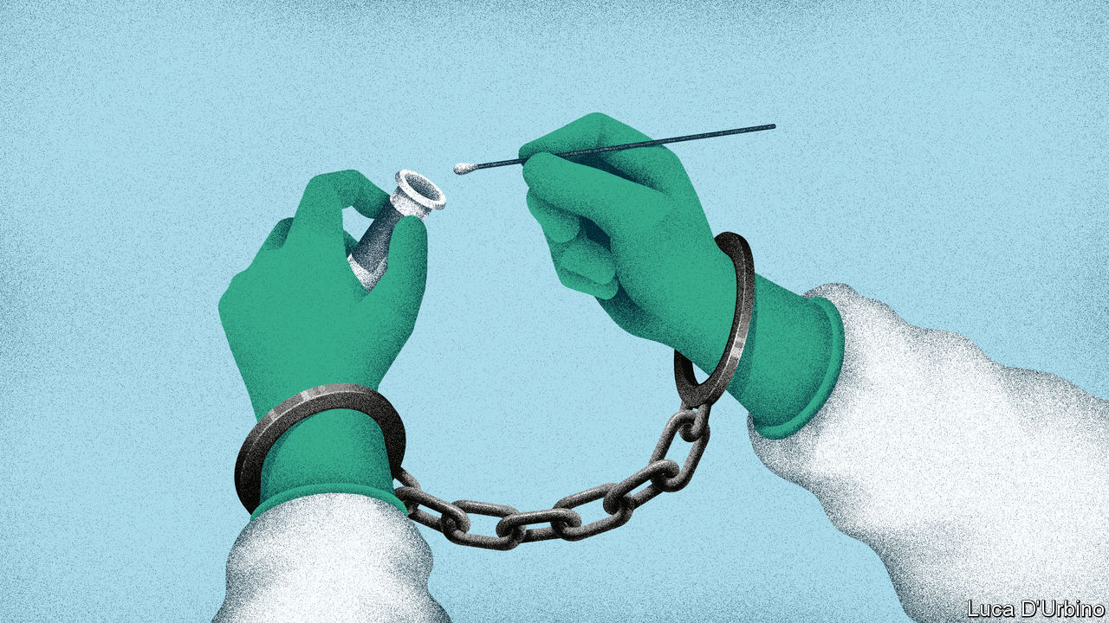

Editor’s note: Some of our covid-19 coverage is free for readers of The Economist Today, our daily [newsletter](https://my.economist.com/user#newsletter). For more stories and our pandemic tracker, see our [hub](https://www.economist.com/news/2020/03/11/the-economists-coverage-of-the-coronavirus)

IN 2014 TOM FRIEDEN, the head of the Centres for Disease Control and Prevention (CDC), appeared almost daily to brief the public about the Ebola virus, the last pandemic to hit the United States before the coronavirus. His agency formulated policy for dealing with Ebola, and also embodied it. The CDC trained 6,500 people in America and 25,000 in West Africa to look after victims. The vaccine that finally treated the disease was tested in a CDC laboratory. The end of the outbreak confirmed the agency as the world’s leading public-health body.

Contrast that with what has happened during the coronavirus outbreak. On May 17th a senior White House official, the director of trade policy, said the CDC “really let the country down”. The administration gutted CDC guidelines telling restaurants, child-care centres and others how to reopen, reducing them from more than 50 pages to six. The CDC has been muzzled, says Jeremy Konyndyk of the Centre for Global Development, a think-tank. It has held no public briefings since mid-March. Meanwhile, the first testing kits that the World Health Organisation is distributing came from Germany.

What used to be America’s most prestigious public-health body has been relegated to one voice among many in the clamour of the White House. The result is to squander expertise, compound confusion about who, if anyone, is in charge of the federal response to the virus and make the reopening of the country riskier than it need be.

America is slowly passing its peak of infection. As it does so, Donald Trump is signalling that governors should take the lead in reopening states. In public-health terms, however, states play only a secondary role; state and city public-health departments mostly do routine things such as providing vaccines for children and hygiene certificates for restaurants. Combating an emergency, by running laboratories or conducting epidemiological research, is financed by the federal government; 55% of state and local public-health spending comes from federal sources. In public health, therefore, the CDC is by far the most important agency and state health departments depend upon it. Some are seeing sharp falls in the number of people testing positive for the virus, including New York and New Jersey. They may be in relatively good shape. But in parts of the South and Midwest, the number of new cases or hospitalisations is rising. Here, the diminishing of the CDC may imperil recovery.

How was the agency brought so low? On February 5th, the CDC sent to state laboratories a testing kit for covid-19 that it had been working on at headquarters. Something was wrong with one of the reagents and state labs could not get the test to work. The Food and Drug Administration (FDA), which regulates medical devices, including tests, then dithered for three weeks before allowing private and university laboratories to work on the problem, which they soon fixed. But when tests did become available, the CDC restricted them to a handful of Americans. By the time the rules were relaxed, the CDC had missed the vital first stages of the epidemic; community transmission was rife.

The agency was at fault. But so were others: the FDA and the head of the Department of Health and Human Services, who has political responsibility. President Trump, who is taking hydroxychloroquine, an anti-malarial drug not approved against the coronavirus, hardly needs an excuse to ignore medical science. But whoever was at fault, the episode widened a gap of distrust between the CDC and the White House.

According to the Washington Post, Deborah Birx, co-ordinator of the White House’s coronavirus task-force, says “There is nothing from the CDC I can trust.” The administration has set up a parallel data-gathering operation, asking a private company to provide statistics on hospital capacity, covid-19 deaths and so on, which the CDC already has. Marc Lipsitch of the Harvard Chan School of Public Health talks of “the handcuffing of a great institution”.

There is a second explanation for the CDC’s marginalisation: money. Though the agency’s own budget has been protected, a wider squeeze on public-health funding has undermined its ability to help states.

Public health is chronically under-funded. In 2018 America spent less than $300 per person on it, compared with over $10,000 on all health care, according to the Trust for America’s Health (TFAH), a not-for-profit group. In the decade to 2017, jobs in public health fell by 50,000.

Mr Trump has proposed cutting the CDC’s budget each year by between 10% and 20%, but Congress has protected the agency. The CDC’s budget has been flat since 2016, and this year emergency-spending bills will provide an extra $6bn over the next five years. However, the two main programmes for helping state and local health-care systems prepare for emergencies, Public Health Emergency Preparedness and the Hospital Preparedness Programme, have been cut by over 50% in real terms since 2003. This has forced states to scale back emergency preparation and left the CDC bearing more of that burden.

It is struggling. Though the agency continues to churn out advice—its website has had 1.2bn clicks since the start of the epidemic—John Auerbach of TFAH, who has worked in state and city health departments for decades, says departments can no longer get the help they need from the CDC. Instead, they are turning to less-reliable and often-conflicting advice, producing a muddle of different rules.

The combination of financial pressure and White House indifference has scuppered any chance America had to produce a national strategy for covid-19. In the past the CDC would have been central to that effort. Now, it is competing with a White House task-force and a group headed by the president’s son-in-law for Mr Trump’s fitful attention. The institution with the largest concentration of scientific expertise has been sidelined, and state health departments are getting flawed advice.■

This article was downloaded by calibre from <https://www.economist.com/united-states/2020/05/23/how-the-worlds-premier-public-health-agency-was-handcuffed>

|  |  |  |  |
| --- | --- | --- | --- |
|  | Articles | Sections | Next |

|  |  |  |  |
| --- | --- | --- | --- |
| Previous | Articles | Sections | Next |

#### Attention deficit disorder

# Whatever happened to Black Lives Matter?

The group is still doing important work, but after Donald Trump became president liberal America stopped paying attention

May 23rd 2020 | CHICAGO

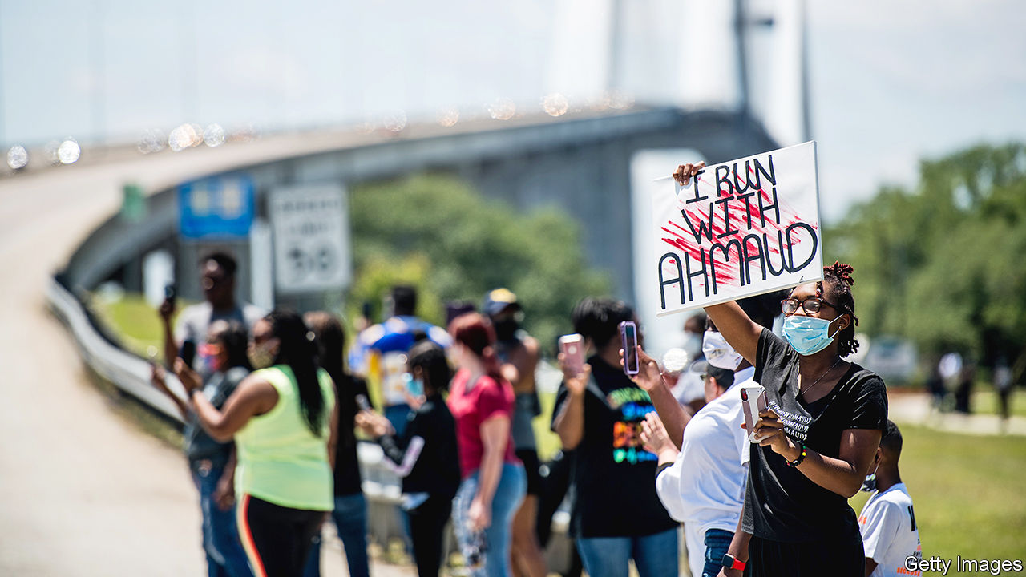

THE WAY Tef Poe sees it, nothing has improved in Ferguson, a mostly black suburb of St Louis, in the past six years. It was there that the rapper and activist co-founded Hands Up United, a campaign group, in 2014, after a policeman shot dead a local teenager, Michael Brown. Mr Poe became a voice of Black Lives Matter (BLM) as police clashed with protesters. He recalls a flurry of public interest, the “trendy movement”, and enthusiasm of hangers-on who saw activism “as the new Nike Swoosh”.

Today he is more guarded. He feels that TV news exploited him, dwelling on violence and drama, while liberal sympathisers online did nothing to improve conditions on the ground. Even “the way we discuss the social movement is problematic.” The “white media” now engage only with “celebrity cases”, such as the killings this year of Ahmaud Arbery, a black jogger shot by two white men in Georgia in February, and Breonna Taylor, a black health worker shot by police in her home in Louisville in March. “The American political gaze has been deactivated,” he says.

Attention is fleeting, but has BLM also lost its way? Interest in it, measured by Google searches, is much reduced. Though coronavirus has killed African-Americans at an estimated rate 2.6 times higher than white Americans, BLM has not been able to stir a national debate on it. Its unusual structure seems a hindrance. It is led by disparate individuals, rather than a single, charismatic figure in the mould of Martin Luther King. “It means there is no one person they had to take out,” explains Melina Abdullah, a co-founder of BLM’s LA chapter, referring to King’s murder. It also means some would-be supporters, donors or partners find it hard to relate to the movement.

Public interest has drifted. Ms Abdullah recalls how for two years she would speak daily on national television about BLM and black rights. Producers stopped calling, she said, the moment Donald Trump was elected. Some sympathisers have also been waylaid by other causes, such as supporting Bernie Sanders’s presidential run. “The general public has become a bit exhausted,” she concedes.

Mr Poe says BLM should “re-evaluate the effectiveness of a lot of our spokespersons”—he thinks many are too liberal, coastal and removed from places like Ferguson—and find ways to build a strong media voice of its own. Online, BLM’s once heavy presence has lost force. Activists still post a lot, seeking attention for black victims of violence. But they lack expertise with “all the apps, bots, to amplify, to get stuff to trend”, says Ms Adbullah. Perhaps, too, Russia’s lost interest matters: in 2016 Russian trolls devoted much effort to amplifying racial problems online in America. They stopped after the election.

Both Mr Poe and Ms Abdullah say BLM remains strong where it matters most, at local level. Ms Abdullah points to students passionate for the cause. She says that in Los Angeles, Chicago and Washington, the cities she counts as having the strongest BLM chapters, scrutiny of the police is stronger than ever. She credits that for a sharp fall in killings over five years. In 2015 police nationally killed 305 African-Americans, most by shooting, including 81 people who were unarmed. By last year that fell to 260 killings, 29 of persons unarmed.

Other factors could also be behind that. Police in both Chicago and Los Angeles have spent time under a “consent decree”, meaning years of scrutiny from the Justice Department to improve behaviour. Police who now do fewer stop-and-searches of young men end up shooting fewer of them. Legalisation of marijuana in some states may have calmed things down. Whatever the cause, fewer such killings could help to explain fading public interest in BLM.

Another way to look at it, argues Eitan Hersh at Tufts University, is that nearly six years after Ferguson, BLM counts as a rare success just for surviving, considering that it first existed mostly online. He has studied how most digital social movements, especially left-leaning ones, fizzle soon after they draw attention to a particular problem. Online outfits hardly ever build structures that have an impact in the real world. They are amplified by what he calls political “hobbyists”, those Americans who post avidly online about social matters—like racial equity—but do nothing practical to follow up offline.

In contrast, “BLM is very concrete and practical. It has a clear goal and is trying to tackle a salient problem,” says Mr Hersh. He too reckons its local actions, such as when activists turn out to speak at public meetings with police, are its most important contribution. Meanwhile, though core members stay committed—Ms Adbullah says black people don’t have the “privilege” of feeling exhausted by a campaign for civil rights the way “non-black folks” can—BLM’S wider allies, who are typically white, well-educated and liberal-minded, seem to have lost interest. The hobbyists now think “this is not a new, sexy thing”, says Mr Hersh: this Swoosh has lost its appeal. ■

This article was downloaded by calibre from <https://www.economist.com/united-states/2020/05/23/whatever-happened-to-black-lives-matter>

|  |  |  |  |
| --- | --- | --- | --- |
| Previous | Articles | Sections | Next |

|  |  |  |  |
| --- | --- | --- | --- |
| Previous | Articles | Sections | Next |

#### Squad goals

# Donald Trump’s favourite freshmen face primaries

Some high-profile left-wing House members are drawing challenges from the centre

May 23rd 2020 | WASHINGTON, DC

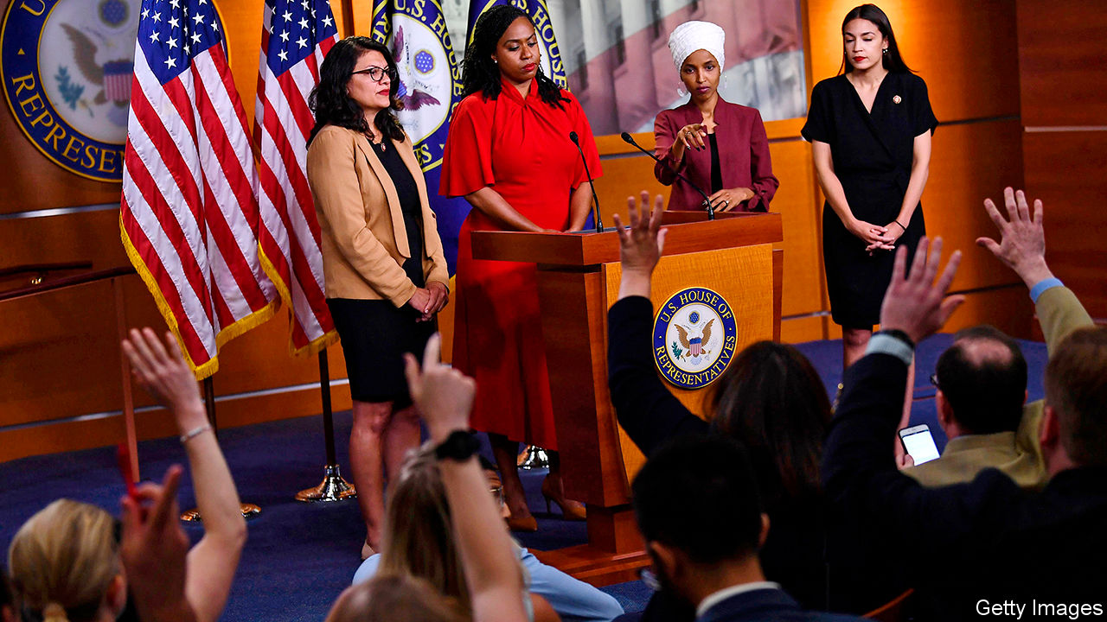

SIX DAYS after she was elected to Congress in November 2018, Alexandria Ocasio-Cortez posted a picture of herself with three other freshmen Democrats—Rashida Tlaib, Ayanna Pressley and Ilhan Omar—and tagged it simply, “Squad”. The name stuck, not least with Donald Trump, who called them “a very Racist group of troublemakers who are young, inexperienced and not very smart”, and urged them to “go back and help fix the totally broken and crime infested places from which they came.”

The quartet have revelled in Mr Trump’s contempt, and occasionally matched his vulgarity: hours after being sworn in, Ms Tlaib vowed to “impeach the motherfucker”. Many saw them as avatars of a new progressive era. In fact, they all replaced incumbents from safe Democratic seats; the Democrats retook the House in 2018 thanks to moderates from swing districts. And with the Squad’s first re-election just months away, three have drawn primary challengers—suggesting that it is not only Republicans who object to their politics.

The nickname links the four in America’s political imagination. But aside from being progressive, non-white women, they differ markedly from each other. Ms Pressley, who is running unchallenged, is an institutionalist who spent 13 years working for John Kerry when he was a senator. In 2009 she became the first black woman ever elected to Boston’s City Council. During her first year in office she introduced more legislation than her fellow Squad members, while keeping the lowest profile—the sort of approach that makes possible a long congressional career.

Ms Ocasio-Cortez, by contrast, has perhaps the highest profile of any representative other than Nancy Pelosi, the House speaker. She is a punctilious questioner and a skilled orator, overflowing with ambition and charisma. Those qualities, combined with her social-media game, made her a star. But her challenger, Michelle Caruso-Cabrera, believes her far-left politics are “robbing the district of opportunities”. Ms Ocasio-Cortez helped lead a fight against Amazon’s second headquarters, with its promise of 25,000 jobs nearby.

Ms Caruso-Cabrera has also dinged her opponent for hypocrisy, accusing her of staying in “a luxury apartment with a Whole Foods in the lobby” in Washington, while the virus wreaks havoc in her district. On this charge, Ms Caruso-Cabrera risks hurling rocks through glass walls. She did not move to the district until late 2019; before then, she lived for several years in the Trump International Hotel and Tower, on the south-west corner of Central Park. Ms Caruso-Cabrera is well-funded but, Ms Ocasio-Cortez’s primary dispatch of Joe Crowley last time round notwithstanding, New York is usually kind to its incumbents.

Ms Omar did not defeat an incumbent; she handily won a six-way primary for an open seat. Before becoming the first Somali-American elected to Congress, she was the first elected to Minnesota’s House of Representatives. Her colourful headdresses and pointed challenges to American foreign policy have made her both instantly recognisable and divisive.

Antone Melton-Meaux, a 47-year-old lawyer and the most serious of her primary opponents, blames Ms Omar for not “work[ing] with the party in a collaborative way...Being a progressive is about progress, meaning getting things done.” Nekima Levy Armstrong, a prominent civil-rights lawyer who headed Minneapolis’s NAACP chapter, has endorsed him, citing both his credentials and Ms Omar’s “lack of presence when it’s time to vote”. But Ms Omar won more votes in 2018 than any other freshman; she will be hard to defeat.

Ms Tlaib is probably the most endangered of the four. In 2018 she defeated Brenda Jones, the Detroit city-council president, by one point in a six-way primary that split the (majority) African-American vote. That contest also featured Bill Wild, the mayor of Westland, a mostly white city in the district’s western edge, who will not be running. Ms Jones is the sole opponent this time. If she can consolidate the African-American vote and capture a critical mass of Mr Wild’s voters, she will win.

Yet should Mr Trump lose in November, Squad members who return to Congress may get less attention. They would no longer have a president who boosts their profiles by insulting them. They would be outspoken progressives in an age of resurgent centrism. Where’s the fun in that?■

This article was downloaded by calibre from <https://www.economist.com/united-states/2020/05/23/donald-trumps-favourite-freshmen-face-primaries>

|  |  |  |  |
| --- | --- | --- | --- |
| Previous | Articles | Sections | Next |

|  |  |  |  |
| --- | --- | --- | --- |
| Previous | Articles | Sections | Next |

#### Sunday slump

# The virus is accelerating dechurching in America

When it comes to organised religion, the US is looking less and less exceptional

May 23rd 2020 | WASHINGTON, DC

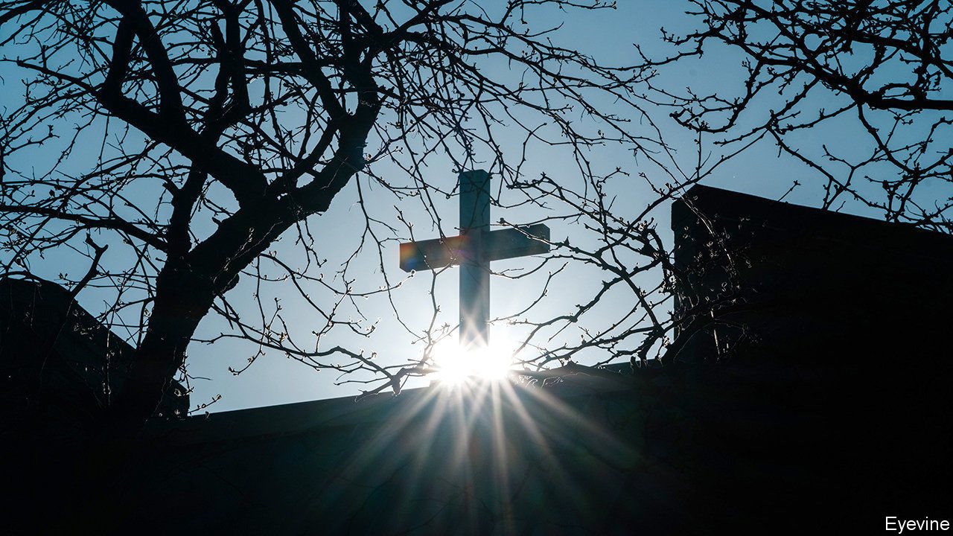

LIVING IN THE shadow of Disney’s Magic Kingdom has mostly been a happy experience for Community Presbyterian church in Celebration, Orlando. Its handsome white building, with storybook steeple, was part-funded by a pious niece of Walt. The nearby theme parks have supplied the church with many of its 800-odd members as well as a steady stream of visitors—in the winter, when tourists flock to Florida, the congregation often swells to 1,500. But when Walt Disney World closed in mid-March and the church did too, its fortunes took a dive.

Its income, which comes chiefly from weekly donations, plummeted. Several employees lost their jobs. Among them was Bill Vanderbush, one of two pastors at the church. “You know, as a pastor, that you are living on the generosity of those around you,” he says. “To lose your job when people are suffering is the nature of ministry.”

His words may prove prophetic. The covid-19 pandemic has hammered churches of all sizes and denominations across America. Most, even those that had encouraged their members to shell out online before the pandemic hit, have seen their incomes plunge. Many do not have sufficient cash reserves to tide them over for more than a few months. And reopening is unlikely to bring the relief that it will to other parts of the economy. In many churches the majority of worshippers are old; if a vaccine is not developed soon, or is less effective in the elderly, many may be reluctant to go to church in future.

The result could be a significant reduction in the number of churches in America. David Kinnaman, the president of Barna Group, an evangelical research outfit, reckons that as many as one in five churches—and one in three mainline ones—could close for good within the next 18 months.

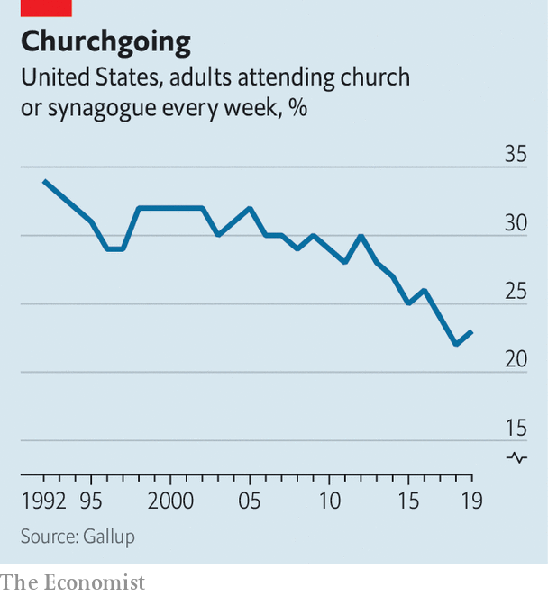

This would represent a rapid acceleration of a long-term decline in American religiosity. Though the process of secularisation has been slower to take hold in America than in other parts of the rich world, it is now well under way. According to Pew Research, the share of Americans who say they attend religious services at least once or twice a month has dropped by seven points over the past decade to 45%. The share who go to church every Sunday is a lot lower: some pollsters put it at 20%. Though the decline is evident among all demographic groups, it appears to be fastest among poor whites.

The institutions that were already seeing the sharp end of this decline will be the first to go. Many of them will be Catholic. Successive clerical sex-abuse scandals have stopped many from going to mass or from going as regularly as they used. That has hit church coffers, reducing the financial support parishes give their dioceses, many of which have been bankrupted by payouts to victims of abuse, leaving them, in turn, less able to support struggling churches. Vocations to the priesthood, meanwhile, which are falling across all mainline churches, have all but disappeared in many Catholic dioceses.

The end can be swift. After the last priest of St Casimir’s in Lansing, Michigan, retired last year and it became clear there were no priests available to replace him permanently, parishioners wondered whether the 99-year-old church would have to close. Within weeks of lockdown it had done so. “It’s almost like a death in the family,” says Greg Perkowski, a member of the church council.

The closure of North Highland Presbyterian church in Denver, Colorado, formed in 2010 out of the merger of two churches, was also abrupt. It had redeveloped its buildings into rental spaces to bolster its income and was “just beginning to make it” when it closed on April 30th, says Ashley Taylor, the pastor. She expects that the buildings, in a gentrifying part of the city, will become apartments.

But the pandemic may also lead to the closure of churches that might otherwise have survived for years. Few organisations of any kind have been ready for the shock of sudden, weeks’ long closure, but many even vibrant churches seem to be particularly ill-prepared. David King, assistant professor of philanthropic studies at Indiana University-Purdue University in Indianapolis says that 39% of all congregations do not have enough cash to survive more than three months.

In the case of small, urban churches this is often because putting aside money that would otherwise be spent on services for the poor is anathema, says Justin Giboney, a political strategist in Atlanta, Georgia. He has helped launch Churches Helping Churches, which has so far provided 121 churches with grants of $3,000 each. Anecdotal evidence suggests that smaller churches have had less success applying for small-business loans under the government’s CARES Act, which, to the fury of some advocates of the separation of church and state, are available to religious outfits.

Big churches can also find themselves suddenly close to the edge. Many have been walloped by the closure of their peripheral businesses, like preschools. Some mega-churches, with big running costs, are heavily mortgaged. It seems likely that, among the small minority of churches that defied orders to close, some were driven by financial considerations as much as by religious-liberty ones.

Which churches will escape unscathed from the pandemic? Small congregations, despite their immediate vulnerability, may prove more robust; many already have part-time pastors and are less likely to be attached to a particular space. Mark Chaves, professor of sociology, religion and divinity at Duke University, reckons that multi-site churches, which have pioneered the use of video sermons broadcast in different church buildings, will also lose fewer members—and their cash.

Yet despite the growth of such outfits, they do not yet provide most American Christians with religious comfort. Though a majority of churches have moved services online, many report falling levels of engagement. The longer parishioners endure a weekly struggle with tech and fail to attain the sense of connection that took them to church in the first place, the likelier they will be to give the whole thing a miss.■

Editor’s note: Some of our covid-19 coverage is free for readers of The Economist Today, our daily [newsletter](https://my.economist.com/user#newsletter). For more stories and our pandemic tracker, see our [hub](https://www.economist.com/news/2020/03/11/the-economists-coverage-of-the-coronavirus)

This article was downloaded by calibre from <https://www.economist.com/united-states/2020/05/23/the-virus-is-accelerating-dechurching-in-america>

|  |  |  |  |
| --- | --- | --- | --- |
| Previous | Articles | Sections | Next |

|  |  |  |  |
| --- | --- | --- | --- |
| Previous | Articles | Sections | Next |

#### Jesus is not his vaccine

# Francis Collins on science and faith

The eminent geneticist is also an evangelical Christian

May 23rd 2020 |

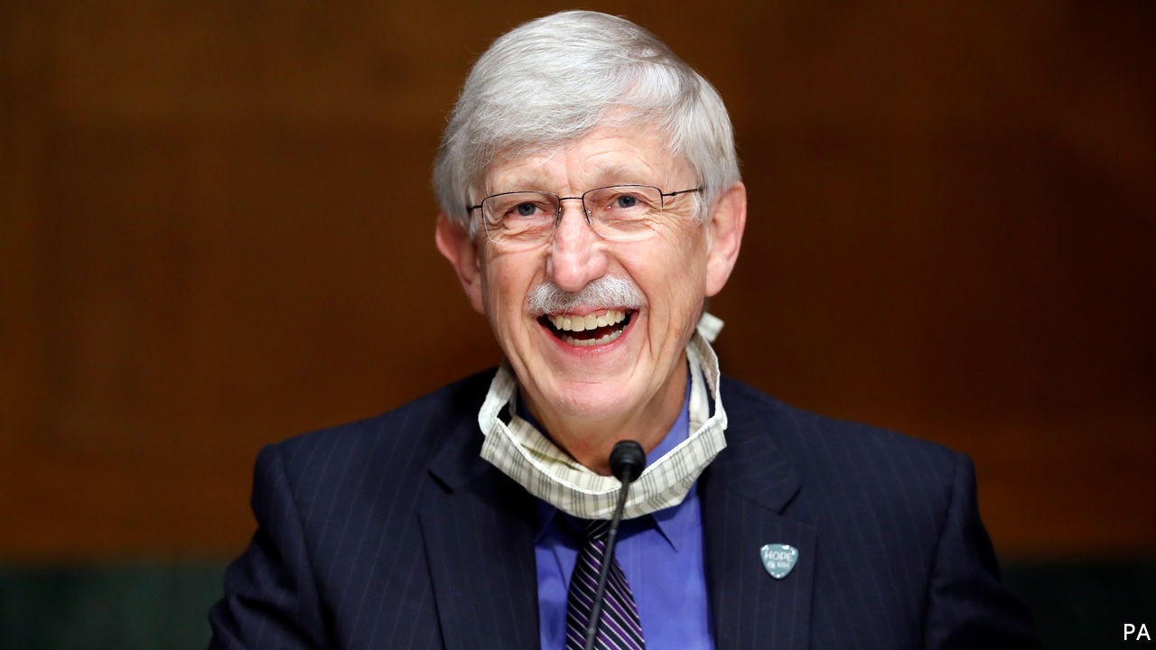

AN EVANGELICAL Christian claiming that science is not in contradiction with the Bible might normally get short shrift in the smarter salons of Washington. But what happens when the speaker is the man who led the sequencing of the human genome and now heads attempts to find a vaccine for covid-19 ? Such is the case of Francis Collins, who on May 20th was awarded the Templeton Prize, perhaps the world’s most prestigious gong for those trying to bridge the gap between science and faith. Recent laureates have included Marcelo Gleiser, a physicist, Alvin Plantinga, a philosopher, and Martin Rees, Britain’s astronomer royal.

Dr Collins is the director of the National Institutes of Health (NIH), the largest supporter of biomedical research in the world. Appointed by Barack Obama in 2009, he is the longest-serving director since the job became a presidential appointment. He is one of the few people to have maintained credibility with both sides in the culture wars.

Born into a staunchly secular family in 1950, Dr Collins gained his doctorate from Yale at 24. Then, as a medical student in North Carolina, he was struck by how often patients he cared for looked to God when facing death. He began reading C.S. Lewis and, “seeking to dismiss the faith perspective, I was stunned to discover a rich vein of philosophical and theological thinking.” At 27, he experienced a religious conversion.

At the University of Michigan he was called the “gene hunter”; in 1989 his team identified the gene that causes cystic fibrosis. In 1993 he succeeded James Watson as director of the National Centre for Human Genome Research. He led the team which, in 2003, announced it had mapped the entire human genome.

As a scientist who is a Christian he often finds himself at the vortex of a culture war that does not readily allow intersection. Yet he does not believe America is as divided as it is often painted. “The culture wars have been portrayed as irreconcilable, making a conversation impossible, so making a solution impossible,” he says. Dr Collins urges believers to trust more in the power of science, saying that it answers the “how?” questions, while Christianity answers the “why?” questions. He has annoyed fundamentalists with his commitment to “evolutionary creation”, and criticism of claims that “Jesus is my vaccine.” He worries that the motivations of evangelicals, which traditionally were more about spreading the gospel and helping the poor and the sick, have too often been eclipsed by politics.

As for the search for a covid-19 vaccine, he is cautious but optimistic. “We are further on than we thought we would be in mid-May,” he says. Meanwhile he spends every hour of lockdown to that end, breaking off only on a Sunday to join his church on Zoom. To him, that is a continuation of the day job. “Science is a form of worship,” he says.

Editor’s note: Some of our covid-19 coverage is free for readers of The Economist Today, our daily [newsletter](https://my.economist.com/user#newsletter). For more stories and our pandemic tracker, see our [hub](https://www.economist.com/news/2020/03/11/the-economists-coverage-of-the-coronavirus)

This article was downloaded by calibre from <https://www.economist.com/united-states/2020/05/23/francis-collins-on-science-and-faith>

|  |  |  |  |
| --- | --- | --- | --- |
| Previous | Articles | Sections | Next |

|  |  |  |  |
| --- | --- | --- | --- |
| Previous | Articles | Sections | Next |

#### A boog’s life

# Why some protesters in America wear Hawaiian shirts

Accelerationism, the boogaloo and the meaning of the extreme right

May 23rd 2020 |



IN MORE THAN 30 of America’s 50 state capitals crowds have been gathering to protest against stay-at-home orders, buoyed by tweets from the president encouraging them to “liberate” their states. A few among them, toting assault weapons, are dressed incongruously in Hawaiian shirts. They might seem comical were it not for the fact that, in some corners of the internet, such leisurewear is recognised as the uniform of the extreme right.

A fractious movement by nature, America’s extreme right has responded to covid-19 by carrying out Zoom-bombings (ie, interrupting videoconference meetings), encouraging others to infect police officers and Jews, and seeking to disrupt government activities, including New York City’s 311 line for non-emergency information and National Guard operations. In March a man with ties to neo-Nazi groups was killed in a shoot-out with FBI officers who were attempting to arrest him for planning to bomb a hospital in Missouri. Though he had considered a variety of targets, the outbreak of covid-19 persuaded him to strike a hospital to gain extra publicity.

Some among the far-right style themselves as “Boogaloo Boys” or “Boojahdeen”. This refers to a belief in an imminent “boogaloo”: an armed insurrection against the American government, a race war, or both. The term is tortuously derived from “Breakin’ 2: Electric Boogaloo”, a film about breakdancing made in 1984. Boogaloo boys imagine the forthcoming confrontation as a repeat of the civil war. The Hawaiian shirts that dot the crowds are a reference to “the big luau”, another name for the “boogaloo”, which celebrates pig (police) roasts. (A luau is a traditional Hawaiian feast.)

The shirt-wearers are usually adherents of accelerationism, a strange marriage of Marxism and neo-Nazism which holds that the contradictions of the economic and political order will cause it to collapse. From the ruins, a nation built on blood and soil will arise. They see the virus both as proof of accelerationism’s truth and an excellent opportunity to hasten the system’s demise.

Followers encourage any act that will “accelerate” this breakdown (an idea borrowed from Lenin). These include the spreading of disinformation and conspiracy theories, attacks on infrastructure (such as that on New York’s 311 line) and lone-wolf terrorism. The would-be hospital bomber was a believer. So was the gunman who attacked a synagogue in Poway, California, last year. All this is spread through an ever-changing litany of internet memes, ranging from George Washington dressed as one of their ranks to Ronald McDonald with a machinegun on his lap. A significant presence in the online gaming world helps attract young recruits.

Protests against stay-at-home orders provide another opportunity to expand. The vast majority of people in attendance are ordinary Americans. But demonstrations decrying overreach by the state also tend to draw radical libertarians, militiamen and Second Amendment die-hards who worry that lockdowns will lead to tyranny and the confiscation of firearms. Extremists think these groups are susceptible to their more radical ideology. The New Jersey European Heritage Association, a white-supremacist group, has been spotted as far away as Florida handing out propaganda. Press reports lumping ordinary protesters in with the extreme right may also help to create a general sense of grievance, on which extremists can prey.■

Editor’s note: Some of our covid-19 coverage is free for readers of The Economist Today, our daily [newsletter](https://my.economist.com/user#newsletter). For more stories and our pandemic tracker, see our [hub](https://www.economist.com/news/2020/03/11/the-economists-coverage-of-the-coronavirus)

This article was downloaded by calibre from <https://www.economist.com/united-states/2020/05/23/why-some-protesters-in-america-wear-hawaiian-shirts>

|  |  |  |  |
| --- | --- | --- | --- |
| Previous | Articles | Sections | Next |

|  |  |  |  |
| --- | --- | --- | --- |
| Previous | Articles | Sections | Next |

#### Lexington

# Joe Biden’s good pandemic

The Democratic champion looks a better candidate holed up in his basement than he did on the trail

May 23rd 2020 |

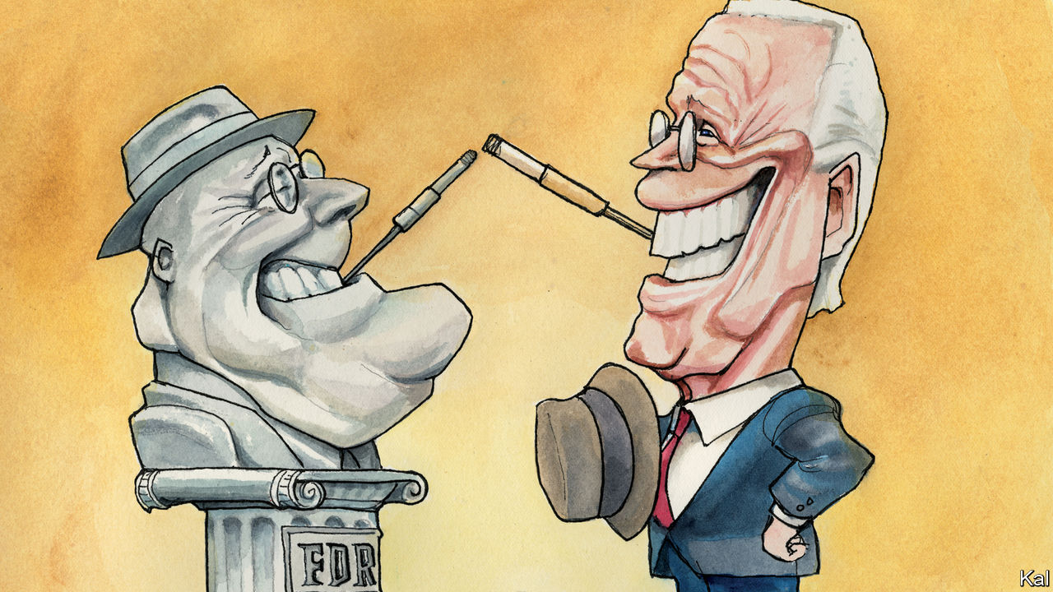

IN 1932 A genial but uninspiring pillar of the Democratic establishment, shadowed by concerns over his physical frailty, wrested the presidency from his unpopular Republican opponent during a depression. Few had high hopes for Franklin D. Roosevelt. “He is a pleasant man who, without any important qualifications for the office, would very much like to be president,” one commentator observed. Yet the “new deal for the American worker” he promised (while providing few details of what it might entail) would be transformational. Could history be about to repeat itself?

Democrats seem increasingly gripped by that idea—actively encouraged by their latest amiable, down-the-line and rather creaky nominee. The health and economic catastrophe America is grappling with may “eclipse what FDR faced”, Joe Biden told CNN from his basement refuge in Delaware last month. During daily Zoom sessions, he and his policy team are now drawing up plans to deal with it, with an apparent confidence and ambition markedly absent from his primary campaign. “It’s striking how much time Joe is devoting to governing,” says Senator Chris Coons of Delaware, a Biden confidant.

For the most part, the former vice-president is said to be focused on what the crisis might look like by January, when the next administration takes office. He has a lot of relevant experience and expertise to call on, since the administration he deputised in took office during the Great Recession. Mr Biden was personally responsible for administering the $787bn stimulus it launched.

Yet he and his advisers also claim to be looking beyond this crisis to the many structural problems it has exposed: in health-care provision, economic security, disaster response and long-term planning, for example. Mr Biden’s much-pilloried claim that “nothing would fundamentally change” under his leadership has been jettisoned. “He has clearly signalled that just getting back to where we were is not acceptable,” says one of his economic advisers, Jared Bernstein.

Comparisons with the New Deal are liable to be overwrought. Roosevelt built a safety-net almost from scratch, at a time when 2m Americans had been forced into vagrancy. Many times that number are now receiving more money in emergency handouts than they were in wages. Yet, as an effort to capture the enormity of a disaster that has destroyed over 36m jobs, and which will surely facilitate more change than America’s choked political system would otherwise have allowed, Mr Biden’s self-interested harking back to the 1930s does not feel inappropriate. It is just one of the ways in which the pandemic appears to have given a much-needed sense of purpose to his candidacy.

When he entered his Wilmington bunker, two months ago, he had all but captured the Democratic nomination. Yet he had three big worries. The core Democratic claim that Mr Trump was a threat to America was belied by the strength of the economy, including near-zero unemployment. The Democratic coalition also looked dangerously split, with many on the left hostile to Mr Biden. And notwithstanding his impending victory, he had shown himself to be an uninspiring, at times incoherent, candidate. His claim to the highest office seemed to boil down to his being more realistic than Bernie Sanders and less unhinged than Donald Trump. Yet none of those problems now pertains to anything like the same degree.

With the economy on life-support, the covid-19 death-toll rising and Mr Trump pushing bleach injections, his presidency has become self-incriminating. Hence the president’s worsening poll numbers—especially among the older Americans who are most vulnerable to the virus—even as Mr Biden’s campaign has struggled to maintain prominence. Meanwhile, the left appears to be falling into line. Mr Sanders’s prompt concession, almost as soon as the pandemic made campaigning impossible, has played a part in that. But so has Mr Biden’s peacemaking.

He has adopted a couple of left-wing proposals, including an idea of Senator Elizabeth Warren’s to allow student debt to be written off in the event of bankruptcy. Last week he launched a clutch of study groups in tandem with Mr Sanders, to look at health care, immigration, climate and other issues. Notwithstanding the involvement of lefties such as Congresswoman Alexandria Ocasio-Cortez in that project, he is in no danger of adopting Medicare-for-All or the Green New Deal, say those familiar with his thinking. But he is expected to make further accommodations to the left. Ms Warren, with whom he is in regular communication, could be offered a place in his cabinet.

Mr Biden’s new, covid-induced sense of mission may prove to be even more broadly appealing. That is not only because the experience and administrative competence the former vice-president is drawing on have never looked more indispensable. It also appears to represent a coherent way to explain the rattlebag of progressive policies he has advanced (notwithstanding his erstwhile claim to be a continuity candidate). In the shadow of the pandemic, his two boldest proposals, to establish universal health care and a serious national climate-change policy, might be considered to have a common logic. Both are overdue efforts to protect Americans against the sorts of massive economic shock they have now suffered twice in a little over a decade—a pattern that climate risk alone suggests is likely to endure.

## A big deal

In the light of that probability, it is somewhat sobering to consider how modest such developments would actually be. Democrats have been trying to pass them for years. The rest of the rich world takes such measures for granted. They would hardly be comparable to the transformative New Deal. Yet in the constrained realm of American policymaking they would still be enormous advances. And Mr Biden’s quietly rising fortunes suggest that this order of change is an increasingly realistic prospect.■

Editor’s note: Some of our covid-19 coverage is free for readers of The Economist Today, our daily [newsletter](https://my.economist.com/user#newsletter). For more stories and our pandemic tracker, see our [hub](https://www.economist.com/news/2020/03/11/the-economists-coverage-of-the-coronavirus)

This article was downloaded by calibre from <https://www.economist.com/united-states/2020/05/23/joe-bidens-good-pandemic>

|  |  |  |  |
| --- | --- | --- | --- |
| Previous | Articles | Sections | Next |

|  |  |  |
| --- | --- | --- |
| United States | Sections | Asia |

The Americas

Mexico: Betting on black

.

Women’s health: Birth pangs

.

Bello: In the valley of the shadow of death

.

|  |  |  |
| --- | --- | --- |
| United States | Sections | Asia |

|  |  |  |  |
| --- | --- | --- | --- |
|  | Articles | Sections | Next |

#### Betting on black

# Nothing can shake AMLO’s fossil-fuel fixation

Mexico’s president is thwarting the development of renewable energy

May 23rd 2020 | MEXICO CITY

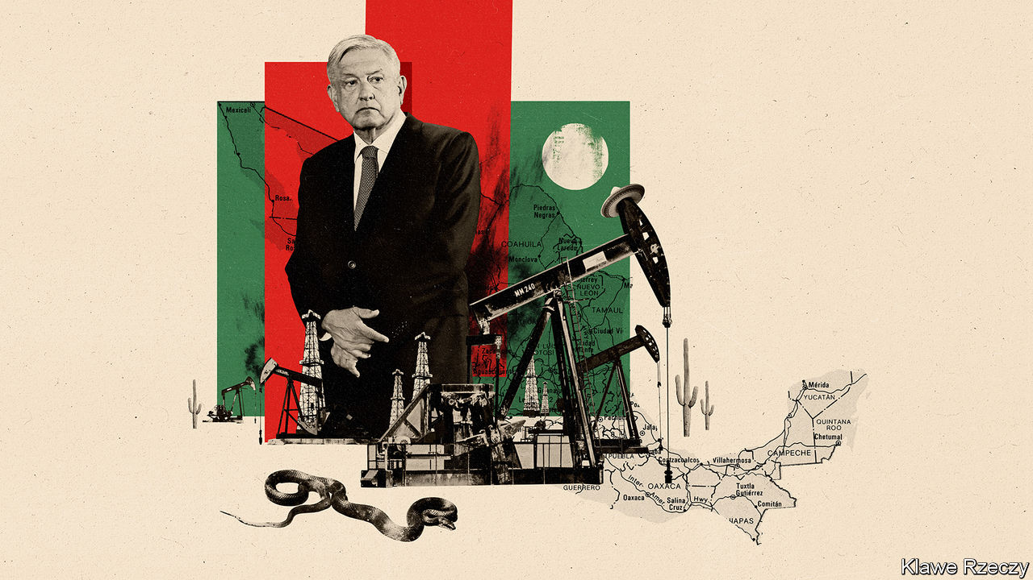

THE PANDEMIC has given environmentalists some cause to cheer. Demand for fossil fuels has plunged. Dispatches of solar and wind energy are up a bit. In Mexico the weather is bright and breezy but the mood in the renewables industry is anything but. Instead of taking advantage of the pandemic to speed up the shift from oil to renewable energy, the country’s populist president, Andrés Manuel López Obrador, is doing roughly the opposite.

On May 15th Mexico’s energy ministry published rules for the national grid, bypassing the normal process of consultation. One orders its controller, CENACE, to choose security over “economic efficiency” when deciding which power to dispatch. Another increases “operational reserves”, backup plants that must run at all times. Both rules disadvantage renewable power and give priority to dirtier, more expensive energy from plants run by the Federal Electricity Commission (CFE), says Julio Valle of the Mexican Wind Energy Association.

These are the latest in a series of blows to Mexico’s renewable-energy industry. The fourth round of auctions for permits to supply renewable energy to the grid, scheduled for late 2018, was cancelled by the López Obrador administration, which had recently taken office. Last month CENACE said it would suspend the inspections that solar and wind farms must undergo to begin operating. All this has unnerved investors in Mexican renewables. The wind industry had expected to triple its capacity to 15GW by 2024. Now it is likely to reach little more than half that figure, says Mr Valle.

Before Mr López Obrador, who is often called AMLO, took over hopes were high. His predecessor, Enrique Peña Nieto, opened up oil and gas to private investment but also set ambitious clean-energy targets and let private wind and solar producers sell power to the grid. The most recent auction for renewables, in 2017, produced some of the lowest green-power prices ever recorded, and the cheapest electricity in Mexico. The country has abundant sun and wind. Its capacity to generate electricity from them has tripled since 2015 to 10.9GW, providing almost 15% of the total. That progress will have to continue if Mexico, the world’s 11th-largest emitter of greenhouse gases, is to meet its (unambitious) commitment to raise emissions by no more than 9% from 2010 to 2030.

But renewables represent much of what AMLO dislikes. Generators are privately owned, often by foreigners. Control is dispersed. Solar and wind farms seem risky. With the 9% drop in electricity demand during the pandemic, surges of power could cause blackouts, the government claims. (Renewables’ share is too small to pose a risk, the industry retorts.) In March, on a visit to a wind farm in the north, AMLO lamented turbines’ “visual pollution”.

Instead, he finds beauty in oil wells. He is openly nostalgic for the days when Pemex, the state oil company, was the engine of Mexico’s prosperity. It pumped from wells offshore from the state of Tabasco, his birthplace. Oil and gas have symbolised sovereignty since President Lázaro Cárdenas expropriated the industry in 1938. AMLO wants to maintain CFE’s share of electricity generation at 54%, its level when he took office, and plans to build seven oil- and gas-fired plants. Centralised, oil-fuelled power boosts AMLO’s political power, points out Duncan Wood of the Wilson Centre’s Mexico Institute in Washington.

The beleaguered state oil firm can expect almost bottomless support. AMLO wants to raise its production by a third to 2.4m bpd by 2024. Although he has been reluctant to boost government spending during the pandemic, since becoming president he has promised $15bn-worth of aid to the company. He plans to spend $8bn to build an oil refinery in Tabasco.

There is little sign that these bets will pay off. Even before oil prices slumped Pemex was in trouble. Its most profitable wells have dried up. The market for the heavy crude it increasingly produces is shrinking. When processed in Mexico’s outmoded refineries, it yields high-sulphur “bunker oil”. In January the International Maritime Organisation banned ships from using this. Refusing to have the crude refined in the United States, Pemex is stuck with oil that few want to buy. Analysts suspect the CFE is being told to use it, displacing natural gas (and shutting down an opportunity for renewables).

Pemex’s cost of production has nearly tripled over the past decade. Factoring in other costs, like taxes and pensions, Pemex needs a price of $70 to break even, says John Padilla of IPD, a consultancy. The pandemic plunge has brought it down to below $30. Pemex made a loss of $23bn in the first three months of 2020. In April Mexico nearly derailed a global agreement on production cuts by refusing to reduce output.

Oil prices may recover, but Pemex’s problems will not go away. More efficient and cleaner producers of oil will have the edge over Mexico as the world reduces its consumption. AMLO’s successor may have to bet on green.■

This article was downloaded by calibre from <https://www.economist.com/the-americas/2020/05/23/nothing-can-shake-amlos-fossil-fuel-fixation>

|  |  |  |  |
| --- | --- | --- | --- |
|  | Articles | Sections | Next |

|  |  |  |  |
| --- | --- | --- | --- |
| Previous | Articles | Sections | Next |

#### Birth pangs

# Latin America ponders how to fight “obstetric violence”

The region has lots of laws to improve treatment of expectant mothers. They are not working

May 23rd 2020 |

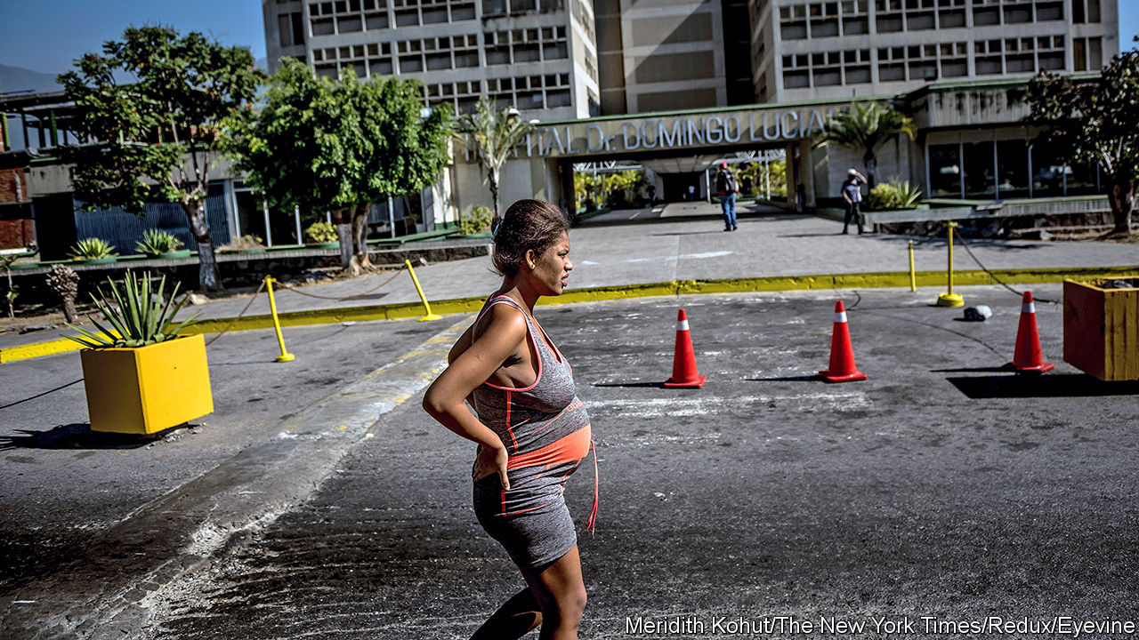

“COME ON, SMILE! This is the most important day of your life.” The midwife was upbeat. But Agustina, a 38-year-old comedian and brand-new mother, was shaken. It was 2012; she had just undergone a Caesarean section at a hospital in Argentina. Her obstetrician, she believes, had made the surgery more likely by inserting hormones into her vagina during a check-up, without explanation.

Two men performed the dangerous Kristeller manoeuvre, pushing down on her belly. She fainted. An assistant lightly slapped her face to keep her awake. Another tied her arm to the bed. None of it felt right. But, she says, “I thought the doctor is like your boss: you do what he tells you.”

Her ordeal was not unusual. Surveys in Latin American countries have found that between a quarter and a third of women who give birth suffer abuse at some point in the process. In one from 2016, 24% of Mexican women reported abuse in their last childbirth and 17% reported non-consensual care. A common form of mistreatment was humiliating comments by staff, reported by 7% of women. Other bad practices were withholding of painkillers without explanation (which 5% of women experienced) and forced contraception and sterilisation after childbirth (4%). A tenth of women who had C-sections said they had not given consent. Very young, unmarried and poor women in public hospitals were likeliest to suffer. Activists denounce what they call “obstetric violence”, a term they apply not only to violent acts.

Such abuse is, perversely, a consequence of progress. Better health care reduced maternal and infant mortality. Yet it also reinforced a culture that treats doctors as infallible, patients as passive and medical intervention as the first resort, even when harmful or against a woman’s wishes. Covid-19 may make the problem worse.

Mistreatment of expectant mothers is not confined to Latin America. A fifth of recent mothers in Italy report abuses. In Ethiopia three-quarters do. What makes the region unusual is decades of activism that have led to laws that seek to reduce abuse. In Brazil, a movement to “humanise childbirth”, led by feminists and public-health experts, has been active for at least 30 years. Later campaigns sought to “educate by law”, says Roberto Castro of the National Autonomous University of Mexico. Statutory changes would make people more aware of the problem, and therefore more likely to put pressure on doctors and other carers to behave well.

In 2007 Venezuela became the first country to define “obstetric violence” in law and make it a criminal offence. There it means the “appropriation of women’s bodies and reproductive processes by health professionals”. Similar laws followed in Argentina, Bolivia and Panama. Other measures are more practical. In 2001 Uruguay gave mothers-to-be the right to have a companion during delivery. This month Puebla, a Mexican state, classified as obstetric violence filming a birth without the mother’s consent.

There is little evidence the laws are working. Few governments release data on implementation. The Mexican states of Tlaxcala and Morelos, among the five where abuse was most prevalent, according to the national survey, reported receiving no formal complaints, says the Information Group on Reproductive Choice, a nonprofit. Courts have been reluctant to go after doctors unless they have physically harmed the mother or baby, in part because other misdeeds cannot be proved using medical records. Rare punishments of doctors do not improve the conditions under which they operate, which is more important, says Arachu Castro of Tulane University in New Orleans. In Mexico some clinics are so overstretched that women give birth on pavements and lawns outside them. During the pandemic in some places some rights, like having a companion or choosing vaginal delivery, have been suspended.

Venezuela’s ruined health system makes a mockery of its “humanised-birth policy”. Women often have to bring their own medical supplies, such as antiseptics, to delivery rooms. When the country’s obstetric-violence law was enacted, Rogelio Pérez-D’Gregorio, a former head of the Society of Obstetrics and Gynecology, advised obstetricians to protect themselves by making note of missing medications and other problems beyond their control.

Such deficits do not explain why women like Agustina, who gave birth at a well-appointed private clinic, suffer as they do. Mr Castro blames an “authoritarian medical disposition”, instilled at medical schools in male and female doctors alike. Critics say that teachers often emphasise technical prowess rather than patients’ welfare. Complaints to prosecutors in Brazil revealed that doctors-to-be were taught to perform episiotomies, surgical cuts to the perineum, to practise their skills, whether or not patients needed them.

While activists focus on pressure and punishment, some governments and international agencies are trying to be less confrontational, starting with the language they use to describe the problem. Last year Rio de Janeiro’s Regional Council of Medicine, which supervises doctors, declared that the term “obstetric violence” was “invented to defame” them. The Pan American Health Organisation prefers to talk of “abuse during childbirth” because “many times just mentioning [obstetric violence] closes to us the possibility of dialogue”, says Bremen De Mucio, an adviser to the group. It plans to launch a seminar on respectful maternal care by October.

Governments are beginning to emphasise training. Brazil’s ministry of health has started a programme that stresses women’s rights in obstetrics in about 100 teaching hospitals. A similar programme in Argentina contributed to declines in infant and maternal mortality.

But progress is slow. When Agustina got pregnant again, in 2014, she changed obstetricians and hospitals and wrote a birth plan. It included a vaginal delivery and immediate skin-to-skin contact with her baby, who would drink breast milk, not formula. The hospital rejected all her requests. After a birth by C-section, a female doctor threatened to report Agustina to child-protection services. She left “screaming in my mind”, unable to work and struggling to bond with her baby. Her marriage ended. In 2016 she filed a lawsuit against her doctors, the hospital and the health insurers, the first case of its kind in Argentina. She is still awaiting a verdict.■

This article was downloaded by calibre from <https://www.economist.com/the-americas/2020/05/23/latin-america-ponders-how-to-fight-obstetric-violence>

|  |  |  |  |
| --- | --- | --- | --- |
| Previous | Articles | Sections | Next |

|  |  |  |  |
| --- | --- | --- | --- |
| Previous | Articles | Sections | Next |

#### Bello

# Latin America’s economic plight is getting worse

Governments have limited firepower to deal with covid-19

May 23rd 2020 |

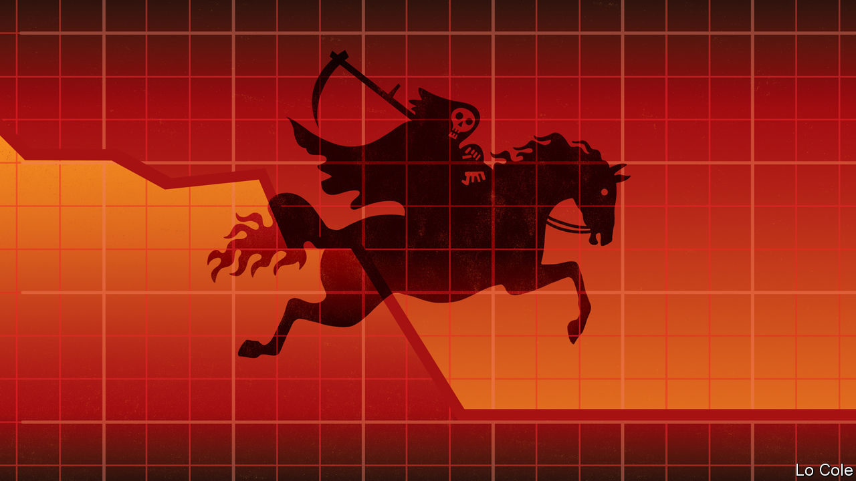

IN SãO PAULO 91% of intensive-care beds in hospitals are occupied even as cases of covid-19 soar. The city has declared a four-day public holiday to reduce travel. In poorer parts of Brazil, such as Fortaleza and Manaus, hospitals are even fuller. Much the same goes for Peru and Mexico. In Chile, which seemed to have been controlling the coronavirus, a sharp rise in cases and deaths saw the government lock down greater Santiago and left the health minister “intensely worried”. Faced with a record rise in cases this week, Argentina extended its lockdown. As the pandemic slows in Europe, it is surging in the Americas.

For Latin America that is both disappointing and worrying. Forewarned, many countries were quick to impose lockdowns two months ago. In a region where one worker in two toils in the informal economy, these are hard to sustain. Many countries, too, have organised emergency payments for large segments of the population and given credit guarantees to firms. But Latin American governments lack the fiscal firepower, as well as the effective institutions, of their counterparts in Europe or the United States. As a result, rather than having a rapid recovery, as some hoped, the region risks entering a dark valley in which both public health and livelihoods suffer over many months. Already, the effects are exacerbating inequality in an unequal region.

Start with public health. The lockdowns did reduce the spread of infection in April, according to Jarbas Barbosa of the Pan American Health Organisation (PAHO). But economic pressures, and in Brazil and Mexico mixed messages from presidents, have led many people to flout the lockdowns. Traffic in the region’s biggest countries is back up to almost half of normal, according to the Inter-American Development Bank (IDB). Street markets are a source of contagion: in a wholesale fruit market in Lima almost 80% of vendors tested positive for the coronavirus. PAHO warns that the urban poor, many of whom live in dense areas, indigenous people in the Amazon and migrants and prisoners are especially vulnerable.

Several smaller countries, such as Paraguay, Costa Rica and Jamaica, have low rates of infection, as does Colombia. Some other governments have simply declared victory and are opening up their economies again. They include Mexico, whose president, Andrés Manuel López Obrador, claims that his country has “tamed” the virus. But even Mexico’s especially suspect official data show cases still rising. “Most countries can’t open up,” says Dr Barbosa. “It would be a recipe for disaster.” He thinks that if social distancing is properly adopted, cases could start falling across the region in the first half of June.

Although the lockdowns are popular, they carry a big socioeconomic cost. A 17-country poll for the IDB in April suggested that 57% of small businesses have shut down temporarily, while nearly 45% of respondents said a household member had lost a job. Countries such as Brazil, Chile and Peru have implemented three-month emergency income schemes. But getting the money to informal workers is hard (and has sometimes prompted infection-spreading crowds outside banks).

If the virus is to be contained, such policies will need to continue for longer. So will credit guarantees and emergency liquidity for firms, if they are to be able to drive economic recovery. Governments will struggle to find the money. “We don’t live in a ‘whatever it takes’ region,” says Mauricio Cárdenas, a former Colombian finance minister, referring to the stance of the European Central Bank. “We can do whatever we can,” he told a World Bank seminar this week.

Only the financially strongest countries, such as Peru and Chile, have public savings to draw on. Many Latin American countries can still raise money in financial markets, but for how long? Trying to reschedule debts, as Argentina is doing, takes time and carries costs. And rather than limiting capital outflows through debt forgiveness, Latin America needs additional inflows. Since March, a dozen Latin American and Caribbean countries have received a total of $4bn in emergency financing from the IMF. But demand for its money will exceed supply.

Mr Cárdenas suggests that the IMF should set up a fund that would issue bonds for rich-country central banks to buy, with the money being used to help Latin America weather the crisis. That may be a tall political order. But the alternative may be years of economic prostration and political instability.

Editor’s note: Some of our covid-19 coverage is free for readers of The Economist Today, our daily [newsletter](https://my.economist.com/user#newsletter). For more stories and our pandemic tracker, see our [hub](https://www.economist.com/news/2020/03/11/the-economists-coverage-of-the-coronavirus)

This article was downloaded by calibre from <https://www.economist.com/the-americas/2020/05/23/latin-americas-economic-plight-is-getting-worse>

|  |  |  |  |
| --- | --- | --- | --- |
| Previous | Articles | Sections | Next |

|  |  |  |
| --- | --- | --- |
| The Americas | Sections | China |

Asia

India’s economy: Lockdown and out

.

Malaysian politics: Muhyiddin’s mess

.

Japanese politics: Unscathed but scathing

.

Power-sharing in Afghanistan: Titles all round

.

Australia’s trade with China: Barley barney and beef beef

.

Cruise ships in the Philippines: Floating confinement

.

Banyan: Sixty-somethings in a sack

.

|  |  |  |
| --- | --- | --- |
| The Americas | Sections | China |

|  |  |  |  |
| --- | --- | --- | --- |
|  | Articles | Sections | Next |

#### Lockdown and out

# India’s economy has suffered even more than most

And covid-19 is still proliferating

May 23rd 2020 | DELHI

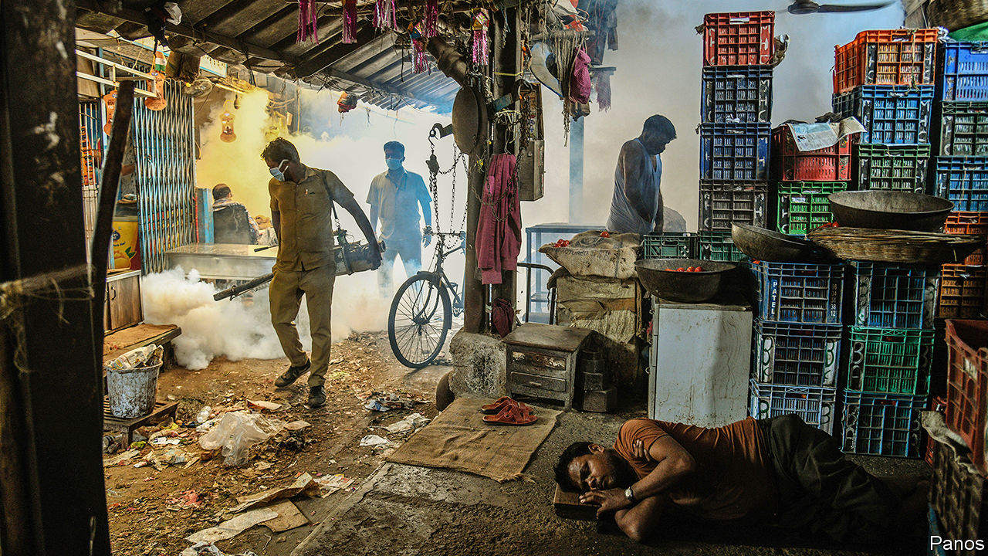

EMERGING FROM two months under one of the world’s most stringent covid-19 lockdowns, India faces a double dilemma. The stay-at-home rules did indeed bend the virus’s growth curve. This means that, so far, fewer Indians are known to have died of the disease than Swedes, even though India has 134 times more people. Yet India’s lockdown failed to bend it far enough. “We put more effort into containing the people than containing the virus,” as one epidemiologist puts it. As a result, official covid-19 deaths have risen steadily to 150 a day and are still rising. The streets and workplaces that 1.3bn Indians are returning to will be more virus-infested than when the lockdown started.

Already, however, India has paid a heavier economic price for the lockdown than have many countries initially hit harder by covid-19. In March alone no fewer than 140m workers are thought to have lost their jobs, catapulting the unemployment rate from 8% to an unprecedented 26% nationwide (see chart). Some 10m-80m migrants—the vagueness of the estimates speaks of the invisibility of the working underclass of street hawkers, labourers and factory hands—have despaired and tried to return to impoverished villages. Millions more Indians who work abroad have either sharply reduced their remittances or plan to return home. The 10% of the workforce in formal employment has fared better, but this is partly because employers have held off firing them for as long as possible. Only now are those cuts multiplying.

Goldman Sachs, a bank, expects the economy to contract by 45% this quarter at an annualised rate, and by 5% over the full year, assuming a big bounce in the second half. The National Council of Applied Economic Research, a think-tank in Delhi, predicts a contraction of 12.5% this fiscal year unless there is a huge stimulus.

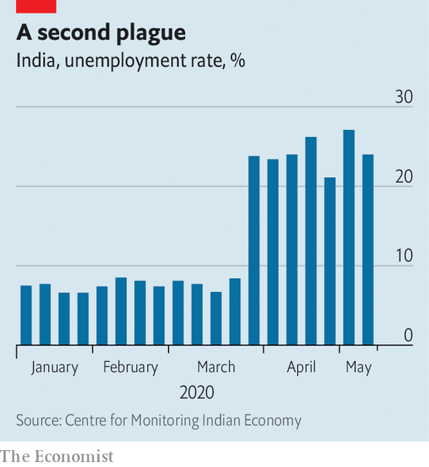

Recognising the pain, Narendra Modi, the prime minister, on May 12th pledged an almost mythical-sounding 20 lakh crore rupees of fresh government spending, equivalent to $265bn or 10% of GDP, to reignite growth. Over the next five days a bank of finance-ministry officials faced cameras, unveiling slice after slice of measures, carefully designed to add up to Mr Modi’s magic number.

Yet although analysts expect the extra spending to push the budget deficits of the central government and the states to about 12% of GDP, and raise the country’s overall debt-to-GDP ratio to a wobbly 80%, many doubt that the measures will work. “What we needed was large tranches of money to go into circulation without ado,” said an editorial in Mint, a financial daily. But instead of a demand-side boost, and in particular urgent cash support for the poorest, what Mr Modi delivered was a hotchpotch of supply-side inducements and prods such as credit guarantees, along with reforms whose impact will only be felt in the medium term, at the earliest. Most of the stimulus was made up either of previously announced measures, or central bank moves to spur lending. Estimates of the actual new fiscal commitment by Mr Modi’s government range from a puny 0.7% of GDP to 1.3%, a far cry from the touted 10%.

Predictably, Mr Modi’s defenders explain that it is prudent to keep the government’s powder dry, considering that its budget amounts to just a sixth of GDP—far less than in richer countries—and it is not yet clear when the crisis will end. Instead of simply throwing money at the poor, the government has instead made it far easier for the small firms that employ most Indians, and form the backbone of the economy, to borrow and invest. The government has, to its credit, enormously increased spending on a rural jobs programme that Mr Modi dismissed as a boondoggle while in opposition. And such reforms as eliminating restrictions on the internal trade in agricultural goods and switching to a national, rather than state-based, system for distributing subsidised food are not just helpful to the poor, but also save the government money.

Even so, it is not just soft-hearted lefties who accuse Mr Modi of stinginess. Two of India’s Nobel laureates, the economists Amartya Sen and Abhijit Banerjee, had suggested that monthly emergency payments of up to $100 could help tide over many families. Instead, the sums offered so far amount to $6.60 each a month for perhaps 200m poor women, and promises of a one-off $26 apiece to some 70m farmers. Even for the 60% of Indians who survive on less than $3.20 a day, the World Bank’s poverty line for lower middle-income countries, such measly sums will not last long, much less stimulate the demand needed to generate jobs. A mountain of bad debt was already weighing on spending and investment before the coronavirus came along. Yet the government and the central bank seem to be hoping to revive the economy by encouraging lending. Critics see attempts to spur a borrowing binge before the wreckage of the previous one has been cleared away as not just optimistic, but foolhardy. “Expecting bank loans to grow more rapidly now is at best a pipe dream,” says Vivek Kaul, a columnist. ■

This article was downloaded by calibre from <https://www.economist.com/asia/2020/05/23/indias-economy-has-suffered-even-more-than-most>

|  |  |  |  |
| --- | --- | --- | --- |
|  | Articles | Sections | Next |

|  |  |  |  |
| --- | --- | --- | --- |
| Previous | Articles | Sections | Next |

#### Muhyiddin’s mess

# Malaysia’s shaky government dodges a no-confidence motion

The prime minister will have been in office for five months before he proves his majority

May 23rd 2020 | SINGAPORE

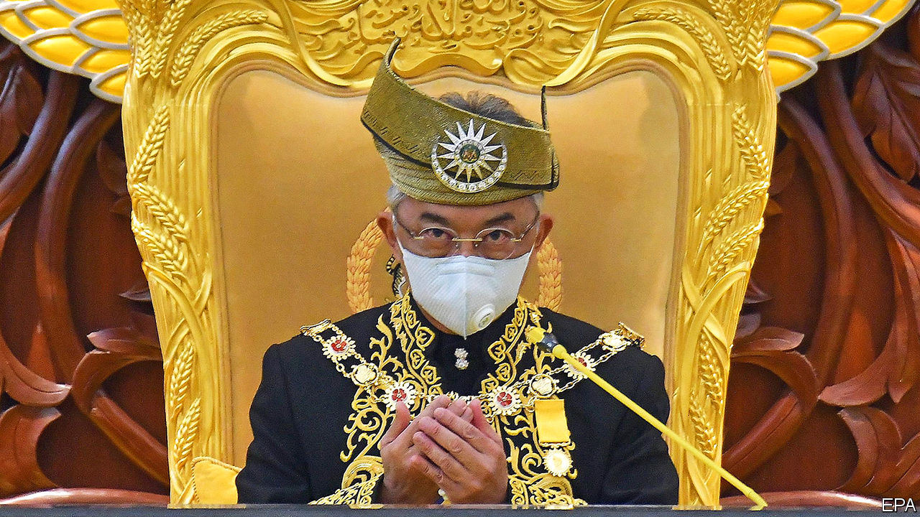

IT WAS THE shortest session on record. Malaysia’s MPs convened on May 18th to hear a speech from the king (pictured). No sooner had he finished than they adjourned until July. The official reason for the brevity was to avoid spreading covid-19. But the brisk timetable also thwarted plans to hold a vote of no confidence in the prime minister, Muhyiddin Yassin.

Mr Muhyiddin only took the job on March 1st and has yet to prove his government’s majority in parliament. His uncertain standing stems from the peculiar manner of his ascent. The previous government, led by Mahathir Mohamad, had fallen when two of its constituent parties split. Factions from both Keadilan, the biggest party in the outgoing government, and Bersatu, the party of both Dr Mahathir and Mr Muhyiddin, decided to form a new majority by aligning with the opposition. Mr Muhyiddin sided with the renegades.

Since he took the top job Mr Muhyiddin has had a tough time of it. Malaysia is battling more than 7,000 cases of covid-19 and has imposed a lengthy “movement control order” to slow its spread. There is not enough money to repair the damage. Although the government’s relief package has a notional value of more than 16% of GDP, it is only boosting spending by around 2% of GDP immediately.

To stay in office Mr Muhyiddin needs the backing of at least 112 of the 222 members of the lower house of parliament. The seating arrangements on May 18th suggest he may have 113 of them in his corner. Lawmakers from the Malaysian part of Borneo helped tip the balance. But bonds of loyalty to Mr Muhyiddin are likely to be loose. Maintaining this wafer-thin majority will consume much of the prime minister’s attention until parliament’s next scheduled meeting, in July.

Bersatu gives an idea of the difficulties. Powerful figures in the party, including Dr Mahathir, remain aligned with the opposition. The nonagenarian is Malaysia’s most experienced statesman and a dangerous foe. It was Dr Mahathir who put forward the motion for the parliamentary vote of no confidence. And his son intends to challenge Mr Muhyiddin for the party’s presidency. Indignation at being ousted from power, meanwhile, has helped to quell infighting within the opposition.

Should Mr Muhyiddin lose control of Bersatu, his new allies are likely to lose patience with him. “He is at the mercy of his colleagues in the same coalition,” explains one Malaysian political consultant. The two other big parties in his government are the United Malays National Organisation (UMNO), which for years was Malaysia’s ruling party, and PAS, an Islamist outfit. While they needed Mr Muhyiddin and other turncoats to join them in order to gain power, the bigwigs of UMNO resent the disproportionate share of jobs in the cabinet that went to members of Bersatu. In a show of petulance, UMNO has refused to declare Bersatu an official ally. And no wonder: Bersatu was only founded in response to corruption within UMNO. The two have an identical agenda—to improve the circumstances of the ethnic Malay majority—and so will compete for the same votes.

By teaming up with UMNO, Mr Muhyiddin has taken away Bersatu’s reason for being. And without a formal alliance, Bersatu will not benefit from UMNO and PAS’s well established campaign networks at the next election. The party will be “the most marginalised” when Malaysia votes again, says Maszlee Malik, a member of Bersatu’s Supreme Council.

Small wonder that Mr Muhyiddin has been coaxing lawmakers to stick with him with promises of cushy jobs and influence. One lawmaker from PAS has expressed confidence that all MPs who back the governing coalition will receive posts in government-linked companies, if they are not already busy with other official positions.

Such behaviour is reminiscent of the government of Najib Razak, the most recent prime minister from UMNO, who lost power two years ago after American officials, among others, accused him of allowing some $4.5bn in public money to go astray. That left UMNO out of government for the first time since independence. Mr Najib remains an MP—and Mr Muhyiddin’s fragile majority depends on his support. ■

Editor’s note: Some of our covid-19 coverage is free for readers of The Economist Today, our daily [newsletter](https://my.economist.com/user#newsletter). For more stories and our pandemic tracker, see our [hub](https://www.economist.com/news/2020/03/11/the-economists-coverage-of-the-coronavirus)

This article was downloaded by calibre from <https://www.economist.com/asia/2020/05/23/malaysias-shaky-government-dodges-a-no-confidence-motion>

|  |  |  |  |
| --- | --- | --- | --- |
| Previous | Articles | Sections | Next |

|  |  |  |  |
| --- | --- | --- | --- |
| Previous | Articles | Sections | Next |

#### Unscathed but scathing

# Japan is not rallying around its prime minister

Even though the country has come through the pandemic in relatively good shape

May 23rd 2020 | TOKYO

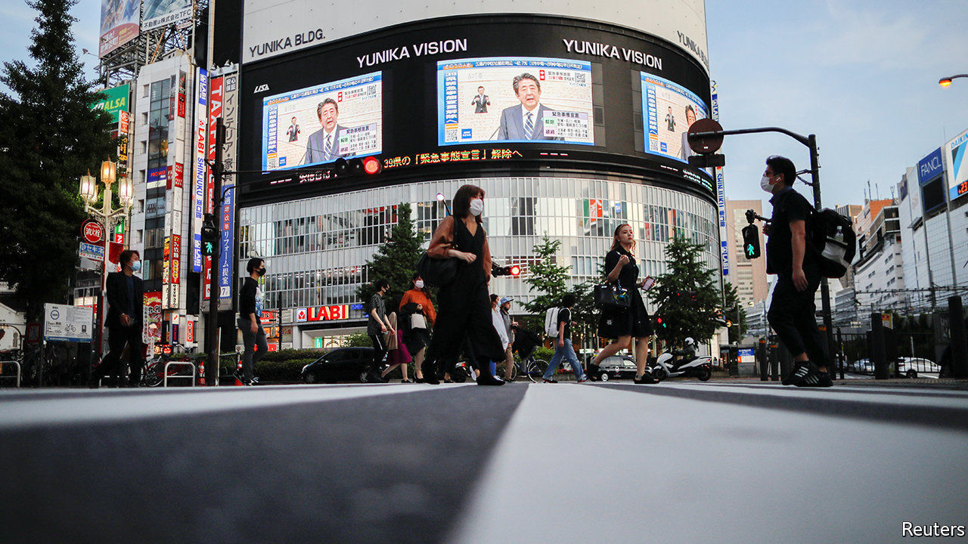

SINCE JAPAN recorded its first case of covid-19 on January 16th, 784 people have died across the country of 126m, fewer deaths than in one day in New York City during the peak of the outbreak there. On May 14th the government lifted the state of emergency in 39 of Japan’s 47 prefectures, with more likely to be released this week. In terms of deaths relative to population, Japan ranks alongside South Korea, whose government has been widely praised for its management of the pandemic.

Yet when it comes to public opinion, Abe Shinzo, Japan’s prime minister, has been one of a small handful of world leaders to see his approval ratings drop, alongside covid-deniers like Brazil’s Jair Bolsonaro. Polls show that more than half of the Japanese public disapproves of the government’s handling of the virus. Limited testing, shortages of protective gear for medical workers, the botched handling of a super-spreading cruise ship and hesitation to impose a state of emergency have fuelled frustration and distrust. “Citizens and the private sector were far ahead of the government,” says Nakabayashi Mieko, a former opposition MP. On May 19th Japan’s national broadcaster, NHK, found that more people disapproved than approved of Mr Abe’s government (see chart).

Mr Abe has cultivated the image of himself as a strong leader. But faced with covid-19 “he has not acted like the leader he claimed he was,” says Tobias Harris, author of “The Iconoclast”, a biography of Mr Abe to be published later this year. Instead, he has appeared hapless and out of touch, much as he did during his brief first stint as PM in 2006-07, when Japanese media pilloried him as kuuki yomenai, or “one who cannot read the air”, says Jeff Kingston of Temple University in Tokyo.

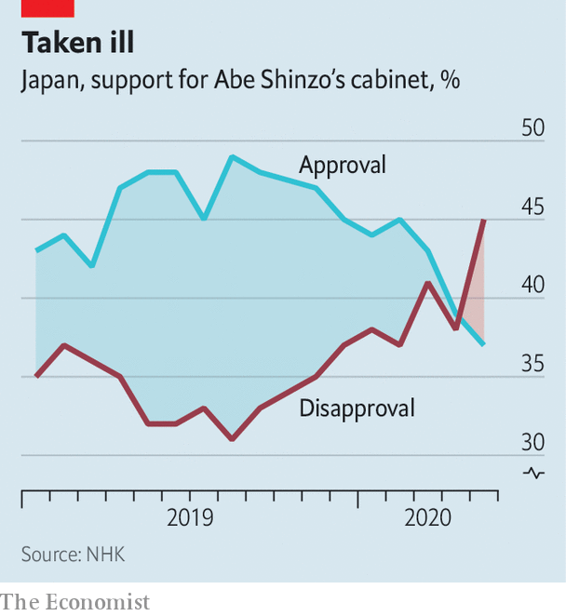

A scheme to send each Japanese household two cloth masks, at a cost of ¥47bn ($436m) to taxpayers, generated scorn. Detractors dubbed the programme “Abenomasks”, a play on “Abenomics”. When the masks started to arrive, many were dirty and defective and, for most people, too small; entire regions have yet to receive any. “Is that really public policy?” asks Sone Yasunori of Keio University.

The government’s economic stimulus measures have been similarly ham-fisted. Mr Abe backtracked on an initial plan to give struggling households ¥300,000 each, shifting instead to a universal ¥100,000 handout favoured by his Liberal Democratic Party’s coalition partner, Komeito. The result looked “muddled instead of decisive”, says Phillip Lipscy of the University of Toronto. The government has yet to dole out the cash; individuals will have to brave a bureaucratic gauntlet to obtain it. Loans and other support measures for businesses have come wrapped in red tape. More than 285,000 businesses inquired about subsidies to put employees on leave, but only 1.9% of them have actually received any payments. Meanwhile, the economy is officially in recession, having shrunk by 3.4% at an annual rate in the first quarter of the year and by 7.3% at the end of last year.

Throughout the pandemic Mr Abe has devoted lots of attention to a controversial plan to raise the retirement age for prosecutors—widely seen as a way to keep allies around. Normally apolitical celebrities waded in to denounce the move on social media. “In the midst of the coronavirus calamity, we should focus on people’s lives,” wrote Miyamoto Amon, a director of musicals and plays. Even Mr Abe’s friends in the conservative media voiced concerns. On May 18th Mr Abe finally backed down. “Day by day, Mr Abe is losing his centripetal force, not only in the government but in the ruling party,” says Toshikawa Takao, editor of Tokyo Insideline, a political newsletter.

Nonetheless, the prime minister remains the unchallenged centre of Japan’s political universe. The inept opposition is “not really taking advantage of this situation”, says Ms Nakabayashi. Although voters during the pandemic have preferred the more decisive leadership of governors such as Tokyo’s Koike Yuriko and Osaka’s Yoshimura Hirofumi, moving from local to national politics is tricky. Ms Koike’s party flopped at national elections in 2017. Mr Abe’s ruling Liberal Democratic Party remains dominant in the polls, and his challengers inside the party have stayed quiet. “People distrust his leadership,” says Mr Toshikawa. “But at the same time they recognise there is no alternative national leader at this moment.” ■

Editor’s note: Some of our covid-19 coverage is free for readers of The Economist Today, our daily [newsletter](https://my.economist.com/user#newsletter). For more stories and our pandemic tracker, see our [hub](https://www.economist.com/news/2020/03/11/the-economists-coverage-of-the-coronavirus)

This article was downloaded by calibre from <https://www.economist.com/asia/2020/05/23/japan-is-not-rallying-around-its-prime-minister>

|  |  |  |  |
| --- | --- | --- | --- |
| Previous | Articles | Sections | Next |

|  |  |  |  |
| --- | --- | --- | --- |
| Previous | Articles | Sections | Next |

#### Titles all round

# Afghanistan’s two rival presidents reach a deal

One will take the equally thankless job of head peace negotiator instead

May 23rd 2020 | ISLAMABAD

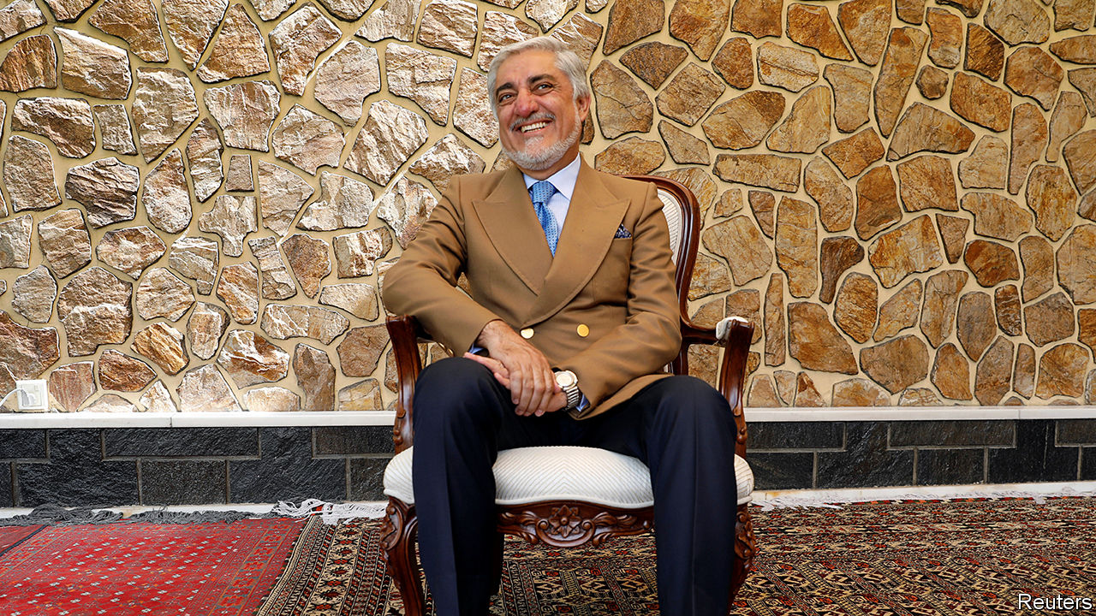

ASHRAF GHANI remains president of Afghanistan, while his eternal rival for the job, Abdullah Abdullah, who disputes the result of the election held last September, gets yet another consolation prize. That, it seems, is the upshot of a deal finally agreed on May 17th, after months of posturing and haggling, including an absurd moment in March when both men had themselves sworn in. Dr Abdullah’s new job, fittingly enough, is to advance the peace negotiations he has been distracting attention from over the past few months.

It is all grimly reminiscent of the deal struck five years ago, when Mr Ghani narrowly defeated Dr Abdullah for the top job, amid similar acrimony. Once again Western governments, fearing that the row would ruin their plans for peace, had to twist the arms of the two rivals into sharing power. America, exasperated by the haggling, cut aid by $1bn in the hope of focusing minds.

Mr Ghani, a former World Bank economist, will remain president for a second and final term, ending in 2024. Dr Abdullah, a sharp-suited former eye specialist and foreign minister, will choose half the cabinet and take a new role overseeing talks with the insurgents of the Taliban, in the hope of ending the long civil war.

That is a notional demotion from 2014, when a power-sharing deal brokered by America gave Dr Abdullah the title of “chief executive”. That post put him at the heart of government: he was to be consulted by the president and he chaired the council of ministers. Those responsibilities have now gone. Instead, he will chair a new high council for national reconciliation that will run whatever negotiations are undertaken with the Taliban. This will give him a high profile, but less of a role in day-to-day government. Instead, his fortunes will depend on the outcome of the talks.

There will be plum jobs for some of Dr Abdullah’s backers, too. Most notably, General Abdul Rashid Dostum, an ethnic Uzbek warlord with a reputation for ruthlessness, will become a field-marshal, despite accusations, which he hotly denies, that he had an adversary sexually abused with a rifle.

Relations between Mr Ghani and Dr Abdullah got so bad during the previous presidential term that they barely spoke to each other, say diplomats. The smiles in photographs of the signing ceremony for the new deal look sickly. Amid routine congratulations, international reaction has mixed relief with frustration. The Americans were furious that the government in Kabul was paralysed during the impasse, when it should have been preparing for talks with the Taliban. Under an accord struck by the Americans and the Taliban in February, representatives of the Taliban and the Afghan government should be in discussions about Afghanistan’s future by now. Instead the process has been held up by a row over prisoner releases—and by the impasse in Kabul. Zalmay Khalilzad, the American envoy who has been shuttling between the two rivals, chided them for their stubbornness even as he congratulated them. The compromise formula had been on the table for ten weeks, he tweeted.

Afghans also resented the haggling. The UN says the Taliban killed or injured 208 civilians in April, while Afghan government forces caused 172 casualties. On May 12th unidentified gunmen stormed a maternity clinic in Kabul, killing 24 people, including babies, mothers and nurses. Covid-19 and food shortages are adding to the misery. Yet Afghans see their leaders as concerned mainly with carving up power. ■

This article was downloaded by calibre from <https://www.economist.com/asia/2020/05/23/afghanistans-two-rival-presidents-reach-a-deal>

|  |  |  |  |
| --- | --- | --- | --- |
| Previous | Articles | Sections | Next |

|  |  |  |  |
| --- | --- | --- | --- |
| Previous | Articles | Sections | Next |

#### Barley barney and beef beef

# China punishes Australia for promoting an inquiry into covid-19

Crushing tariffs on barley follow a ban on certain beef imports

May 21st 2020 | SYDNEY

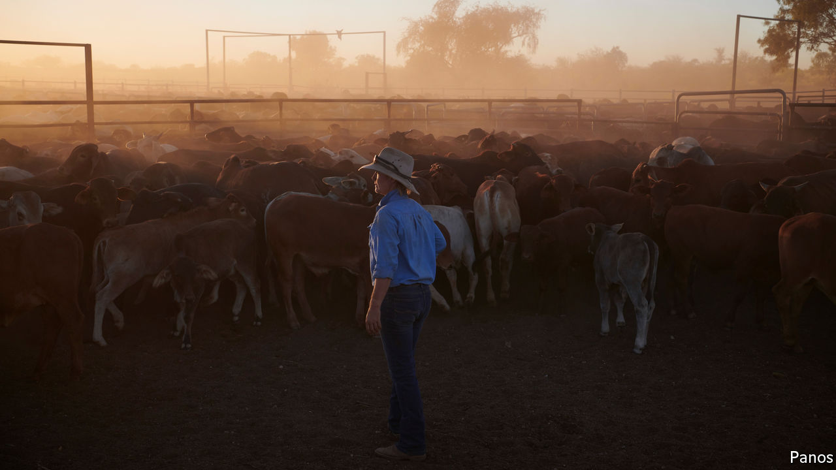

CHINA’S AMBASSADOR to Australia, Cheng Jingye, recently warned Australia it was treading a “dangerous” path by pressing for an independent inquiry into the origins of the coronavirus (one that might reveal China doing more to suppress information about early infections than to quash the outbreak itself). If relations between the two countries soured, Mr Cheng threatened, Chinese tourists might have “second thoughts” about holidaying Down Under. Families might wonder whether Australia really was the “best place to send their kids” to study. Ordinary Chinese might no longer want to “drink Australian wine, eat Australian beef”.

In the event, China this week agreed to an inquiry, in the face of international pressure at the World Health Organisation’s annual assembly (held online). But it did so after slapping tariffs of over 80% on Australian barley on May 18th, having already banned beef from Australia’s four biggest abattoirs on May 12th.

The abattoir ban blocks perhaps 35% of Australia’s exports of beef to China. Karen Penfold, whose family is among the exporters affected, says it has been scrambling to find other buyers for its prime steak. Barley growers, based mostly in Australia’s west, send at least half, or A$600m ($393m), of their annual exports to China, where the grain is used as animal feed and to make beer. Farmers reckon the new tariffs will all but kill the trade.

China has not directly linked its measures to displeasure with Australia. It claims to be worried about labelling and sanitary standards when it comes to the beef. The barley tariffs are the culmination of an 18-month investigation into hidden subsidies. Moreover, Australia has itself imposed anti-dumping measures on 17 Chinese exports, including office printing paper and stainless steel sinks. Some of Australia’s trade complaints “have long stretched credibility”, says Gareth Evans, a former foreign minister.

Yet there is little doubt that China’s moves are in retaliation for criticism of the way it handled the pandemic. “This is clearly a case of political coercion,” says Peter Jennings of the (hawkish) Australian Strategic Policy Institute, a think-tank in Canberra. China has long resented Australia’s suspicious politicians, who have legislated to stop China meddling in Australian democracy and were quick to bar Huawei, a Chinese telecoms giant, from building 5G networks in Australia on security grounds. Australia has objected to China’s increasing aggression in the disputed South China Sea, and criticised the internment of over 1m Muslim Uighurs in China’s far west. Richard McGregor of the Lowy Institute, a think-tank in Sydney, says China sees Australia as stirring hostile sentiment by “going around the world and warning other countries about China’s misbehaviour”. Mr Cheng accuses the Australian government, under Scott Morrison, the prime minister, of following instructions from President Donald Trump to “launch a political campaign against China”.

The products caught up in the spat represent only a tiny sliver of Australian exports to China, which amounted to A$153bn (7.7% of GDP) last year. The biggest earners include coal, gas, iron ore, tourism and education. But the latter two are likely to shrink rapidly as fewer people venture abroad because of the pandemic. What is more, the huge scale of trade gives China ample opportunity to inflict further harm. Australia exports more to it than to its five next biggest markets combined.

Bloomberg, a news agency, reports that the Chinese government is considering submitting other choice Australian products, including seafood, dairy and wines, to new quality checks and anti-dumping reviews. Obscure changes to rules about iron ore are causing alarm. This highlights Australia’s conundrum: it has no consistent China policy. For years it has been happy to sell stuff into what Mr Jennings calls an “easy market”. But it also wants to continue to air ideological and geopolitical grievances. As a result, China has it over a few million barrels of full-bodied Shiraz. ■

Editor’s note: Some of our covid-19 coverage is free for readers of The Economist Today, our daily [newsletter](https://my.economist.com/user#newsletter). For more stories and our pandemic tracker, see our [hub](https://www.economist.com/news/2020/03/11/the-economists-coverage-of-the-coronavirus)

This article was downloaded by calibre from <https://www.economist.com/asia/2020/05/21/china-punishes-australia-for-promoting-an-inquiry-into-covid-19>

|  |  |  |  |
| --- | --- | --- | --- |
| Previous | Articles | Sections | Next |

|  |  |  |  |
| --- | --- | --- | --- |
| Previous | Articles | Sections | Next |

#### Floating confinement

# Why the Philippines is a magnet for idled cruise ships

And why thousands of crew members are still waiting impatiently to disembark

May 23rd 2020 | MANILA



IN HEALTHIER TIMES the sight of a fleet of cruise ships lying at anchor in Manila Bay, silhouetted against the sunset, would gladden the hearts of business people on shore, eager to relieve free-spending passengers of their money. But the 21 vessels dotting the seascape on May 21st were not so much floating hotels as prison hulks. The passengers are long gone. Instead, the ships serve as quarantine quarters for crews made idle by the collapse of the cruise market thanks to covid-19. For many of the hapless mariners, quarantine is proving endless.

The fleet anchored in Manila Bay began to gather after April 16th, when the Philippine government declared that, unlike many others in Asia, it would let foreign cruise ships call to land idled crews, as long as some of the staff were Filipino. As it happens, Filipinos make up about a third of all cruise-ship crews, so plenty of vessels met the criterion. Notorious arrivals include the Ruby Princess, which became a hotbed of covid-19 while cruising off Australia.

The government is allowing Filipino staff to land only after they spend 14 days in quarantine aboard ship and then test negative for covid-19. Even after a 14-day isolation, foreign crew-members can only come ashore if they have a reservation on a flight leaving Manila within four hours.

That is fine in theory. But four weeks after the government first let foreign liners into Manila Bay some 5,300 Filipino seafarers were still confined to their ships, along with an unknown number of foreigners. Delays in administering and processing tests is one problem. Another is the lack of transport to take Filipinos from Manila to their home provinces, since the government has banned most domestic travel.

Onward travel is even more daunting for foreigners, since flights in and out of Manila have all but evaporated. The government has restricted incoming air traffic because it has insufficient quarantine facilities on land to confine Filipinos arriving by plane—including, ironically, cruise-ship crews returning home by air.

The delay is spurring other complaints. Some unlucky sailors have been confined to windowless cabins. Several ships are anchored too far offshore to pick up mobile signals. Some trapped sailors say they are no longer being paid. A typhoon that scattered the Manila Bay fleet for a while added to their unease. One posted a plaintive plea on Facebook: “Please let us go home, we are begging whoever is in charge.” ■

Editor’s note: Some of our covid-19 coverage is free for readers of The Economist Today, our daily [newsletter](https://my.economist.com/user#newsletter). For more stories and our pandemic tracker, see our [hub](https://www.economist.com/news/2020/03/11/the-economists-coverage-of-the-coronavirus)

This article was downloaded by calibre from <https://www.economist.com/asia/2020/05/23/why-the-philippines-is-a-magnet-for-idled-cruise-ships>

|  |  |  |  |
| --- | --- | --- | --- |
| Previous | Articles | Sections | Next |

|  |  |  |  |
| --- | --- | --- | --- |
| Previous | Articles | Sections | Next |

#### Banyan

# Vietnam’s secretive Communist Party embarks on a leadership transition

The jostling behind the scenes would put ferrets in a sack to shame

May 23rd 2020 |



IN JANUARY FOUR grey apparatchiks with little name or face recognition inside Vietnam, let alone abroad, will emerge from a five-yearly congress of the Communist Party to take charge of the youthful country of 96m. The line-up will telegraph order and consensus, the obsession of one of the world’s most secretive political organisations. Yet, out of sight, the struggle for the top jobs will put ferrets in a sack to shame.

The consensual order disapproves of the kind of personal power that Xi Jinping has garnered in China. It calls for four “pillars”: separate holders of the posts of party general secretary (the most crucial job), state president (often a figurehead), prime minister (who runs the government day-to-day) and chair of the National Assembly (which, once wholly obedient, is gradually finding a voice). It is exception enough that Nguyen Phu Trong, the current general secretary, had to take over the job of president when the incumbent died in 2018. Next year the highest leadership will almost certainly revert to four.

The parameters are long-established. Seven Politburo members over 65 must go, to be refreshed by seven or so new recruits from the party secretariat. Only one oldie is allowed to stay, as general secretary. It is unlikely to be the long-serving Mr Trong, who is 76 and thought to be in ill health.

The prime minister, Nguyen Xuan Phuc, who is 65, may fancy his chances. He directed the fight against covid-19, in which Vietnam excelled, with no confirmed deaths. A competent economic manager, he is now trying to revive battered trade and foreign investment. But, says Tuong Vu of the University of Oregon, Mr Phuc lacks the essential trait to lead the party: devotion to Marxist-Leninist ideology as demonstrated by experience in propaganda or disciplinary work. Of other contenders, the head of the National Assembly, Nguyen Thi Kim Ngan, suffers from being a woman, while the 49-year-old Vo Van Thuong, an up-and-coming propaganda wizard, is probably too young. So bet on the 67-year-old Tran Quoc Vuong, Mr Trong’s right-hand man, succeeding his boss.

After that, candidates for the other three posts more readily fall into place. Mr Phuc’s deputy, Vuong Dinh Hue, might succeed him as prime minister. Ms Ngan might hand over to another woman, Truong Thi Mai, steeped in party work. The current foreign minister, Pham Binh Minh, could become president.

All smooth enough. Yet three threats could challenge the consensual order in years to come. One is failing to control corruption. Scandals surrounding party bosses in the country’s two biggest cities, Hanoi and Ho Chi Minh city, have tarnished the party’s reputation. Mr Trong once said that fighting corruption while maintaining stability is like “catching a rat without breaking the pot”.

Another threat is the north’s hold on power. Since the Vietnam war, northerners have viewed the south as ideologically suspect. Hanoi and its surrounding regions have also hogged infrastructure development, paid for by the bustling south. If, as is likely, no one from the south is represented in the top leadership, says Le Hong Hiep of the ISEAS-Yusof Ishak Institute, a think-tank in Singapore, southerners must be promoted into the Politburo with an eye to the next reshuffle in 2026. Otherwise southern resentment will build.

The third threat comes from Vietnam’s complex relationship with China. Economic entanglement and ideological ties run deep. But Vietnam views its northern neighbour with distrust. That helps explain its coronavirus success: not trusting China’s reassurances about the course of the infection in its early days, Vietnam quickly put itself on a war footing, even launching cyberattacks against China to glean information about the real course of the epidemic.

Elsewhere leaders struggle to deal with China over disputed territory and maritime claims in the South China Sea. Under cover of the global pandemic, China has become increasingly assertive, sinking a Vietnamese fishing vessel, giving Chinese names to dozens of reefs and rocks in the sea and establishing new administrative districts over islands and atolls it controls, including the Paracels, seized from Vietnam in 1974.

Vietnam’s leaders anxiously foster peaceable ties with China. But if China’s expanding ambitions in the sea make no concessions to Vietnamese sensibilities, then an eventual rupture becomes more likely. That would ruffle the grey hairs of any leadership line-up.

This article was downloaded by calibre from <https://www.economist.com/asia/2020/05/23/vietnams-secretive-communist-party-embarks-on-a-leadership-transition>

|  |  |  |  |
| --- | --- | --- | --- |
| Previous | Articles | Sections | Next |

|  |  |  |
| --- | --- | --- |
| Asia | Sections | Middle East & Africa |

China

Arms control: Be afraid, America

.

Coal-fired power: Brown elephants

.

Chaguan: Critical condition

.

|  |  |  |
| --- | --- | --- |
| Asia | Sections | Middle East & Africa |

|  |  |  |  |
| --- | --- | --- | --- |
|  | Articles | Sections | Next |

#### Three’s a crowd

# Donald Trump wants China to join a nuclear-weapons pact

Why prospects look dim

May 23rd 2020 |

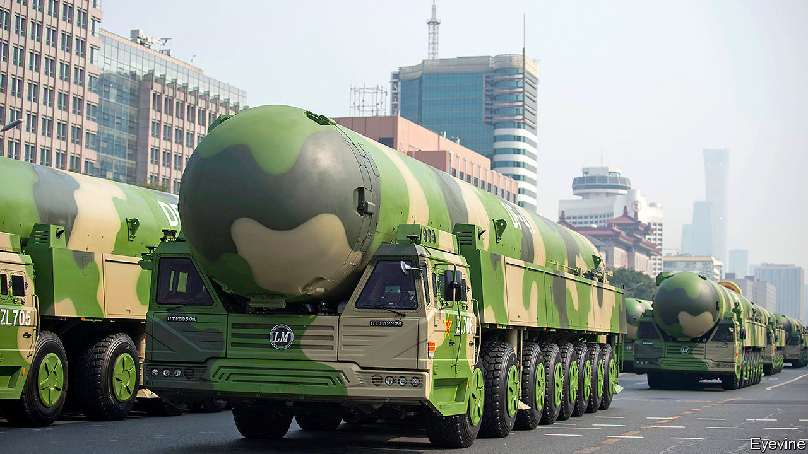

SINCE TESTING its first nuclear bomb 56 years ago, China has never revealed even a ballpark figure for the size of its arsenal. So recent debate on Chinese social media about the number of warheads the country ought to amass has been striking for its specificity. It began on May 8th with a suggestion by the editor of a nationalist tabloid in Beijing that China should expand its stockpile to 1,000 nuclear weapons. These, he said, should include 100 DF-41s, a new kind of intercontinental missile capable of hitting anywhere in America. Thousands of commentators have cheered him on. A few have called for more restraint.

America, while not welcoming such a build-up, would like it if China were to make its intentions so clear. It wants the country to end its obsessive secrecy and join America and Russia in setting limits to the size of their nuclear arsenals. The DF-41s, first displayed in public last October at a National Day parade in Beijing (see picture), are one reason why America is growing ever more keen to get China talking. They are China’s first missiles with such a range that can go on roads, making them more difficult for American weapons to knock out than ones fired from silos or fixed launchers. They can probably carry multiple warheads, making it even harder to protect America from their devastation.

By calling for such a build-up, Hu Xijin, the editor of the Global Times, appeared to give credence to Western estimates that China has far fewer than 1,000 warheads—about 300 is widely considered to be a reasonable guess. By contrast, America and Russia have around 4,000 apiece. But whereas those two countries, over the decades, have signed pacts to prune their arsenals, China has sat out arms-control. Its nuclear forces have been growing in size and sophistication, in part to ensure that they could survive a surprise strike from America’s increasingly accurate weapons. If America’s Defence Intelligence Agency is right, Mr Hu’s goal may not be far off. Last year the agency’s head, Lieutenant-General Robert Ashley, said that in the next decade China was likely to “at least double” the size of its stockpile in “the most rapid expansion and diversification” ever of its nuclear arsenal. Some experts believe that the growth rate is not as fast as he claims.

Last year America pulled out of a treaty with Russia banning medium-range missiles fired from land. It did so ostensibly because of Russian cheating, but the Pentagon made no secret of its desire to match China’s unchecked build-up of such weapons. Now China casts a shadow over the one nuclear pact that still binds America and Russia, the New START treaty. Signed in 2010, it caps “strategic” (ie, long-range) weapons and allows each side to inspect the other’s 18 times a year. It expires in February, but could be renewed if both agree.

Vladimir Putin, Russia’s president, says he is game. But Donald Trump and many of his advisers want China to sign up first. “The administration’s goal is to keep China’s stockpile from growing,” says Tim Morrison of the Hudson Institute, who served in Mr Trump’s National Security Council until October. American officials believe that if they renew the treaty too quickly, or for too long, China will feel no pressure to join. But neither America nor Russia wants to slash its arsenal to China’s level. That would leave the improbable idea of an unequal treaty—a phrase that in China recalls the reviled pacts that the country was forced to sign with colonial powers in the 19th and early 20th centuries.

In a recent report by the Institute for Peace Research and Security Policy at the University of Hamburg, David Santoro, Alexey Arbatov and Tong Zhao, experts from America, Russia and China respectively, suggest ways of breaking the impasse. Mr Zhao, who is a senior fellow at the Carnegie-Tsinghua Centre for Global Policy in Beijing, says a three-way deal could start with a cap on intermediate-range missiles, where China’s advantage in land-based rockets is offset by America’s edge in air-launched ones. Or it could cover all delivery systems (ground launchers, submarine tubes and bombers) with a reach longer than 500km. All three countries possess these in roughly equal numbers, unlike warheads, of which America and Russia have many more.

One incentive for China to agree to negotiate is the risk that, if it does not, New START will unravel. Mr Zhao says this would not only end limits to the American arsenal but also shroud it in secrecy. Each of the three countries might then base its actions on worst-case estimates of the others’ forces. That could drag China into a nuclear-arms race with the other two, says Mr Zhao—an economic burden that would be keenly felt by China as its economy slows.

There may also be diplomatic dividends for China should it enter talks. Doing so would “raise China’s status as a major global military power on a par with the two former superpowers”, says Mr Zhao. China may benefit in such negotiations by having Russia, a strategic partner, in the room. Both countries are deeply wary of America’s efforts to build missile defences.

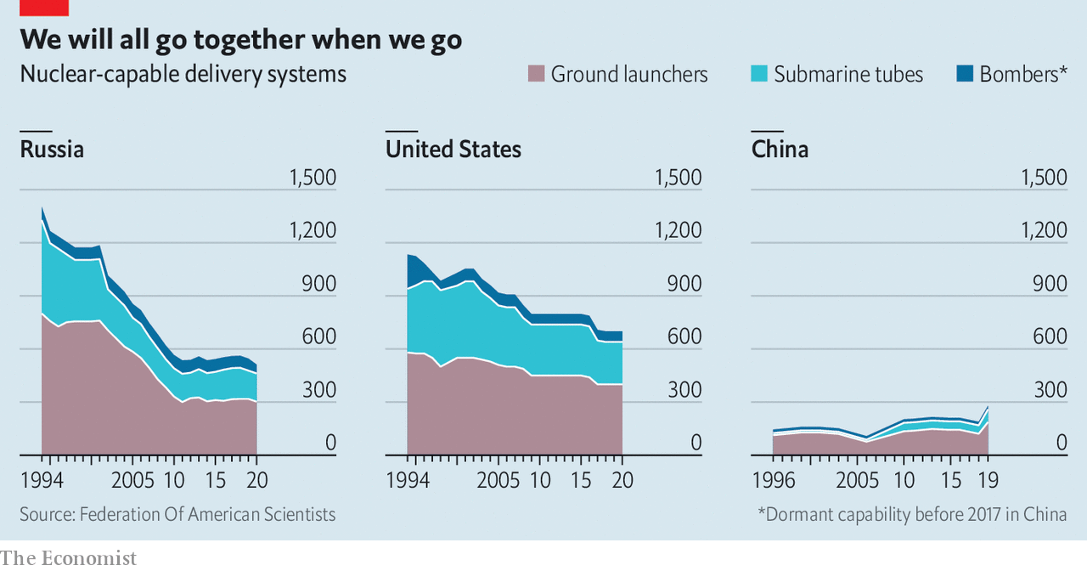

The problem, however, is that neither China nor Russia is keen on trilateral talks. On May 15th China again rejected the idea. This week Russia said that if America wanted to engage China on nukes, it should leave Russia out of it. In the past, Russian officials have said that if China were to join in, then Britain and France—American allies with 485 nuclear warheads between them—should be involved, too. In February Mr Trump agreed to a Russian proposal for a meeting of all five permanent members of the UN Security Council to discuss strategic matters. American officials said they would use the opportunity to press for new arms control. Such a forum would conveniently rope in China, as well as Britain and France. But if a trilateral dialogue would be hard, a pentalateral one would be a nightmare. None is scheduled.

Many experts think a more realistic approach would be for America and China to begin exploratory talks by themselves. America has long proposed such a “strategic nuclear dialogue”. China has demurred, for several reasons. It complains that whereas America accepts “mutual vulnerability” with Russia—an acknowledgment that each side can inflict terrible nuclear harm on the other—it refuses to do so with China. Many Chinese officials also fret that revealing the size or other details of their modest arsenal would make it even more vulnerable to a bolt from the blue.

One way to allay these fears would be to start small. All three countries could begin discussing the risks that arise from emerging technologies, from cyber-attacks on nuclear command-and-control networks to the use of artificial intelligence in early-warning systems. Rose Gottemoeller, a former American official, says America could invite China to a mock New START inspection to show how verification works. Or the two countries could agree to notify one another of missile tests, as America and Russia have done for decades. But it will be a long road. As Mr Zhao notes, China’s tradition of military secrecy is “deeply rooted”. Opening up will require trust. What little there is between China and America is being threatened by the pandemic. ■

This article was downloaded by calibre from <https://www.economist.com/china/2020/05/23/donald-trump-wants-china-to-join-a-nuclear-weapons-pact>

|  |  |  |  |
| --- | --- | --- | --- |
|  | Articles | Sections | Next |

|  |  |  |  |
| --- | --- | --- | --- |
| Previous | Articles | Sections | Next |

#### Brown elephants

# A glut of new coal-fired power stations endangers China’s green ambitions

Why build them when they struggle to sell their electricity?

May 21st 2020 |

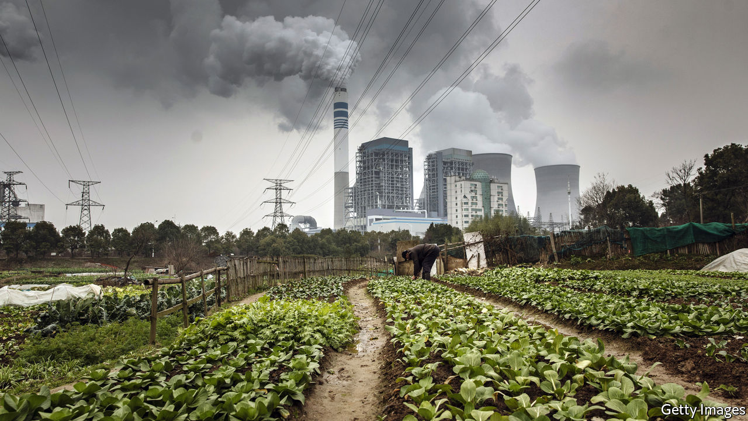

CHINA IS HOME to half the world’s coal-fired power stations, the most polluting type of generator. Their share of the country’s electricity market is shrinking as nuclear plants and renewables slowly elbow them off the grid. But Chinese investors and local governments are still keen on them. Last year coal-fired generating capacity expanded in China by 37GW (factoring in plant closures)—more than the amount by which it grew globally. China has been relaxing curbs on building such plants. That suggests more to come.

Work on many of the new coal-fired stations began after the central government gave local officials greater freedom to approve construction at the end of 2014. The aim was to cut red tape, not to ramp up the burning of coal. But it resulted in a blizzard of new permits. Within about a year provinces had approved enough new plants to expand China’s coal-powered generating capacity by a quarter.

China does not need a lot more power. Its economy is growing less energy-intensive as it relies less on manufacturing and construction. Lately coal-power plants have been able to sell less than half the electricity they are able to produce, down from 60% a decade ago. But local governments see any big construction project as a potential boost to growth. Some also have coal-mining industries to protect.

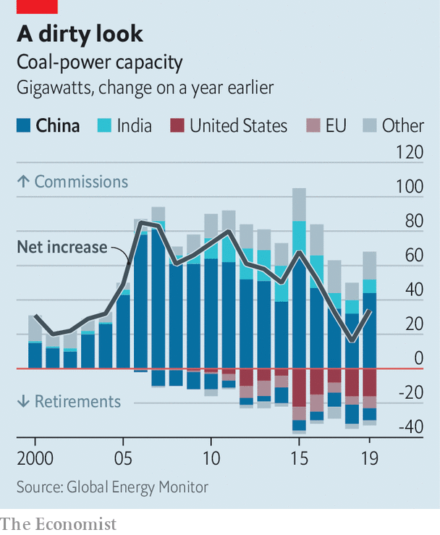

In 2016, recognising its mistake, the central government began clawing back the authority it had devolved to the provinces. But it worried that halting projects would threaten local economies, so it allowed many of those under way to proceed. Soon it began to relax curbs on the approval of new stations. In January China had 135GW of coal-power capacity either permitted or under construction, says Global Energy Monitor, an NGO in San Francisco. That is equal to about half the total coal-power capacity in America.

The new power stations will not be put to full use. They will face fierce competition from renewable energy. China’s capacity for producing this is also growing fast. Plants using coal risk limits on their output imposed by governments to improve air quality. Instead of increasing the total amount of electricity China gets from coal, new stations may simply pinch operating hours from existing ones.

That would be a problem for power-firms’ balance sheets. But the world may also suffer. China’s targets to reduce carbon emissions remain too low. The economic blow it has suffered as a result of covid-19 will deter it from making new pledges that could restrain its freedom to boost growth with the help of large and dirty building-projects. The glut of underused, debt-laden power stations could further weaken China’s emissions-cutting resolve.

By building so many new coal-fired plants, China has wasted money that could have been spent more greenly, and given vested interests more reason to try to delay its energy transition. The big state-owned firms that operate coal-burning generators are also being relied upon by the government to produce much of China’s renewable energy, notes Lauri Myllyvirta of the Helsinki-based Centre for Research on Energy and Clean Air. But they would rather not hasten the closure of carbon-spewing power stations that they had intended to keep working for a good three decades. ■

This article was downloaded by calibre from <https://www.economist.com/china/2020/05/21/a-glut-of-new-coal-fired-power-stations-endangers-chinas-green-ambitions>

|  |  |  |  |
| --- | --- | --- | --- |
| Previous | Articles | Sections | Next |

|  |  |  |  |
| --- | --- | --- | --- |
| Previous | Articles | Sections | Next |

#### Chaguan

# Educational freedom is under assault in Hong Kong

“There is no room for discussion,” says the education secretary

May 23rd 2020 |



AT LUNCHTIME ON May 14th a chat group for Hong Kong history teachers buzzed with reviews of this year’s school leavers’ examination. Their tone was upbeat, seeing no surprises in the history paper. That included Question 2(c), which, as in previous years, used extracts of historical documents to prod students to consider both sides of a controversial question. This year’s extracts explored how early 20th-century reformers in China looked to Japan as a model of modernisation and indeed attended Japanese colleges in their thousands. Hong Kong pupils study that period rather briefly, spending more time on the years when Japanese nationalism led to violent imperialism, including Japan’s brutal occupation of swathes of China in the 1930s and 1940s. The paper asked candidates to weigh the statement: “Japan did more good than harm to China in the period 1900-45”. Teachers saw a familiar exercise: an invitation to set out a conventional view—that on balance Japan inflicted terrible suffering—while exploring a few counterarguments. In the chat group someone remarked: “These questions are so similar to previous years.” Then the sky fell in.

Over the next two days the question was called unpatriotic by a teachers’ union loyal to Hong Kong’s ruling establishment (and by extension, to Communist Party leaders in Beijing). It was denounced by officials in mainland China and disowned by Hong Kong’s education bureau. As framed, the question risked leading students to a biased conclusion that would “seriously hurt the feelings and dignity of the Chinese people”, the bureau said. That language is straight from mainland propaganda manuals, though the bureau is the education ministry of a territory that was supposed to enjoy considerable freedom after it returned to China in 1997, under the slogan “one country, two systems”.

Kevin Yeung Yun-hung, Hong Kong’s secretary of education, called for the question to be expunged from the exam, unmarked. Japan did only harm to China, Mr Yeung thundered. “There is no room for discussion.” China’s state news agency, Xinhua, declared that if the question were not struck down, “the rage of all Chinese sons and daughters” would be unquenchable.

These expressions of wrath are ominous enough. But the focus of the establishment’s anger is still more alarming. Officials and pro-government politicians in Hong Kong do not deny the authenticity of the texts quoted in Question 2(c). No cries of “fake history” fill the air. Nor is anyone claiming that local students are ignorant of mainland China’s suffering under Japanese occupation. Indeed, all evidence points the other way. A study by Edward Vickers of Kyushu University in Japan compared Hong Kong’s schoolbooks from before and after the end of British rule. Already, publishers have quietly responded to calls to instil patriotic values, the study found. Post-handover textbooks expanded sections about Japanese militarism and added more photographs of notorious events, such as Japan’s massacre of civilians in Nanjing in 1937. Recent editions of a popular textbook dropped an exercise that urged pupils to remember Japan’s wartime occupation of Hong Kong, and added an exercise recalling horrors on the mainland.

Instead, the complaint from pro-establishment types is simpler. They say it was harmful for Question 2(c) to ask for nuance at all, when youngsters should be bowing to what Mr Yeung calls “the nation’s common understanding of history”. Such attacks on a single exam provide cover for a larger assault on Hong Kong’s education system, and its emphasis on critical thinking. It is no accident that government loyalists pounced on Question 2(c) just days after the territory’s chief executive, Carrie Lam, declared that without stricter regulation, Hong Kong’s schools and colleges would resemble a “doorless chicken coop”, leaving the young unprotected from foreign infiltrators and false ideas. Ms Lam expressed special disdain for what educators in Hong Kong call “liberal studies”, namely secondary-school lessons promoting critical thinking and civic consciousness. The territory’s ruling elite blames liberal studies for fuelling student protests last year. That same elite had backed the subject’s introduction in 2009, fearing that rote learning was eroding the territory’s dynamism.

## Learning to obey

One of Ms Lam’s predecessors, Leung Chun-ying, announced that a website for pro-government tip-offs now offers rewards for reports about teachers who spread dangerous ideas. A history teacher describes a mood of growing insecurity. “Since teacher training I have been told to promote critical thinking. And now the education secretary tells me that some things cannot be discussed.” Bringing the young to heel will be a long and unhappy struggle, she predicts. “It is going to take at least ten years. They will have to indoctrinate them from primary school or kindergarten.”

Chaguan spoke this week to four teenagers who took the history paper causing all the fuss. Earnest and shyly twisting their headphone cables during a group Zoom interview, the students made clear that as they walked into their exam they saw exploring all sides of a historical question mostly as a step required to gain full marks. Yet now that others have politicised Question 2(c), they are ready to defend a quest for balance as a matter of principle.

One student said she had been pondering a history major, and possibly a teaching career. But seeing her own teachers self-censoring, she is having second thoughts. A second teenager moved from the mainland eight years ago. Frightened of how Hong Kong’s schools are becoming breeding grounds for protesters, her parents sent her younger sister to school on the mainland. A boy recalled rows with his pro-government parents, who dismiss liberal studies as “brainwashing”. It would hurt society if the young were less capable of independent thought, he argued. But maybe, he wondered, political leaders want a society that is easier to govern. That is a bitter lesson to draw from a school leavers’ exam. Alas, all signs are that Hong Kong’s youngsters have more harsh lessons ahead. ■

This article was downloaded by calibre from <https://www.economist.com/china/2020/05/23/educational-freedom-is-under-assault-in-hong-kong>

|  |  |  |  |
| --- | --- | --- | --- |
| Previous | Articles | Sections | Next |

|  |  |  |
| --- | --- | --- |
| China | Sections | Europe |

Middle East & Africa

Egypt’s economy: Riders wanted

.

Iran’s bourse: A bizarre bazaar

.

Israel and the Palestinians: Nice while it lasted

.

Félicien Kabuga: The man who wasn’t there

.

The African School of Economics: Lessons from Leonard

.

|  |  |  |
| --- | --- | --- |
| China | Sections | Europe |

|  |  |  |  |
| --- | --- | --- | --- |
|  | Articles | Sections | Next |

#### Ahead of the covid curve

# Egypt chose a looser lockdown. Its economy is still in crisis

Other Arab states will face similar problems

May 23rd 2020 | BEIRUT



THERE WAS never much chance of social distancing in Cairo, a city more populous than most countries. Buses fill to overflowing, passengers dangling out of open doors. Millions live in informal settlements with streets barely wide enough for a sedan. And indeed, unlike many other Arab countries, Egypt did not try to impose a strict lockdown. There is a night-time curfew; busy spaces like restaurants and cafés are shut. But public transport is running, factories are humming and shops keep at least limited opening hours.

So far, Egypt has dodged a devastating outbreak. Confirmed cases—about 14,000 on May 21st, in a country of 100m—are an unreliable measure. Data suggest the government is testing only about 30,000 people a week (it does not release exact figures). Some Egyptians who test positive are told that relatives living in the same house cannot be swabbed unless they show symptoms. But the death toll, a more reliable measure, is less than seven per 1m citizens, below some wealthy Gulf states, to say nothing of hard-hit countries such as Britain (over 500 per 1m citizens).

The looser lockdown has not spared Egypt an economic crisis, however. The private sector, weak to start, is in free fall: the purchasing managers’ index crashed from 44.2 in March to 29.7 in April, an all-time low (anything below 50 suggests a contraction). Export orders fell even faster. Big sources of foreign currency are particularly vulnerable to a downturn. Citizens were already struggling after years of political turmoil and austerity; the state lacks the resources and reach to deliver large amounts of aid. Egypt may be first, but similar problems will clobber the Arab world’s other non-oil states in the coming months.

First to suffer was tourism, which employs one in ten Egyptians. Last year foreign visitors brought in $13bn, about 5% of GDP (see chart). With airports closed since March, revenue is now zero. The national carrier, Egyptair, had hoped to resume international flights in June, but the government has extended the closure indefinitely. Desperate to snag some cash, hotels have started to reopen (at a maximum 25% occupancy) for domestic tourists, but they spend a lot less than foreigners.

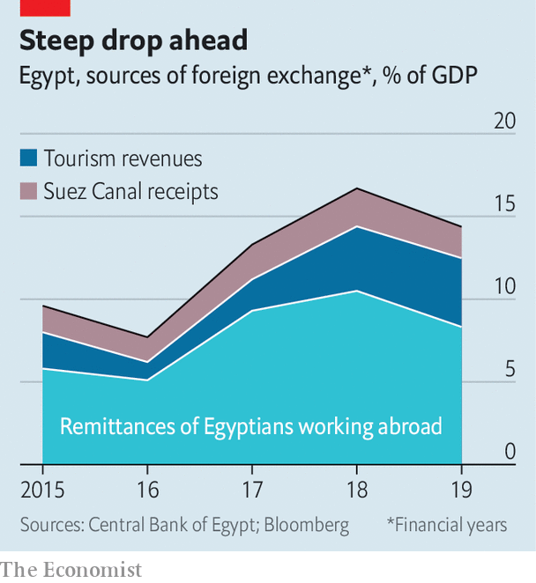

A larger concern is the 3.4m Egyptians who work overseas. In 2019 Egypt was the fifth-largest recipient of remittances: $27bn, about 9% of GDP. It is too early to say how far that number will fall, but the World Bank estimates that global remittances could drop by 20% this year. More than half of Egyptian expats work in the Gulf states, which have begun widespread salary cuts and lay-offs driven by low oil prices.

Even the Suez canal, which collects a reliable $5bn-6bn in annual transit fees, could take a hit. Fully laden vessels can pay almost $1m to sail through it. They pay the toll because the alternative is to sail thousands of miles round Africa. But low oil prices mean fuel is cheap, and weak global demand means ships are in no hurry to make port. Almost two dozen vessels sailing to and from Asia have skipped the canal and gone the long way. The canal authority has lowered fees to stay competitive.

Foreign reserves, which plunged after the revolution in 2011, had recovered to a comfortable $45bn in February. They are now dropping again, to $37bn at the end of April, as the state covers loan repayments and portfolio outflows. Fitch, a ratings agency, thinks they will hit $31bn this year. It sees the current-account deficit widening to 5.3% of GDP, up from 3.6% last year.

Bankers estimate that Egypt will need at least $10bn in external financing. It has already turned to the IMF. Last year it finished a three-year, $12bn IMF programme that trimmed the deficit to 8% of GDP, from 12% three years earlier. The fund has already approved $2.8bn in new emergency financing and is in talks for a standby loan of up to $5bn more.

Still, the state has limited firepower to help those struggling. Civil servants and pensioners will receive a modest pay bump. But many will have to give back 1% of their monthly income in a new “corona tax”. Thousands of families were added to the main cash-transfer schemes, which reach 10% of the population. The central bank has earmarked 50bn pounds ($3.2bn) for soft loans to help tourist businesses. They carry two-year repayment terms; travel agents think it will take at least that long for the sector to rebound. Informal workers generate perhaps half of GDP. Most are now idled. The government promised them 500 pounds a month for three months—less than half the average weekly wage. Charities are distributing twice as many food boxes this Ramadan as last year.

Business is slumping. Many big firms reported soft sales in the first quarter, which captures only the early weeks of the pandemic. GB Auto, a car giant, saw revenue fall by 4.1% compared with 2019. Edita, a snack firm, reported a 44% drop in year-on-year profits. Billboards along Cairo’s main roads, which should be full of advertisements aimed at Ramadan shoppers, are blank. Sensing a growing unease, the government has stifled any criticism.

Other Arab states are emerging from lockdown into the same problems. Although Egypt’s tourism revenues are large in absolute terms, the sector in Tunisia, Lebanon and Jordan is bigger as a share of GDP. The latter two also depend heavily on remittances. All three have lower long-term credit ratings than Egypt (none worse than Lebanon, which defaulted in March). Egypt was astute to ask the IMF for early help: its neighbours are not far behind. ■

Editor’s note: Some of our covid-19 coverage is free for readers of The Economist Today, our daily [newsletter](https://my.economist.com/user#newsletter). For more stories and our pandemic tracker, see our [hub](https://www.economist.com/news/2020/03/11/the-economists-coverage-of-the-coronavirus)

This article was downloaded by calibre from <https://www.economist.com/middle-east-and-africa/2020/05/23/egypt-chose-a-looser-lockdown-its-economy-is-still-in-crisis>

|  |  |  |  |
| --- | --- | --- | --- |
|  | Articles | Sections | Next |

|  |  |  |  |
| --- | --- | --- | --- |
| Previous | Articles | Sections | Next |

#### A bizarre bazaar

# Why Iran has the world’s best-performing stockmarket

Investors don’t seem to mind sanctions, disease or a shrinking economy

May 23rd 2020 |

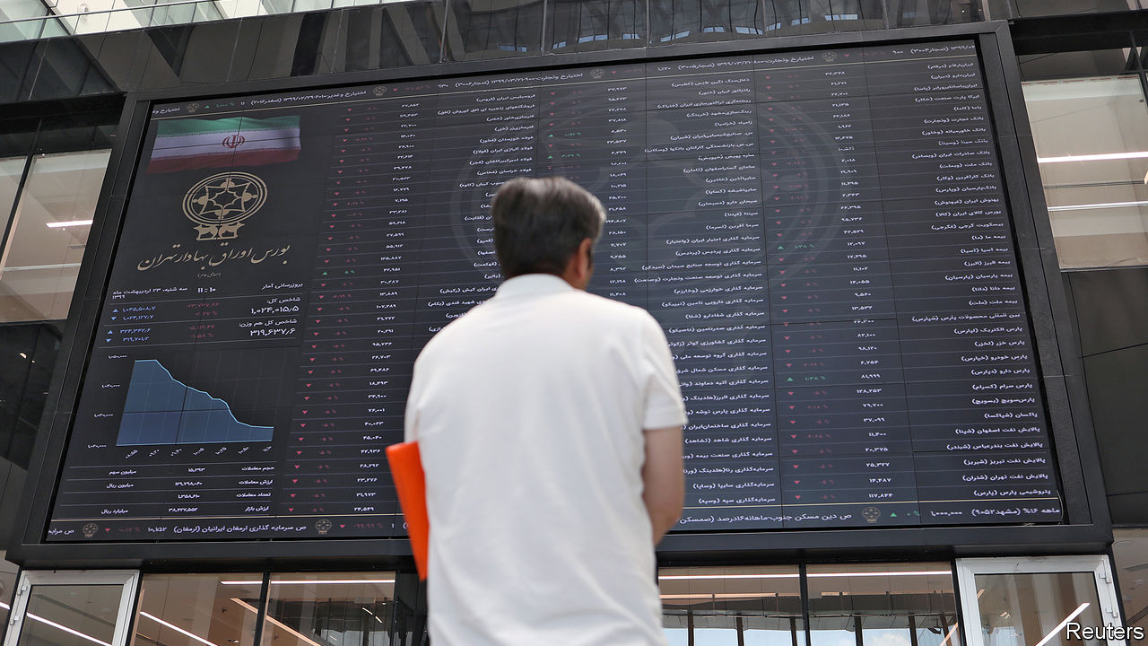

THERE SEEMS to be no end to Iran’s suffering. It has struggled with one of the world’s worst outbreaks of covid-19. As it opens back up there are signs that it is being hit by a powerful second wave. Last year the economy shrank by almost 8%. It may do worse this year. American sanctions had largely cut if off from the global market. The coronavirus has just about finished the job.

Yet, somehow, the Iranian stockmarket is booming. Its main index, the Tedpix, has soared tenfold in two years in local currency terms, and doubled since Iran declared a lockdown on March 27th. Even when measured in hard currency it is the world’s best-performing index. “In three years we’ve tripled our euro value,” says Maciej Wojtal, who manages Europe’s only fund focused on Iran’s market.

The main reason it is booming is that Iranians have few other places to put their cash. With inflation above 30% and the value of the Iranian rial dropping, there is little incentive to open a savings account at home. The government makes it hard to buy foreign currencies; American sanctions put stockmarkets abroad out of reach. Some Iranians buy land or cars, but prices are too high for most.

Even novices are getting in on the action. In April the authorities allowed Iranians to trade their “justice shares”—holdings in state firms which the government gave to poor people years ago. Daily trading volumes have risen from around $100m to $400m in two years.

Iran’s leaders encourage the activity, anxious to sustain hope in an otherwise dire situation. They also see an opportunity to raise state revenues hit hard by sanctions. The government recently listed an exchange-traded fund with government stakes in banks and financial institutions and may soon do the same with its mining, steel and petrochemical holdings. (None of this actually improves the companies, mind.)

Hassan Rouhani, the president, sees the boom as a matter of national pride. “As Iran’s bourse has developed, [our enemies] become nervous,” he says. But experienced investors and even some officials worry about a bubble that could burst and lead to unrest. Mr Wojtal sold half his holdings in March.

This article was downloaded by calibre from <https://www.economist.com/middle-east-and-africa/2020/05/23/why-iran-has-the-worlds-best-performing-stockmarket>

|  |  |  |  |
| --- | --- | --- | --- |
| Previous | Articles | Sections | Next |

|  |  |  |  |
| --- | --- | --- | --- |
| Previous | Articles | Sections | Next |

#### West Bank job

# How fast will Israel’s new government proceed with annexation?

A period of co-operation with the Palestinians may be coming to an end

May 23rd 2020 | JERUSALEM

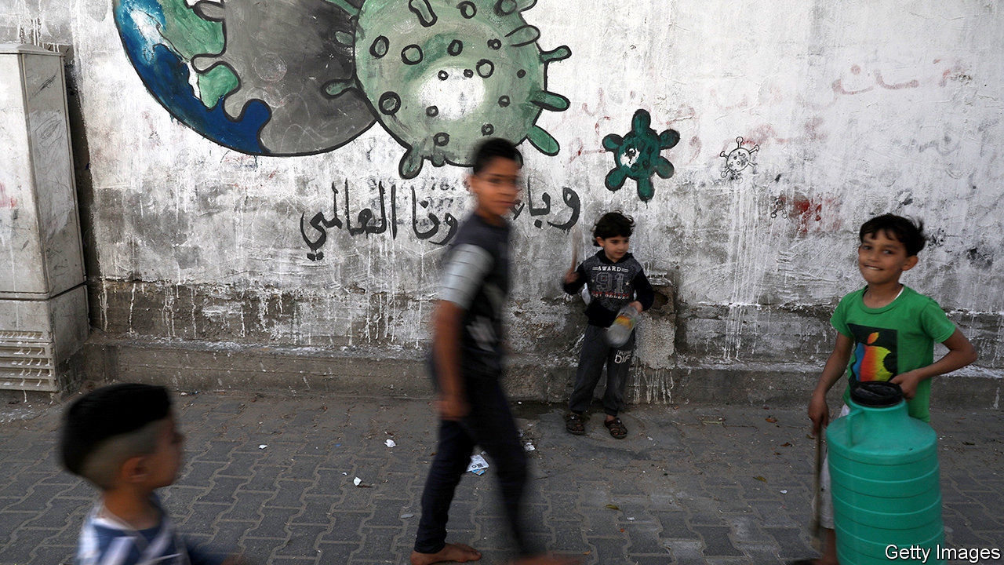

IT HAS BEEN six years since Israeli and Palestinian leaders last talked to each other. There is no end in sight to the decades-old confrontation between the two sides. But the outbreak of covid-19 has at least led to “inspiring examples” of co-operation, says Nickolay Mladenov, the UN’s envoy in the region. On May 19th, for example, Israel allowed a plane from the United Arab Emirates, with which it does not have formal relations, to deliver medical supplies to the Palestinians. Israel itself has trained Palestinian medics and ensured that testing kits and protective gear reach the occupied territories. It is also planning a loan for the Palestinian Authority (PA), which runs the West Bank. “The recognition of this interdependence could—if there is political will—translate into tangible progress towards resolving the conflict,” Mr Mladenov says hopefully.

Yet a new government in Israel, sworn in on May 17th, may bring this period of co-operation to an end. After three elections and over a year of political deadlock, Binyamin Netanyahu, the prime minister, reached a deal with his former rival, Benny Gantz, to share power. Mr Netanyahu will stay in the top job until November 2021, when Mr Gantz (currently the “alternate prime minister”) will take over. The big question is how will they proceed with annexation. Mr Netanyahu has promised to extend Israeli sovereignty over chunks of the West Bank that the Palestinians see as part of their future state. According to the coalition agreement, he can hold a vote on annexation in the cabinet or parliament any time after July 1st. America must also approve any move.

Donald Trump, America’s president, gave Mr Netanyahu a push in January when his administration released a peace plan that would have Israel maintain control of all of Jerusalem and take parts of the West Bank, where Israel has dozens of settlements, and all of the Jordan Valley (see map). In his inaugural speech Mr Netanyahu sounded eager “to write a glorious new chapter in the history of Zionism”. But currently he is focused on restoring “jobs, jobs, jobs” to an economy hit hard by the virus—and fighting corruption charges in a trial that begins on May 24th. He has not specified a timetable for annexation, and when he spoke to his new ministers he didn’t list it as a priority. “It was a good election gimmick for Netanyahu to rally his base,” says a minister. “And it worked. But I don’t think he’s going to go through with it. Perhaps he’ll make do with a symbolic annexation of a couple of settlements.”

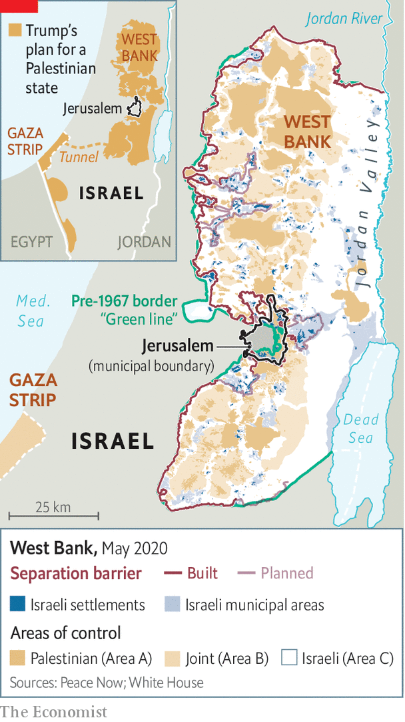

Mr Netanyahu’s new partners are also sounding cautious. Gabi Ashkenazi, the foreign minister (and an ally of Mr Gantz), says the Trump plan is a “historic opportunity”, but that Israel will proceed “responsibly, in co-ordination with the United States, while safeguarding peace agreements and Israel’s strategic interests”. Mr Ashkenazi is concerned about Jordan, which is at peace with Israel and is home to millions of Palestinians. King Abdullah of Jordan worries that annexation would kill any hope of a two-state solution and stir up his own Palestinian subjects.

Mr Netanyahu’s supporters want him to push ahead while Mr Trump is still in office. Lately, though, the White House, under pressure from Arab leaders, has sounded less gung-ho about annexation. When Mike Pompeo, America’s secretary of state, visited Israel on May 13th, he said Mr Netanyahu and Mr Gantz, a former army chief who opposes unilateral annexation, “will have to find the way forward together”. Israeli diplomats say the administration has asked Mr Netanyahu to put things on hold, for now. Some on the Israeli right hope that Mr Trump, who is up for re-election in November, may yet push for annexation in order to win over evangelicals and right-wing Jewish voters.

The Palestinians, for their part, are outraged. Mahmoud Abbas, their president, says the annexation clause in the Israeli coalition deal means the PA is no longer bound by its agreements with Israel. He has made such statements before, but never followed through by, for example, ending security co-operation. Joint action against the outbreak continues. The death rate from covid-19 has been low on both sides. “I can work with my Israeli colleagues against the coronavirus for the health of my people,” says a Palestinian doctor. “It doesn’t change the ugly reality of occupation.” ■

This article was downloaded by calibre from <https://www.economist.com/middle-east-and-africa/2020/05/23/how-fast-will-israels-new-government-proceed-with-annexation>

|  |  |  |  |
| --- | --- | --- | --- |
| Previous | Articles | Sections | Next |

|  |  |  |  |
| --- | --- | --- | --- |
| Previous | Articles | Sections | Next |

#### A genocide suspect faces trial

# Félicien Kabuga, Africa’s most wanted man, is arrested

But questions remain over how the Rwandan evaded the law for so long

May 23rd 2020 | NAIROBI

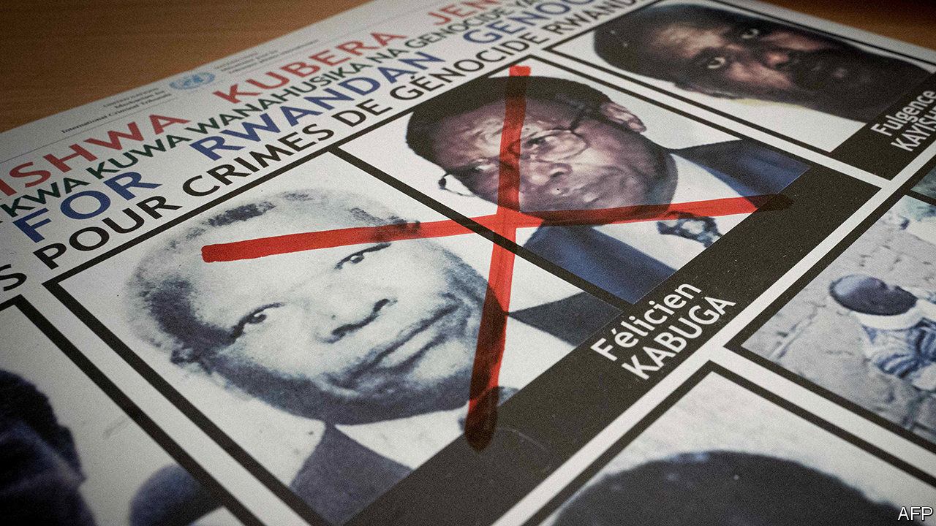

THE TRAP had been set. American and Kenyan investigators were in position outside a house in a smart Nairobi suburb. But Rwanda’s most notorious fugitive never showed up. When police finally burst in two days later they found not their target, Félicien Kabuga, but blood-spattered walls and the partially acid-dissolved corpse of William Munuhe, an FBI informant. An enterprising hack, Munuhe had promised to lure Mr Kabuga to his house under the pretext of discussing a business deal in exchange for the $5m reward promised by the State Department.

That was in 2003. For 17 years, Mr Kabuga, seen as a bankroller of the genocide in which perhaps 500,000 Rwandans were murdered in 1994, remained elusive. On May 16th police raided a flat on the northern outskirts of Paris. Inside they found a shuffling 84-year-old who had outwitted police forces all over the world for almost 25 years. “He was our Klaus Barbie, our Eichmann,” Reuters quoted Etienne Nsanzimana, the head of a group for genocide survivors living in France, as saying.

Mr Kabuga, once one of Rwanda’s richest men, faces three main accusations. First, in the months before the genocide, his company allegedly imported hundreds of thousands of machetes, the weapon of choice during Rwanda’s 100 days of slaughter. These were then doled out to the Interahamwe, the Hutu militia responsible for much of the killing. Second, Mr Kabuga is accused of having financed the Interahamwe, supplying uniforms and vehicles. Finally, he allegedly provided the genocide’s soundtrack. Radio Mille Collines, the station he partly owned, referred to Rwanda’s Tutsi minority as “cockroaches” and urged their neighbours to kill them all.

Most people had given up the idea of ever catching Mr Kabuga. The International Criminal Tribunal for Rwanda, which indicted 93 genocide suspects (including Mr Kabuga) and convicted 62 of them, wound up in 2015. But last year eight Western countries mounted a fresh mission to find him. Surveillance operations against Mr Kabuga’s 11 children in Britain, France and Belgium eventually led to his discovery in Asnières-sur-Seine.

Yet uncomfortable questions remain. How did Mr Kabuga escape detection for so long? Osama bin Laden skulked in caves and a nondescript house in Pakistan. Radovan Karadzic donned a beard and eked out a living selling quack medicine. But Africa’s most-wanted suspected génocidaire seems to have swanned around the world at will. At various times he lived in Switzerland, Germany, Belgium, the Democratic Republic of Congo and Kenya, as well as France, where the police say he had 28 aliases.

Some questions will be directed at Kenya. Much of Mr Kabuga’s time was spent there, almost certainly with the connivance of officials. Attempts to nab him in Nairobi in 1997, 2003 and 2008 came to naught. Instead, detectives would find a note on a kitchen table warning Mr Kabuga to get out—or find a corpse. In 2002 Pierre-Richard Prosper, America’s then special ambassador for war crimes, accused a Kenyan official of harbouring him, which the official denied.

Human-rights activists suggest that as recently as 2016 Mr Kabuga may have lived in the Kenyan town of Eldoret. By then, however, American investigators had given up trying to catch him, fearing that other informants could end up like Munuhe. Those trying to uncover who harboured Mr Kabuga will probably not get much help from Kenya, where the president and deputy president have both had run-ins with the International Criminal Court. ■

This article was downloaded by calibre from <https://www.economist.com/middle-east-and-africa/2020/05/23/felicien-kabuga-africas-most-wanted-man-is-arrested>

|  |  |  |  |
| --- | --- | --- | --- |
| Previous | Articles | Sections | Next |

|  |  |  |  |
| --- | --- | --- | --- |
| Previous | Articles | Sections | Next |

#### No-frills education

# Trust, slavery and the African School of Economics

Leonard Wantchekon is trying to build a world-class university in Benin

May 23rd 2020 | ABOMEY-CALAVI

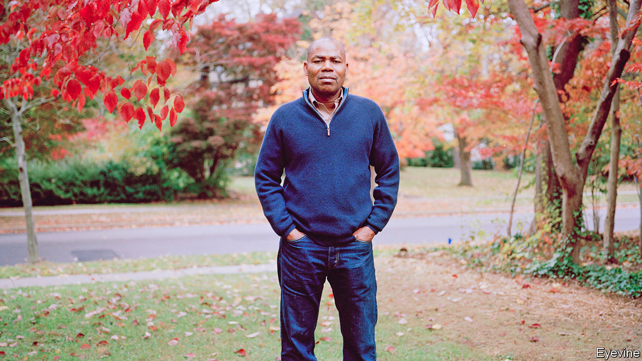

AS LEONARD WANTCHEKON was having breakfast with his wife, Catherine Kossou, in 2007, she recalled how one friend could not trust anyone. Even as a child her friend would say: “That person is going to sell you,” or “He will make you disappear.”

The words struck a chord with Mr Wantchekon. Now a professor at Princeton University, he was born in Zagnanado in central Benin. Some of the music he listened to in his youth—such as that of Orchestre Poly-Rythmo de Cotonou—had songs that warned against trusting those close to you.

He wondered: “Does this have something to do with slavery?” Benin was a hub of the slave trade. More than 1m people were trafficked from the interior to the port of Ouidah, and then to America, Brazil or the Caribbean. Alongside Nathan Nunn of Harvard University, Mr Wantchekon looked for a relationship between the intensity of the slave trade and low levels of trust (and thus commerce). He found one. The resulting article is in the top 1% of most-cited economics papers.

The story of the paper has broader relevance, explains Mr Wantchekon (pictured). It was his data-mining skills that helped him find the answer. But it was his Beninese background that raised the question.

Mr Wantchekon is one of just a few African economists at elite Western universities. Most scholarship about Africa is done by academics who are neither African-born nor based in Africa. Influential development journals have few African scholars on their boards. Most major conferences about Africa do not take place there.

The imbalance is partly a result of bias in overseas universities. But it is also because of conditions at African ones. Higher education is not a priority for politicians, who often send their children abroad, or donors, who prefer to fund schools. The result is underfunded and overcrowded universities that do not equip enough African graduates with the skills required to get into world-class doctoral programmes.

The consequence is a profound loss, argues Mr Wantchekon. Countless young African intellectuals do not get a fair chance. The world gets a skewed picture of African countries because many of the best researchers come from elsewhere.

That may be changing. In 2014 Mr Wantchekon founded the African School of Economics in Abomey-Calavi, Benin. Its aim is to offer African students the highest standards of mathematics and economics teaching, ensuring they can compete with graduates overseas.

It is refreshingly drab, with no splurging on a flashy campus or needless technology. The 100 or so students pay $2,400 per year, about the same as at a public university. “This is not about doing something grandiose,” says Mr Wantchekon. It is a model that can be replicated. Another campus was opened this year in Ivory Coast.

The school draws on several influences. The name nods to the London School of Economics. Princeton is one of more than a dozen “academic partners”. But another institution serves as an inspiration, too.

Mr Wantchekon’s home town had one of the first schools set up by missionaries in Benin. Its presence changed the lives of many young people—and not just pupils. Studies by Mr Wantchekon and others have shown that the effects of missionary schools were felt broadly. Even children of villagers who did not go to the schools did better in life, a result of higher aspirations and a better-educated social network. Mr Wantchekon believes that his new school of economics can have widespread knock-on effects as well.

The journey of the son of two illiterate farmers from rural Benin to the Ivy League is remarkable. But so is the detour. After enrolling at university Mr Wantchekon became an activist, campaigning against Mathieu Kérékou, a dictator who ruled for nearly 30 years. He lived on the run for five years before being arrested in 1985.

A year and a half later, after charming prison guards and exaggerating his arthritis to get treatment outside the prison, Mr Wantchekon escaped. He crossed the border to Nigeria and, after a brief spell in Ivory Coast, became a refugee in Canada. He returned to his studies, completing a PhD at Northwestern University under the mentorship of Roger Myerson, a Nobel laureate, who describes him as “one of the best students I ever had”.

Mr Wantchekon retains a fascination for African politics. He has written about the conditions under which warlordism can turn into democracy. He has co-written probably the only studies in which presidential candidates running in elections have subjected themselves to randomised controlled trials. These have found that, while promises of patronage are powerful in swaying voters, as cynics suggest, there are caveats. Women are less wooed by patronage, for example. And when candidates held town-hall meetings to discuss policy platforms, voters became more likely to vote on the basis of education and health rather than handouts.

Another result of Mr Wantchekon’s political past is a preference for empiricism over ideology. A trip to Albania ended his blind affection for socialism. His school is not part of efforts to “decolonise” the African academy. Any student of politics must read Rousseau and Madison, he argues. The aim is to add to the sum of human knowledge, not subtract from it. “Be angry but also be thoughtful,” he says. ■

This article was downloaded by calibre from <https://www.economist.com/middle-east-and-africa/2020/05/23/trust-slavery-and-the-african-school-of-economics>

|  |  |  |  |
| --- | --- | --- | --- |
| Previous | Articles | Sections | Next |

|  |  |  |
| --- | --- | --- |
| Middle East & Africa | Sections | Britain |

Europe

Russia and covid-19: The anatomy of lies

.

Bailing out Europe: Not quite Hamiltonian

.

Tourism: We aren’t off to sunny Spain

.

Indigenous rights: Sami difference

.

Charlemagne: The wizards of Luxembourg

.

|  |  |  |
| --- | --- | --- |
| Middle East & Africa | Sections | Britain |

|  |  |  |  |
| --- | --- | --- | --- |
|  | Articles | Sections | Next |

#### Anatomy of lies

# Russia’s covid-19 outbreak is far worse than the Kremlin admits

Like its Soviet predecessor, Vladimir Putin’s system is steeped in falsehoods

May 21st 2020 |

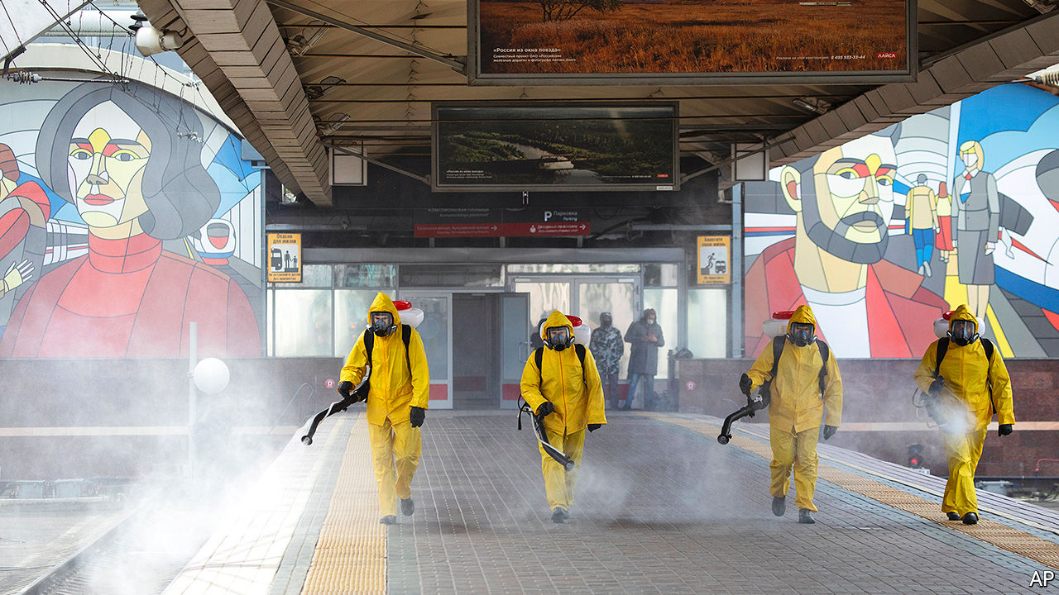

Editor’s note: Some of our covid-19 coverage is free for readers of The Economist Today, our daily [newsletter](https://my.economist.com/user#newsletter). For more stories and our pandemic tracker, see our [hub](https://www.economist.com/news/2020/03/11/the-economists-coverage-of-the-coronavirus)

RUSSIA IS MORE successful in fighting covid-19 than the West, thanks to its superior health-care system and excellent leadership. Though faced with one of the highest rates of infection, its fatality rate is a seventh of that in most countries. That is, if you believe Russian statistics.

Few independent experts do. Russia has officially recorded just over 300,000 cases of covid-19 and 2,900 deaths, which makes its fatality rate less than 1%, compared with 4.5% in Germany and 14% in Britain. Yet the fatality rate among Russia’s front-line health professionals, who keep their own records, is about 16 times as high as in comparable countries, which suggests that the official figures are much too rosy.

Nonetheless, these were the figures that on May 11th led Vladimir Putin, Russia’s president, to order an end to a period of “non-working days”, a euphemism for a national lockdown that he never officially declared. Although he transferred responsibility for retaining restrictions to regional authorities, he signalled that Russia was through the worst. “We must give thanks to our doctors and our president, who works day and night to save lives,” Vyacheslav Volodin, the speaker of the Duma, declared.

The Russian government was upset when, on the same day, the Financial Times reported that the real death toll could be 70% higher; the New York Times quoted an expert as saying it could be nearly three times the official tally. These estimates were derived by calculating excess deaths. One member of the Duma demanded that the journalists’ accreditation be revoked. Kremlin mouthpieces denounced what they called an orchestrated attack on Russia by the West.

Meanwhile, some Russian doctors on social media say they were told to keep numbers low by including in the covid statistics only those who died directly of the disease, not those who had underlying conditions that might have contributed to their demise. Victims’ relatives are furious.

Adding weight to the suspicion are the improbable figures posted by some regions. For example, in Krasnodar, a region with 5.2m people, the number of reported infections has fluctuated only minutely, between 96 cases and 99 cases a day for the past two weeks. Statistically speaking, that is extremely unlikely.

Several other regions have produced odd statistics. They show the number of infections recorded in regional centres and those recorded in adjacent territories fluctuating in opposite directions, thus balancing each other out and producing a straight line of cases across the region.

The official numbers reveal less about covid-19 than they do about Russia’s political system, which, like its Soviet predecessor, is saturated with lies. Russian elections throw up similarly strange graphics. Many Russian athletes during the Sochi winter Olympics in 2014 took performance-enhancing drugs, and their cheating was covered up by secretly swapping urine samples with official connivance.

Konstantin Sonin of the University of Chicago says the problem is not that the Kremlin hides or distorts figures, but that it often does not have them in the first place. Most regional bigwigs are not accountable to voters but are entirely dependent on the Kremlin for status and money. They file rosy reports so as to appear to be meeting official targets. The aim is to please the president, not the people. “The Kremlin does not even need to tell them what figures to report; they know to report what the Kremlin likes to hear,” he says.

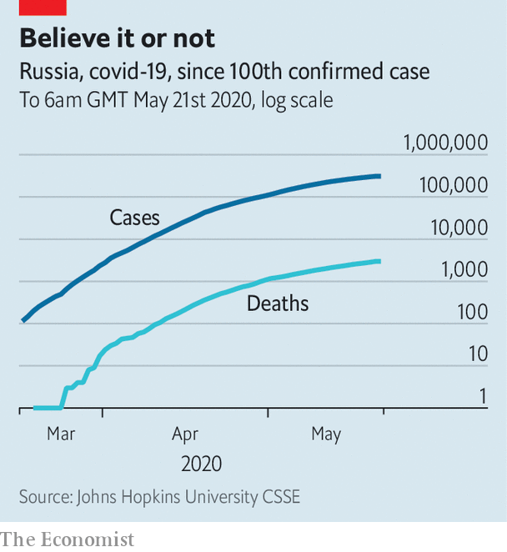

Over the past few weeks Russian state television has provided a perfect illustration of this system. In the West officials have at least tried to communicate with their electorates and the media. On Russian television people see their officials reporting to the self-isolated Mr Putin via a videoconference screen. The screen resembles a Russian Orthodox icon: Mr Putin is displayed in a large central box, surrounded by 12 “apostles” in smaller boxes.

Yet this manufactured image is starting to crack. Mr Putin’s ratings have dropped to historic lows in recent weeks. On May 17th the health minister in Dagestan, a Russian territory of 3m people in the North Caucasus, told a local blogger that the true number of infections on his patch was four times that reported, and that outbreaks of pneumonia had killed 657 people, not the officially recorded 27. Fully 40 medics had died of it. Mr Putin blamed citizens for trying to treat themselves at home.

Some big cities have been more open than the Kremlin. Moscow admitted that the real number of cases could be significantly higher than officially reported, and retained a lockdown.

The Kremlin’s handling of the crisis reminds some of the cover-up of the Chernobyl nuclear disaster, which prompted Mikhail Gorbachev, the Soviet leader, to launch glasnost, a campaign for more openness. “The whole system is penetrated by the spirit of bootlicking, persecution of dissidents, clannishness, window-dressing. We will put an end to all this,” Mr Gorbachev told his politburo at the time. Mr Putin, who began his presidency 20 years ago by covering up the sinking of the Kursk submarine, is determined not to repeat the glasnost experiment, which helped to bring the whole system crashing down. ■

This article was downloaded by calibre from <https://www.economist.com/europe/2020/05/21/russias-covid-19-outbreak-is-far-worse-than-the-kremlin-admits>

|  |  |  |  |
| --- | --- | --- | --- |
|  | Articles | Sections | Next |

|  |  |  |  |
| --- | --- | --- | --- |
| Previous | Articles | Sections | Next |

#### Who will pay for the pandemic?

# The Merkel-Macron plan to bail out Europe is surprisingly ambitious

Germany is making a big concession to support weaker states

May 21st 2020 | BERLIN AND PARIS



“IN EVERY BEGINNING dwells a certain magic,” beamed Angela Merkel, cribbing from Herman Hesse, when a freshly inaugurated Emmanuel Macron visited Berlin three years ago. But Germany’s chancellor added an earthy caveat: “The magic lasts only when there are results.” And there have been precious few to speak of. A plan to reboot the euro area was ground down to a budget of homeopathic insignificance. A revised Franco-German treaty substituted symbols for substance. Mrs Merkel and Mr Macron fell out on everything from Brexit to the Balkans. Europe’s “locomotive” was left idle in the sidings.

So the ambition of the two leaders’ proposal for a post-covid EU recovery plan, unveiled on May 18th, came as a genuine surprise. The plan, mainly thrashed out in three videoconferences between the pair, comprises four pillars, including boosting the EU’s health-care capabilities and its economic “sovereignty”, a pet theme for Mr Macron. But at its heart is a recovery fund worth €500bn ($546bn), or 3.6% of the EU’s GDP, to be financed by common borrowing and sitting inside the club’s seven-year budget (“multiannual financial framework”, or MFF). Italy and Spain immediately signed on. Markets surged and Italian borrowing costs fell. French media, often hostile to Mr Macron, were cock-a-hoop.

Mr Macron would have preferred a larger fund, preferably operating outside the MFF. But by far the bigger compromise is Mrs Merkel’s. As covid-19 ripped through Europe, the chancellor resisted calls to lend Germany’s full weight to collective efforts to support the hardest-hit countries. France led a nine-country push for joint and severally guaranteed “coronabonds”, but Peter Altmaier, Germany’s economy minister and a Merkel confidant, dismissed it as a “phantom debate”.

That has not changed. Under the new plan governments’ liabilities would be limited to guarantees equivalent to their contribution to the MFF (Germany’s 27% share would leave it on the hook for €135bn). Yet German support for EU debt incurred on this scale is “an enormous shift in principle”, says Iain Begg, an EU-watcher at the London School of Economics. Mrs Merkel’s second concession is to agree that countries that receive the funds, which will be directed to regions and sectors in acute need, need not repay them. Germany, relatively unscathed by the crisis and less exposed to its economic consequences, such as a collapse in tourism, can therefore expect to stump up a lot more than it receives.

The deal appears to have come together only in the few days preceding the announcement, after pressure on Mrs Merkel from both Mr Macron and Olaf Scholz, Germany’s finance minister. Why did she budge? Officials say her first instinct was simply for a larger MFF, until it became clear that cash-strapped governments could not afford it. The chancellor repeatedly described the crisis as the worst the EU has ever known, a hint she was open to more drastic steps. A recent ruling by Germany’s constitutional court questioning the European Central Bank’s bond-buying may also have focused her mind on the risks of over-reliance on monetary policy.

Criticism from Mrs Merkel’s conservative allies has been muted. But other challenges lie ahead. The first is to plug the plan’s gaps, among them the rules for allocating funds and repaying the debt. This is the job of the European Commission; its MFF proposal, which may offer loans on top of the envisaged transfers, will be unveiled on May 27th. That in turn will kick off fierce negotiations among the EU’s 27 governments, all of which must approve the new budget. Several have already signalled displeasure. Austria, Denmark, the Netherlands and Sweden, the self-styled “frugal four”, want a smaller fund, loans rather than grants, and tight conditions.

These minnows will surely bow before the combined might of France and Germany, but may extract a price. MFF disbursements are usually light on conditions. But the Franco-German deal commits governments that tap the fund to “sound economic policies and an ambitious reform agenda”. German sources have hinted at a role for the annual economic-reform proposals Brussels sends to governments. But accepting structural reforms demanded by outsiders could prove hard to swallow for countries like Italy.

The frugals’ greatest fear is a permanent shift to deeper fiscal integration. The new fund is supposed to be temporary, and can only hope to mitigate the harm to ravaged economies. But establishing the principle that common challenges require common debt may ensure that next time the threshold for action is lower, says Jacob Funk Kirkegaard at the Peterson Institute for International Economics. The need to repay the debt will also spur ideas for common EU revenues, such as a tax on plastic or climate-unfriendly imports. Mrs Merkel’s rhetoric on EU reform has begun a curious shift; in the twilight of her chancellorship she has revived talk of revising its treaties to shift towards “political union”. This week’s may not be her last surprise. ■

Editor’s note: Some of our covid-19 coverage is free for readers of The Economist Today, our daily [newsletter](https://my.economist.com/user#newsletter). For more stories and our pandemic tracker, see our [hub](https://www.economist.com/news/2020/03/11/the-economists-coverage-of-the-coronavirus)

This article was downloaded by calibre from <https://www.economist.com/europe/2020/05/21/the-merkel-macron-plan-to-bail-out-europe-is-surprisingly-ambitious>

|  |  |  |  |
| --- | --- | --- | --- |
| Previous | Articles | Sections | Next |

|  |  |  |  |
| --- | --- | --- | --- |
| Previous | Articles | Sections | Next |

#### Empty beaches

# Will tourists come to sunny Spain this year?

The omens are not good

May 23rd 2020 | MADRID

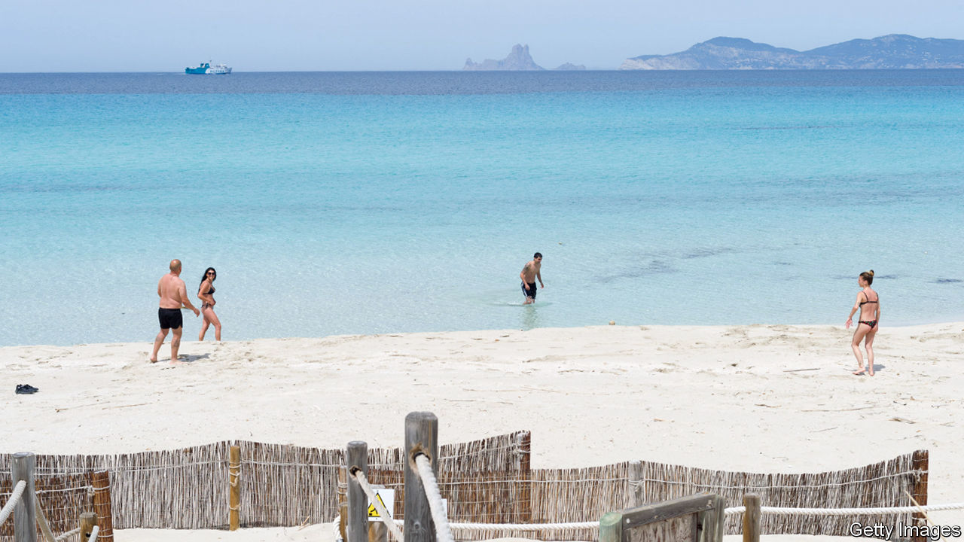

ON MAY 18TH for the first time in nine weeks the idyllic beaches of Formentera, the smallest of the Balearics, were open for bathing. The same went for three of the eight Canary Islands. The coronavirus lockdown means that all of Spain’s other beaches will remain closed for at least another week. But even when they open, how many holidaymakers will be able or willing to laze on them?

For Spain much hangs on whether at least some of the summer season can be rescued from the virus. The tourist industry is 12% of the country’s economy and provides 13% of jobs. In the Balearics and the Canaries, the respective figures rise to over a third. And they are especially dependent on northern European sunseekers: between July and September 91% of tourists to the Balearics are foreigners, and to the Canaries the figure is 79%.

Officials in both regions, which have seen low infection rates, are raring to open for business. The loss of the season would be “catastrophic”, says Francina Armengol, the regional president of the Balearics. She says she wants to open up flights for “pilot groups” of tourists through “safe corridors” from similarly virus-free European regions by the end of June. Such groups might include second-home owners.

Those hopes were dashed when Spain’s government this month unexpectedly imposed a 14-day quarantine for arriving passengers. An official argued that it would be anomalous for Germans with holiday homes in the Balearics to travel there while many Spaniards cannot. Under Spain’s complex, four-stage and regionally varied deconfinement plan, domestic tourism will not start until July at the earliest.

The quarantine “gave a very bad message”, says José Luis Zoreda of Exceltur, a tourism lobby, when rival destinations such as Portugal and Greece are sounding more welcoming. The minority coalition government of Pedro Sánchez, Spain’s prime minister, is under rising pressure to pay more heed to the shackled economy. With the conservative opposition now out to make life awkward for the government, only with difficulty this week did it scrape up enough parliamentary votes to prolong the state of emergency imposed in March for another two weeks.

The government is coming round to allowing tourist flights to the islands from July, from places where the epidemic is under control. Whether that includes all or parts of Britain, usually the largest source of arrivals, will depend on the extent of the virus there and then. José Luis Ábalos, the transport minister, said he will not insist on empty seats on planes. The tourist industry is working on sanitary rules, to include safe distancing between towels on beaches and disinfecting hotel rooms.

How many tourists might come? The Balearic administration reckons its islands may see 25% of the normal rate of arrivals in August, rising in September and October. Many northern Europeans may skip a foreign holiday this year, because of loss of income, to avoid risk, or because they like to plan ahead. For those who pluck up the courage, those Balearic beaches are likely to be pleasantly uncrowded and the locals unusually welcoming. ■

Editor’s note: Some of our covid-19 coverage is free for readers of The Economist Today, our daily [newsletter](https://my.economist.com/user#newsletter). For more stories and our pandemic tracker, see our [hub](https://www.economist.com/news/2020/03/11/the-economists-coverage-of-the-coronavirus)

This article was downloaded by calibre from <https://www.economist.com/europe/2020/05/23/will-tourists-come-to-sunny-spain-this-year>

|  |  |  |  |
| --- | --- | --- | --- |
| Previous | Articles | Sections | Next |

|  |  |  |  |
| --- | --- | --- | --- |
| Previous | Articles | Sections | Next |

#### Sami difference

# Sweden’s reindeer-herding Sami take back control

An indigenous people wins the right to decide who hunts and fishes on public land

May 23rd 2020 |

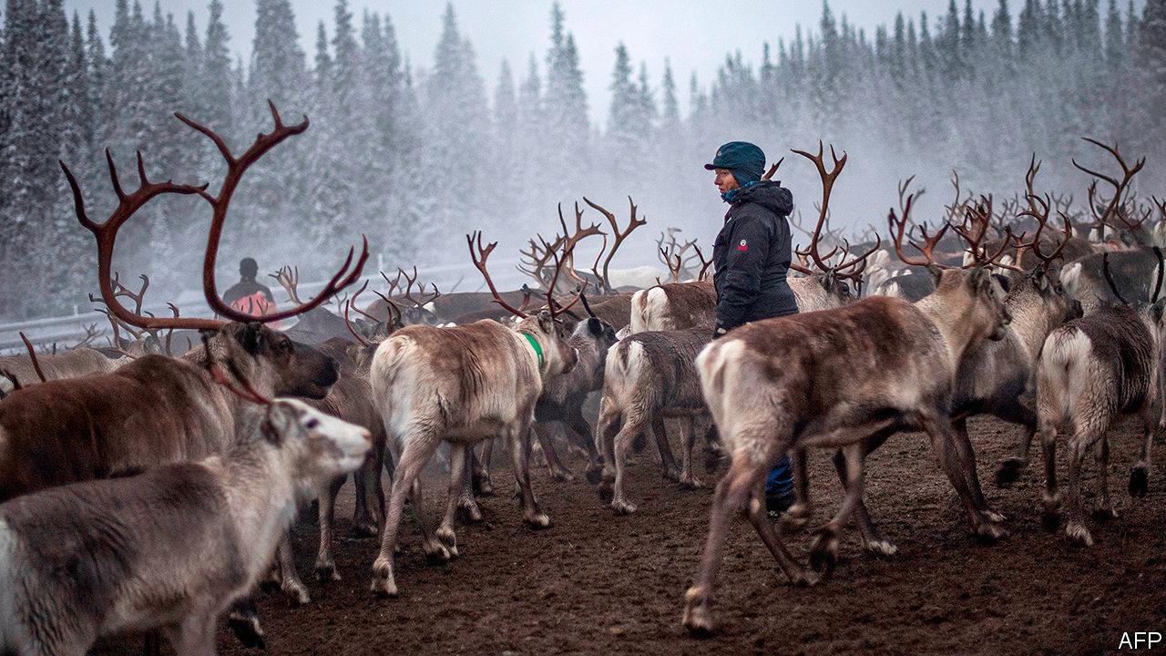

TO MOST PEOPLE, one reindeer looks much like another. But for Anders-Erling Fjallas, one of the Sami people indigenous to northern Sweden, it is easy to tell which reindeer belongs to whom. “We carve our brand in their ears with a knife when the calves are a few months old,” says Mr Fjallas, who owns about 700 of the animals. Once hunter-gatherers, the Sami switched to herding reindeer (caribou) in the Middle Ages. Nowadays they move with their herds between the lowlands and the mountains. But their lifestyle is threatened by development.

Until recently there was little they could do about this. But in 2009 Girjas, a Sami community, sued the government for control of hunting and fishing permits in their territory. On January 23rd Sweden’s supreme court ruled for the Sami, citing government records going back to the 16th century which recognised Sami rights in exchange for taxes (paid in fur). Until the government passes new legislation, any Sami community can sue and win such rights across much of northern Sweden.

Not everyone is thrilled, particularly around the northern mining town of Kiruna. Elsewhere, Sami groups have opposed mining projects they said would interfere with herding. Like the Sami, Kiruna itself is migrating. The tunnels through its iron-ore deposits are caving in, forcing the whole town to move two miles (3.2km). In February reindeer belonging to Sami started showing up dead, with bullet holes in them. Some Sami received death threats.

The city council condemned such nastiness. “Racist hatred must never be tolerated,” says Mattias Timander, the council’s chairman. Still, critics argued that Sami should be treated like anyone else. The politics of indigenous rights in Sweden differ from those in America or Canada: ethnic Swedes consider themselves natives, too.

The Sami have been in Scandinavia for millennia. They are linguistically and genetically distinct. In Sweden, a country of 10m people, there are only about 20,000 Sami. But the state owes them a fair shake. It long oppressed them on racial grounds. The main thing, Mr Timander and Mr Fjallas agree, is for the government to incorporate the ruling into law so herders, hunters and miners can stay out of each other’s way.

This article was downloaded by calibre from <https://www.economist.com/europe/2020/05/23/swedens-reindeer-herding-sami-take-back-control>

|  |  |  |  |
| --- | --- | --- | --- |
| Previous | Articles | Sections | Next |

|  |  |  |  |
| --- | --- | --- | --- |
| Previous | Articles | Sections | Next |

#### Charlemagne

# The wizards of Luxembourg

The EU’s top court gets used to life in the spotlight

May 23rd 2020 |

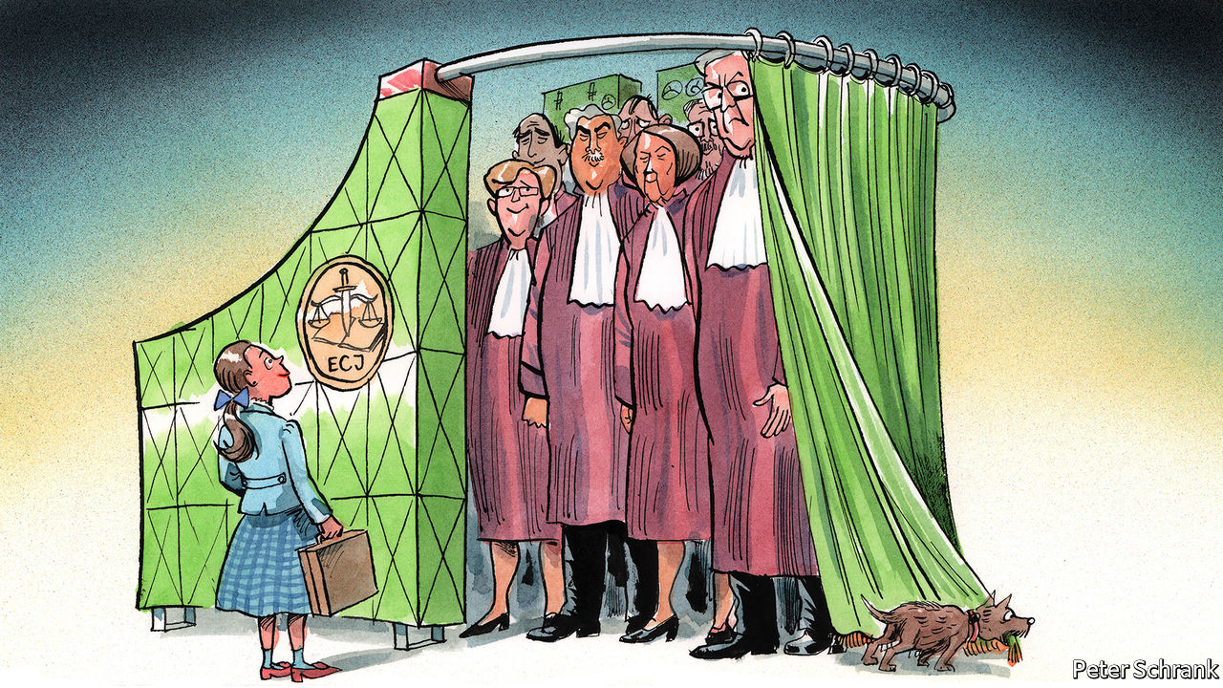

IN THE ATTENTION-STARVED world of EU politics, officials and politicians like to vaunt themselves. Folks in the European Commission refer to themselves as the “guardians of the treaties”, which sounds like a tagline from a superhero movie starring polyglot bureaucrats. More enthusiastic MEPs label the European Parliament “the heart of European democracy”. The woeful turnout at European elections—51% in 2019—suggests otherwise.

Only the inhabitants of the European Court of Justice, the EU’s top court, play down their importance. The court is a mere “umpire”, says its president, Koen Lenaerts, a Belgian jurist who has sat on it for three decades. It simply clears up any confusions left over in the bloc’s treaties, steering clear of politics. The Luxembourg-based court often resembles the Wizard of Oz in reverse: a mighty institution determined to portray itself as a puny one.

The court found itself unwillingly thrust into the public gaze this month after Germany’s constitutional court declared that the ECJ had acted ultra vires—beyond its mandate—in giving its blessing to a European Central Bank programme of bond-buying. The ECJ’s decision, which is supposed to be final, was “incomprehensible”, said the German judges. They provoked a terse response from the ECJ, which reminded its German peers that it had the final say on matters of EU law.

This was a very public scrap for a remarkably private institution. For most of its 68-year existence, the ECJ has been in the shadows, acting as a quiet but powerful motor of European integration. Rights associated with the EU, such as the ability to trade across borders or to seek work in another EU member state, owe as much to its judges as to its politicians. As the EU’s responsibilities have deepened, so have the court’s. Whereas once it ruled only on dry economic issues, such as the import of blackcurrant liqueur, today its remit includes everything from asylum to gay marriage.

Where European treaties are vague, it is the court’s job to bring clarity. Such a mandate gives the EU’s judges scope to roam. When negotiations involve 27 countries, hundreds of MEPs and legions of officials, the result is often unclear. Better to have a blurred text than no text at all, is the mantra of politicians working on a continental level. In Mr Lenaerts’ view, the ECJ has “no choice but to complete the constitutional lacunae” left by lawmakers.

But one man’s lacuna-filling is another man’s power grab. Critics portray the court as a power-hungry institution, hellbent on federalising Europe. Roman Herzog, a former German president, diagnosed the court as having a “centralising fever”. Its early years were marked by judicial radicalism, which shaped the constitutional foundations of the bloc. It was a case in 1964 over an electricity bill worth 1,925 lire—about €22 in today’s money—in which the court determined that EU law trumped national law.

Such judgments have been “tolerated, acquiesced [to] or encouraged” by national governments, says Takis Tridimas, a professor of European law at King’s College, London. If legislators did not like the court’s actions, they could always change the law. That they hardly ever do suggests that they do not object strongly to the court’s rulings. In this sense the ECJ resembles an S&M dungeon. National governments are happy to be tied up and slapped around in a dimly lit room by people in odd outfits. However, they would prefer not to mention this fact to their jealous spouses back home: domestic courts and domestic voters.

Such furtive consent has lurked at the heart of the ECJ’s success. Governments may grumble about decisions, but they obey them. Increasingly, however, judges in national courts have chafed at rulings from their European peers. The top courts of smaller countries, including Denmark and the Czech Republic, have rejected the ECJ’s judgments in the past. But size matters. In both the Czech and Danish cases, each country eventually tweaked its own legislation, stitching the tear in the EU’s legal fabric. German judges, by contrast, questioned far more fundamental principles. That rip is not so easily fixed.

## Courting public opinion

A public struggle for supremacy will draw attention to an institution as peculiar as it is powerful. Based in Luxembourg, it is a two-hour drive—or an interminable three-hour train ride—from Brussels, where most EU business is done. It is the only EU institution to operate solely in French, which creates both a translation bottleneck and a tricky learning curve for arriving judges. As is often the case at EU institutions, its staff are a mix of the crème de la crème and dregs sent by national capitals as a reward for good behaviour or to be kept out of the way. “Some are very brilliant; some are tourists,” is the verdict of one former judge. Now a panel vets potential candidates. Last year, 8 of 29 candidates were quietly rejected, including two who were suggested for the court’s highest chamber, which deals with the thorniest constitutional cases.

The ECJ is slowly growing used to the glare of public attention. An older judicial doctrine that the court communicates only through its judgments has been abandoned. Although proceedings are still not televised, the idea has been discussed internally. The court’s president does more interviews than his predecessor, treating journalists to thorough lectures in European law that drop out of his mouth in fully formed chapters.

European voters have yet to realise how powerful the court has become. Any American who reads a newspaper can name a couple of Supreme Court judges, but even the biggest EU nerd would struggle to name their European peers. Few wish to replicate America’s politicisation of judicial appointments. But the court’s increasing impact on the lives of EU citizens should be accompanied by greater scrutiny. Walter Bagehot once argued that the monarchy’s defenders “must not let daylight in on the magic”. Courts require less mystery. The wizards of Luxembourg have nothing to fear from letting in more light. ■

This article was downloaded by calibre from <https://www.economist.com/europe/2020/05/23/the-wizards-of-luxembourg>

|  |  |  |  |
| --- | --- | --- | --- |
| Previous | Articles | Sections | Next |

|  |  |  |
| --- | --- | --- |
| Europe | Sections | International |

Britain

Peak London: The wheel turns

.

Grand houses: A palace of one’s own

.

Transport: The great land grab

.

Government finances: Not so burdensome

.

Health care: Now for the recovery

.

Politics: The pandemic goes partisan

.

|  |  |  |
| --- | --- | --- |
| Europe | Sections | International |

|  |  |  |  |
| --- | --- | --- | --- |
|  | Articles | Sections | Next |

#### Peak capital

# London may have gone into a covid-accelerated decline

The shift could reverse three decades of ascendancy

May 23rd 2020 |

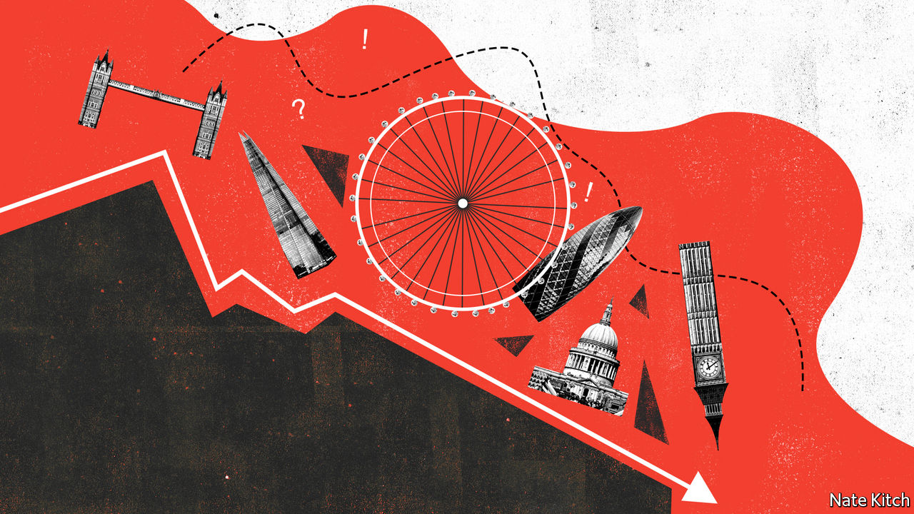

BEFORE IT WAS blown off course by covid-19, Boris Johnson’s government had big plans to reshape the economic geography of Britain. Poor parts of the Midlands and north of England would get lots of infrastructure investment, helping them to close the productivity gap with London. The country would be “levelled up”.

The idea always seemed a little far-fetched. British governments have been trying to boost productivity outside London for decades, with not much success. And it seems less and less likely that the government will be able to focus on grand new designs as opposed to hasty repair jobs. But something else might happen, to spare Mr Johnson’s blushes. Rather than levelling up, Britain could be about to level down, as London sags.

London was not always the great success it is now. After the second world war the government, which had already pinched the capital with a thick Green Belt, deliberately pushed businesses and citizens out to “new towns” in the Home Counties. Manufacturing declined, as did the docks that had once provided jobs and prosperity. By the 1980s the city’s population had fallen by a quarter from the 8.6m it had hit in 1939. London’s schools and services were famously awful.

After the Big Bang deregulated financial services in 1986, the logic of agglomeration reasserted itself and London took off. The creative industries and, in recent years, a thriving tech centre have joined the staples of banking, asset management and business services. Schools, policing and transport have all been transformed. People have flooded in from all continents, making London the world’s most global city.

Yet some warning signs have been visible for a while. Although London’s population has continued to grow, over the last decade that has been driven by international migration and the birth rate. Between 2008 and 2018, 550,000 more Britons left London than moved to it. People complain of high costs and anxiety. One league table in which London scores poorly is the Office for National Statistics’ rankings of well-being and life satisfaction. Since 2015 migration from the capital has helped reduce the differential between London’s house prices and those in the rest of the country (see chart).

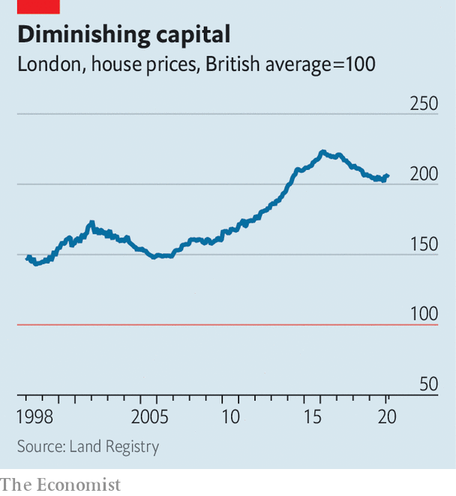

But London’s house prices remain double those elsewhere. After housing costs are accounted for Londoners are, on average, worse off than residents of the rest of southern England or Scotland. The chairman of PWC, a professional-services firm, has argued that graduates are turning their backs on London. Whereas 60% of graduates working for the big four accounting firms used to be based in the capital, in 2018 60% of new starters were outside.

The London office-cost premium is even higher than the housing-cost one. Prime square footage in the capital costs three times as much as space in other southern cities and seven to nine times as much as elsewhere in Britain. According to a legal recruitment firm, a company can save about £20,000 ($24,500) a year by moving a lawyer out of central London, after office costs and salary are taken into account. “Northshoring”—usually referring, confusingly, to places such as Birmingham that are far from northerly—has become something of a buzzword in the industry. HSBC chose to move its British retail banking headquarters to Birmingham in 2017. Amazon, an internet retailer, picked Manchester for its major British corporate site in 2018.

If the coronavirus crushes property values and office rents, London might become a little less offputting. Perhaps some graduates will be tempted back from Leeds or Manchester. But covid-19 and the extreme social-distancing measures used to combat it pose a new and more profound danger to the capital, for they threaten two factors that have been central to its success: fun and foreigners.

London’s triumph is at least partially based on it being a fun place to live. “People come here not only because you can get paid well but because you can have a good time,” says Douglas McWilliams of the Centre for Economics and Business Research, a consultancy. The bars and cafes of the East End have been an important driver of what Mr McWillams once dubbed the “flat white economy”, where people with interesting hair bounce ideas off each other while drinking trendy beverages.

It is hard to have a flat white economy when you have to maintain two-metre distancing while queuing for your caffeine. Restaurateurs fear that being forced to operate at a lower capacity will drive many of them out of business. Theatres are facing disaster. As a hedge-fund manager puts it, “London without the culture and the restaurants is just a more expensive Frankfurt with more congestion.”

Covid-19 might combine with Brexit to cut international migration. Although foreign candidates for London jobs will score better on Britain’s new points-based immigration system than those for jobs elsewhere in the country, because the jobs are better paid, the signal has been sent: Britain is not keen on mass immigration. Universities fear that foreign student numbers could fall by 20-50% in the year ahead. For London, with its more than 100,000 foreign students, that is a problem.

Like all great cities, London could also suffer from changing assumptions about work. Many firms now expect that some people will keep working from home even after the danger of coronavirus has receded—if not every day then several days a week. As firms learn to make do with smaller offices, workers might prize bigger homes outside London where they can have an office. The trade-off between space and commuting time looks different if you only have to go in two or three times a week. But if this happens, it will probably benefit commuter towns in the south-east rather than the northern and Midlands towns that Mr Johnson wanted to help.

Lisa Taylor of Coherent Cities, a consultancy, remains optimistic. “The next two years are going to be very tough,” she argues.“But a different city could emerge on the other side. One where land use has changed, where we have more co-working and co-living spaces.” She reckons that a greener, less congested London could take its inspiration from cities like Copenhagen and Amsterdam. But those are hardly world-beating metropolises.

London is unlikely to slip back into the dismal state it was in before the mid-1980s. It is likely to remain richer and more productive than the rest of Britain. It will remain Europe’s most powerful magnet for talented immigrants. Still, its pulling power is likely to wane. If that happens, Britain’s economy will probably suffer. But a less centralised country, in which opportunity was more evenly distributed, might be a better place in other ways.■

Editor’s note: Some of our covid-19 coverage is free for readers of The Economist Today, our daily [newsletter](https://my.economist.com/user#newsletter). For more stories and our pandemic tracker, see our [hub](https://www.economist.com/news/2020/03/11/the-economists-coverage-of-the-coronavirus)

This article was downloaded by calibre from <https://www.economist.com/britain/2020/05/23/london-may-have-gone-into-a-covid-accelerated-decline>

|  |  |  |  |
| --- | --- | --- | --- |
|  | Articles | Sections | Next |

|  |  |  |  |
| --- | --- | --- | --- |
| Previous | Articles | Sections | Next |

#### Grand houses

# Britain’s palaces and stately homes are empty

That’s quite nice for the people living in them

May 23rd 2020 |

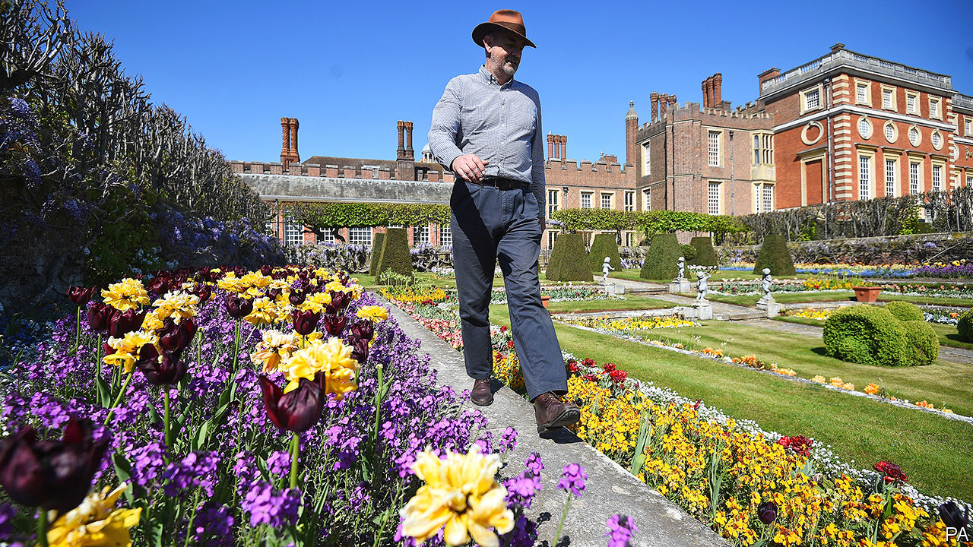

“SOMETIMES WHEN I’m here early in the morning, it’s like some kind of scene from ‘Brideshead Revisited’...this huge great rambling medieval palace, with the gardens slowly becoming overgrown, and there’s just a couple of people walking around.” Graham Dillamore (pictured), gardens and estates operations manager at Hampton Court Palace, Henry VIII’s favourite residence, is enjoying an experience which few have ever had before: being almost alone in a palace. The absence of visitors, he says, may have encouraged supernatural occupants to come out. “I keep looking behind me, and hearing footsteps.”

National crises tend to have nasty consequences for grand houses. About a sixth of those standing in 1900 were demolished in the 20th century. Socialism mostly did for them, but war didn’t help: houses were requisitioned and left in tatters, and hefty taxes followed. Planning laws put a stop to the vandalism in 1968, by forcing owners to seek permission to demolish listed buildings, and many of the landed gentry sold up, experimented with safari parks and adventure playgrounds to attract the hoi polloi, or handed their piles over to the National Trust, a charity that allows former owners to live in properties on condition that they are open to the public.

Those with the keys to Britain’s grand houses worry about the effect of covid-19. The National Trust, which owns 200 of them, is set to lose £200m this year through foregone entrance fees and cancelled subscriptions. “We have pulled back on over 60% of our projects,” says Hilary McGrady, the trust’s director-general. “We’re only continuing with the projects that we have to do—sewage, asbestos, a wall that is going to fall down. Tree planting, river restoration work, anything that wasn’t essential has had to be put on hold. The impact on us, from an economic point of view, is huge.”

But for the aristocrats who have continued to live in properties owned by the National Trust there is an upside: they are free to kick back and enjoy them as their forefathers had intended. “It’s a big change not to have the visitors, and in some ways, it’s very nice,” says Sir Charles Elton, whose family has lived in Clevedon Court in Somerset for 300 years. When he was seven, his father handed the place over to the National Trust, and this is the first time since then that the 11th baronet hasn’t had to accommodate paying visitors. He is exploring. “The house is full of evidence of the passions of various members of my family. So my great-grandfather was an arts-and-crafts potter; we’ve got a whole room devoted to it. My grandmother collected glass, my father had a huge collection of industrial art. They’re weird collections put together by a weird family.”

And for those who still own their country pile and need cash, covid-19 is a bonus. Rich urban types are keen to get out of the cities, and can’t take summer holidays abroad. Crispin Holborow, deputy chairman of Savills, an estate agent, says of owners, “Some have rented out their houses, and moved into an annex—suddenly you have this surge of people who want to rent a smart country house in good condition.” But there are new challenges for owners who have furloughed staff. “It’s all hands to the pump; the family is out mowing the lawns,” says Mr Holborrow of the owners of a country house he knows in Northamptonshire. “I don’t think the stripes are quite as good as they were before.”

It isn’t just the residents who are enjoying the shutdown. Dominic Hare, chief executive of Blenheim Palace, the Duke of Marlborough’s home, says that in the absence of tourists, locals have been making the grounds their own, walking their dogs and watching the lambing. “There’s an awful lot of families in the nearby area”, says Mr Hare, “for whom suddenly it becomes their personal oasis.” In this world turned upside down, Mr Dillamore finds his position as pseudo-aristocrat somewhat disconcerting. “I’m just waiting for someone to bring the guillotine out.” ■

Editor’s note: Some of our covid-19 coverage is free for readers of The Economist Today, our daily [newsletter](https://my.economist.com/user#newsletter). For more stories and our pandemic tracker, see our [hub](https://www.economist.com/news/2020/03/11/the-economists-coverage-of-the-coronavirus)

This article was downloaded by calibre from <https://www.economist.com/britain/2020/05/23/britains-palaces-and-stately-homes-are-empty>

|  |  |  |  |
| --- | --- | --- | --- |
| Previous | Articles | Sections | Next |

|  |  |  |  |
| --- | --- | --- | --- |
| Previous | Articles | Sections | Next |

#### The great land grab

# Walkers and cyclists are using the covid-19 crisis to swipe road space

They may not give it back to cars

May 23rd 2020 |

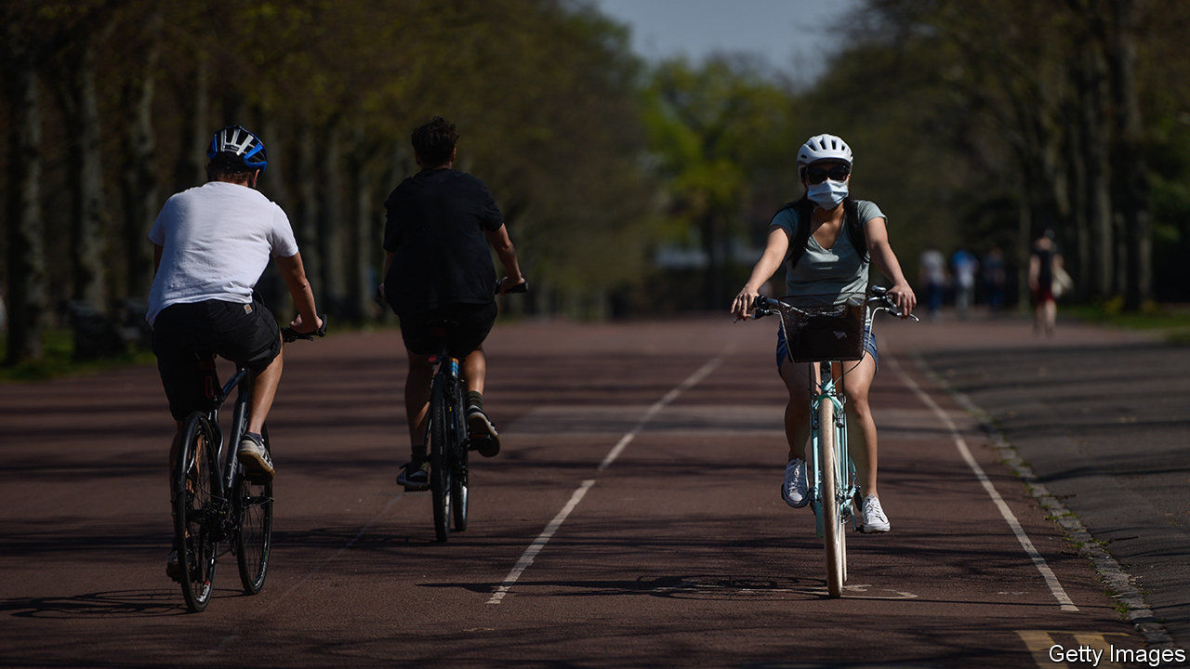

AFTER LONDON was destroyed by fire in 1666, several worthies drew up bold plans for a new city. The philosopher Robert Hooke, who lived and worked at Gresham College near Bishopsgate, envisaged a gridded city with small parks, rather like Barcelona. Others, including Sir Christopher Wren, an architect, and John Evelyn, a diarist, devised plans to improve the city. All were disappointed—the authorities moved too slowly, and London was rebuilt along its old medieval roads. But the streets around Hooke’s former home may be about to change.

The Corporation of London, which runs the financial district, proposes to make the roads that once led to Gresham College one-way, and give space now occupied by cars to pedestrians and cyclists. Cars and buses will be barred altogether from other nearby streets between 7am and 7pm. Transport for London plans to sweep cars off London Bridge and Waterloo Bridge. These are bold schemes, affecting major roads that had been considered untouchable, says Giulio Ferrini of Sustrans, a cycling and walking charity. And central London is not the only place with plans.

Camden High Street in north London is a mess of barriers and traffic cones, which take road space away from parked cars and give it to pedestrians. Bike lanes have popped up on thoroughfares like Park Lane and Euston Road. Birmingham’s city council plans to cut street parking and is considering carving bike lanes out of dual carriageway roads. Bristol, Edinburgh, Liverpool and Manchester have similar plans. JSP, a company that makes barriers and traffic cones (including one called “dominator”) says that demand for its products has jumped.

Will Norman, London’s walking and cycling commissioner, argues that the city has no choice but to repurpose roads for walking and cycling. In normal times Londoners rely on trains, buses and the Tube for more than two-fifths of their travel (see chart). Covid-19 has made them fearful of doing so: on the morning of May 18th London Underground carried 8% of the passengers that it did a year earlier. If lots of people transfer from public transport to cars, the streets will gum up and pollution will rise. The city must be quickly reconfigured to make that option seem less attractive, and cycling and walking more so.

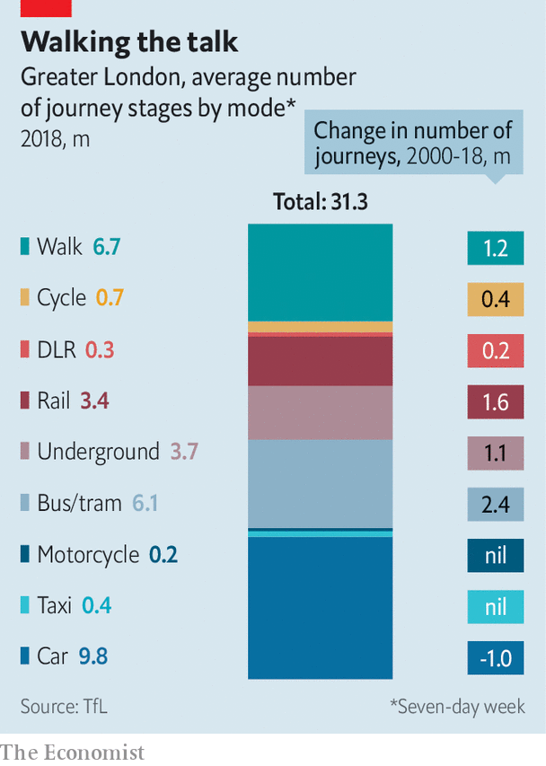

Yet the danger of gummed-up streets seems a long way off. London and other British cities are still deathly quiet. And if they do bounce back to life—which, if social distancing is a long-term reality, they may not—taking lanes away from cars might exacerbate congestion. Steve McNamara of the Licensed Taxi Drivers’ Association reckons that covid-19 is merely an excuse to force through an anti-car strategy. “This is a land grab,” he says.

It might be a worthy one nonetheless, if urbanites can be jolted out of their cars and onto pedals or pavements. The construction of a network of more-or-less safe bike routes is one reason that cycling has roughly doubled in London since 2000. But it is still a minority activity, accounting for less than 3% of journeys. For all the cost and unpleasantness of driving in London, one in three trips is by car. Outside the capital, two-thirds are—a proportion that has barely changed in 15 years, according to the National Travel Survey.

The cycling and driving lobbies agree on one thing: although they are sometimes described as temporary, many of the changes to roads will be permanent. People get used to new arrangements, and those who benefit do not want to give them up. “We’re not going to go back to the same situation,” says Mr Norman. Cities have learned the lesson of London in the 17th century. You can change a city following a crisis, but you have to move quickly, before things go back to normal. ■

Editor’s note: Some of our covid-19 coverage is free for readers of The Economist Today, our daily [newsletter](https://my.economist.com/user#newsletter). For more stories and our pandemic tracker, see our [hub](https://www.economist.com/news/2020/03/11/the-economists-coverage-of-the-coronavirus)

This article was downloaded by calibre from <https://www.economist.com/britain/2020/05/23/walkers-and-cyclists-are-using-the-covid-19-crisis-to-swipe-road-space>

|  |  |  |  |
| --- | --- | --- | --- |
| Previous | Articles | Sections | Next |

|  |  |  |  |
| --- | --- | --- | --- |
| Previous | Articles | Sections | Next |

#### Not so burdensome

# As debt soars, the cost of servicing it keeps falling

Good news for the British government’s finances

May 23rd 2020 |

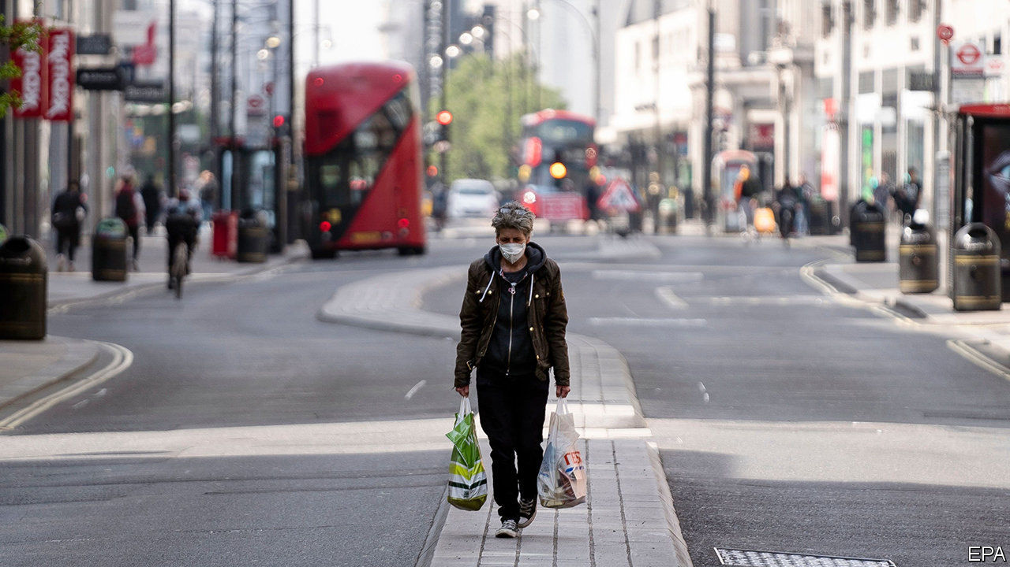

AN AWFUL LOT has changed since Rishi Sunak, the chancellor, unveiled his budget in March. Britain’s economy looks set to experience an unprecedentedly rapid and deep recession. What is more, the government, through actions such as the furlough scheme to support employment, is choosing to bear an unusually large share of the initial costs. The result will be much higher government debt than previously anticipated. And yet the actual cost of servicing that higher debt may well turn out to be lower than was expected back in March.

There is now so much uncertainty that the official government forecasters—the Office for Budget Responsibility (OBR) and the Bank of England—have declined to issue their usual forecasts, instead presenting what they call “scenarios”. More detailed modelling by the Resolution Foundation shows what may be to come. According to the think-tank’s three-month lockdown estimate, the debt-to-GDP ratio will soon head back to the 100% mark—a level not seen since the 1950s, when Britain was still burdened with the costs of fighting the second world war.

But at the same time, interest rates have collapsed. When the budget was delivered, the OBR expected the yield on government debt to average around 0.9% a year between 2020 and 2023. Since then the Bank of England has cut rates to a record low and restarted its programme of quantitative easing (buying government debt). As a result, the yield on the benchmark ten-year government debt has fallen to closer to 0.2%. On May 20th the government sold two-year gilts to investors with a negative nominal yield for the first time. For some maturities, the government is therefore being paid to borrow. Many bond strategists now reckon that leaving the European Union without a deal would push the Bank of England into taking its base rate negative, putting yet more downward pressure on borrowing costs.

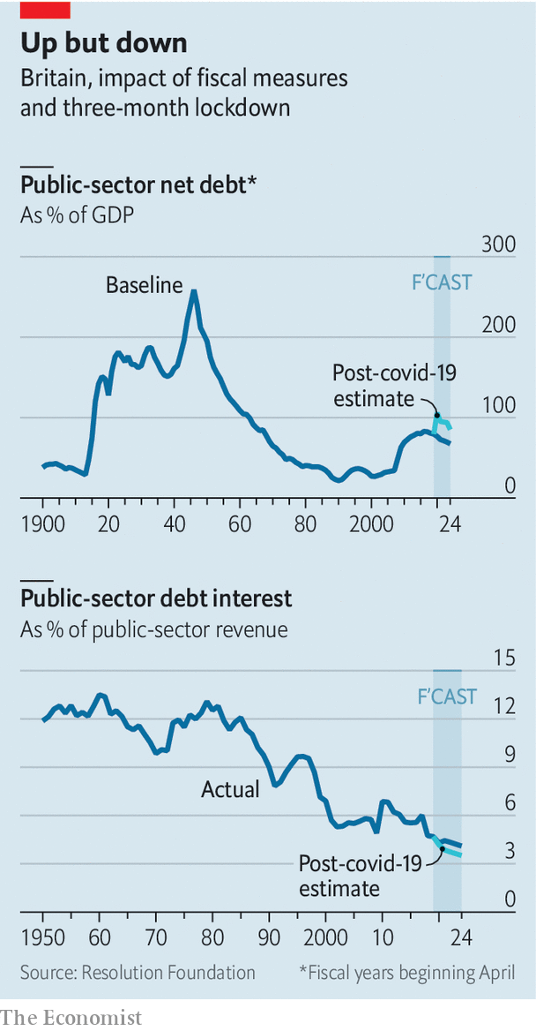

Low borrowing costs are good news for the government’s finances. In the Resolution Foundation’s scenario, interest costs will take up a smaller share of tax revenues by 2024 than was expected at the budget. Indeed, they will be lower than at any point in Britain’s post-war history. And not only will new borrowing attract a lower rate, but as existing debt is refinanced the cost of servicing it will fall, too. More debt leaves the government vulnerable if interest rates return to higher levels. So far, though, there is little sign of that happening.

This article was downloaded by calibre from <https://www.economist.com/britain/2020/05/23/as-debt-soars-the-cost-of-servicing-it-keeps-falling>

|  |  |  |  |
| --- | --- | --- | --- |
| Previous | Articles | Sections | Next |

|  |  |  |  |
| --- | --- | --- | --- |
| Previous | Articles | Sections | Next |

#### Unwinding the National Covid Service

# Why the NHS will not be back to normal for a very long time

Numbers of covid patients are falling. Yet the health service faces an enormous backlog

May 23rd 2020 |

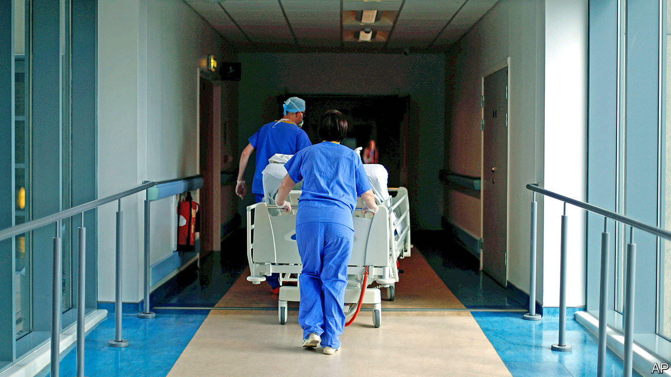

OVER THE past few months, the thousands of organisations that make up the National Health Service, and the 1.7m people they employ, have turned their attention to one task: dealing with the pandemic. The astonishing transformation that resulted saved many people’s lives, and the health service from collapse. Now, however, it must be undone. Medics everywhere are working out how to return to something like normality, even as the virus circulates. Many hospital chiefs believe doing so will prove even more difficult than the initial transformation.

The covid-19 burden has at least become less pressing. In England fewer than 700 victims a day are now hospitalised with the virus, down from a peak of 3,121 on April 2nd. So people are being encouraged to seek treatment for other issues, with doctors worried they are avoiding doing so for fear of contagion. On May 16th Matt Hancock, the health secretary, tweeted a video in which he said that “it’s really important that you help us help you, by coming forward with problems if you have them...If you’re asked to go to a hospital by a clinician then please do go.” Numbers arriving at accident-and-emergency departments are beginning to rise, though they are still below pre-crisis levels (see chart).

In truth, the NHS will never return to its pre-pandemic state. For one thing, NHS England, which runs the health service, is working out which innovations introduced because of covid-19 should stay. Almost all prescriptions and primary-care appointments now happen online, as do lots of outpatient ones. Doctors have been surprised by how well this works. Other changes—like the retraining of specialists and the increase in intensive-care capacity—will become a permanent feature to protect against further waves of the virus. According to the Financial Times, the NHS London region plans to double the number of intensive-care beds in its hospitals.

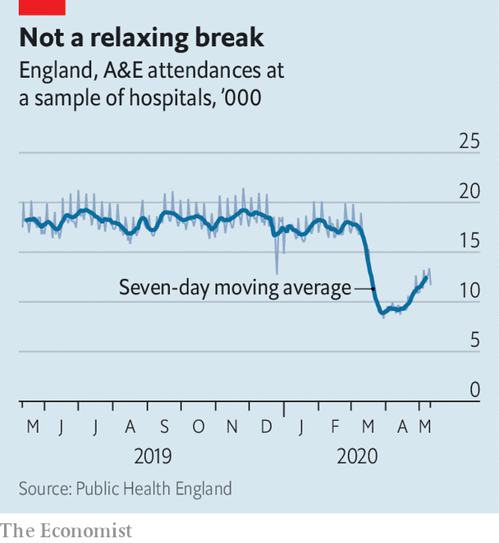

Such innovations will make the NHS more resilient. But even if it manages to keep them, the health service will still face difficulties. Before the crisis, it was in bad shape. In February just 85% of people turning up at accident-and-emergency departments were seen in four hours, for instance, against a target of 95%. And dealing with yet more sweeping changes will be a big ask for staff who “are absolutely wrung dry”, says Sir Chris Ham, co-chair of the NHS Assembly, which advises on the integration of the health service.

The knackered workforce will have to deal with an enormous backlog of patients. In a typical month 1.5-1.7m people start a new course of treatment. But as Nigel Edwards of the Nuffield Trust think-tank has noted, in many hospitals levels of elective care have been running at 15-20% of normal, suggesting the backlog will be in the millions. Many patients will require more complex care, too, their problems having worsened without treatment.

It has also become clear that hospitals are a good place to catch covid-19. Thus waiting rooms will have to be emptied, protective kit donned and deep cleaning regularly carried out. Radiologists expect that such precautions will halve the number of CT scans that can be carried out. Neil Mortensen, president-elect of the Royal College of Surgeons of England, predicts a similar fall in the capacity to carry out surgery. “You can’t just flick a switch and go back to what it was before,” he says.

In a few big cities it may be possible to run some hospitals “red” (taking covid patients) and other ones “green” (not taking them), which would speed things up. In more sparsely populated parts of the country, this division will have to happen within hospitals, which will be trickier to manage. All of this means that overall capacity will be way down on pre-pandemic levels.

At the end of March the NHS struck a deal that allowed the state to use private-sector beds. An extension is likely to be announced soon, with the extra capacity used to treat the backlog, rather than the virus itself. Some senior people in the system want the emergency “Nightingale” hospitals, which are being mothballed, to be repurposed to help out. Yet even with these measures, the combination of a huge backlog and reduced capacity means that waiting times are about to become very long indeed. Like many covid victims, the NHS will take time to get back on its feet. ■

Editor’s note: Some of our covid-19 coverage is free for readers of The Economist Today, our daily [newsletter](https://my.economist.com/user#newsletter). For more stories and our pandemic tracker, see our [hub](https://www.economist.com/news/2020/03/11/the-economists-coverage-of-the-coronavirus)

This article was downloaded by calibre from <https://www.economist.com/britain/2020/05/23/why-the-nhs-will-not-be-back-to-normal-for-a-very-long-time>

|  |  |  |  |
| --- | --- | --- | --- |
| Previous | Articles | Sections | Next |

|  |  |  |  |
| --- | --- | --- | --- |
| Previous | Articles | Sections | Next |

#### Politics

# The pandemic is dividing Britons, not uniting them

Views on covid-19 are splitting along party lines

May 23rd 2020 |

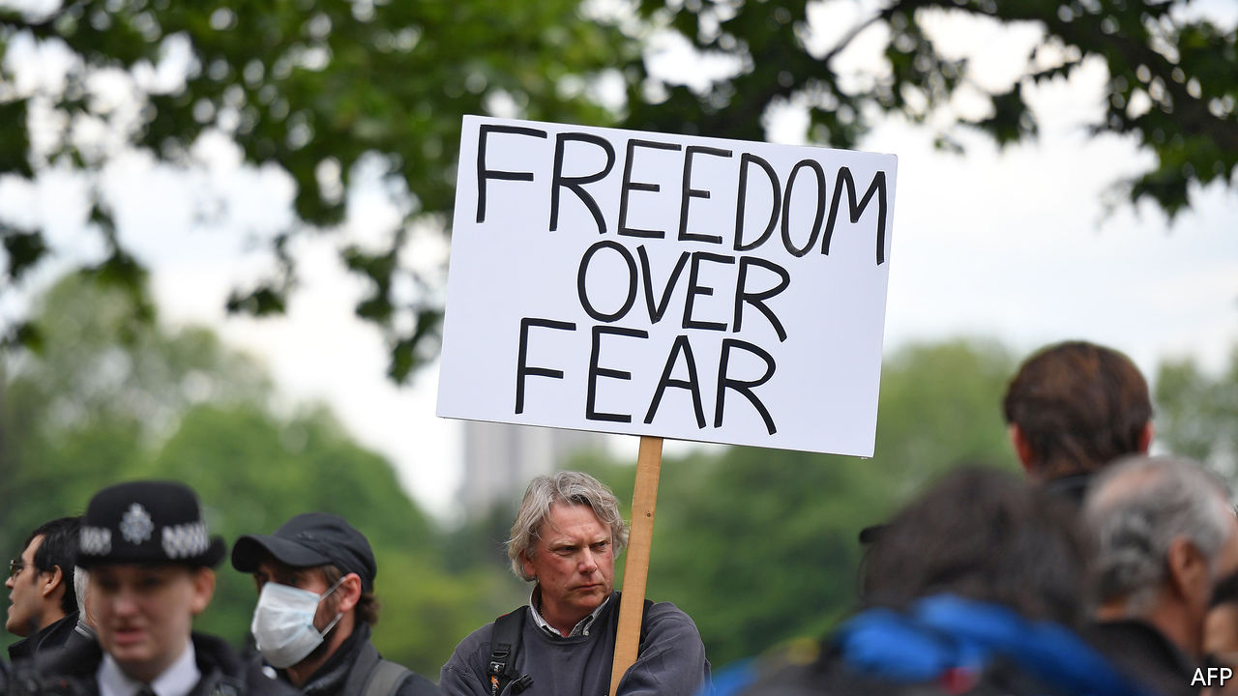

WHEN BORIS JOHNSON announced lockdown on March 23rd, he was supported by Sir Keir Starmer, front-runner to be Labour leader, and the governments in Scotland, Wales and Northern Ireland. A furlough scheme to allow workers to be kept on in their jobs was designed with trade unions’ assent. More than 90% of voters backed the shutdown; the support was consistent across parties and around the country. Steve Baker, a self-described libertarian MP, suppressed tears as he told the House of Commons the “dystopian” restrictions were unavoidable.

Now politics is back. Labour and the unions are increasingly critical of government policy. There is sniping from Scotland and Wales, too. And Mr Baker has returned to his usual occupation of snapping at the government’s ankles.

Harassment from the right focuses on hostility to the lockdown. Ardent Brexiteers and climate-change sceptics have reunited around the issue, and are attacking the model from Imperial College London on which the government based its decision to shut the economy down as a “buggy mess”. A Tory MP approvingly compares the row to that over the validity of climate-change forecasts that engulfed the University of East Anglia a decade ago.

On the left, the teachers’ unions are refusing to go back to work until schools are “safe’”—which leaves much scope for disagreement. The government wants schools to reopen on June 1st. A number of councils have weighed in to support the unions, and the devolved governments of Wales, Scotland and Northern Ireland are taking a more cautious line on school reopening.

Voters, too, are dividing. Britain is not seeing the same deep polarisation as America, where a deep partisan split over whether the virus was dangerous or not appeared swiftly. There is little support outside the Conservative back benches for an immediate reopening of schools and pubs, and Britons of all parties tell pollsters they are worried by the virus. But their views about the future and the government’s response are shaped by party allegiance. “The immediate effect of the emotional shock starts to fade, and when it does you see familiar patterns of divergence re-emerge in the public,” says Rob Ford, a political scientist at the University of Manchester. Voters are exploring a strange new world through old political lenses.

Nearly two-thirds of Tories support the modest relaxation of the lockdown, while two-thirds of Labour voters oppose it, according to YouGov, a pollster. Labour voters are more prone to say that public health should trump economic concerns. Tories are more likely to be among the handful of voters who think schools and pubs should reopen next month.

A belief that people should be free to take risks has long been part of the Conservative cause. But tribalism probably helps explain the split, too. When faced with complex questions—such as how to loosen a lockdown, or what trade policy to pursue after Brexit—uncertain voters form their views based on prompts from the political elites they like, such as politicians, trade unions or newspapers, says Professor Ford. Those signals have been getting stronger in recent weeks. “If you ask people about what they think of the epidemiological uncertainties of the risk of sending your kids back to school, they think: ‘What does somebody I trust say on that?’”

Mr Johnson has insisted that his strategy is rooted in science, not politics, but science may not be a unifying force. Tory voters have more confidence in Chris Whitty, England’s chief medical officer, who is a fixture at Boris Johnson’s press conferences, than Labour voters do. “It’s not that Whitty is a partisan figure, but he is associated with government policy,” says Will Jennings, a political scientist at the University of Southampton.

Britain is likely to dodge a Brexit-style culture war over coronavirus, says Professor Jennings. Voters of all stripes accept that the virus poses a significant threat to health, and there have been few American-style protests. Yet Mr Johnson still faces a moment of difficulty. There was consensus on introducing the lockdown, but there is none on easing it.■

Editor’s note: Some of our covid-19 coverage is free for readers of The Economist Today, our daily [newsletter](https://my.economist.com/user#newsletter). For more stories and our pandemic tracker, see our [hub](https://www.economist.com/news/2020/03/11/the-economists-coverage-of-the-coronavirus)

This article was downloaded by calibre from <https://www.economist.com/britain/2020/05/23/the-pandemic-is-dividing-britons-not-uniting-them>

|  |  |  |  |
| --- | --- | --- | --- |
| Previous | Articles | Sections | Next |

|  |  |  |
| --- | --- | --- |
| Britain | Sections | Business |

International

Covid-19 and global poverty: The great reversal

.

|  |  |  |
| --- | --- | --- |
| Britain | Sections | Business |

|  |  |  |  |
| --- | --- | --- | --- |
|  | Articles | Sections | Next |

#### The great reversal

# Covid-19 is undoing years of progress in curbing global poverty

The number of very poor people was steadily falling; now it is rising fast

May 23rd 2020 | DELHI, KAMPALA AND MEXICO CITY

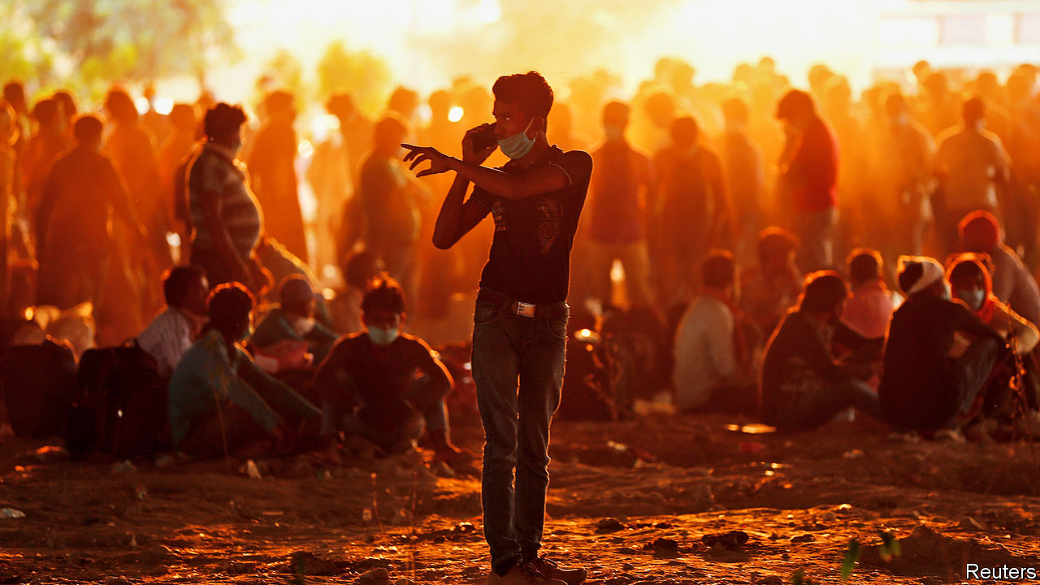

Editor’s note: Some of our covid-19 coverage is free for readers of The Economist Today, our daily [newsletter](https://my.economist.com/user#newsletter). For more stories and our pandemic tracker, see our [hub](https://www.economist.com/news/2020/03/11/the-economists-coverage-of-the-coronavirus)

JANE KABAHUMA has been eating one meal a day since the end of March, when the lockdown began. She used to work in a hotel, but it had to close, along with most businesses in Uganda. She thinks “it will take time” before the work comes back. In five months she is expecting a baby; it may arrive before a job does.

Her standard of living has plummeted. She used to pay to fill her jerrycans from a clean tap, but these days fetches water from a dirty well, because it is free. She gets by, more or less, with help from friends and family. But for how long?

In normal times, people in poor countries have many ways to cope with shocks. If one member of a family falls sick, the others can work longer hours to make up for the lost income. Or they can ask cousins or neighbours for help. Or, if a whole village is impoverished by a bad harvest, they can ask a nephew working in a big city or a foreign country to send some extra cash. All these “coping mechanisms”, as development experts call them, depend on calamity not striking everywhere at once. Alas, covid-19 has done just that.

In many places, workers cannot make up for lost income by working harder because demand for their labour has collapsed. Empty restaurants need no waiters; shuttered malls need no mopping; and few motorists are rolling down their windows to buy fruit from street hawkers.

The newly impoverished cannot easily get help from friends or relatives because, no matter where in the world they are, they are all experiencing a simultaneous and massive economic shock. The World Bank predicts that remittances from migrant workers will drop by 20% this year. Male Nepali migrants who are still overseas are now sending back only a quarter of what they were in January. Many send back nothing at all, having returned home.

Most countries in the developing world still require their citizens to stay at home, except to duck out for essentials. But few of the world’s poorest can work from home. And without work, many cannot eat. Thus, covid-19 imperils one of the greatest achievements of recent decades—the stunning reduction in global poverty.

From 1990 until last year the number of extremely poor people—those who subsist on less than $1.90 per day—fell from 2bn, or 36% of the world’s population, to around 630m, or just 8%. Now, for the first time since 1998, that number is rising—very fast. The big questions are: how many millions will slip back into penury? And will they quickly escape again when the pandemic is past, or will its effects be long-lasting, or even permanent?

The answers to those questions are maddeningly hard to pin down. The World Bank estimates that national lockdowns and the global economic collapse will push at least 49m people into extreme poverty, eliminating nearly all the gains made since 2017. That seems implausibly rosy—the bank’s estimate was based on data published in April. More recent numbers are far gloomier. For example, on May 17th Goldman Sachs estimated that India’s economy is shrinking at an annualised rate of 45%. Andy Sumner of King’s College London estimates that if global income per head falls by 20%, which it may for several months at least, the number of extremely poor people could increase by 420m—as much as the entire population of South America. That would wipe out a decade of gains in the fight against poverty.

Many poor countries have copied the kind of lockdowns that have been imposed in rich countries. But the circumstances are utterly different. The well-off are much more likely to have jobs that can be done from home. And workers in rich countries who cannot do their jobs, such as hotel receptionists or waiters, are typically wellsupported by taxpayers.

By contrast, when India imposed a strict and dramatic lockdown on March 24th, the 140m people who are estimated to have lost their jobs were suddenly in big trouble. Tens of millions of migrants who had moved from villages to cities suddenly had no income, no way to pay the rent and no trains to take them home, since those were also cancelled. Millions trudged hundreds of kilometres back to their home villages, where their families at least would take them in. The lockdown has been extended to May 31st, with only small adjustments (see article).

Similar tales of woe are coming from other poor places. Over 80% of Kenyans and Senegalese reported a loss of income in early April. In a study for the University of Manchester, 60 Bangladeshi families have been writing “money diaries”. Before March, about $1,000 a month passed through each household (not all of it income). In April that fell to $300 or so.

In middle-income countries, too, lockdowns have been excruciating. Colombia’s was so tough that it sparked protests in working-class barrios. In Altavista, a neighbourhood near San Salvador, the capital of El Salvador, people have taken to hanging white flags from their windows to show that they have run out of food.

“Almost overnight people go from having income to having no income,” says Carolina Sánchez-Páramo of the World Bank. Less income often means less food. The World Food Programme (WFP) predicts a doubling of acute hunger by the end of 2020. David Beasely, its boss, worries that the world could see “multiple famines of biblical proportions” within a few months.

Health-care systems have been disrupted not only by the virus itself but also by lockdowns, which make it harder for people to seek treatment for other illnesses. A team at Johns Hopkins University calculates that across 118 poor and middle-income countries, disruption to health systems and hunger could kill 1.2m more children and 57,000 mothers over six months. The Stop TB Partnership, an international research group, reckons that in India alone interruptions of diagnosis and treatment from a three-month lockdown, followed by a 10-month recovery period, could cause 500,000 excess deaths from tuberculosis.

Some kinds of lockdown could cost more lives than they save. A report by the London School of Hygiene and Tropical Medicine estimates that if restrictions prevent vaccinations, in Africa 140 will die for every covid-19 death prevented.

Even moderate lockdowns can be harmful in very poor countries. The Malawian National Planning Commission and two think-tanks did a cost-benefit analysis of continuing Malawi’s restrictions, which include closing schools, curbing travel and stopping health outreach work. They estimated that the lockdown, if maintained for nine months, would avert 12,000 deaths from covid-19. However, it would also cause more people to go hungry, making them vulnerable to TB and malaria, so the net number of deaths avoided would be roughly half that. And because the victims of coronavirus would be largely old people, whereas the victims of malaria would often be infants, the lockdown would actually cause a net loss of 26,000 years of life.

The lockdown would also leave Malawi $12bn worse off, by stopping people from working and interrupting children’s education, thus dooming them to earn less in the future. That is equivalent to nearly two years’ GDP—an astounding sum. Overall, they estimated that the costs of the lockdown outweighed the benefits by 25 to 1.

Such calculations are subject to a wide margin of error. Nonetheless, they explain why many experts think that rich-country style lockdowns are unsustainable in many poor countries.

## No work, no pay, no food

People who lack savings or a functioning safety net cannot simply stop working. Yet millions are being forced to do so. Before the crisis Jonathan Solmayor drove a tuk-tuk in Davao City in the Philippines. “I am feeding four mouths,” he says, but “my only source of living was stopped.” In western Nepal men have seen the hours they can work for wages fall by about 75%, according to the Yale Research Initiative on Innovation and Scale. In Uzbekistan the number of households where at least one person works has dropped by over 40%.

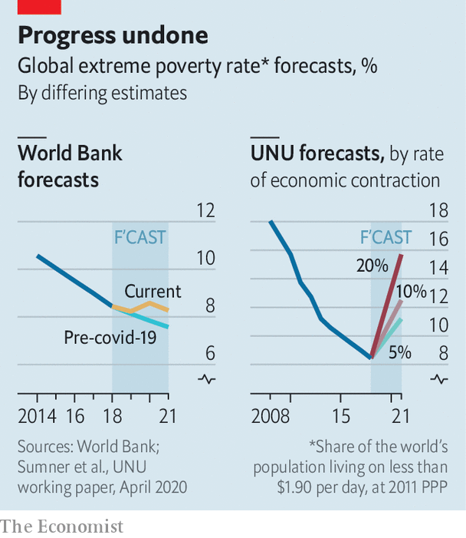

As the number of breadwinners falls, the price of food is rising. In India the price of potatoes has jumped by over 15%. In Uganda the prices of most key foods have gone up by over 15% since mid-March. The global food supply is holding up, but local disruptions are severe. In the province of Quezon in the Philippines an “extreme” quarantine has seen squash, beans, and watermelons wither in the fields. In India vegetables that were harvested have been left to rot as they cannot be transported to market. In East Africa covid-19 is not the only plague to strike this year: trillions of locusts are once again devouring crops.

Some hope that the rural poor may escape the worst. The virus has taken longer to reach remote villages, where social distancing is easier than it is in slums. Subsistence farmers might be able to feed themselves. But even the poorest rural households in Africa buy almost half their food. Many would normally top up their income with paid work, but no longer can.

Those who were already miserable have become more so. In Uganda the WFP has cut rations for refugees by 30%, and funding is drying up. In Bangladesh more than 70% of Rohingya refugees say they are now unable to buy food.

The most concentrated suffering will be in big cities such as Kolkata and Kinshasa, says Ms Sánchez-Páramo. Even before the pandemic about 130m city-dwellers were extremely poor. Many kept their heads above the poverty line by pedalling rickshaws or hawking vegetables. Lockdowns have stopped that. In India 84% of poor urban self-employed have lost their work.

Even where lockdowns are less strict, the urban poor are struggling. In Mexico City, where staying at home is more of a suggestion than a requirement, Romaldo San Juan Garcia normally spends his days polishing shoes. But these days the kind of people who can afford shoe-shines no longer wear leather shoes, since they are staying away from the office. In a long day on the street Mr Garcia polished only two pairs. Just to pay his monthly rent, he needs to shine about 100. In tough times his children would usually pick up extra shifts waiting tables. But because of the virus, the restaurants are shut.

With so few other options, many of the newly destitute are doing things that will make it harder for them to escape poverty even if the economy recovers. They are eating less, selling productive assets and even pulling children out of school.

“When I eat supper it means I will sacrifice lunch,” explains Nathan Tumuhimbise, a flower worker in Uganda who was sent home on unpaid leave. He has no idea whether he will be able to pay for his daughter’s next instalment of school fees. In desperation he has called his father in the village to sell some of the family goats. “I’m overwhelmed,” he says. Other workers he knows are even selling off their land. Why? “Survival, life and death,” he says.

Assets such as land, livestock and motorbike taxis can be sold only once. When so many people try to sell them at the same time, prices collapse. And people who sell their productive assets today will have no source of income tomorrow.

Cutting back on food is risky, too, especially for children. Malnutrition stops brains and bodies from growing properly. Stunting results in lower IQs, greater risk of chronic illness and lower lifetime earnings. In towns in Sierra Leone almost 60% of people said they had eaten fewer times than normal in the past week, according to the Yale Research Initiative. Fully 14% have gone a whole day without eating.

Pulling kids out of school has awful long-term consequences. One World Bank paper found that if schools remain closed for just four months, the reduction in their lifetime earnings will be equivalent to 15% of a year’s global GDP.

## We’re here to help

Governments can help. Fully 181 countries have announced extra efforts to protect the poor, about 60% of which involve cash or food aid. For millions, these have proven a lifeline. Ganesh, an auto-rickshaw driver in Delhi, says he was lucky to spot an advert about a state government scheme to pay idle auto drivers a one-off 5,000 rupees (about $70). He texted in his ID and soon got the money. However, the vast majority of the cash in all these new welfare schemes is in rich countries. In the poorest ones, extra social spending announced so far amounts to just $1 per head—in total, not per day. Other drivers applied for help too, says Ganesh, but they have not received anything.

Existing safety nets have long focused on rural folk, which used to make sense because they were the poorest. However, many of the newly poor are in cities. Systems need to adapt, but many are badly managed. India’s federal programme of cash and food handouts is scattershot and misses many of the neediest. In Uganda the government’s own spokesperson described its efforts to get aid to the right people as “inadequate, incompetent, disorganised.” Egypt has managed to get payments only to 2m of its 100m people.

In countries such as Kenya and Bangladesh mobile money is being used to distribute aid more quickly. But the poorest are often hard to reach. Governments often do not know who they are. And welfare systems were not designed with pandemics in mind. In South Africa delays have led people to form queues (not always socially distanced ones) outside post offices to sign up for benefits. In many countries corruption limits the effectiveness of welfare. In Zimbabwe aid has been steered to supporters of the ruling party. In Uganda MPs initially put themselves in charge of distributing $2.6m of relief cash in their constituencies (a court ruled they should pay it back).

The biggest problem, though, is simply that governments in the poorest countries do not have much money. And they are getting poorer. The World Bank says that African government revenues will drop between 12% and 16% this year. In Nigeria, home to more extremely poor people than any other country, the collapse of the oil price has shredded government spending plans. During the global financial crisis many poor countries slashed spending on education; they may do so again.

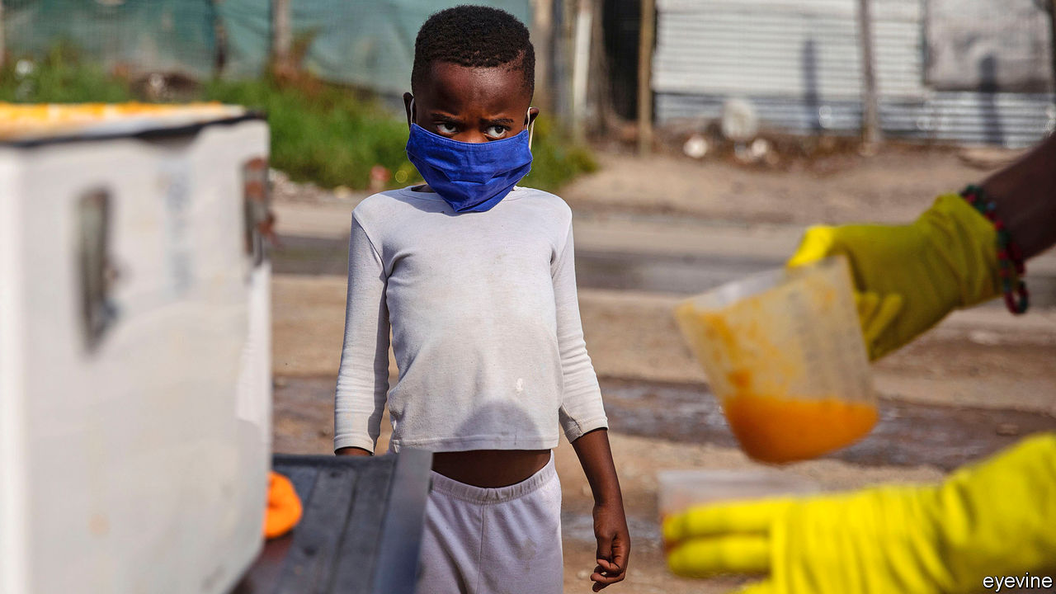

He needs protection, too

All this has prompted calls to ease lockdowns. That will not save poor countries from being battered by the global economic crisis. Nor will all businesses reopen if people are still scared of being infected. But at least the poor would be able to try to work and children would be able to get vaccinations.

Nigeria has already loosened lockdowns in some big cities, even as cases rise. Bangladesh and Pakistan have eased up, too. India will open up somewhat next month. This is not always popular—after two weeks shut in, 82% of Indians supported the first extension there. Ghana, one of the first in Africa to remove some restrictions, shows the risks. In one fish factory, 533 workers were recently infected.

## Lock down smarter

However, the choice is not binary: total lockdown or no precautions at all. Governments and citizens can do a lot to prevent infections without freezing the whole economy. They can protect the elderly while letting most adults go to work and children go to school. They can keep nightclubs closed but allow markets, bus stations and factories to open—with compulsory masks, hand-washing and social distancing. They can do a better job of spotting outbreaks and quarantining the infected. They can teach people the facts about the disease, so they can protect themselves. Community health workers did this well during the Ebola crisis.

Whatever the approach, poor countries will need help from developed ones. Rich countries have spent a stunning $8trn on supporting their own citizens during the pandemic, notes Homi Kharas of the Brookings Institution, a think-tank. It is in their interest to help poor countries grapple with the disease—otherwise they will become a coronavirus reservoir that can reinfect the rich. Yet the international response has been “very go slow”, says Matthew Spencer of Oxfam, an NGO. So far the IMF and World Bank have lent about $20bn and $6bn respectively. Talks about debt relief are moving lethargically.

In the past, crises have sometimes fostered solidarity with the poor, notes Amartya Sen of Harvard University. In Britain during the 1940s life expectancy shot up by seven years, thanks to a wartime rationing system that ensured everyone had nourishing (if dull) food. According to a forthcoming UN Development Programme study between 2013 and 2016, despite an Ebola epidemic, living standards in Sierra Leone improved faster than in any of 70 poor countries. The huge effort to fight Ebola had spillover effects, as aid-workers and public servants also helped improve nutrition and child mortality. It would be wonderful if covid-19 could inspire similar efforts. But for now, the rich world is too distracted by its own problems to pay much heed to the poor.■

This article was downloaded by calibre from <https://www.economist.com/international/2020/05/23/covid-19-is-undoing-years-of-progress-in-curbing-global-poverty>

|  |  |  |  |
| --- | --- | --- | --- |
|  | Articles | Sections | Next |

|  |  |  |
| --- | --- | --- |
| International | Sections | Finance & economics |

Business

Chip wars: Immaculate misconceptions

.

SoftBank: Born again

.

Indian capitalism: Elephants in the room

.

Walmart: A nimble beast

.

Bartleby: Zoomers, zeros and Gen Z

.

Schumpeter: Closing time

.

|  |  |  |
| --- | --- | --- |
| International | Sections | Finance & economics |

|  |  |  |  |
| --- | --- | --- | --- |
|  | Articles | Sections | Next |

#### Immaculate misconceptions

# America’s latest salvo against Huawei is aimed at chipmaking in China

It may push the industry out of America, too

May 23rd 2020 | HONG KONG

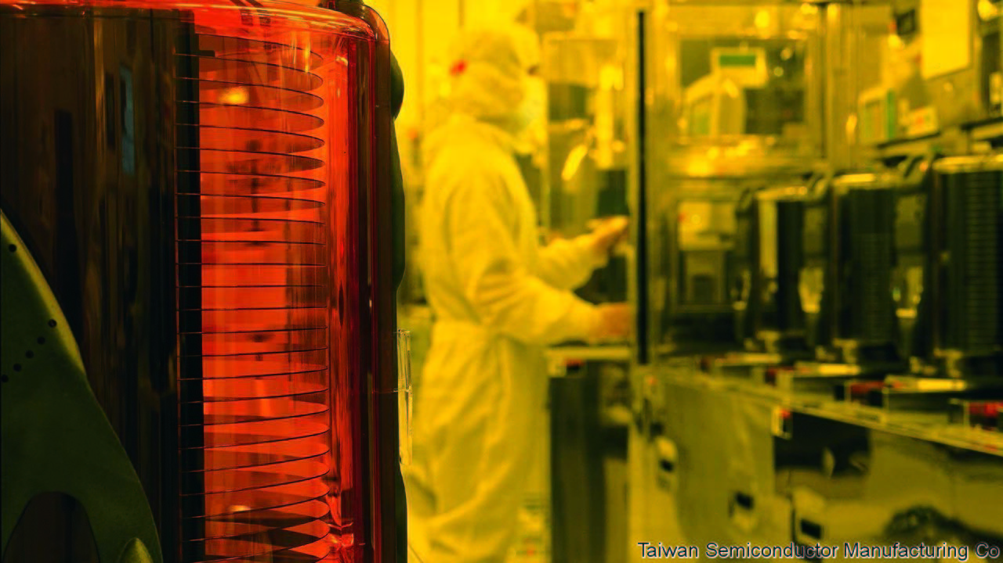

AMERICA HAS it in for Huawei—and not just because some of its politicians fear the Chinese giant’s networking gear lets spooks in Beijing eavesdrop on customers’ communications. The firm, a world leader in futuristic 5G telecoms, also symbolises China’s technological and economic ascent. President Donald Trump does not like it one bit. William Barr, his attorney-general, has warned that America risks “surrendering dominance” to China if it cannot “blunt Huawei’s drive” to 5G supremacy.

An earlier attempt at blunting, which made it illegal to sell American-made components to Huawei, including advanced computer chips on which the Chinese firm relies, was not the knock-out blow the White House hoped it to be. Chipmakers were able keep shipping Huawei semiconductors from factories outside America. So on May 15th the Trump administration extended its restrictions from chips to the tools used to make them—many of which come from America. So long as big microprocessor producers, like Taiwan Semiconductor Manufacturing Company (TSMC), use American-made equipment, they will no longer be able to forge Huawei-designed chips anywhere in the world.

In a press conference on May 18th a reticent Huawei said that the new rule put its survival at risk. Three days later President Xi Jinping vowed to invest $1.4trn by 2025 to increase China’s tech independence. Yet as with America’s original restrictions, the latest blast in the Sino-American chip war may not end up having the intended effect.

## Playing dirty in the clean room

The new rule may miss its target entirely. Huawei pays contract manufacturers to assemble its phones and base stations. The chips that TSMC makes for Huawei are sent to those companies, not to the Chinese firm, for integration. Finished products are usually sent directly to Huawei’s customers. Huawei need not touch the blacklisted chips at any point. This may get Huawei off the hook. Some lawyers note that the new restriction does not seem to apply to items sent to third parties and not destined for Huawei, even where these are being supplied at Huawei’s direction.

Even if the legal experts are wrong, the rule will be difficult to enforce: the clean rooms of Asian chip foundries are hard to monitor. More important, the $412bn semiconductor industry is so globalised that even the long arm of American law will struggle to pin it down. The likelier upshot of the new export controls may be to drive a portion of America’s chipmaking industry from its shores.

The industry’s geographic scope was already becoming broader—and less American—over time. One crude yardstick for this is to track where its physical assets sit, as recorded in the filings of public tech businesses (see chart). The top dozen global semiconductor firms, for example, now have only 20% of their plant in America. Asian firms, such as TSMC, SMIC and Samsung, mostly locate their factories at home. American chipmakers, meanwhile, and many suppliers, have been diversifying geographically for years, says Dan Hutcheson of VLSI, a consultancy—partly in pursuit of cheap labour, partly to protect against natural disasters.

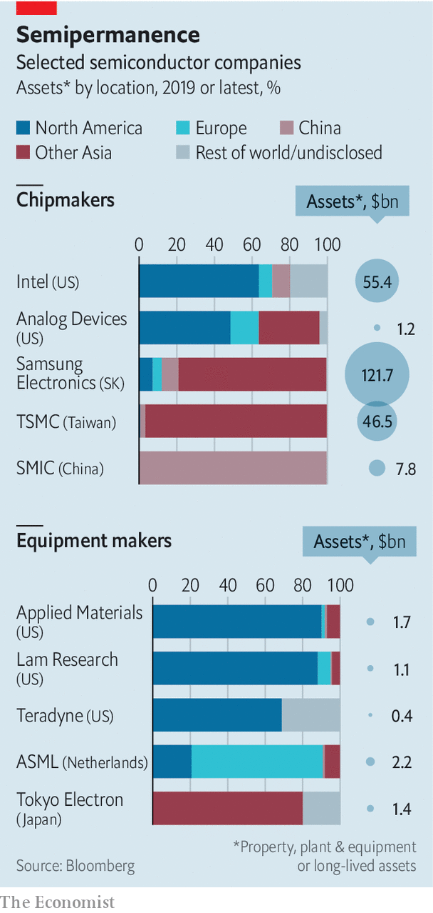

Consider Intel, which makes chips of its own design for customers (among them Huawei) that assemble electronic devices. In 2019 the American giant had over 35% of its $55bn in physical assets, a rough proxy for manufacturing capacity, abroad. Some $8bn-worth sat in Israel and another $4bn in Ireland. Industry insiders report that China-bound shipments from both places have increased since America’s Huawei-baiting began. Intel also has more than $5bn in assets in China, its biggest market. All told, $20bn of its $72bn in revenues last year came from China.

Another example is Analog Devices, a smaller American firm which makes radio-frequency chips on which Huawei relies heavily for the assembly of telecoms base stations. It, too, is spread around: half of its assets sit in the Philippines, Ireland, Singapore and Malaysia. Perhaps that might make it easier for the firm to explore the option of making its Huawei-bound chips in non-American facilities.

Geographic complexity has made it hard for America’s government to stop chipmakers’ kit from reaching Huawei. Hence the new focus on chipmaking tools, many of which are still made in America and so easier for Washington to control. Applied Materials, based in California, builds kit used to etch patterns into silicon, has 90% of its assets in the United States. Lam Research, an American maker equipment used by TSMC and others to process silicon wafers, has 88% of its $1.1bn plant at home.

One big unknown surrounding the new Huawei rule—which the chip industry’s lawyers are busily unpacking—is whether, under it, equipment manufactured at American firms’ overseas facilities counts as “American”. If so, advanced chipmaking factories that rely on such kit to fabricate cutting-edge chips for Huawei, as TSMC does, will need alternative suppliers. The American toolmakers’ Japanese rivals, such as Tokyo Electron and Hitachi High-Technologies, suddenly find themselves with a new geopolitical competitive edge.

Another mystery relates to an announcement made just as the new American measures against Huawei were being unveiled. On May 15th TSMC confirmed it would build a $12bn chip factory in Arizona, to be up and running by 2024. Why would the Taiwanese firm, which gets 15% of its revenue from Huawei, agree to pour billions into America just as its new host in effect deprived it of a big customer? It may be currying favour with the administration, hoping to avert sanctions against more Chinese customers. Observers point to another possibility. TSMC could equip the Arizona foundry with American gear from its existing factories, freeing space in its Taiwanese operations for brand new non-American kit that can freely serve Chinese customers. TMSC did not respond to a request for comment.

Even if that is not TSMC’s intention, workarounds are bound to proliferate. On May 18th the boss of Samsung Electronics toured his company’s new chip factory in Xian, a city in central China. The South Korean firm, which plans to invest $115bn in its chipmaking business over the next decade, has made it clear that it will not ignore China. America’s export controls may prompt it to kit out its foundries with equipment that will not fall foul of Sino-American geopolitics.

Chip-industry insiders report that semiconductor equipment is already being marketed inside China as “EAR free”—meaning Chinese buyers need not worry about the “export administration regulations” that the Trump administration is using to attack Huawei. A person close to American toolmakers says some of them are thinking about moving their patents abroad to rebuild operations from scratch away from America’s jurisdiction, in order to circumvent present and future anti-Chinese restrictions. Mr Trump’s attempt to de-Sinify the semiconductor industry may do more to de-Americanise it instead. ■

This article was downloaded by calibre from <https://www.economist.com/business/2020/05/23/americas-latest-salvo-against-huawei-is-aimed-at-chipmaking-in-china>

|  |  |  |  |
| --- | --- | --- | --- |
|  | Articles | Sections | Next |

|  |  |  |  |
| --- | --- | --- | --- |
| Previous | Articles | Sections | Next |

#### Born again

# SoftBank is a big beneficiary of the Fed’s pandemic response

Now the Japanese technology group hopes a tech rally will boost its huge but underperforming startup fund

May 21st 2020 |

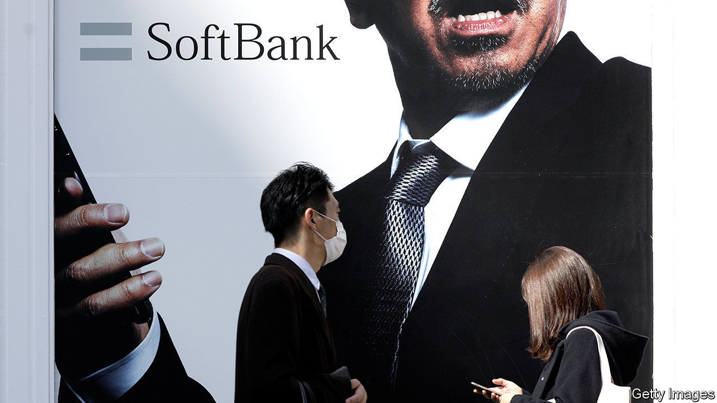

SHARES IN SOFTBANK, a Japanese conglomerate, have gained almost 70% in value since mid-March, more than twice as much as Tokyo’s Nikkei stockmarket index. One big reason is $23bn in share buy-backs, announced in March and now under way. Another is central-bank activity. In April America’s Federal Reserve started buying junk debt.

Two months ago fears that SoftBank’s debt-addiction could spell ruin sent its own junk bonds tumbling; now yields have fallen. This has given SoftBank’s eccentric boss, Son Masayoshi, a confidence boost, even as he reported a record $8.8bn loss for the year to March on May 18th. Rather than repent and praise the Fed for the manna from monetary heaven, Mr Son likened himself to Jesus.

Just as the saviour was misunderstood in his day, Mr Son mused, so is he—specifically with respect to the Vision Fund. The tech-investing vehicle, 48% of whose equity came courtesy of SoftBank, lost $17.7bn in the past year, mostly on paper and in the last quarter. The fund runs until 2029 so needn’t divest. Since 2017 it has booked $4.9bn of realised gains and $200m of realised losses. Add paper ones and you get an overall loss of $800m, or 1% of the fund’s $81bn investments—“not bad”, Mr Son said, considering the market meltdown.

The pandemic is a handy cover for trouble that began a few years ago, when Mr Son started overvaluing WeWork, an office-sharing firm, and other startups. The resulting financial hit—and a loss of confidence in Mr Son—forced SoftBank into the buy-backs. They will be partly financed by selling forward contracts on some of its lucrative 26% stake in Alibaba, China’s e-commerce titan, and, maybe, $20bn of its stake in T-Mobile, an American telecoms firm. This week SoftBank said Jack Ma, Alibaba’s founder, would step down from its board.

With technology shares soaring, especially in America, some of the Vision Fund’s 88 startups may prosper post-pandemic. SoftBank could list a few over the next couple of years, reckons Atul Goyal of Jefferies, a bank. One of the fund’s biggest bets is ByteDance, owner of TikTok, a hit video app. The Chinese firm’s valuation has reportedly risen to over $100bn of late. Without the Fed’s moves, says Mr Goyal, Mr Son would have struggled under the weight of debt. Now he has a shot at redemption.

This article was downloaded by calibre from <https://www.economist.com/business/2020/05/21/softbank-is-a-big-beneficiary-of-the-feds-pandemic-response>

|  |  |  |  |
| --- | --- | --- | --- |
| Previous | Articles | Sections | Next |

|  |  |  |  |
| --- | --- | --- | --- |
| Previous | Articles | Sections | Next |

#### Elephants in the room

# India Inc’s profits increasingly belong to a tiny clutch of companies

Just 20 firms account for 70% of all corporate earnings

May 21st 2020 | DELHI



AROUND THE world industries have grown more concentrated over the past few decades. In America 20 companies capture roughly a quarter of all corporate profits. If you thought that was sobering news for budding American capitalists, spare a thought for their Indian counterparts. According to a study by Marcellus Investment Managers, a Mumbai-based firm, last year a score of companies accounted for nearly 70% of India Inc’s total earnings, up from 14% three decades ago (see chart). In a growing number of product categories—from paint and adhesives to biscuits and baby formula—monopolies or duopolies skim off 80% of profits.

Broadly, Marcellus’s top 20 can be split into three groups. The first contains well-run companies with strong management of capital and data. They inhabit vibrant sectors like information technology (notably Tata Consultancy Services and Infosys), finance (for instance, HDFC bank) and consumer goods (ITC, a cigarette-maker). Their capital costs are low; HDFC can fund itself more cheaply than India’s government. So is their level of debt—a blessing given that India Inc pays average interest of 9.25% on credit, three times as much as a typical American firm. ITC and the IT consultancies are in effect debt-free.

Companies in the second group are unusually lucrative for less deserving reasons. They include state-controlled remnants of Nehruvian socialism. They can count on cheap loans from state-owned banks and, often, cosy monopolies (like Coal India’s, until the government ended it to fight covid-19). This group is shrinking, albeit slowly: Marcellus’s top 20 contained seven state-owned firms in 2019, down from 13 in 2004.

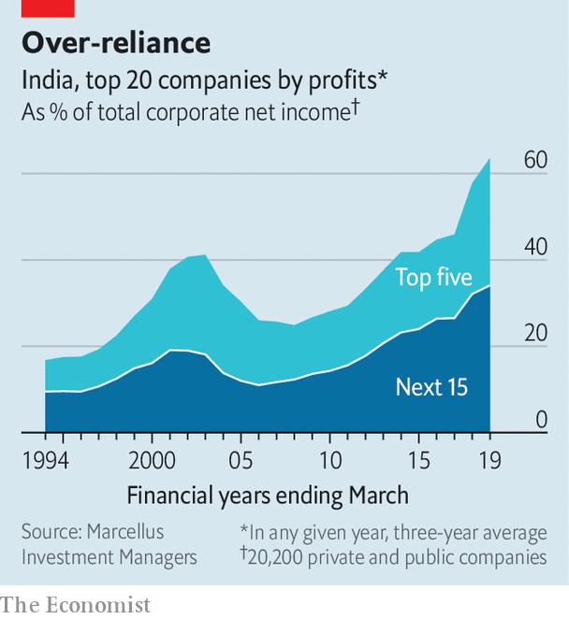

The last bucket blends the other two. These are huge private companies with mediocre returns but a knack for navigating both India’s labyrinthine bureaucracy and its corridors of power. They operate in heavily regulated industries: Larsen & Toubro, an engineering group, builds roads; Hindustan Zinc, a subsidiary of London-listed Vedanta Resources, is a big miner.

The canonical example is Reliance Industries. Its net income last year of $5.2bn made it India’s most profitable firm—and accounted for 13% of the country’s corporate profits. Its businesses range from a core refining operation to the disruptive Jio mobile network. Despite negative cashflow and a meagre 7% return on capital, investors cannot seem to get enough of it. Reliance recently announced that Facebook and three large American private-equity firms, Silver Lake, Vista Equity Partners and General Atlantic, will buy large stakes in Jio. They may reasonably have concluded that it can count on continued support from its parent, which is alone in having featured among the top 20 profit-makers every year since 1992. ■

This article was downloaded by calibre from <https://www.economist.com/business/2020/05/21/india-incs-profits-increasingly-belong-to-a-tiny-clutch-of-companies>

|  |  |  |  |
| --- | --- | --- | --- |
| Previous | Articles | Sections | Next |

|  |  |  |  |
| --- | --- | --- | --- |
| Previous | Articles | Sections | Next |

#### A nimble beast

# Walmart ekes out an edge in groceries during the pandemic

America’s biggest retailer has outshone Amazon when it comes to food

May 23rd 2020 | NEW YORK

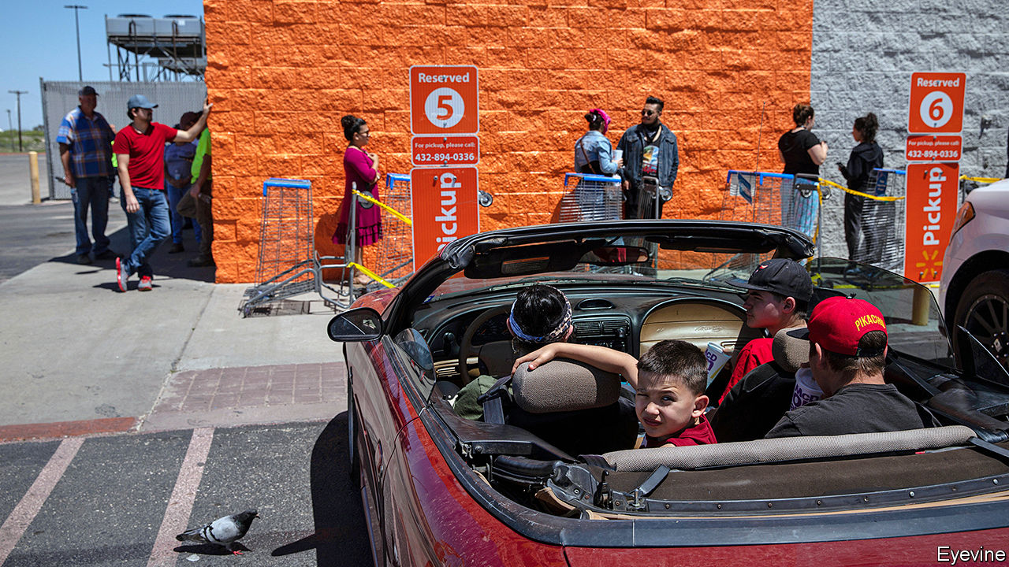

AS COVID-19 began to spread across America shoppers rushed to stock up on pasta, hand-sanitiser and loo roll. Other things equal, that should be good news for purveyors of these and other essentials. But other things are not equal: social-distancing restrictions have disrupted retailers’ supply chains and their operations. Amazon, whose e-commerce empire reported record sales in the first quarter, booked lower profits as a result of ballooning pandemic-related expenses. Could Walmart, with a quarter of America’s grocery market, 5,000-plus stores and 1.5m employees in America, including 235,000 temporary ones hired to cope with coronavirus-fuelled demand, cope any better with the pandemic?

On May 19th the answer came in Walmart’s earnings report for the three months to April. It was a resounding “yes”. Total revenue shot up by 9%, year on year, the highest rate in nearly two decades, to $135bn. Same-store sales rose faster still. The firm’s “omnichannel” sales, which combine online shopping with in-store pick-up, surged by 74%. Unlike Amazon, it also saw quarterly net income rise relative to the same period last year, by 4% to $4bn, despite nearly $900m in corona-spending (on things like “co-payments” for employee health bills, higher wages and bonuses for workers). The Arkansan behemoth is proving not only essential but nimble, too.

The sales surge was not just the result of panic-buying—though there was that, too, especially in March, when the firm reported “unprecedented demand” for staples, which pushed monthly revenues up by 15%, year on year. Things slowed down in April, once the initial panic eased. But only a bit: sales grew by 9.5% compared with the same month last year, nearly three times the rate in February, as Americans spent some of their stimulus cheques from the government on higher-margin feel-good purchases like clothes and video games.

Walmart’s performance owes much to its renowned ability to contain expenses—or at least not let them spiral out of control. The cost of sales rose by around 10%, year on year, last quarter, roughly in line with revenues.

But the company has also displayed dexterous management. Paul Lejuez of Citigroup, a bank, points out that before covid-19 it offered a “ship from store” service from about a hundred of its locations. As its 45 online fulfilment centres became overwhelmed, it quickly expanded that to some 2,500 stores. It piloted a two-hour delivery service at 100 stores in April, and has already expanded it to 1,000 stores. It plans to double that within weeks.

Walmart allows shoppers to order groceries online and then get them delivered or pick them up at drive-through stations. Such blended purchases of food products helped drive the rise in omnichannel sales, the firm says. They are well suited to times when fear of infection puts shoppers off jam-packed supermarket aisles.

It is here that Walmart has really outshone Amazon, which has yet to crack groceries. Whole Foods, Amazon’s upmarket chain of food shops, is virtually nonexistent outside big cities and too pricey for most Americans, especially the millions on the dole amid the covid-19 slump. Cheaper Amazon Fresh has struggled to cope with demand. Some shoppers fed up with delayed deliveries turned instead to Walmart, a trusted brand with “everyday low prices”. The firm says the number of people placing online orders rose fourfold in the quarter, compared with a year ago.

This has allowed Walmart at last to reap rewards from years of e-commerce investments once seen as a money pit. The firm does not disclose figures but by the reckoning of Simeon Gutman of Morgan Stanley, an investment bank, Walmart has so far invested a total of $15bn in online operations, which made a loss of over $1.6bn last year. Now Mr Gutman is encouraged by the improved outlook for e-commerce profits, thanks to those higher-margin purchases. Doug McMillon, Walmart’s boss, told analysts that his firm has expanded the assortment to “much more than grocery”.

Some new customers who have sampled Walmart’s digital offering because their favoured retailer was closed or unavailable may not stick around once things get back to normal. But Mr Lejuez, pointing to evidence from the last recession, thinks the firm may hang on to many of them.

His view is bolstered by a survey by Greg Melich of Evercore, an advisory firm. It reveals that, in antepandemic America (ie, February), consumers of all ages expected to purchase ever less from bricks-and-mortar shops. No surprise there. More revealing was the finding that shoppers also thought they would buy less from purely online shops—but more from retailers that, like the beast of Bentonville, mix bricks with pixels. ■

Editor’s note: Some of our covid-19 coverage is free for readers of The Economist Today, our daily [newsletter](https://my.economist.com/user#newsletter). For more stories and our pandemic tracker, see our [hub](https://www.economist.com/news/2020/03/11/the-economists-coverage-of-the-coronavirus)

This article was downloaded by calibre from <https://www.economist.com/business/2020/05/23/walmart-ekes-out-an-edge-in-groceries-during-the-pandemic>

|  |  |  |  |
| --- | --- | --- | --- |
| Previous | Articles | Sections | Next |

|  |  |  |  |
| --- | --- | --- | --- |
| Previous | Articles | Sections | Next |

#### Bartleby

# Zoomers, zeros and Gen Z

The pandemic has widened two divides in the labour market

May 23rd 2020 |

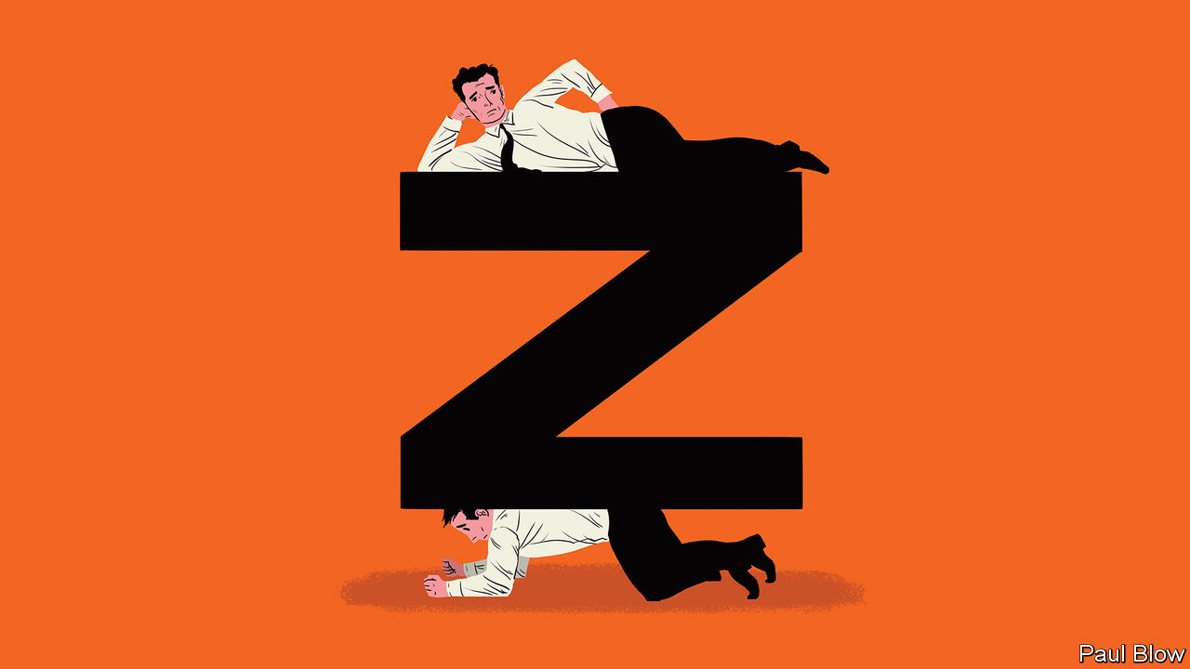

COUNTRIES ARE beginning to emerge from economic lockdown. As they do, the statistics show how different segments of the population have been affected by the pandemic. And the evidence is clear that the virus has widened existing divides between professionals, low-paid workers and the young.

Start with the most fortunate. Many professionals can easily work at home, replacing one-to-one meetings with phone calls and group meetings with Zoom gatherings or Google hangouts. These “Zoomers” are mostly working on full pay and are currently being spared the daily commute. For them, the lockdown may be an inconvenience (particularly if they have children) but it is not a threat to their standards of living.

For many others, however, the pandemic is a serious threat. Some are key workers, who have to attend their jobs and are at more risk from the virus. Others cannot work from home and have either lost their jobs or seen their incomes cut (despite help from government schemes). Many in this group were already in a weaker position than the Zoomers, because they were in jobs with lower wages or less security.

Some people in this less fortunate group can be dubbed the “zeros”. In Britain, almost three-quarters of those on zero-hours contracts are key workers or work in shut-down sectors, says the Resolution Foundation, a think-tank.

A further clue to the toll on the low-paid came from the latest American non-farm payroll figures. Average hourly earnings rose by 4.7% in April, the biggest monthly gain on record. That sounds like good news but isn’t. It is the result of low-wage workers losing jobs in sectors like hospitality. The same trend can be seen in Britain, where the average wage of those in shut-down sectors is less than half of those working at home, according to the Resolution Foundation.

The mortality rates make even grimmer news. The low-paid (and ethnic minorities) have suffered most. Figures from Britain’s Office for National Statistics showed that death rates of security guards, care workers and bus drivers were much higher than average, while those in “professional occupations” had death rates well below the mean.

Another great divide is between those already established in the workforce and Generation Z—those born in the late 1990s and early 2000s who are now coming of age. They are entering a job market extremely hostile to their prospects. Around 30% of British employees aged under 25 worked in one of the shut-down sectors, according to the Institute for Fiscal Studies, another think-tank, compared with 13% of those aged over 25.

Those in university education are also badly affected. For a start, it is harder to get work experience. In America 22% of employers have cancelled internship offers, according to the National Association of Colleges and Employers. In the first week of May just under 2,500 internships were posted on Monster.com, a recruitment website, compared with over 18,000 in the same week last year. Many of the remaining internships were in roles which could be done remotely. In Britain firms have cut entry-level jobs by 23%, says the Institute of Student Employers, a recruiters’ association.

The short-term shock of the pandemic will leave long-term scars. The Resolution Foundation estimates that the pandemic means those emerging from education this year will be less likely to have jobs in three years’ time. The likelihood of being in employment would fall by 13% for graduates and 37% for those with the fewest qualifications.

The effect could last into the 2030s. A study of the effect of recessions on younger workers by Bart Cockx of Ghent University in Belgium found that it takes about ten years for cohorts that enter the labour market during a downturn to catch up with cohorts that did not.

At least young people are far less likely to suffer severe symptoms from the virus than older generations. But the economic hit comes at a time when many already worry about the burden of student debt and the lack of well-paying jobs: a survey last year by Deloitte, a consultancy, found that a third of Gen Z-ers who planned to move jobs felt there were not enough opportunities to advance in their careers.

That the low-paid and the young are the hardest hit economically by the pandemic is a dark echo of the King James Bible: “But whosoever hath not, from him shall be taken away even that he hath.” The social and political consequences may be huge.

Editor’s note: Some of our covid-19 coverage is free for readers of The Economist Today, our daily [newsletter](https://my.economist.com/user#newsletter). For more stories and our pandemic tracker, see our [hub](https://www.economist.com/news/2020/03/11/the-economists-coverage-of-the-coronavirus)

This article was downloaded by calibre from <https://www.economist.com/business/2020/05/23/zoomers-zeros-and-gen-z>

|  |  |  |  |
| --- | --- | --- | --- |
| Previous | Articles | Sections | Next |

|  |  |  |  |
| --- | --- | --- | --- |
| Previous | Articles | Sections | Next |

#### Schumpeter

# Farewell for now to a golden age of drinking

The pandemic has hurt the booze business

May 23rd 2020 |

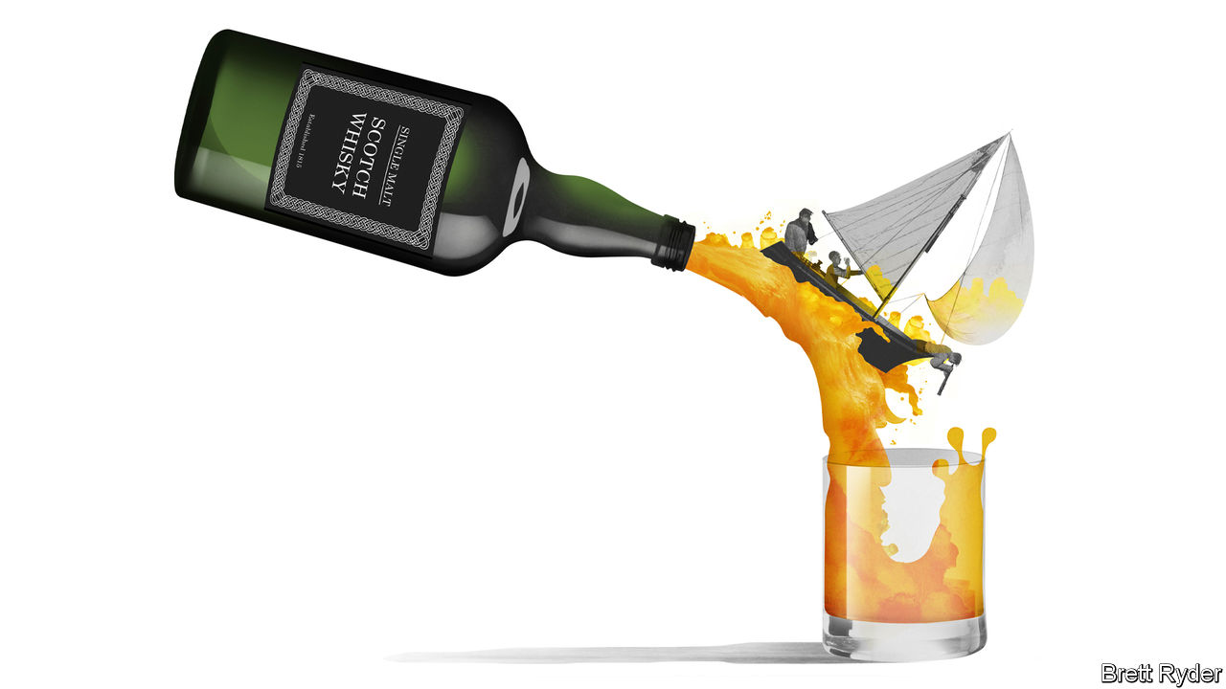

A YEAR AGO your columnist joined a sailing trip to Islay, an island in western Scotland famous for peaty malt whisky that can singe the hair off your nostrils. The mooring was in front of a distillery called Ardbeg, its name painted in huge black letters on a whitewashed wall facing the sea. Its breakfast included haggis—and a dram of scotch. Then came the distillery tour, and more samplings. Even at midnight, the air reeked with the smoky vapours coming from the mash tun. Night workers cooed over the spirit as it flowed through pipes and jars. They said demand was so strong that production was running round the clock.

Thanks to such artisan devotion, in recent years the $1.5trn booze business has become a gilded one. For the well-heeled (or deck-shoe clad), brands like Ardbeg, owned by LVMH, a French luxury-goods firm, could sell rare whiskies at more than $100 a bottle. Champagne had record turnover last year, and among still wines even rosé, long frowned upon by connoisseurs, developed a cachet. Financially, the biggest drinks companies performed a feat of mixology that would make a bartender blush. As overall volumes declined in the West, firms like Diageo and Pernod-Ricard coaxed people into spending more on higher-quality brands, sharply increasing profits. Brewers, led by Anheuser-Busch InBev (ABI) and Heineken, acquired competitors and slashed costs, creating a high-margin duopoly in some emerging markets.

Yet the greatest effervescence was at the hipster level. Innovation, in the form of craft beers, locally distilled gins and mezcal bars, fizzed with the energy of the cocktail age in late 19th-century America. That helped revitalise gourmet culture and inner-city life (as well as irrigating a bizarre beard-revival).

So far covid-19 has not been a full-blown disaster for the drinks business. The speed with which the wines-and-spirits stock in Schumpeter’s drinks cupboard has dwindled in recent weeks proves that drinking is not just a way to celebrate good times but to endure bad ones. Sales for home consumption have boomed. Yet even if there is plenty of pent-up demand for social lubrication when lockdowns end, a golden age of booze is probably over.

The immediate reasons for this are social distancing and economic hardship. The first may have the more detrimental impact on wine-and-spirits producers. They are overwhelmingly reliant on bars, nightclubs and duty-free shops, where markups of 30% are common, to encourage consumers to experiment with fancier tipples. Such “premiumisation” is crucial for profits, observes Mark Meek, who runs IWSR Drinks Market Analysis, a data-gatherer. It may suffer as people remain wary of crowds or travel; a wave of recent infections in Seoul’s night spots is a bad omen. The continued rationing of restaurant space, sports and mass entertainment will further depress sales of beer, wine and champagne. Without a vaccine, many of these activities may take years to recover, Mr Meek says.

The economic situation is the second blight. This is likely to hurt brewers more than other drinks companies. That, at least, was the experience during the financial crisis a decade ago, when beer and cider sales went from 6% growth in 2007 to a 1% decline in 2009. ABI is particularly vulnerable: weighed down by $96bn in net debt, it is unable to diversify away from beer. But sales of wines and spirits for drinking at home will suffer, too. Firms will probably try to promote their most affordable brands, reducing margins. Even Ardbeg has gone downmarket with a youthful five-year-old whisky called Wee Beastie.

Lockdown and its aftermath leaves craft firms most exposed. Some have been bought by industry giants; ABI now owns Goose Island and Camden Town Brewery. But many still sell from their own small premises, making it harder to attract social-distancing customers. Even in good times many barely covered their costs. Being small, they have less leverage to force their wares onto supermarket shelves. Some will either be sold or sluiced down the drain. Inevitably, the industry will lose some of its creative fizz.

In addition, two longer-term threats loom on the horizon: demography and drugs. Studies show that Generation Z, the eldest of whom have recently reached drinking age, are far less likely to consume alcohol than their elders, says Javier Gonzalez Lastra of Berenberg, a bank. That will affect the drinks industry for years to come, because peak alcohol consumption has traditionally been between the ages of 18 and 34. Partly as a result, in America, historically the world’s biggest drinks market, total alcohol sales volumes have declined for three years in a row. Overlapping with youthful sobriety is cannabis use. A report co-written by IWSR last year found that this was an emerging alternative to booze among the young. Millennials in America accounted for almost half of “dualists”, who both smoke pot and imbibe. Covid-19 could benefit cannabis further. In Schumpeter’s limited experience, pot-smoking has always been something of a furtive activity. That may make it better suited to social distancing than clinking glasses in a pub.

## Grant me temperance, but not yet

Drinks firms can take some comfort from China, where covid-19 fears are on the wane. Punters there are once again queuing up to enter bars. The share price of Kweichow Moutai, China’s most exclusive brand of baijiu firewater, continues to soar, hinting at a thirst for luxury tipples among the super-rich. And some quarters are abuzz about the potential of e-commerce to reshape the business, arguing that if producers can use technology to sell booze directly into the home rather than through supermarkets, they can gain a better understanding of how to get deeper down drinkers’ throats. There will, to be sure, be more opportunities to innovate. But for now most of the excitement will be about new direct-to-consumer business models, rather than new types of exotic liquor. Business innovation is always alluring. Not quite in the same way as whisky fumes in the nostrils, though. ■

Editor’s note: Some of our covid-19 coverage is free for readers of The Economist Today, our daily [newsletter](https://my.economist.com/user#newsletter). For more stories and our pandemic tracker, see our [hub](https://www.economist.com/news/2020/03/11/the-economists-coverage-of-the-coronavirus)

This article was downloaded by calibre from <https://www.economist.com/business/2020/05/23/farewell-for-now-to-a-golden-age-of-drinking>

|  |  |  |  |
| --- | --- | --- | --- |
| Previous | Articles | Sections | Next |

|  |  |  |
| --- | --- | --- |
| Business | Sections | Schools brief |

Finance & economics

Sovereign-wealth funds: Raid on the piggy banks

.

The World Trade Organisation: Trading places

.

Buttonwood: Darcy and debt

.

All work and no play: Economic recovery

.

Banking in Africa: Borrower beware

.

Free exchange: The land down under

.

|  |  |  |
| --- | --- | --- |
| Business | Sections | Schools brief |

|  |  |  |  |
| --- | --- | --- | --- |
|  | Articles | Sections | Next |

#### Raid on the piggy banks

# Sovereign-wealth funds face lean years

Revenues have fallen, and governments are eyeing their riches

May 23rd 2020 |

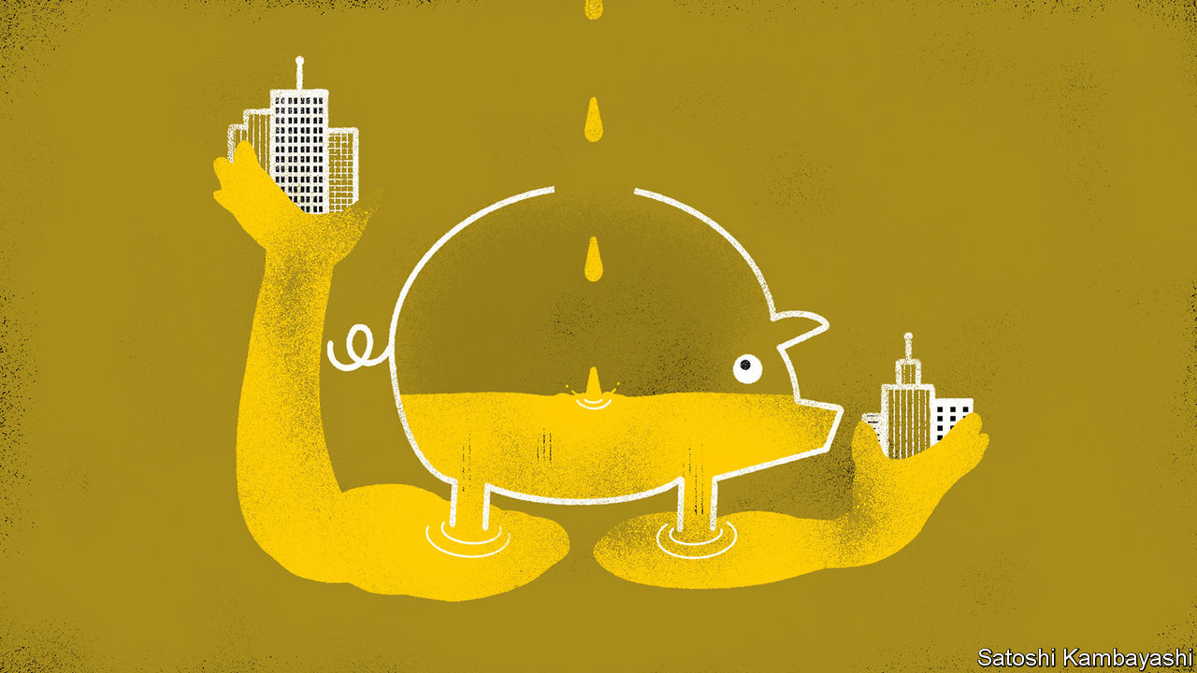

EVERY OTHER Monday Kirill Dmitriev, the boss of the Russian Direct Investment Fund (RDIF), dials in to Zoom to chat with 15 peers from around the world. The hours-long calls often yield precious nuggets of information, both about the state of the pandemic and of financial markets.

Mr Dmitriev says he was convinced early on that the outbreak would be severe. RDIF, which manages $50bn on behalf of the Russian state, has since invested in vaccine research and testing. It has also injected cash into private ventures like uchi.ru, an online-education platform, and ivi.ru, Russia’s Netflix. Meanwhile other sovereign funds, such as Saudi Arabia’s Public Investment Fund (PIF), have taken advantage of bargains in stockmarkets. In the first three months of the year PIF spent $8bn buying up stakes in companies ranging from Boeing to Uber.

The world’s 90-odd sovereign-wealth funds (SWFs) have gained significant clout in markets over the past two decades (see chart 1). Together they oversee more than $8trn in assets, equivalent to around 10% of global GDP. The downturn presents them with an opportunity. Free of the liabilities burdening insurers or pension funds, they are immensely patient investors, and can snap up bargains. But the pandemic also introduces strains. As governments at home battle economic collapse, the SWFs are being urged to chip in, just as, for many, inflows from oil and commodity earnings have dried up. Such pressures could lead funds to change how they invest.

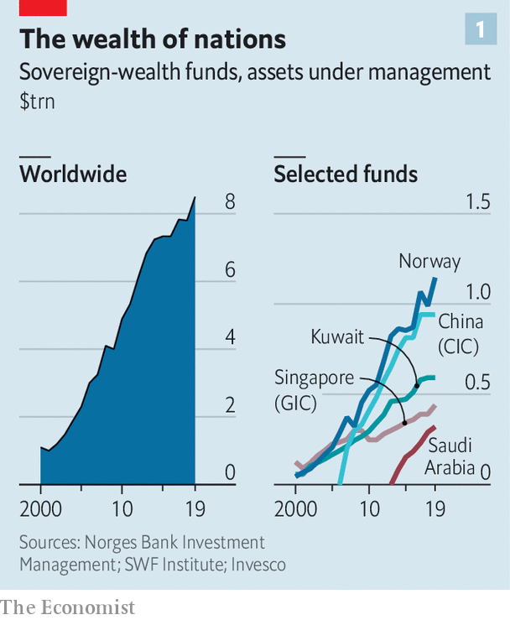

Cash-rich countries have been stashing their excess foreign currency in kitties since the 1950s, when Kuwait launched its fund. SWFs often have two aims: to smooth out fiscal policy, by releasing cash when the weather turns, and to pass wealth on to future generations, in case luck (or oil) runs out. They grew fast in the 2000s, as China’s hunger for raw materials and other goods fed surpluses in oil-rich states and export champions, and in the 2010s, when funds posted strong returns. Since 2015, for instance, PIF has made returns of nearly double its target of 4-5% a year, according to a source familiar with the fund.

SWFs have largely weathered this year’s market rout. Most are notoriously opaque, but calculations by Javier Capapé of IE University for The Economist indicate that the biggest 15 funds, responsible for 80% of transactions, have made $62bn in paper losses on their largest public-equity stakes so far. Two-thirds of that, though, is accounted for by China Investment Corporation, through which Beijing owns stakes in its top four banks. Other big funds have seen losses of less than a third of those in 2008. When asset prices peaked in early 2019, many started holding more cash than usual. A correction seemed due, says Angela Rodell, who runs Alaska’s Permanent Fund (APF).

It helps that policymakers have, in effect, put a floor under stock prices. Governments have unveiled stimulus worth 3.8% of global GDP, more than twice that in 2008. But SWFs have grown savvier, too. The drubbing they took in 2008 led them to diversify, making portfolios resilient. Once obsessed with glitzy towers and football clubs, some have hired armies of investment bankers to make wiser picks. PIF has grown from 40 staff in 2016 to 700 today (though that has not stopped an iffy investment in Softbank’s Vision Fund).

Markets now offer buying opportunities. SWFs have stuck to their “allocation targets”, which dictate how much of their total assets they can invest in a given type of security. When listed stocks collapsed in March, they rushed to buy some more. Bid-ask spreads—the gap between the prices at which investors want to buy and sell—widened, but transaction volume did not dry up, says Yngve Slyngstad, who runs Norway’s $1trn Government Pension Fund Global (GPFG), the world’s largest SWF, which owns 1.5% of all shares issued in the world.

PIF’s recent purchases include a stake in Carnival, a cruise operator (whose share price jumped by 30% when the stake was disclosed in April). Others are betting on Chinese stocks, or privately held assets. James Burdett of Baker McKenzie, a law firm, saw a fund finalise a property-investment platform worth hundreds of millions of dollars weeks into the lockdowns.

Involvement in private markets carries risks, though. In recent years SWFs have piled into such illiquid assets (see chart 2). Where stocks go, unlisted assets often follow. Valuations are uncertain. Matt Whineray of NZ Super Fund, which owns farms and forests, says price ranges for these are now much wider. Low interest rates should push prices up; but investors are also more cautious, which pulls them down.

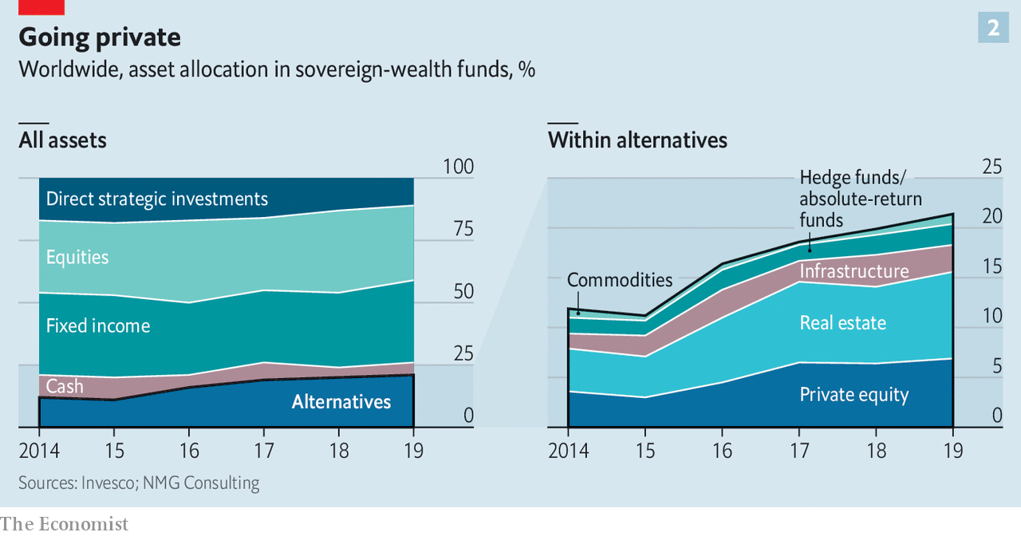

Another, bigger threat comes from governments. Gulf funds confess to having been asked to assist with covid-related bail-outs. An asset manager says some Asian funds have been coerced to fire-sell assets. Norway’s fund expects to inject cash worth 4.8% of its assets into public coffers in 2020, above its usual limit of 3%. APF, from which the government already plans to withdraw $3.1bn (about 5% of its assets), faces pressure to support struggling firms and pay three dividends to Alaskans this year, up from one.

The onslaught has yet to start in earnest. Instead of dipping deep into long-term savings, Gulf states, which enjoy good credit ratings, have issued billions of dollars in debt, says Jihad Azour, a former finance minister of Lebanon now at the IMF. But the longer the crisis, the greater the need, and the bigger the temptation.

The squeeze on SWFs is exacerbated by losses in revenues. GPFG, which had expected to receive oil proceeds worth 2.5% of its assets going into the crisis, will see these fall to 1%. That implies net outflows in 2020, a situation Mr Slyngstad describes as “unusual”. Gulf SWFs are expected to slim down by more than $300bn (roughly 15% of their assets) in 2020.

The pressure on incomings and outgoings could change the way the funds invest. SWFs will have to post nominal returns of 6-8% to avoid shrinking in the coming years, estimates Max Castelli of UBS, a bank. Slow growth and low interest rates make that a tall order. “If returns are not sufficient, we will see some liquidations,” says Mahmoud Mohieldin of the UN, who considered setting up a SWF for Egypt in the 2000s. Returns could also turn volatile if SWFs are nudged to invest more at home, making portfolios less diversified.

Large funds may also become more active investors. Because of their size, many tend to use a “core/satellite approach”. This allocates most of their assets to low-cost funds tracking indices and uses active investments to insulate their portfolios against long-term risks, like climate change, at the margin. The need for extra returns will demand more of the latter.

In one respect, at least, SWFs are ahead of the curve. Since 2014 one-fifth of their venture-capital investments have backed health-care startups—appetite for which is now proving contagious. ■

This article was downloaded by calibre from <https://www.economist.com/finance-and-economics/2020/05/23/sovereign-wealth-funds-face-lean-years>

|  |  |  |  |
| --- | --- | --- | --- |
|  | Articles | Sections | Next |

|  |  |  |  |
| --- | --- | --- | --- |
| Previous | Articles | Sections | Next |

#### Trading places

# A memo to candidates for the WTO’s next boss

What Roberto Azevêdo’s prospective successor should expect

May 23rd 2020 | WASHINGTON, DC

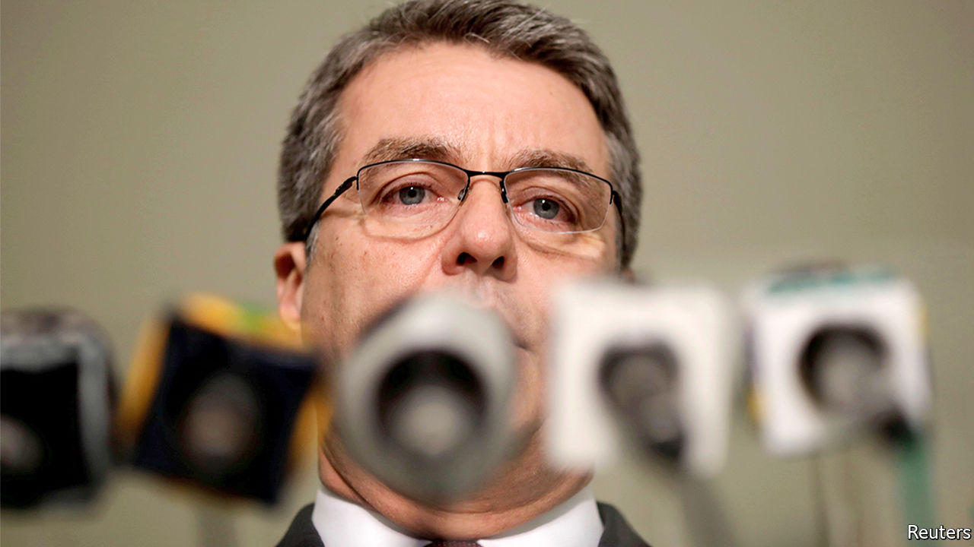

SO YOU WANT to be the next director-general of the World Trade Organisation (WTO). If successful, you will lead one of the world’s big multilateral institutions and rub shoulders with heads of state. The tax-free salary and benefits are cushy. But that is where the perks end. Here is what you can expect from the job.

Trade in goods could fall by as much as a third this year. Even before covid-19, the trade rule book was in tatters. The pandemic seems set to make protectionist barriers rise even faster. Australia and China are squaring off (see article). This, you might think, is your moment to shine. You might hope to broker grand deals, or, at the very least, to fix the WTO’s system of settling disputes.

We suggest you manage those expectations—all the way down. Roberto Azevêdo, the departing director-general, was respected by members. But he found his diary emptying faster than a shipping broker’s order book. “There’s nothing happening in terms of regular work” at the WTO, he told Bloomberg recently. He is leaving a year before his term’s up. Forget building a new architecture of the global trading system, or haranguing members into lowering tariffs. If the WTO’s members do not want something, it will not happen. Your job instead is to focus on the smaller fry. Talks to limit subsidies for fisheries were the only ones going anywhere in recent months. Full steam ahead? Afraid not. They stalled on May 7th.

You will discover that the WTO would be a marvellous institution were it not for its members. The poor ones want exemptions from rules that have not yet been written. The rich ones are loth to make the concessions needed to get anything done. Some of America’s lawmakers want to withdraw from the organisation (a “relic”) altogether. You might find yourself wishing they just got on with it. But their heft makes them useful, when they choose to be.

Be cautious, like Mr Azevêdo, and you will be accused of getting too little done. Be ambitious, and, like his predecessor Pascal Lamy, you will be attacked for alienating members—and also for getting too little done. Best to expand your definition of success to include vaguely worded joint statements calling for free and fair trade.

To become a candidate, a member must put you forward before July 8th. The winner must be agreeable to America, Europe and China. If such a person even exists, it probably won’t be one of their own. Perhaps that clears the way for the first African boss. Names being floated include Amina Mohamed, Kenya’s former WTO ambassador, and Yonov Frederick Agah, a Nigerian and Mr Azevêdo’s deputy.

The Americans and the Europeans say they want to arrange a speedy replacement for Mr Azevêdo, who leaves on August 31st. But if the WTO’s past trade rounds are a guide, resolution won’t be swift. Many members will stall, in case Donald Trump loses America’s presidential election. Prepare to wait for months, even years.

A quick approval, against those odds, could mean that members want to save the institution. Or it could mean that you are bland enough that no one could rouse themselves to object to your appointment: a sorry form of comparative advantage. ■

This article was downloaded by calibre from <https://www.economist.com/finance-and-economics/2020/05/23/a-memo-to-candidates-for-the-wtos-next-boss>

|  |  |  |  |
| --- | --- | --- | --- |
| Previous | Articles | Sections | Next |

|  |  |  |  |
| --- | --- | --- | --- |
| Previous | Articles | Sections | Next |

#### Buttonwood

# Why you need to read Jane Austen to appreciate perpetual bonds

It takes a nineteenth-century perspective to see the merit of consols

May 23rd 2020 |

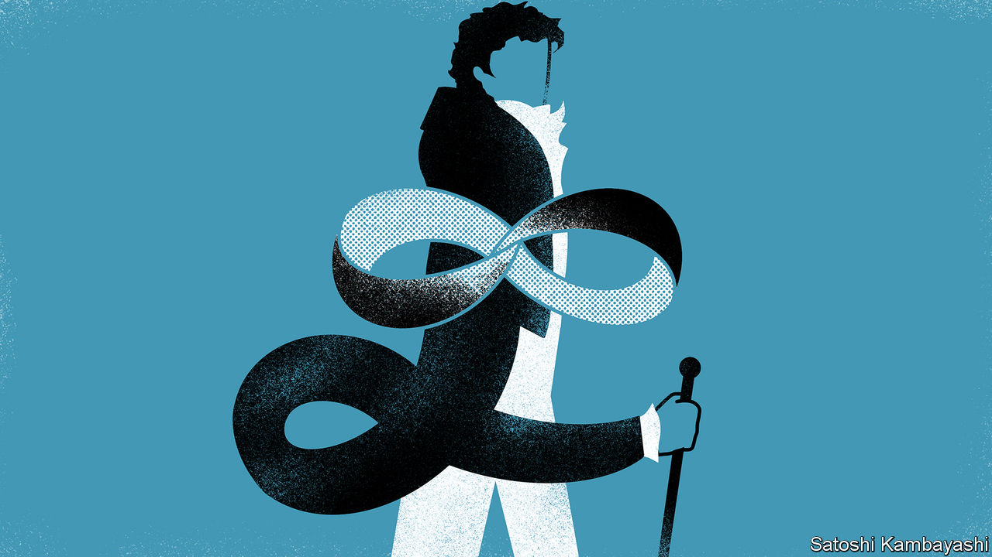

EVERYBODY AGREES that Jane Austen’s “Pride and Prejudice” is a love story. A truth less universally acknowledged is that it is also about money. When Mr Darcy first enters the Meryton assembly, the stir he causes owes something to his looks and bearing. But it owes a lot more to the fast-circulating report of his £10,000 a year. Darcy’s money is old money. It comes neither from commerce nor the professions, but from Pemberley, the family pile in Derbyshire.

In Jane Austen’s day, wealth was measured by the yearly income it provided. The reckoning for sovereign debt was similar. Britain financed the Napoleonic wars by issuing “consols”—bonds that could not be redeemed but which, like Darcy’s estate, promised payments in perpetuity. There are now demands for consols to be revived as a means to manage the escalating fiscal costs of the coronavirus. Francesco Giavazzi and Guido Tabellini of Bocconi University have called for a perpetual-bond issue to be jointly backed by euro-zone countries. George Soros has echoed this.

Any scheme that adds to fiscal firepower without adding to the measured stock of debt might be especially welcome in euroland. But it is quite wrong to view consols as a means to circumvent fiscal discipline. Perpetual bonds are an ideal form of debt. Many bondholders care far more about how much income a bond pays than its capital value. You might call this the Darcy doctrine.

To understand it, consider the goals of public-debt management. One is to finance budget deficits at the least cost consistent with steady taxes and spending. Another is to supply safe and liquid financial assets. The more able governments are to meet the demand for securities, the lower and more stable is the long-run cost to the taxpayer. The need to keep costs down leads them to issue short-term bills, which are usually in high demand and carry the lowest interest rates. The need to keep costs stable and predictable leads them to issue long-term bonds.

These goals can be met at least as well by issuing consols. In a thought-provoking paper in 2015*, John Cochrane of the University of Chicago proposed that the entire stock of American public debt should be made up of two securities. The first would have a fixed value of $1 forever and a coupon payment that is set in line with overnight interest rates. The second would have a fixed coupon payment of $1 forever and a price that is determined by market forces. The fixed-value, floating-rate bond would meet the need for a safe, trusted and highly liquid security. It would have the same qualities as a Treasury bill. The fixed-coupon security would have the character of long-term debt.

Perpetual bonds have several advantages. A big one is liquidity. America’s sovereign debt is currently divided up into hundreds of distinct securities with different maturities. A 30-year bond that is issued in one year becomes a 29-year bond the next. The more individual bond issues there are, the less liquid each one is. By contrast, perpetual bonds are identical. A consol issued today is the same as a consol issued last year. And there is never the need to roll it over.

There are advantages for bondholders, too. A floating-rate perpetual would be a super-liquid, super-safe asset. A fixed-rate perpetual, meanwhile, would be in high demand from pension funds with promises to retirees that stretch into the indefinite future. Ideally the coupon would be inflation-protected.

A bond that pays the same in real terms for many years is the quintessential Darcy asset, say Victor Haghani and James White of Elm Partners, a fund-management firm.** Much of people’s wealth—their human capital; their pension benefits; their homes—is akin to an inflation-protected long-lived bond. It is judged by income, just as Austen saw it.

Why, then, is so much debt made up of bonds with a principal that is paid back at a relatively short, set maturity? Credit risk is part of the explanation. In a company bankruptcy or when a country defaults on its foreign-currency debt, bondholders are paid back some fraction of the principal value of the bonds. But consols have no principal. Only countries with pristine reputations might be trusted to stand behind them.

Prejudice is a potential barrier to perpetual bonds. But they should be judged on how well they meet debt-management goals. On that basis, they are useful tools. Why not use them?

* “A New Structure of U.S. Federal Debt” (May 2015).

** “Reviving a 19th Century Perspective on Financial Well-Being” (May 2020).

This article was downloaded by calibre from <https://www.economist.com/finance-and-economics/2020/05/23/why-you-need-to-read-jane-austen-to-appreciate-perpetual-bonds>

|  |  |  |  |
| --- | --- | --- | --- |
| Previous | Articles | Sections | Next |

|  |  |  |  |
| --- | --- | --- | --- |
| Previous | Articles | Sections | Next |

#### All work and no play

# Tracking the economic recovery

Though some lockdowns are being lifted, economies are not roaring back

May 23rd 2020 |

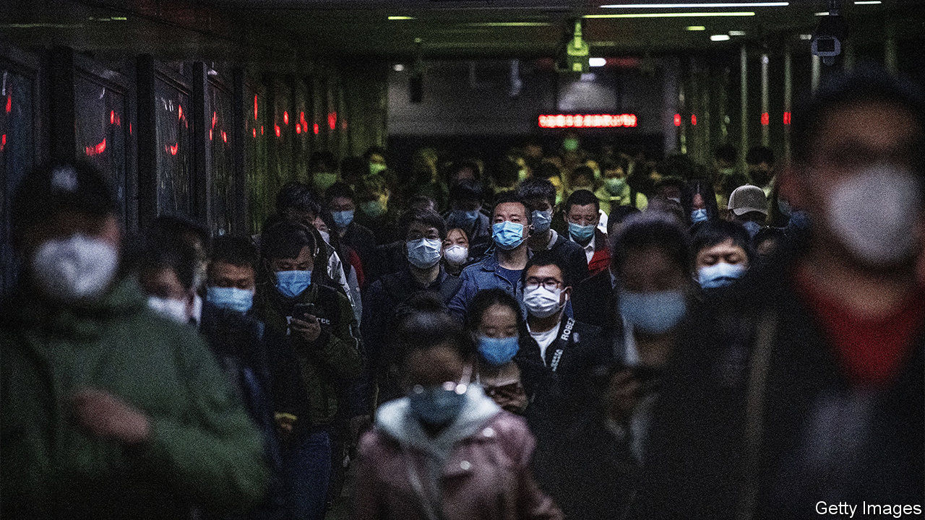

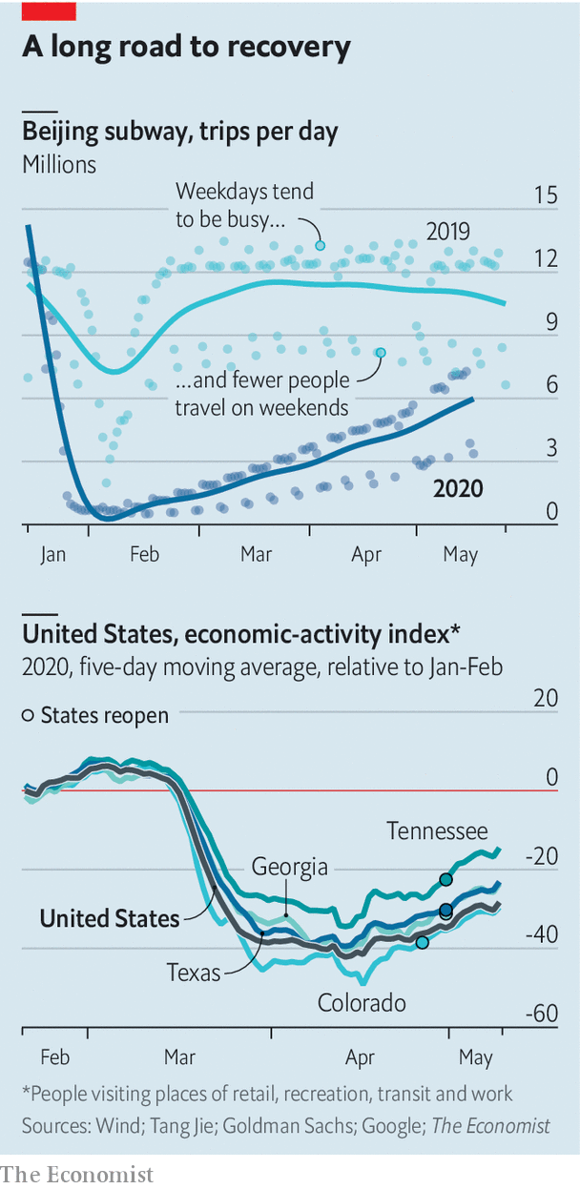

LAST MONTH The Economist coined the term "90% economy" to describe what will happen as lockdowns are eased across the world. It depicts a more solitary and less fun sort of society—the sort of place where the office is open but the pub isn’t. Analysis by Tang Jie of Peking University finds that weekday subway trips in China have recovered to a greater extent than weekend ones, suggesting that people are more prepared to travel for work than for pleasure. Sales of instant noodles, savoured by homebodies, have rocketed. Meanwhile, some American states have started to lift lockdowns, but there is little sign of economies roaring back.

Editor’s note: Some of our covid-19 coverage is free for readers of The Economist Today, our daily [newsletter](https://my.economist.com/user#newsletter). For more stories and our pandemic tracker, see our [hub](https://www.economist.com/news/2020/03/11/the-economists-coverage-of-the-coronavirus)

This article was downloaded by calibre from <https://www.economist.com/finance-and-economics/2020/05/23/tracking-the-economic-recovery>

|  |  |  |  |
| --- | --- | --- | --- |
| Previous | Articles | Sections | Next |

|  |  |  |  |
| --- | --- | --- | --- |
| Previous | Articles | Sections | Next |

#### Borrower beware

# Why interest rates are so high in Africa

Banks generate high returns, but have steep costs

May 23rd 2020 | KAMPALA

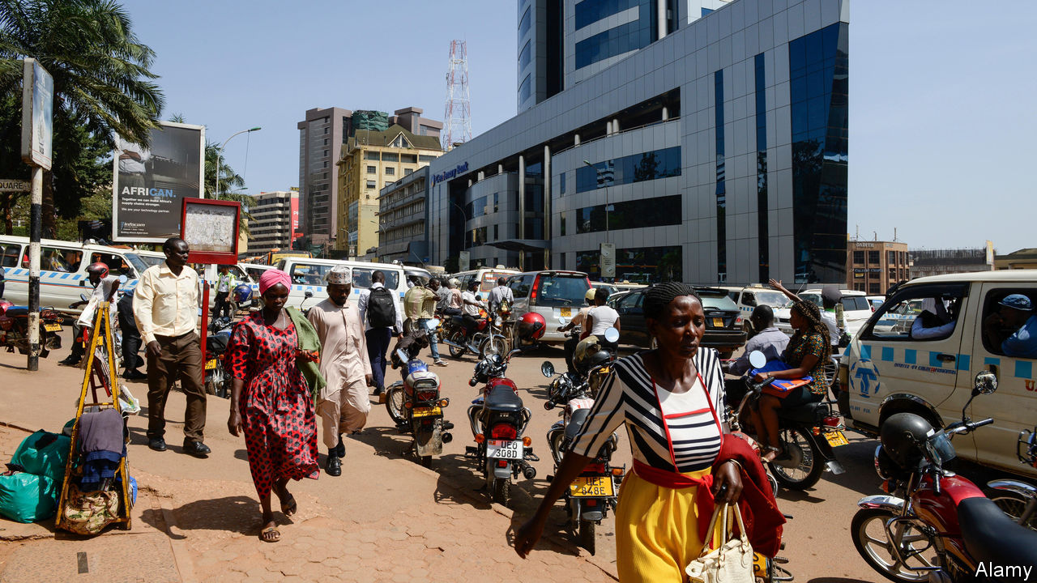

WHEN ROBERT MATSIKO was a young man his grain-milling business in Sheema, western Uganda, was destroyed by fire. These days, after building it back up from the ashes, he is being burned by high interest rates. To buy a new machine he must borrow from a bank at an annual rate of 22%. “You fear to do that,” he says. Many other entrepreneurs feel the same, which stops their businesses from growing.

Just as Mr Matsiko funnels grain from farms to supermarkets, banks are the bridge between savers and borrowers, paying interest on savings and charging it on loans. And in sub-Saharan Africa, the gap between deposit and lending rates is higher than anywhere else. In 2017 net interest margins in the median African country were 6.8%, according to the World Bank. That healthy mark-up in part helps cover overheads that are chunkier than those in other regions. But it also allowed African banks to generate a 17% return on equity for shareholders. On that measure, Africa’s banks are the most profitable in the world—while also being the least efficient.

Last year Uganda’s central bank estimated that half of banks’ interest margins are swallowed by operating costs. “Opening up a branch probably costs half a million dollars,” says Patrick Mweheire, who heads east African operations for Standard Bank, the continent’s biggest lender. Smaller banks are ground down by the cost of electricity, data storage or simply moving money, he adds. “If you look at a highway you will see six cash-in-transit trucks, one for each bank, all a quarter full.”

In some countries, high inflation can help explain high interest rates, albeit less so than in the past. Interest rates also price in risk. Assessing borrowers is hard when they often lack credit histories. Chasing up bad loans is a struggle. Creditors can only expect to recover one shilling in every five they have lent to a business that goes insolvent in Tanzania, according to the World Bank. In Niger, the resolution process takes five years, on average.

Many bankers save themselves the hassle by lending to the state instead. The double-digit interest rates that the government pays set “a floor” on the rates paid by everyone else, says Adam Mugume of Uganda’s central bank. In the average African country, according to the European Investment Bank, lenders’ holdings of public debt increased from 14% of their assets in 2008 to 19% by 2017.

Critics say that banks are abusing their market power to rip off customers. The World Bank estimates that the banking system in the typical African country is no more concentrated than in Europe or Latin America. But the fact that banks can sustain high profits could suggest they have some market power. And in some smaller countries, the market is more concentrated. Competition for small business loans is weaker than for corporate deals.

Governments have tried and failed to bring rates down. In 2016 Kenya capped commercial-loan rates at four percentage points above the central bank’s policy rate. The move backfired. Bankers slashed credit to small businesses, reasoning that the rewards of lending no longer matched the risks. The cap was scrapped last year.

In Nigeria the central bank penalises banks that do not meet lending targets. But it also pushes up interest rates through tight monetary policy, intended to keep the naira strong. Banks must hold lots of liquid assets, such as cash and treasury bills, and keep on hand at least 27.5% of their deposits, one of the highest ratios in the world.

New models could spur change. Joshua Oigara, the boss of KCB bank and chairman of the Kenya Bankers Association, says that mobile banking, credit-information sharing and, before the pandemic, a stable economy helped to bring down lending costs. Others are saving on bricks and mortar by enlisting local agents, such as shopkeepers. Barely 18 months after adopting this model, Standard Bank’s Ugandan subsidiary processes more transactions through agents than at branches.

Innovation can bring down costs, but it cannot loosen demographic constraints. It costs more to borrow locally when there are fewer savings to go around, notes Charles Robertson of Renaissance Capital, an investment bank. African households save less than those in Asia, say, in part because workers support more dependants. “If you’ve got six kids you’ve got no savings, whether you’ve got a mobile phone or not,” he argues. Until birth rates fall, interest rates will stay relatively high. ■

This article was downloaded by calibre from <https://www.economist.com/finance-and-economics/2020/05/23/why-interest-rates-are-so-high-in-africa>

|  |  |  |  |
| --- | --- | --- | --- |
| Previous | Articles | Sections | Next |

|  |  |  |  |
| --- | --- | --- | --- |
| Previous | Articles | Sections | Next |

#### Free exchange

# Should the Fed cut rates below zero?

Negative rates are not a cure for what ails the global economy

May 23rd 2020 |

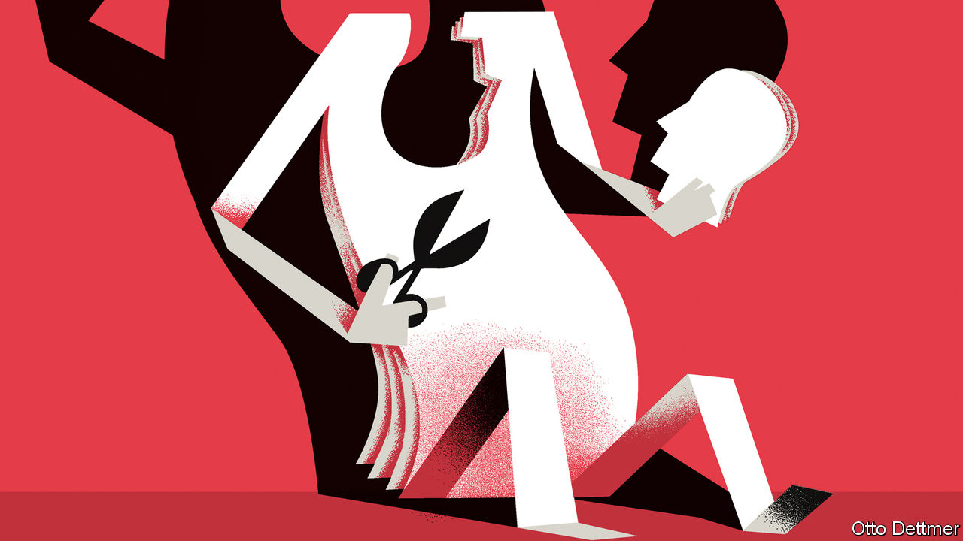

YOU COULD be forgiven for supposing that the Federal Reserve has already thrown everything—kitchen fixtures included—at the covid-19 downturn. In recent months the Fed has slashed its benchmark interest rate to near zero, bought nearly $3trn in assets and launched a bevy of lending programmes. But America’s central bank appears conservative in one respect. Whereas peers in the euro area and Japan long ago pushed their short-term interest rates into negative territory, the Fed, like the Bank of England, has stayed positive. Now it faces pressure to change course. President Donald Trump has tweeted that the Fed should accept the “gift” of negative rates. Investors’ bets in the derivatives markets signal a belief that rates may eventually drop below zero. Jerome Powell, the Fed’s chairman, still insists that negative rates are not “appropriate or useful” for America. Regardless of whether he holds firm or markets are proved right, a spell in negative territory would not dramatically change the economic outlook.

Economists have argued energetically over negative rates since the global financial crisis, when rates around the world first dropped towards zero. Many policy rules—used to estimate an appropriate interest rate based on the rate of inflation and estimates of the extent of slack in the economy—suggested that rates ought to be cut deep into negative territory. Work by Jing Cynthia Wu of the University of Notre Dame, for instance, found that rates needed to be as low as -3% in America in 2014 and -6.5% in Britain in 2013. At first it was thought that negative rates were infeasible altogether. Cash pays an effective interest rate of zero; faced with negative deposit rates, bank customers could always withdraw their savings and stash them under their mattresses instead. That would suggest a “zero lower bound” on central banks’ tool of first resort. In fact the limit has not been as inflexible as all that. Piles of cash are more vulnerable to theft (or costly to store safely) and cannot be spent very easily. These costs mean that rates can go at least modestly negative, and some central banks have felt secure enough to dip their toes into sub-zero waters. The European Central Bank dropped its main rate to -0.1% in 2014 and has since cut it to -0.5%. Japan’s policy rate has stood at -0.1% since 2016.

The dire state of the world economy has economists asking whether more can be done. Central bankers weighing further rate cuts face three important questions. The first concerns the technical feasibility of more deeply negative rates. If Europe and Japan are a guide, rates in America and Britain could at least go modestly negative. Some economists, such as Kenneth Rogoff of Harvard University, suggest that with regulatory tweaks the effective lower bound on rates could be pushed much lower. Eliminating high-denomination banknotes and imposing fees on large transfers, for instance, might raise the cost of hoarding cash by enough to allow rates to be cut by a few percentage points.

More negative rates might thus be possible. But a second question is whether they undermine the stability of the financial system, hurting growth. Economists have explored the existence of a “reversal rate”, beyond which interest-rate cuts weaken demand rather than boost it. Negative policy rates mean that some or all of the reserves that banks must keep at the central bank lose value. But banks might not pass those rates on to their depositors, for fear of scaring customers off. A negative turn in rates therefore squishes banks’ margins. Less profitable banks, which struggle to boost their capital buffers by retaining earnings, might opt to curtail their lending, choking off investment and growth. Work by Markus Brunnermeier and Yann Koby of Princeton University concludes that reversal rates almost certainly exist, though their level depends on a banking system’s characteristics.

So far negative rates have not obviously hit the contractionary threshold. Those in Europe have indeed coincided with a drop in banks’ earnings. But Melanie Klein of the Bundesbank notes that, while lower bank margins are generally associated with reduced lending, the link seems to break down when rates move into negative territory. In fact, euro-area credit growth has accelerated since 2014. That does not settle the matter. Other factors, such as an improvement in demand, are likely to have boosted borrowing. And the squeeze that negative rates places on bank earnings has been muted by “tiering”—in which central banks apply different rates to different categories of bank reserves—which may also have limited their effect on the broader economy. For now, the effectiveness of negative interest rates remains an unsettled question.

## You better take cover

Nor is the risk of a contraction in bank lending the only potential drawback to negative rates. Some investors warn that they could cause an exodus from money markets, a component of the shadow-banking system that many large firms and banks use to park cash and fund themselves. Money-market funds in Europe and Japan have coped, so far, with the problem of negative-yielding investments. But more deeply negative rates—or their arrival in America, where money markets play a far bigger role in the financial system—could bring different results.

All this leads to a third question: are negative rates worth the hassle? As the experience in Europe and Japan has not been disastrous, central bankers in America and Britain may eventually gingerly cut rates to below zero. (On May 20th Andrew Bailey, the governor of the Bank of England, said that negative rates were under “active review”.) But an easing of half a percentage point or so, while not unwelcome, is too small to mean the difference between a strong recovery and a weak one. Regulatory changes needed to achieve deeply negative rates at acceptable risk would probably prove politically contentious. Meanwhile, far more potent weapons—such as fiscal stimulus in combination with central-bank asset purchases—have not reached their economic and political limits. Little reason yet to venture far into sub-zero terrain. ■

Editor’s note: Some of our covid-19 coverage is free for readers of The Economist Today, our daily [newsletter](https://my.economist.com/user#newsletter). For more stories and our pandemic tracker, see our [hub](https://www.economist.com/news/2020/03/11/the-economists-coverage-of-the-coronavirus)

This article was downloaded by calibre from <https://www.economist.com/finance-and-economics/2020/05/23/should-the-fed-cut-rates-below-zero>

|  |  |  |  |
| --- | --- | --- | --- |
| Previous | Articles | Sections | Next |

|  |  |  |
| --- | --- | --- |
| Finance & economics | Sections | Science & ... |

Schools brief

Energy transitions: Not-so-slow burn

.

|  |  |  |
| --- | --- | --- |
| Finance & economics | Sections | Science & ... |

|  |  |  |  |
| --- | --- | --- | --- |
|  | Articles | Sections | Next |

#### Not-so-slow burn

# The world’s energy system must be transformed completely

It has been changed before, but never as fast or fully as must happen now

May 23rd 2020 |

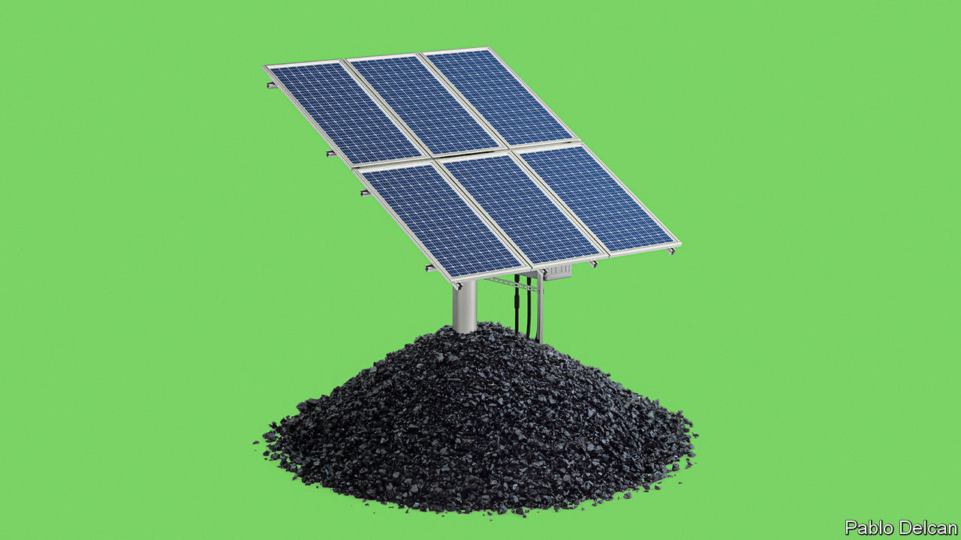

FOR MORE than 100,000 years humans derived all their energy from what they hunted, gathered and grazed on or grew for themselves. Their own energy for moving things came from what they ate. Energy for light and heat came from burning the rest. In recent millennia they added energy from the flow of water and, later, air to the repertoire. But, important as water- and windmills were, they did little to change the overall energy picture. Global energy use broadly tracked the size of a population fed by farms and warmed by wood.

The combination of fossil fuels and machinery changed everything. According to calculations by Vaclav Smil, a scholar of energy systems at the University of Manitoba, between 1850 and 2000 the human world’s energy use increased by a factor of 15 or so.

The expansion was not homogeneous; over its course the mixture of fossil fuels used changed quite dramatically. These are the monumental shifts historians call “energy transitions”. They require huge amounts of infrastructure; they change the way the economy works; and they take place quite slowly.

James Watt patented his steam engine in 1769; coal did not exceed the share of total energy provided by “traditional biomass”—wood, peat, dung and the like—until the 1900s (see chart overleaf). It was not until the 1950s, a century after the first commercial oil well was drilled in Titusville, Pennsylvania, that crude oil came to represent 25% of humankind’s total primary energy. Energy transitions were slow largely because the growth in total energy use was fast. In the century it took oil to capture a quarter of the total, that total increased. They are also always incomplete. New fuels may reduce the share of the pie that old fuels control, but they rarely reduce the total energy those fuels supply. Much more “traditional biomass” is burned by the world’s poor today than was burned by the whole world in 1900.

To give the world a good chance of keeping global warming, measured against the temperature pre-coal, well below 2°C (3.6°F) will require an energy transition far larger and quicker than any before it. In the next 30-50 years 90% or more of the share of the world’s energy now being produced from fossil fuels will need to be provided by renewable-energy sources, nuclear power or fossil-fuel plants that bury their waste rather than exhaling it.

During this time, the pie will keep growing—but not necessarily as fast as it used to. The direct relationship between GDP and energy use, which held tight until the 1970s, has weakened over the past half century. It is possible for growth per person to continue without energy use per person increasing. Though the population is no longer growing as fast as it did at the 20th-century peak of its increase, it will still be the best part of 2bn higher by mid-century. And all those people should be able to aspire to modern energy services. Today more than 800m people still lack electricity—hence all that burning of traditional biomass.

The good news, however, is that governments say they are willing to push through the change. Previous transitions, though shaped by government policy at national levels, were mostly caused by the demand for new services that only a specific fuel could provide, such as petrol for engines.

The growth in renewable-generation capacity is the exception. It has not been driven by the fact that renewable electrons allow you to do things of which those from coal are not capable. It has largely been driven by government policy. This has not always had the near-term effects for which such policy should aim. Germany’s roll-out of renewables has been offset by its retreat from nuclear, and its emissions have risen. But subsidies there and elsewhere have boosted supply chains and lowered the cost of renewable technologies.

During the 2010s the levelised cost (that is the average lifetime cost of equipment, per megawatt hour of electricity generated) of solar, offshore wind and onshore wind fell by 87%, 62% and 56%, respectively, according to BloombergNEF, an energy-data outfit (see chart overleaf). This has allowed deployments that were unthinkable in the 2000s. Britain now has 10,000 offshore wind turbines. They are built by developers chosen based on how low a price they are willing to take for their electricity (the government pledges to make the cost up if the market price falls below it).

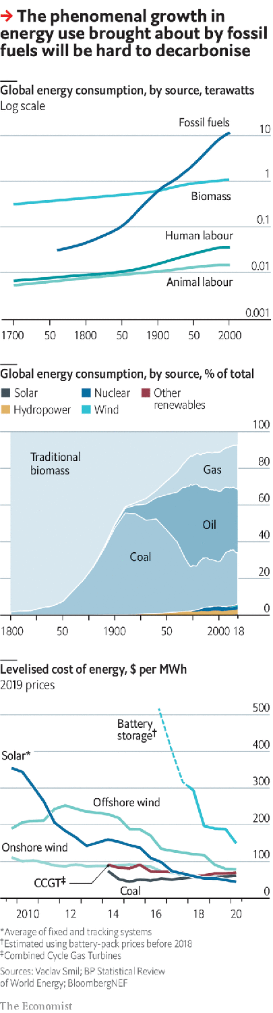

In 2015 winning bids were well over £100 ($123) per MWh, far higher than the cost of fossil-fuel electricity. Thanks to predictable policy, fierce competition and technical progress, a recent auction brought a bid as low as £39.65 per MWh, roughly the level of average wholesale power prices. Solar and onshore wind are even less expensive. About two-thirds of the world’s population live in countries where renewables represent the cheapest source of new power generation, says BloombergNEF.

Solar power is the really spectacular achiever, outstripping the expectations of its most fervent boosters. Ramez Naam, a bullish solar investor, recently recalibrated his expectations to foresee a future of “insanely cheap” solar power. By 2030, he reckons, in sunny parts of the world, building large new solar installations from scratch will be a cheaper way of getting electricity than operating fully depreciated fossil-fuel plants, let alone building new ones. Michael Liebreich, a consultant on renewable energies, speculates about a “renewable singularity” in which cheap renewable electricity opens up new markets that demand new capacity which makes electricity cheaper still.

Even without such speculative wonders, the effect of renewables is appreciable. Together with natural gas, which America’s fracking revolution has made cheaper, solar and wind are already squeezing coal, the energy sector’s biggest emitter (a megawatt of coal produces a stream of emissions twice the size of that given off by a megawatt of gas). In 2018 coal’s share of global energy supply fell to 27%, the lowest in 15 years. The pressure that they can apply to oil is not yet as great, because oil mostly drives cars, and electric cars are still rare. But as that changes, renewables will come for oil, as they are already coming for gas.

There are stumbling blocks. Neither the sun nor the wind produces energy consistently. Germany’s solar-power installations produce five times more electricity in the summer than they do in the winter, when demand for electricity is at its peak. Wind strengths vary not just from day to day but from season to season and, to some extent, year to year. This amounts to a speed bump for renewables, not a blockade. Long transmission lines that keep losses low by working at very high voltages can move electricity from oversupplied areas to those where demand is surging. Lithium-ion batteries can store extra energy and release it as needed. The economic stimulus China announced in March includes both ultra-high-voltage grids and electric-vehicle-charging infrastructure.

## Thou orb aloft, somewhat dazzling

As the sun and wind account for a larger share of power, renewables might store power by splitting water to create hydrogen to be burned later. More ambitiously, if technologies for pulling carbon dioxide back out of the air improve, such hydrogen could be combined with that scavenged carbon to make fossil-free fuels.

In doing so, they might help remedy the other problem with renewables. There are some emissions which even very cheap electricity cannot replace. Lithium-ion batteries are too bulky to power big planes on long flights, which is where artificial fuels might come in. Some industrial processes, such as cement-making, give out carbon dioxide by their very nature. They may require technology that intercepts the carbon dioxide before it gets into the atmosphere and squirrels it away underground. When emissions cannot be avoided—as may be the case with some of those from farmland—they will need to be offset by removing carbon dioxide from the atmosphere either with trees or technology.

None of this happens, though, without investment. The International Renewable Energy Agency, an advisory group, estimates that $800bn of investment in renewables is needed each year until 2050 for the world to be on course for less than 2°C of warming, with more than twice that needed for electric infrastructure and efficiency. In 2019 investment in renewables was $250bn. The big oil and gas firms invested twice as much in fossil-fuel extraction.

If governments want to limit climate change, therefore, they must do more. They do not have to do everything. If policy choices show that the road away from fossil fuels is right, private capital will follow. Investors are already wary of fossil-fuel companies, eyeing meagre returns and the possibility that action on climate change will leave firms with depreciating assets.

But governments need to make the signals clear. Around the world, they currently provide more than $400bn a year in direct support for fossil-fuel consumption, more than twice what they spend subsidising renewable production. A price on carbon, which hastens the day when new renewables are cheaper than old fossil-fuel plants, is another crucial step. So is research spending aimed at those emissions which are hard to electrify away. Governments have played a large role in the development of solar panels, wind turbines and fracking. There is a lot more to do.

However much they do, though, and however well they do it, they will not stop the climate change at today’s temperature of 1°C above the pre-industrial. Indeed, they will need to expand their efforts greatly to meet the 2°C target; on today’s policies, the rise by the end of the century looks closer to 3°C. This means that as well as trying to limit climate change, the world also needs to learn how to adapt to it. ■

This article was downloaded by calibre from <https://www.economist.com/schools-brief/2020/05/23/the-worlds-energy-system-must-be-transformed-completely>

|  |  |  |  |
| --- | --- | --- | --- |
|  | Articles | Sections | Next |

|  |  |  |
| --- | --- | --- |
| Schools brief | Sections | Books & arts |

Science & technology

Controlling covid-19: To each according to his need

.

Photovoltaics: Solar’s new power

.

Covid-19 in the young: Suffer the little children

.

|  |  |  |
| --- | --- | --- |
| Schools brief | Sections | Books & arts |

|  |  |  |  |
| --- | --- | --- | --- |
|  | Articles | Sections | Next |

#### To each according to his need

# The risk of severe covid-19 is not uniform

That calls for a fine-tuning of measures to stop the disease spreading

May 21st 2020 |



Editor’s note: Some of our covid-19 coverage is free for readers of The Economist Today, our daily [newsletter](https://my.economist.com/user#newsletter). For more stories and our pandemic tracker, see our [hub](https://www.economist.com/news/2020/03/11/the-economists-coverage-of-the-coronavirus)

NABBING A DISEASE hotspot is to epidemic control what locking up a serial perpetrator is to crime investigation. Success hinges on similar skills, as John Snow, an Englishman who drew up the principles of modern epidemiology, demonstrated in 1854. That year a cholera outbreak in central London killed more than 500 people in just two weeks. Snow investigated around 60 of those deaths and found a common factor: a contaminated water pump. Removing its handle ended the outbreak.

The lockdowns to stop covid-19 have been a radical departure from the tenets of epidemiology. They are the equivalent, in cholera terms, of taking the handles from all of London’s water pumps. But emerging patterns in the outbreaks and deaths from the infection suggest that the post-lockdown phase will involve a return to classic epidemiology. It will, in other words, be calibrated to the places and people involved. What might work in densely packed, multicultural New York City will be different from what is suitable in homogeneous, rural Wisconsin. The ultimate goal is unchanged, however: to shield those most likely to develop severe symptoms from exposure to SARS-CoV-2, the virus that causes the disease.

## Homes and castles

Who these high-risk individuals are is now becoming clearer, as research from around the world piles up. Some of the strongest evidence is from a study published on May 7th by Ben Goldacre of Oxford University and his colleagues. This looked at the medical records of more than 17m people in Britain, about 6,000 of whom had died from the new illness. The Goldacre study confirmed previous suspicions that mortality risks are particularly high (after accounting for old age, smoking and poverty—which other investigations have not had the data to do) for people who are obese, who have diabetes, who have cancer or who have received a transplanted organ. Being a man is also risky. The biggest risk factor of all, nevertheless, is being old. People in their 60s are twice as likely to die of covid-19 than are those in their 50s. Mortality from the disease shoots up still more rapidly from the age of 70, so that even healthy elderly people are at significant risk. Data for nine rich countries gathered from various sources by The Economist show that care homes for the elderly and infirm have accounted for 40-80% of covid-19 deaths (see chart 1).

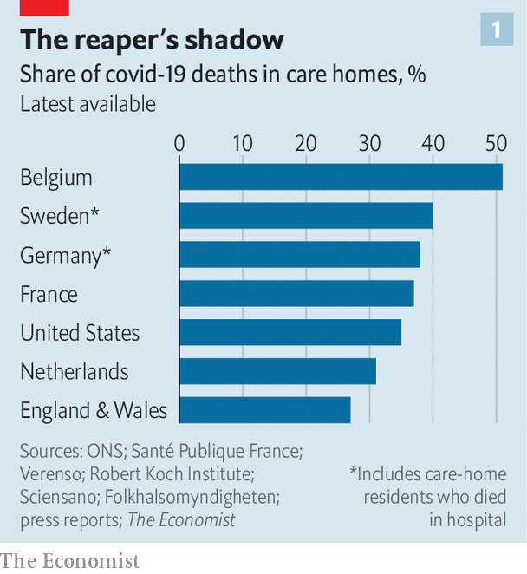

That is a dreadful fact. But it also offers an opportunity. Focusing efforts on care homes would cut the death toll considerably. This means implementing infection-prevention routines similar to those in hospitals, such as protective masks and gowns for staff, as well as testing both staff and residents frequently for active SARS-CoV-2 infection. Testing regular visitors may be prudent too—or finding other ways to stop them bringing in the virus. Some Dutch care homes, for example, have installed glass partitions in the rooms where residents and visitors meet.

Generalising this approach may offer lessons for dealing with the disease in the wider world. One strategy, put forward by academics from Edinburgh University, is to divide the population into three segments: those most vulnerable; their close regular contacts (which the researchers call “shielders”); and everyone else. Shielders include those who live with the vulnerable, relatives who visit them and social workers who care for them. In this analysis, the vulnerable themselves need to take the strictest precautions to avoid infection and shielders need to take greater precautions than everyone else.

Ideas about how to make this happen are already popping up. Gibraltar and Bulgaria, for example, have designated a Golden Hour each day, when parks and public spaces are reserved for the elderly, with others asked to stay home. Contact-tracing apps, which alert those who have been close to an infected individual, would be particularly valuable for shielders—along with stricter hand-hygiene measures, face masks and social distancing. Shielders could also be given priority for testing.

How many would be in each of these segments depends on the criteria for vulnerability. England’s National Health Service has identified 1.5m people at high risk because of a pre-existing medical condition. That is 2.7% of the population. If the definition were expanded to include people over 70 and those under that age who are in care homes, thereby accounting for roughly 80% of those who seem to suffer severe covid-19 infections, it would include 20% of the population. The Edinburgh team estimates that, on average, there is one shielder for each person in this expanded group. That would let 60% of the population go about their daily lives with only moderate levels of social distancing.

## Who’s who?

Identifying who is vulnerable is, though, itself fraught with difficulties. Besides the elderly and those with particular medical conditions, a third set of people confirmed to be at risk by Dr Goldacre’s study were members of certain ethnic minorities. Even after accounting for differences in other illnesses and poverty, black people and those whose ancestors came from South Asia were 60-70% more likely to die from covid-19 than white Britons. In Sweden the share of immigrants from Iraq, Syria and Somalia among those in hospital with severe covid-19 has been substantially bigger than their share of the Swedish population. In Norway, where 15% of residents are foreign-born, they constituted 25% of those who had tested positive for SARS-CoV-2 by April 19th. In America minorities are suffering too. Covid-19 deaths have been disproportionately concentrated among blacks and Hispanics.

These sorts of data can help disease-control authorities identify the mix of measures that can best cut SARS-CoV-2 deaths in specific subgroups. One revelation from the statistics so far is that living arrangements such as multigenerational households, which are common among some minorities for cultural and economic reasons, make it harder for them to prevent infection of vulnerable household members. In America 26% of blacks and 27% of Hispanics live either in households which include at least two adult generations, or in so-called grandfamilies of grandparents and grandchildren under 25, but without the intermediate children. That compares with 16% of white Americans in similar circumstances. Overcrowding is also a problem. In Britain about a third of Bangladeshi households and 15% of black-African households are classified as overcrowded by the Office for National Statistics, compared with 2% of white British households.

To resolve these matters some places have set up quarantine facilities for those who cannot isolate themselves at home. Sweden is particularly generous in this regard. Stockholm is offering separate flats to people in big immigrant households who are at high risk of severe covid-19.

Communication is also important. Translating information on SARS-CoV-2 prevention into the languages spoken by immigrant groups was an early omission in many sets of control measures. So was the dissemination of relevant information through the channels used to learn about such things, such as local community leaders and radio stations in people’s first languages. Measures of this sort are not a novelty in public health. They were deployed, for example, in recent outbreaks of measles in Britain, many of which started among immigrants from eastern Europe.

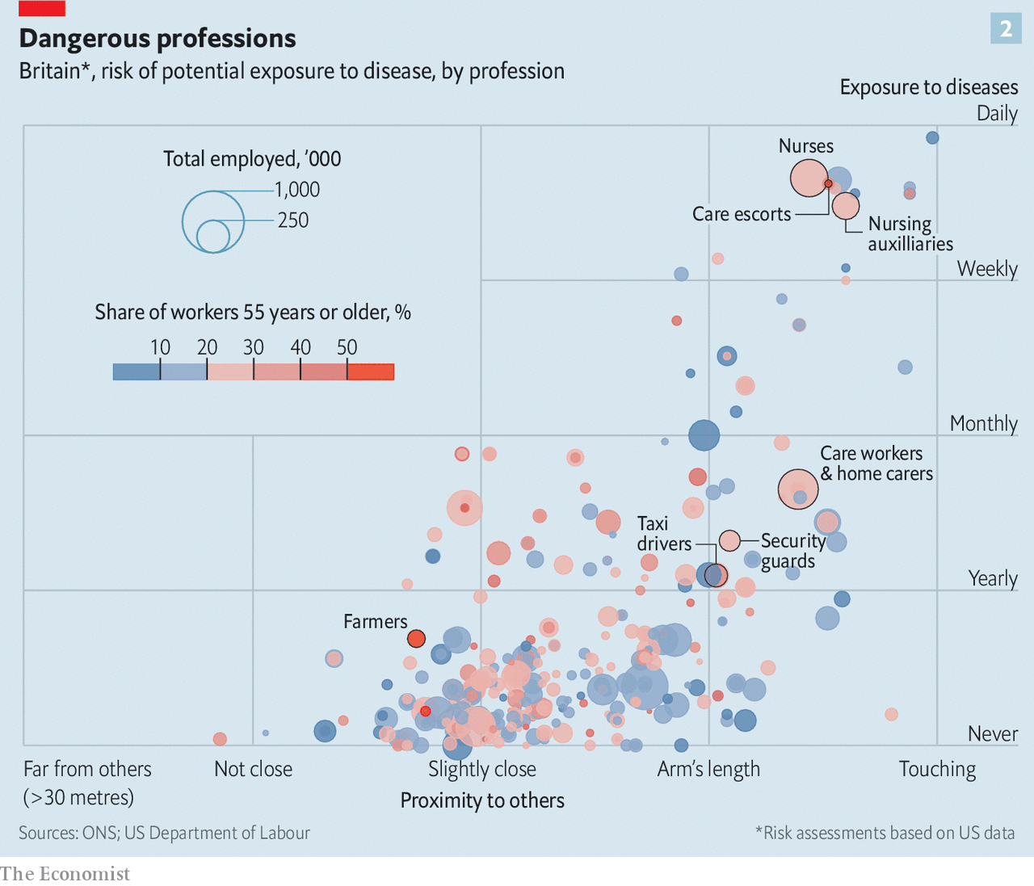

Certain jobs, too, carry a particular risk of infection. Some of the biggest outbreaks in America, Germany and Denmark have been in slaughterhouses, where crowded working conditions, and also possibly the cold (for there is evidence that SARS-CoV-2 survives better at low temperatures), make the spread of the virus particularly easy. Nor does it help that workers in these places are often migrants who live in crowded housing. Some other jobs, too—especially in the service sector of the economy—have a similar double-whammy: a greater risk for SARS-CoV-2 infection and a high share of older workers (see chart 2). In Britain jobs that fall into this category include security guards, plumbers and bricklayers. Employers need to follow stricter measures to shield such workers from infection. These could include reassigning the vulnerable to less risky tasks, stricter hygiene, rules that ensure physical distancing in the workplace and routine checks for symptoms.

All of these fine-grained prevention strategies would depend on the continued collection of data about the prevalence of infection in various groups. Increased testing capacity and better tests for current and past infection are making that easier. If these can be rolled out quickly and reliably, the next waves of covid-19 cases should be smaller and less damaging to social life and national economies. ■

This article was downloaded by calibre from <https://www.economist.com/science-and-technology/2020/05/21/the-risk-of-severe-covid-19-is-not-uniform>

|  |  |  |  |
| --- | --- | --- | --- |
|  | Articles | Sections | Next |

|  |  |  |  |
| --- | --- | --- | --- |
| Previous | Articles | Sections | Next |

#### Solar’s new power

# New solar cells extract more energy from sunshine

Much greater efficiency is coming

May 23rd 2020 |



SOLAR ENERGY has had a good crisis. In many parts of the world skies clear of pollution have helped photovoltaic power stations, which convert light into electricity, become more productive and reliable. Declining demand, meanwhile, has seen coal- and gas-fired stations taken offline. In Britain, on April 20th, solar generation peaked at 9.7 gigawatts. At the moment this happened that represented almost 30% of the country’s electricity supply—ten times the usual proportion. In Germany the proportion of solar in the mix reached 23% for an entire week in April, compared with an average of about 8% during 2019.

Though temporary, such figures are impressive. Solar power, they suggest, has come of age. In some ways, however, despite solar’s new and shiny image, this is the victory of an old technology.

The first practical solar cell was made in the 1950s at Bell Labs in New Jersey. It had an efficiency of 6% and was horrendously expensive. It did, though, prove to have a killer application in powering the satellites of the superpowers in the forthcoming space race. That kept interest alive.

Gradually, costs came down, efficiencies tripled to 17-20% and applications widened, until the point, now arrived at, where grid managers faced with surplus capacity are preferring solar to fossil-fuel generation. For all that they have got better in detail, though, solar cells have stayed the same in principle. Two layers of ultrapure (99.9999%) silicon, each doped with an additive to make it semiconducting, absorb light and use the energy from this to move electrons across the junction between them, thus generating an electric current.

For gridscale electricity produced in standard solar farms this arrangement is likely to continue. But many people think solar energy has wider potential than that. Some want to redesign solar farms in radical ways. Others see it as having small-scale applications that do not require connection to a grid. Both of these approaches will require efficiencies that standard silicon has never managed to achieve. But both will permit high prices for cells that do so.

## Layer cake

One way to boost a cell’s efficiency is to add layers tuned to different parts of the solar spectrum. This means reaching beyond silicon to other materials. So-called III-V semiconductors, made of elements from group III of the periodic table (aluminium, gallium and indium) and group V (phosphorus and arsenic) are one approach. Indeed, gallium arsenide is already used in applications like satellites. John Geisz and his colleagues at the National Renewable Energy Laboratory, in Colorado, have produced a six-junction cell containing various III-V mixtures, each with different light-absorbing properties. This cell has an efficiency of 47.1% in laboratory conditions—a new record, which the researchers reported in Nature Energy in April. With further work, they reckon, an efficiency of more than 50% should be possible.

Intriguingly, the efficiency of Dr Geisz’s cell rises as more light is concentrated on it. Laid out in standard solar farms it would manage a bit under 40%. The 47% figure comes when it is bathed in illumination equivalent to 143 suns. Roughly speaking, then, a six-junction cell with a suitable arrangement of mirrors concentrating the sun’s light onto it could turn out the same amount of electricity as a standard silicon cell that had 400 times the area. Those are the sorts of numbers that disruptive technologies are made of.

Another promising group of materials for making new types of solar cells are perovskites. The original substance of this name is a mineral, calcium titanium oxide, discovered in the Ural mountains in 1839 and called after Count Lev Perovski, a Russian mineralogist. As is often the way with minerals, though, the basic crystal lattice involved can be created from many sorts of atoms. “Perovskite” has thus now become a generic term for any of these variants.

Not all perovskites are semiconductors. But a group based on a metal, such as tin, and a halogen, such as chlorine, bromine or iodine, do have that property. The ingredients of these metal-halide perovskites are, moreover, abundant and inexpensive. One of the leaders in the field of making cells out of them is Oxford PV, a British firm founded in 2010 to exploit work done on perovskites by Henry Snaith of Oxford University. The firm’s design is a hybrid structure, known as a tandem cell, that coats a silicon layer with perovskite.

This brings two advantages. One is that, like a multilayered III-V cell, a perovskite-silicon tandem cell divides up the job of capturing sunlight. The upper, perovskite, layer is tweaked to absorb light from the blue end of the spectrum. The lower, silicon, layer mops up the remaining wavelengths towards the red end. This makes for high efficiency. In a test in 2018 such a tandem cell set a new record for its type with an efficiency of 28%. Eventually, the firm’s engineers think, they can push this into the “mid-30s”.

The second advantage of piggybacking the perovskite on silicon is that the cells are fairly easy to make into solar panels using standard industrial processes. That helps keep them competitive with conventional solar panels. A new factory that will do just this is currently under construction in Germany. The hope is that—the pandemic provided—the first panels made in this plant will go on sale next year.

Whether an efficiency in the mid-30s will be enough to displace silicon cells from part of their existing market remains to be seen. Perovskites may, however, have applications doing jobs that silicon cannot manage. For instance, they work well in low light intensities. This has permitted a group led by Thomas Brown of Tor Vergata University of Rome and John Fahlteich of the Fraunhofer Institute’s campus in Dresden, Germany, to develop versions which operate at the levels of illumination found inside buildings. The amount of energy in artificial lighting is vastly less than that in sunshine. Nevertheless, Dr Brown and Dr Fahlteich have found, according to a paper they published this month in Cell Reports Physical Science, that their cells can achieve a conversion efficiency of up to 22.6%, thereby producing enough juice to run small, low-power devices like wireless sensors and remote-control units, which would otherwise require batteries.

Though it may seem odd to turn artificial, indoor lighting into electricity, given that it has been created from electricity in the first place, the truth is that all such light which does not end up entering a human eye is wasted. This approach simply reduces the level of waste. With the growth of the so-called internet of things, which relies on many different types of sensors, wireless control systems and other bits of electronic kit, such an approach could have wide application. If it works, the label “batteries not included” will go from being a warning to a recommendation.■

This article was downloaded by calibre from <https://www.economist.com/science-and-technology/2020/05/23/new-solar-cells-extract-more-energy-from-sunshine>

|  |  |  |  |
| --- | --- | --- | --- |
| Previous | Articles | Sections | Next |

|  |  |  |  |
| --- | --- | --- | --- |
| Previous | Articles | Sections | Next |

#### Suffer the little children

# Thoughts that the young are not much affected by SARS-CoV-2 look wrong

It seems to manifest as a rare syndrome called Kawasaki disease

May 23rd 2020 |

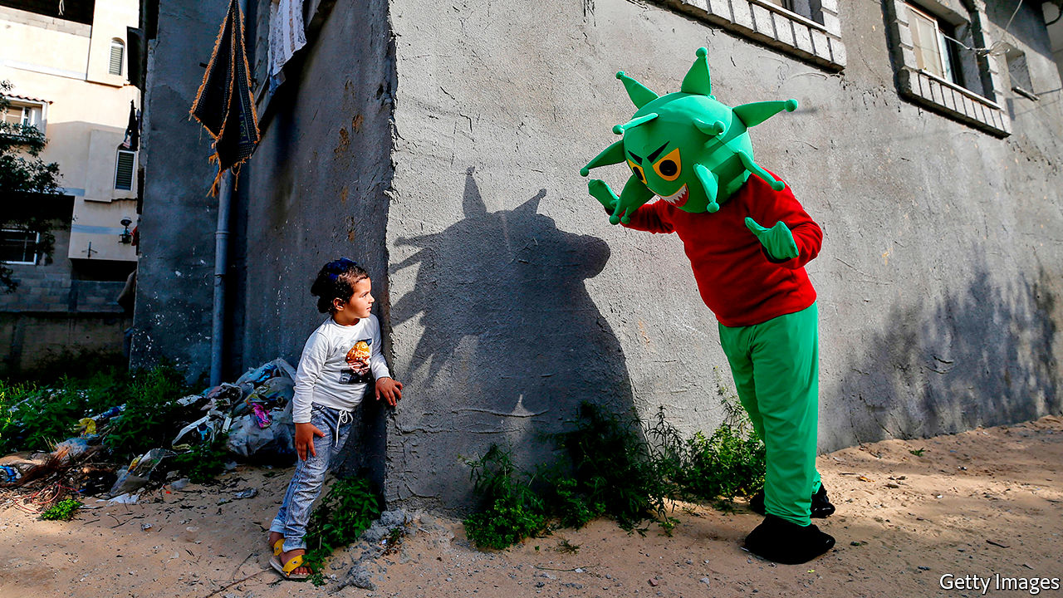

Editor’s note: Some of our covid-19 coverage is free for readers of The Economist Today, our daily [newsletter](https://my.economist.com/user#newsletter). For more stories and our pandemic tracker, see our [hub](https://www.economist.com/news/2020/03/11/the-economists-coverage-of-the-coronavirus)

SOMETIME IN FEBRUARY or early March a six-month-old girl was admitted to a hospital in the Stanford area of California. She had a fever, a blotchy rash, mild congestion and cracked lips, and was refusing to eat. Her doctors diagnosed Kawasaki disease, a rare paediatric illness originally identified in Japan in 1967.

Kawasaki disease is poorly understood, but is suspected to be the result of an overreaction by the immune system to some as-yet-unidentified stimulus—which some past evidence suggests may be a coronavirus. If untreated (which is usually a result of misdiagnosis, precisely because it is so rare), it can result in potentially lethal cardiac complications. Recognise it in time to treat it, though, and patients normally recover. And in this case it was recognised, and the patient was treated appropriately. Moreover, as part of that treatment—because, although she had no respiratory problems she did have a fever—her doctors screened her for covid-19. The tests came back positive.

Not long after this incident, doctors in New York City started reporting a surge in cases of Kawasaki disease. In a typical year, New York might see a few dozen instances. The city’s health department has now confirmed 147 cases since the covid-19 epidemic began—though how many of these were in children infected with SARS-CoV-2 is unknown. In Britain, meanwhile, the South Thames Retrieval Service, which provides intensive care to children in parts of south-east England, including London, handled eight Kawasaki cases during a ten-day period in mid-April. All these patients, one of whom died, tested negative for the virus, but positive for antibodies related to it.

South Thames would normally expect to see one or two Kawasaki patients in a period like this, so eight might just about have been written off as a blip—except for the overlap with those antibodies and the fact that, in the week after the team concerned submitted their report, they documented a further 12 cases. Something odd, it seems, is going on.

The strongest evidence yet that something odd is indeed going on comes from Italy, in the form of a paper published in the Lancet by Lorenzo D’Antiga, a paediatrician at Pope John XXIII hospital in Bergamo. This city has one of the worst local covid-19 epidemics in the country. Dr D’Antiga noted early on in it that children with Kawasaki-like symptoms were arriving at his hospital at a substantially increased rate.

Between the beginning of 2015 and February 17th of this year Pope John XXIII had admitted only 19 such patients. Between February 18th and April 20th it received ten. This is equivalent to a monthly incidence 30 times that of the previous five years. Nor was the number of these cases the only odd thing. The previous 19 had had an average age, on presentation at the hospital, of three. The 2020 patients have an average age of seven-and-a-half.

Spotting this anomaly led Dr D’Antiga to collect nose swabs and blood samples from his Kawasaki patients, regardless of their other symptoms, in order to search for signs of the virus. The results were intriguing. Only two of the swabs tested positive—an indication that a patient has a current, active infection. Eight of the ten children, though, had pertinent antibodies. These included the two with positive nose swabs. But the other six had clearly been infected in the past. Moreover, further blood samples revealed that nine of the ten recent patients, including the two with negative antibody tests, had markedly reduced white-blood-cell and lymphocyte levels—traits commonly seen in adult covid-19 patients who are severely ill.

How far the implications of all this extend is not yet clear. The elevated Kawasaki caseload may be seized on by those who would like to keep schools closed in the face of the epidemic. The illness does, nevertheless, remain rare, and recognising it early leads to a good prognosis. That argues for vigilance, rather than the continued interruption of children’s education. More positively, understanding how the virus interacts with the immune system to produce these symptoms may help to develop weapons with which it can be defeated.■

This article was downloaded by calibre from <https://www.economist.com/science-and-technology/2020/05/23/thoughts-that-the-young-are-not-much-affected-by-sars-cov-2-look-wrong>

|  |  |  |  |
| --- | --- | --- | --- |
| Previous | Articles | Sections | Next |

|  |  |  |
| --- | --- | --- |
| Science & ... | Sections | Economic & ... |

Books & arts

Solidarity in reading: The lives of others

.

Instagram: The camera always lies

.

Crime fiction: Ice-cold cases

.

American history: The ballad of Malcolm and Martin

.

Home Entertainment: Discover trio sonatas

.

Home Entertainment: Travel in confinement

.

|  |  |  |
| --- | --- | --- |
| Science & ... | Sections | Economic & ... |

|  |  |  |  |
| --- | --- | --- | --- |
|  | Articles | Sections | Next |

#### The lives of others

# Diaries written in adversity can be a source of solace

The feelings and fears of their authors often chime with today’s

May 23rd 2020 |

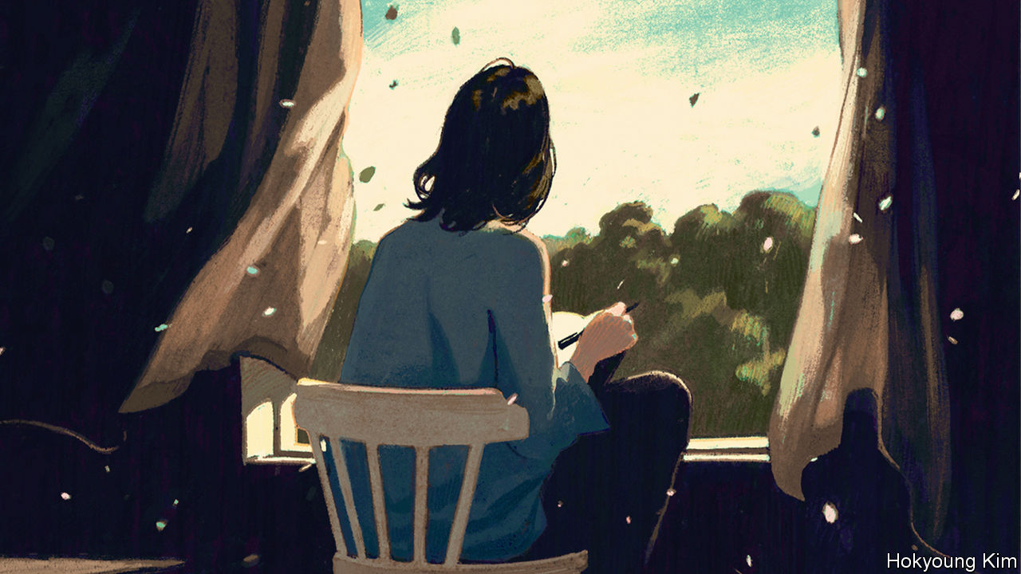

THE DIARIES of Virginia Woolf are bookended by wars. Early entries, written when she was a young novelist, describe sheltering in her kitchen during the now-forgotten air-raids over London in 1917. Over nearly three decades she would fill 26 volumes, usually settling down after tea to write up the day or, if she had been laid low by mental illness, as she often was, to recount events spanning weeks or months. Her observations of people, places and books are sometimes catty and prejudiced, often wry and incisive. In October 1940, an established modernist author living in Sussex, she chronicled another conflict:

I want to look back on these war years as years of positive something or other…Queer the contraction of life to the village radius. Wood bought enough to stock many winters. All our friends are isolated over winter fires. Chance of interruption small now. No cars. No petrol. Trains uncertain. And we on our lovely free autumn island.

Five months later, as she sensed another nervous breakdown approaching, Woolf would drown herself in the River Ouse. Yet on that autumn day she could find solace in the quiet of village life—in “October blooms; brown plough; and the fading and freshening of the marsh.” Her diary is testament to the complex, shifting moods of a brilliant mind, but also to the possibility of finding beauty amid chaos.

During a crisis, whether political or personal, writing a diary can be a comfort. In March, as lockdowns were imposed around the world in response to covid-19, columnists advised the quarantined to keep a journal of the warped new reality in which they communicated with loved ones through pixelated screens. Astronauts disclosed how recording their thoughts and dreams helped them endure the loneliness of space. New Zealand’s prime minister, Jacinda Ardern, encouraged people to annotate their days for a more prosaic reason: it could aid in tracing the disease.

But for frazzled minds, with attention spans cut by the rolling, roiling news, prying into other lives can be even more therapeutic than documenting your own. Unlike novels, which demand commitment or at least the pretence of it, you can dip in and out of diaries; they are episodic by nature, broken into shards of days, weeks and months. Entries are often hastily written, and can be consumed just as quickly. Sometimes, as with the contraction of Woolf’s world and her isolated friends, they offer unexpected parallels with the pandemic—suggesting that, in the face of very different adversities, people have experienced familiar feelings and fears.

Take Samuel Pepys’s diaries, which describe the course of the plague that hit London in 1665, when he was 32. His early entries that year are filled with blithe, gluttonous descriptions of food, plays and women. Arguments with his wife feature prominently. In April he “Lay long in bed, troubled a little with wind, but not much.”

## The uses of adversity

By the end of that month, however, he refers to another ailment: “Great fears of the Sicknesse here in the City, it being said that two or three houses are already shut up.” By June he sees red crosses painted on doors; before long, the “town grows very sickly, and people [are] afeared”. Yet still the disease seems distant—disbelief and denial always seem to accompany epidemics—and life and laughter keep breaking in. In the middle of July Pepys shares a water-taxi with a stranger, a “man of love to Musique”, and they “sung together all the way down—with great pleasure”. That evening he “dined well, and mighty merry”. After all the gaiety, he curtly records: “Above 700 dead of the plague this week.”

As the months pass, his anxiety rises. He worries about catching a cold and about a servant’s headache. He ponders the plague’s impact on the vogue for the “periwig” (he has not worn his new one for fear of catching someone else’s lice). He walks through a changed London: “But Lord, how empty the streets are, and melancholy.”

This uncanny sense of a city sliding from familiar to strange recurs in the diaries George Orwell kept during the second world war. “Huge areas of London almost normal,” he observes as the Blitz begins in September 1940, “and everyone quite happy in the daytime…” Four days later, though, he finds Oxford Street empty of traffic and almost deserted, “the late afternoon sun shining straight down the empty roadway and glittering on innumerable fragments of broken glass”.

War is not a precise parallel for pandemics, however fond today’s politicians are of martial rhetoric. But war diaries such as Orwell’s are full of moments that resonate now. “As soon as war started the carrying or not carrying of a gas mask assumed social and political implications,” he writes in June 1940, though he might have been talking about masks in the age of covid. “You are still a little stared at if you carry one without being in uniform.” Or take the day in July when he sees a heron flying over Baker Street: “I suppose it is possible that the war, ie the diminution of traffic, tends to increase bird life in inner London.”

## Life to lead

The wartime diaries of Astrid Lindgren, author of “Pippi Longstocking”, highlight the shortages and terror of invasion that gripped even neutral Sweden—and the challenges of motherhood when you have to worry about feeding and entertaining children. Lindgren worked as a censor, learned about overseas atrocities early, and worried that they would happen in Sweden, too. After opening letters describing starvation in Belgium and France she writes: “It makes one feel quite hopeless, sitting at work and reading them.”

In many war diaries there is an uneasy tension between headline events and personal tribulations. “Not much news”, Orwell writes, “ie only events of worldwide importance…” Three years into the war Lindgren recalls how “we used to talk about it all the time; now we see it as a necessary evil, to be thought of and talked about as little as possible.” By contrast, in the diaries of Derek Jarman, a British film-maker and artist, the personal and the political fuse.

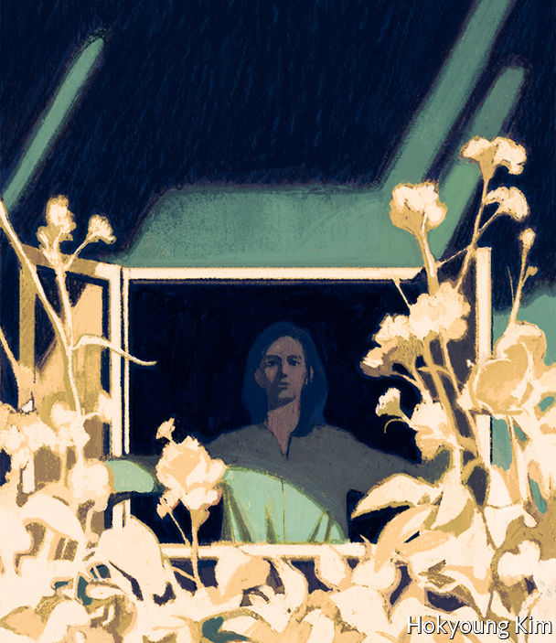

Jarman began his diaries, published in two volumes as “Modern Nature” and “Smiling in Slow Motion”, soon after learning he was HIV-positive, and just before he revealed the diagnosis publicly. Behind the tally of days, weeks and months runs an undercurrent of mortality—a fate that many people, even if they know their death is close, try to ignore. Jarman faces the ultimate, inevitable adversary head on.

His record of his last five years is angry, beautiful and haunting by turns. As he grapples with the effects of the disease and the attendant hospital visits, he records the stigma HIV-positive people faced in the 1980s and 1990s, brilliantly articulating the mental toll of a physical illness: “I’m less alive. There’s less life to lead. I can’t give 100% attention to anything—part of me is always thinking about my health.”

In “Modern Nature”, which begins in 1989, he reflects on his life as a gay man in London in the 1960s and 1970s, his childhood, the experience of living with a scourge that would kill many close friends, and on things which give him pleasure—including his partner, “HB”, and his garden at Prospect Cottage in Dungeness:

Behind the façade my life is at sixes and sevens. I water the roses and wonder whether I will see them bloom. I plant my herbal garden as a panacea, read up on all the aches and pains that plants will cure—and know they are not going to help…Yet there is a thrill in watching the plants spring up that gives me hope.

Just as Woolf found a spell of respite in the landscape of Sussex, so Jarman’s brightly coloured shingle garden is a place where he can find peace.

Diaries can show people at their messiest (even if they are intended for publication, as Jarman’s were). At the best of times people are anxious, lonely, bitter, prejudiced, annoyed and confused. Encompassing all these feelings, diaries can be as expansive and gripping as fiction. They display the best and worst sides of their writers; they show readers that they are not alone in feeling scared or miserable. And reading the lives of others suggests that, even at times of crisis and distress, it is possible to find and grasp moments of joy. ■

Editor’s note: Some of our covid-19 coverage is free for readers of The Economist Today, our daily [newsletter](https://my.economist.com/user#newsletter). For more stories and our pandemic tracker, see our [hub](https://www.economist.com/news/2020/03/11/the-economists-coverage-of-the-coronavirus)

This article was downloaded by calibre from <https://www.economist.com/books-and-arts/2020/05/23/diaries-written-in-adversity-can-be-a-source-of-solace>

|  |  |  |  |
| --- | --- | --- | --- |
|  | Articles | Sections | Next |

|  |  |  |  |
| --- | --- | --- | --- |
| Previous | Articles | Sections | Next |

#### The camera always lies

# “No Filter” chronicles the rise of Instagram

Sarah Frier, a reporter for Bloomberg, also offers glimpses of Silicon Valley’s weirdness

May 23rd 2020 |



No Filter. By Sarah Frier.Simon & Schuster; 352 pages; $28. Random House Business; £20.

ON A BEACHSIDE walk in Mexico in 2010, Kevin Systrom’s girlfriend explained the problem with his new photo-sharing app, then called “Codename”. Professionals might want the world to see their pictures, but her own phone snaps weren’t good enough. Back at the hotel, Mr Systrom coded a quick solution: a filter that gave even the most basic shot a hipster finish. He applied it to a snap of a dog by a taco stand, and uploaded it, making it the first image posted to what became Instagram.

A billion users later, the look in that filtered photo is ubiquitous. Square proportions, high contrast and darkened edges have instantly smartened up profile pictures, holiday albums and advertising campaigns around the world. In “No Filter” Sarah Frier, a technology correspondent at Bloomberg, uses close access to Instagram insiders to give a lively and revealing account of how the world came to see itself through Mr Systrom’s lens.

The tale of nerds who struck gold offers glimpses of Silicon Valley’s weirdness. In the early days Mr Systrom and his co-founder, Mike Krieger, patched errors with their laptops on camping trips and took a call from Justin Bieber when he forgot his password. Later, haggling over Instagram’s sale to Facebook, a crunch negotiation took place over a barbecue at Mark Zuckerberg’s mansion, with the Facebook founder grilling meat he boasted of shooting himself, though he was unsure if it was venison or boar. Mr Systrom went to the Vatican to persuade the ultimate influencer to sign up—and @franciscus obliged.

The sale, for a then-unthinkable $1bn, went sour. At Facebook “every single activity…stemmed from a religious obsession with growth,” writes Ms Frier, who is even-handed but seems closer to Instagram’s founders than Facebook’s high command. As its new owner steered Instagram towards taking ads and making money, some early employees, who had wanted to build “a community centred around the appreciation of art and creativity...instead felt that they had built a mall”. Mr Systrom, a perfectionist who initially oversaw every ad carried on Instagram, personally editing one to make the French fries look crispier, was seen by Facebookers as a precious snob.

As Instagram grew bigger and cooler, Facebook began to act “like the big sister that wants to dress you up for the party but does not want you to be prettier than she is”, complains one Instagram executive. Mr Zuckerberg limited how many people Instagram could hire. He even got cross that its new video app, IGTV, had a logo that looked a bit like that of Facebook Messenger. In 2018, after six years of this, Mr Systrom and Mr Krieger quit.

Within this business story are several subplots. One is how Instagram blurred the lines between the personal and the promotional. Snoop Dogg, a rapper, made what may have been the first paid Instagram post in January 2011, when he uploaded a picture of himself “Bossin up wit dat Blast”, a new drink. At least before covid-19 struck, Kim Kardashian could make $1m from a single post to her 157m followers; over 200m users had 50,000 followers or more, enough to make a living as “human billboards”. America’s Federal Trade Commission has said influencers should declare when they are being paid. They often don’t.

Another subplot is how an app that people use to document their life turned into one that determines how they live it. At first this was a virtue. In the early days Instagram began encouraging wholesome outings to scenic spots for users to photograph. But it has become a problem. Some photogenic places, like Norway’s Trolltunga cliff, have been overrun. Worse, the ability to edit photos to perfection has spread insecurity. “I don’t know what real skin looks like any more,” complains Chrissy Teigen, an Instagram star.

All this brought in $20bn for Instagram in 2019, or a quarter of Facebook’s revenue. But perhaps encouragingly, some in the company have come to see perfectionism as a risk to Instagram’s business. Young people have embraced Snapchat and, more recently, TikTok, as networks where they can go unfiltered. There they can post even imperfect shots: of their ordinary selves, their ordinary lives, even an ordinary dog by a taco stand. ■

Dig deeper:

* [Instagram treats its HQ like a showcase. Sarah Frier goes through the keyhole](https://www.1843magazine.com/upfront/postcard-from-silicon-valley/the-instagram-aesthetic-comes-home)

This article was downloaded by calibre from <https://www.economist.com/books-and-arts/2020/05/23/no-filter-chronicles-the-rise-of-instagram>

|  |  |  |  |
| --- | --- | --- | --- |
| Previous | Articles | Sections | Next |

|  |  |  |  |
| --- | --- | --- | --- |
| Previous | Articles | Sections | Next |

#### Ice-cold cases

# Investigating the mysterious appeal of Scandi noir

An enthusiast tours the region to explain the genre’s rise

May 23rd 2020 |



Scandinavian Noir. By Wendy Lesser. Farrar, Straus and Giroux; 288 pages; $27 and £20.99.

THE BIGGEST mystery of Scandinavian crime fiction is how five countries with a combined population of around 27m produced so many hit novels that the region’s noir has become a genre in itself. Jo Nesbo, creator of the lugubrious Norwegian detective Harry Hole, has sold over 45m books worldwide. The Kurt Wallander novels, by Henning Mankell, have been turned into dozens of films and television episodes.

One answer is that although, for some outsiders, Scandinavia is a beacon of social democracy, the reality of life is darker and more complicated. Social pressure to conform, the near-endless winters, the poverty and depression behind the sleek prosperity, rising xenophobia—all these drawbacks and more are explored by Wendy Lesser in her lively, perceptive guide to Scandi noir. Sweden’s smugness, she says, conceals a murky past. Its post-war wealth is rooted in wartime trade with Nazi Germany, to which the Swedes sold steel to make Panzer tanks and the ball-bearings on which their tracks turned.

The book begins with a breezy, well-informed tour of the genre. Ms Lesser, the editor of the Threepenny Review, a literary magazine, is especially sharp on the detective series written by the Swedish couple and co-authors Maj Sjowall and Per Wahloo in the 1960s and 1970s, widely regarded as the beginning of the trend. Its hero, Martin Beck—the model in part for Wallander and Hole—shone a light into the shadiest crevices of Swedish society. After that comes an actual travelogue through Norway, Denmark and Sweden (Ms Lesser elects to skip Finland and Iceland, too, even though that tiny nation produces lots of distinguished crime fiction).

She peppers the book with observations on Scandinavian life and writing, from the treatment of domestic space—“the Swedes, Danes and Norwegians seem to occupy their interiors…more cosily than [Americans] do”—to the copious sexual antics of the fictional protagonists. Beneath the romps lie more sinister themes. These books have a disturbing predilection for child abuse, she notes. A history of sexual abuse motivates Lisbeth Salander, heroine of Stieg Larsson’s bestselling “Millennium Trilogy”. “In almost every series”, Ms Lesser calculates, “some child or teenager is sexually or psychologically abused by adults.” Others are murdered: kidnapped from parks, sold to paedophiles. As in reality, the abuser often turns out to have been abused.

This is a rich subject. But instead of probing deeply into the Scandinavian psyche, Ms Lesser moves on to discuss the weather. She might profitably have woven the two halves of her book together, introducing authors as she wanders around their countries and riffing off the people and places she encounters. The travelogue is needlessly written in the third person (“the first time she sees Stockholm, she feels she is coming home”). Her chatty voice sometimes slips into banality.

Still, Ms Lesser is an engaging and amiable guide to a cultural phenomenon that has swept much of the planet. She visits Ystad, the pleasant but unremarkable Swedish town which, in Mankell’s stories, is home to Wallander. Its streets are thronged with tourists following in the detective’s footsteps. Here, perhaps, is the answer to the mystery of Scandi noir’s appeal: Wallander, like Hole and Salander, offers safe passage into a bleak and dangerous world, one which readers in other countries may enter and leave at their pleasure. ■

This article was downloaded by calibre from <https://www.economist.com/books-and-arts/2020/05/23/investigating-the-mysterious-appeal-of-scandi-noir>

|  |  |  |  |
| --- | --- | --- | --- |
| Previous | Articles | Sections | Next |

|  |  |  |  |
| --- | --- | --- | --- |
| Previous | Articles | Sections | Next |

#### The ballad of Malcolm and Martin

# A twin biography retells the story of the civil-rights movement

Malcolm X and MLK had more in common than is often believed

May 21st 2020 |

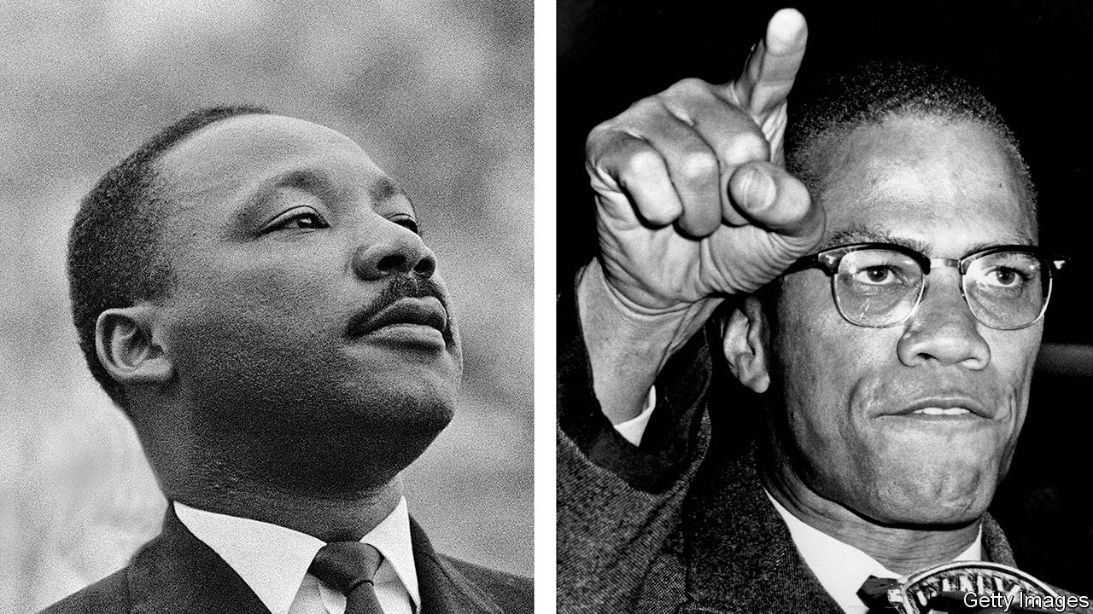

The Sword and the Shield. By Peniel Joseph.Basic Books; 384 pages; $30 and £25.

HIS INDEX finger says it all—pointing accusingly, arm outstretched. He bites his lip in righteous fury. Since his assassination in 1965 Malcolm X’s glare has adorned the T-shirts and dorm rooms of generations of rebellious students. In a simplistic view of the civil-rights movement, he is the radical counterpart to Martin Luther King junior, himself murdered three years later. King is the peacemaker, the Baptist preacher who called for an integrated America that fulfilled its promise of equality. Malcolm is the militant, the Muslim convert who advocated using “any means necessary”, implicitly including violence, to achieve dignity for black Americans.

Peniel Joseph, a historian at the University of Texas at Austin, wants to complicate this story. Malcolm’s and King’s views on American racism and injustice were not always far apart, he argues, and their strategies for advancing black rights were often symbiotic rather than conflicting. The two may have begun as rivals, but by the mid-1960s they had a tacit “political partnership” in which Malcolm’s stance allowed King to portray himself as a moderate. In this telling, the traditional juxtaposition seems less a fair analysis than a reflection of expectations: because Americans often see racial politics as a contest between reconciliation and revenge, they are inclined to classify black leaders as either compromisers or extremists.

Mr Joseph is hardly the first to argue that King’s posthumous image is too soft. It is often noted that, although he is a national hero today, most white Americans disapproved of him during his lifetime. The non-violent marches against segregation which he led across the South were condemned as provocations not just by southern conservatives but by many northern liberals. Disappointed with the civil-rights laws passed by President Lyndon Johnson, King grew more radical in the last years of his life, helping lead opposition to the Vietnam war and flirting with socialism.

Malcolm’s moderate turn, meanwhile, has been on record at least since his autobiography was published shortly after his death. He had joined the Nation of Islam, a sect launched in Detroit in the 1930s, during a stint in prison, imbibing its anti-white theology along with its discipline. His charisma made him a leader in that outfit and beyond. While King insisted on non-violence, Malcolm warned that blacks had the right to meet police brutality with force, and deployed the Nation’s nattily dressed toughs to show he meant it. But he feuded with the sect’s hierarchy, eventually leaving it for mainstream Sunni Islam and building relationships with post-colonial African and Arab leaders. After a pilgrimage to Mecca in 1964, awed by the pan-racial spectacle of the haj, he began describing American racism as a perverse system trapping both whites and blacks.

Mr Joseph’s twin biography provides insights into why the two leaders took such different paths. King was the son of a successful pastor in Atlanta, brought up in a stable family that belonged to the city’s black elite. He attended the historically black Morehouse College and Boston University, where he befriended national civil-rights figures. Once back in the South and a pastor himself, he exploited these connections. His organising efforts, courageous as they were, utilised the existing political infrastructures of blacks and liberal whites. He saw integration as a natural goal.

By contrast, Malcolm grew up poor. He was six years old when his father, a radical preacher and activist, was killed. His mother later suffered a nervous breakdown, and Malcolm, a promising student, ended up in Boston with a cousin. There he drifted into gang life. Joining the Nation of Islam and isolating himself from mainstream society were the beginning of his redemption. It is not surprising that he endorsed black separatism, nor that someone who suffered as he did through racial inequality would embrace drastic solutions to it.

This book’s main weakness begins to emerge in its fondness for effusive clichés. Both men were certainly brilliant, but Mr Joseph says so incessantly and applies the word to half the people they meet. Speeches are electrifying, abilities uncanny, humour scathing. This stylistic problem eventually becomes a substantive one.

## How long? Too long

Take the phrase “truth telling”, which Mr Joseph uses repeatedly. In a discussion with the writer James Baldwin in 1963, a week after the “I Have a Dream” speech, Malcolm dismissed King’s rhetoric: “It’s not integration with us until the entire thing is laid on the table, not a hundred years from now, but in the morning.” Baldwin, Mr Joseph writes, was “mesmerised by the sheer audacity of Malcolm’s truth telling”. Yet it is not clear what Malcolm meant. (How exactly does a society lay the entire thing on the table?) This seems less an example of truth telling than of what social-media activists would call edgelord behaviour: a provocative figure, sensing that a rival has seized the initiative, trying to outflank him with a more extreme approach.

Mr Joseph’s hero-worship of both men sometimes undermines his effort to demystify the opposition between them. The book is at its best when it treats them pragmatically, as two leaders with different inclinations and separate power bases but sometimes convergent interests. Turning them into icons itself plays into the tendency to sort black leaders into angry radicals and compromising moderates, a habit Mr Joseph means to critique.

This tendency is as old as racial oppression in America, which is to say as old as the nation. To some extent, it is driven by fear. Consciously or otherwise, some whites fear the history of white supremacism is unforgivable. For their part, many black Americans think racism is ineradicable (according to a survey by Pew last year, half of black adults consider it unlikely that racial equality will ever be achieved). On that painful view, moving on means living with discrimination. Thus some whites wonder if black politicians despise them; blacks sometimes ask if they have sold out. It may have been inevitable that the leaders of the civil-rights movement came to be judged along these enduring lines. ■

This article was downloaded by calibre from <https://www.economist.com/books-and-arts/2020/05/21/a-twin-biography-retells-the-story-of-the-civil-rights-movement>

|  |  |  |  |
| --- | --- | --- | --- |
| Previous | Articles | Sections | Next |

|  |  |  |  |
| --- | --- | --- | --- |
| Previous | Articles | Sections | Next |

#### Home Entertainment

# Trio sonatas are the ideal music for the lockdown

Warm and uplifting, they are built for the spare room, not the concert hall

May 23rd 2020 |



“A SYMPHONY MUST be like the world,” the Austrian composer Gustav Mahler wrote; “it must contain everything.” Today, however, the world seems remote. Everything might be too much to bear. So put aside those all-encompassing operas and immersive string quartets and instead choose the music built on a scale for life under lockdown: the trio sonata.

People don’t write them any more—they haven’t for over 150 years. But in the second half of the 17th century, trio sonatas spread from Italy across northern Europe, still reeling from the Thirty Years War. They were partly a vehicle for the violin, the new musical phenomenon prized for its ability to sing like the human voice. The Italians, says Rachel Podger, a British violinist, “were extravagant in their style and not shy to show what they could do.”

“Trio sonata” is a capacious term. Some were written for the church, others to play at home. Despite being called trios, there are usually four players—two upper lines, often violins but sometimes winds; a bass part, often a cello or a bass viol; and an instrument to fill in the harmony, a harpsichord, say, or a lute. But all rules are made to be broken. Johann Sebastian Bach’s trio sonatas comprise three strands of exquisite music written for the organ alone.

Early exponents included the Venetians Dario Castello (1602-31) and Giovanni Legrenzi (1626-90). The form was picked up in Germany by Georg Philipp Telemann (1681-1767) and Bach’s sons, including Carl Philipp Emanuel (1714-88) and Wilhelm Friedemann (1710-84), and in Britain by Henry Purcell (1659-95), George Frideric Handel (1685-1759) and William Boyce (1711-79). But the trio-sonata king was Arcangelo Corelli (1653-1713), a rock-star violinist like Antonio Vivaldi, whose perfectionism honed a powerful economy. “There’s never any hot air,” Ms Podger says of his compositions. “You know exactly what he means.”

To his contemporaries, he was a giant. Roger North, an English writer, thought that “if musick can be immortall, Corelli’s consorts will be so.” Yet today his work ranks low in the pantheon, overshadowed by later sonatas and string quartets. In the 18th century fashion shifted from counterpoint to melody. The lower strings became subordinate to the top line. Keyboard players wanted more than to add blocks of harmony. Audiences grew. By the time Haydn established the string quartet, trio sonatas were in decline.

Time to rediscover them. Their twisting counterpoint and sparkling clarity help clear the quarantine fug. Their dance rhythms and harpsichord beats are uplifting. Made for the spare room, not the concert hall, they are warm and life-affirming.

Ms Podger compares the instruments in a trio sonata to contrasting but co-operative housemates. “You might agree, you might disagree.” The form “reflects the intimate nature of being at home and digging in the garden and cooking and conversing around the table.” It is music for now. ■

For a playlist, go to [economist.com/triosonatas](https://economist.com/triosonatas)

Editor’s note: Some of our covid-19 coverage is free for readers of The Economist Today, our daily [newsletter](https://my.economist.com/user#newsletter). For more stories and our pandemic tracker, see our [hub](https://www.economist.com/news/2020/03/11/the-economists-coverage-of-the-coronavirus)

This article was downloaded by calibre from <https://www.economist.com/books-and-arts/2020/05/23/trio-sonatas-are-the-ideal-music-for-the-lockdown>

|  |  |  |  |
| --- | --- | --- | --- |
| Previous | Articles | Sections | Next |

|  |  |  |  |
| --- | --- | --- | --- |
| Previous | Articles | Sections | Next |

#### Home Entertainment

# Confined in prison, Marco Polo roamed across the world

His travelogue shows that you can go anywhere in your imagination

May 23rd 2020 |

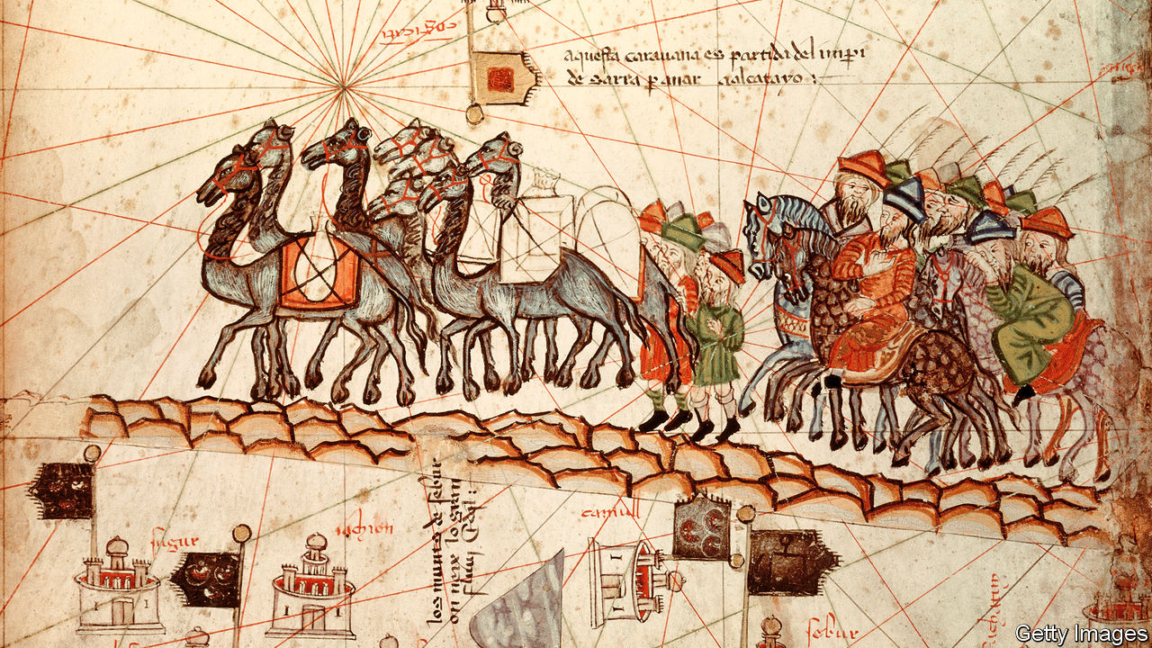

EXPLORERS DO NOT thrive in captivity, so it must have stung when Marco Polo was imprisoned in Genoa in 1298. The length of his internment depended on the course of the city-state’s war with his native Venice. But he did not waste it. “Rather than idle away time he decided to put together this book,” explains the prologue of “The Travels” (in Nigel Cliff’s translation). Written with Rustichello of Pisa, an author and fellow inmate, it is one of literature’s great travelogues—a meandering voyage through the cultures and kingdoms of the Middle East, China, South-East Asia, India and Russia.

A seasoned itinerant merchant, Polo lays out his material with a flourish, while doggedly assuring readers of its authenticity. Genuine and fake, history and dream are woven together. Detailed figures—the tonnage of ships on the Yangzi, the commission charged for exchanging old Chinese banknotes, the going rate in India for Arabian horses—sit alongside flights of fancy. The technique lends credibility to the magic and lustre to the humdrum.

If Polo’s body was imprisoned, his mind roamed free. Some of the inventions, such as a levitating column in Samarkand, are obvious. But elsewhere what looks like fantasy is fact seen through the lens of novelty. A “unicorn” in Sumatra, for instance, is “a very ugly beast to look at” with a black horn and stumpy feet. Hardly anyone from Europe had seen a rhinoceros before.

The intoxicating centrepiece is Polo’s sojourn in China, then governed by Kublai Khan, founder of the Yuan dynasty. His palace at Khanbaliq (modern-day Beijing) is topped with roofs of “scarlet and green and blue and yellow” that “shimmer like crystal” in the sun. Mile-long walls enclose a park filled with roe deer and white stags. The account of the Great Khan’s summer abode at Shangdu—built of bamboo canes tied with silk, and dismantled and moved at the Khan’s whim—inspired the “stately pleasure-dome” in Samuel Taylor Coleridge’s Xanadu.

Many of Polo’s contemporaries dismissed him as a fraud. Giant man-eating serpents were all very well, but what was this nonsense about paper money? Some modern academics still question whether he visited China at all. But his tales were too tantalising to resist. A well-thumbed copy of “The Travels” features in the library of Christopher Columbus. Children supposedly chased Polo through the streets of Venice, beseeching him to tell them “another lie”. On his deathbed, when asked for the umpteenth time to own up to his fibs, he is said to have responded: “I have not told half of what I saw.”

Today his book remains a feast, opening up places that are now inaccessible, or perhaps never existed. If writing it was Polo’s way of escaping his Genoese cage, for covid-era readers it is a chance to swap quarantine for a mysterious world where the wondrous becomes true. ■

Editor’s note: Some of our covid-19 coverage is free for readers of The Economist Today, our daily [newsletter](https://my.economist.com/user#newsletter). For more stories and our pandemic tracker, see our [hub](https://www.economist.com/news/2020/03/11/the-economists-coverage-of-the-coronavirus)

This article was downloaded by calibre from <https://www.economist.com/books-and-arts/2020/05/23/confined-in-prison-marco-polo-roamed-across-the-world>

|  |  |  |  |
| --- | --- | --- | --- |
| Previous | Articles | Sections | Next |

|  |  |  |
| --- | --- | --- |
| Books & arts | Sections | Graphic detail |

Economic & financial indicators

Economic data, commodities and markets

.

|  |  |  |
| --- | --- | --- |
| Books & arts | Sections | Graphic detail |

|  |  |  |  |
| --- | --- | --- | --- |
|  | Articles | Sections | Next |

# Economic data, commodities and markets

May 21st 2020 |

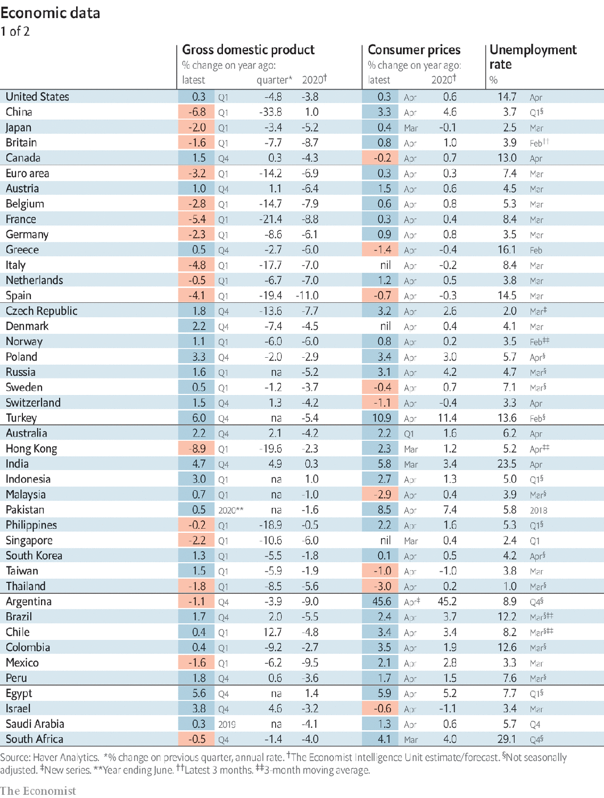

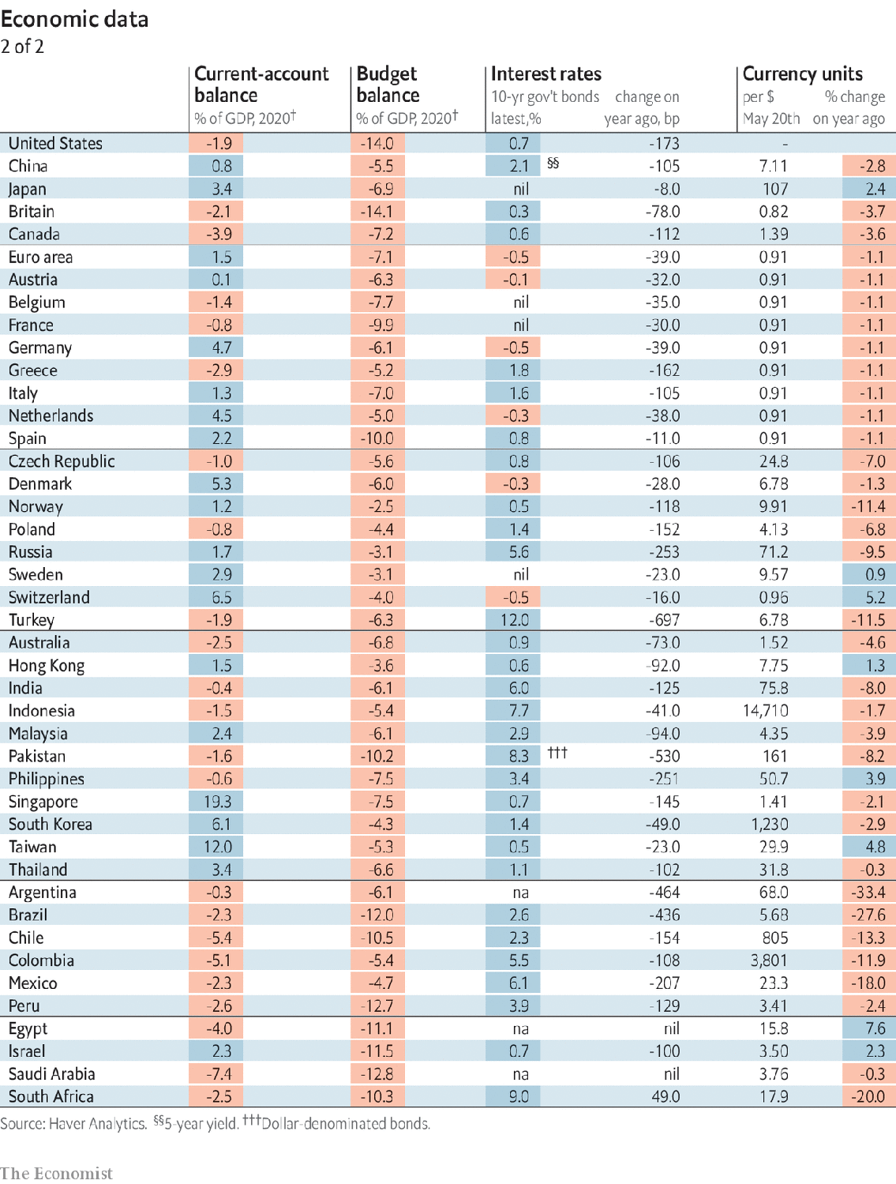

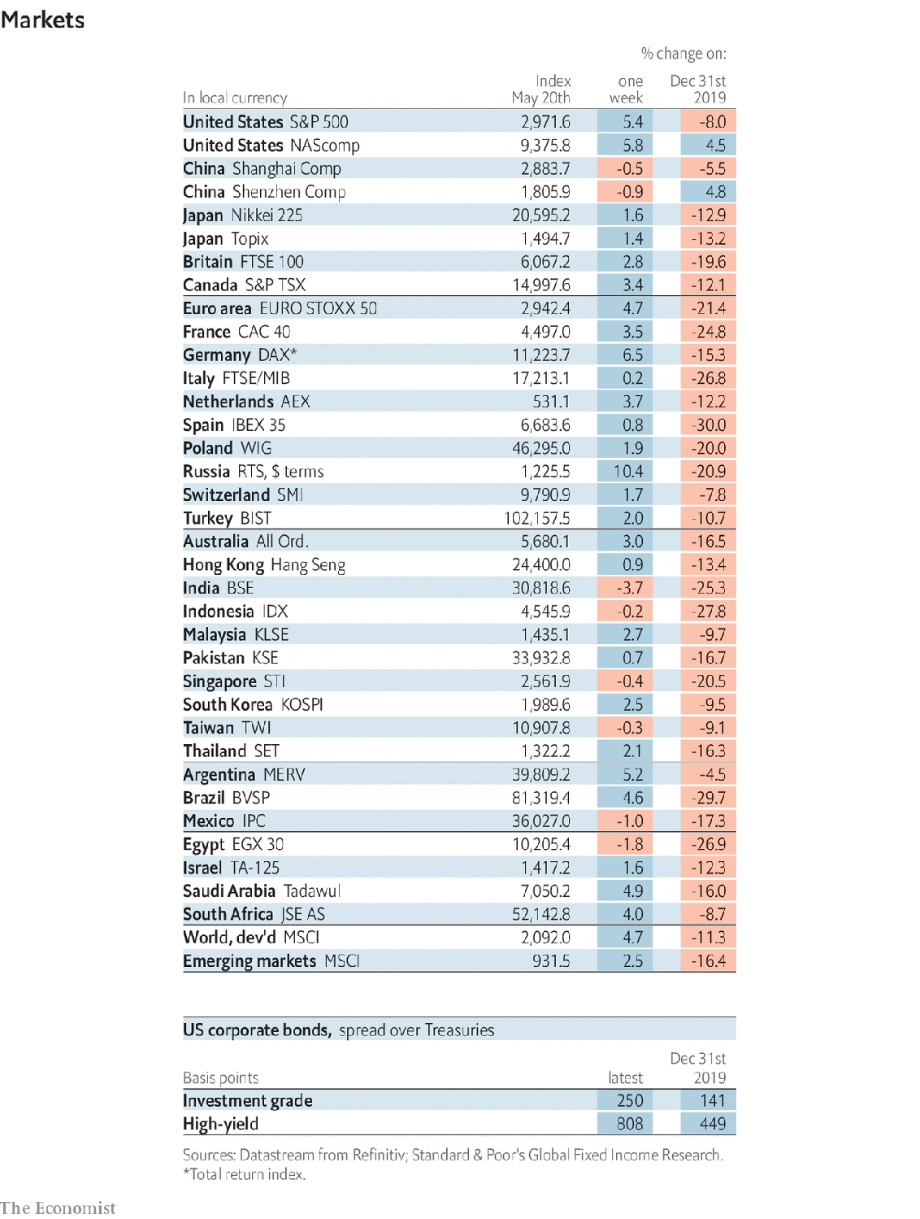

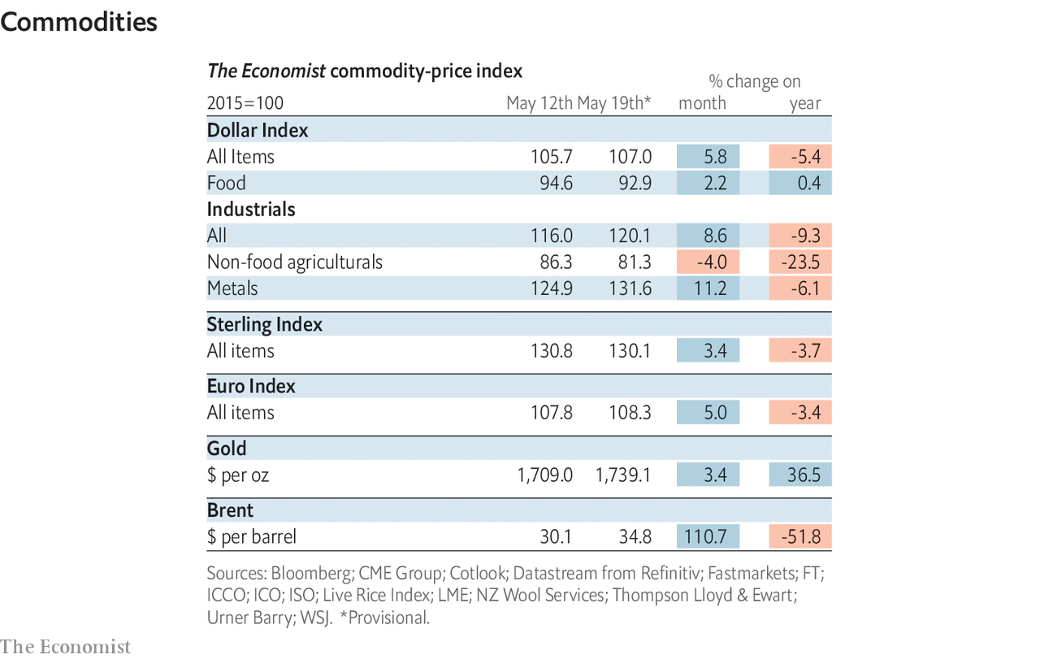

This article was downloaded by calibre from <https://www.economist.com/economic-and-financial-indicators/2020/05/21/economic-data-commodities-and-markets>

|  |  |  |  |
| --- | --- | --- | --- |
|  | Articles | Sections | Next |

|  |  |  |
| --- | --- | --- |
| Economic & ... | Sections | Obituary |

Graphic detail

Forecasting covid-19: A terrible toll

.

|  |  |  |
| --- | --- | --- |
| Economic & ... | Sections | Obituary |

|  |  |  |  |
| --- | --- | --- | --- |
|  | Articles | Sections | Next |

#### Forecasting covid-19

# Early projections of covid-19 in America underestimated its severity

By luck or by design, they have improved markedly since

May 23rd 2020 |

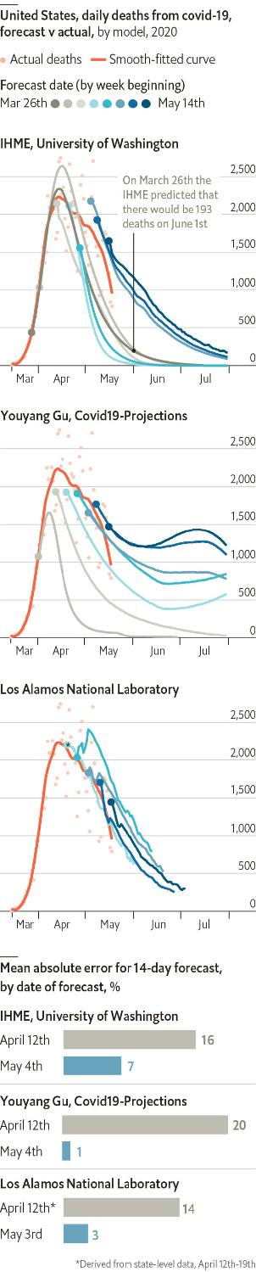

SOME 80 DAYS have now passed since the first death from covid-19 occurred on America’s shores. Since then over 90,000 people in the country have succumbed to the virus. That toll is greater than America’s combat deaths in Korea, Vietnam, Afghanistan and Iraq combined. Whereas governments do not release their forecasts of how many people will be killed in wars, predictions of covid-19 deaths in America have been published and are widely scrutinised.

As in the fog of war, early epidemiological projections have been subject to the largest errors. One of the first prominent institutions to issue a long-run forecast for covid-19 was the Institute for Health Metrics and Evaluation (IHME) at the University of Washington. On March 26th it predicted that a total of 81,000 people were likely to die from the epidemic in America. Though they were uncertain about the precise toll—estimates ranged from 38,000 to 162,000—their model was confident that the virus would be done by July. The IHME’s projections fluctuated wildly afterwards. A forecast issued in mid-April predicted just 60,000 deaths.

Despite the misgivings of many experts, the IHME’s model was widely cited. Donald Trump’s administration used the forecasts as part of its evidence of when best to ease lockdowns. Meanwhile, the IHME’s method raised concerns among fellow health experts because it used an unorthodox “curve-fitting” approach rather than a conventional SEIR method. SEIR has been the basis for most epidemiological models for 100 years, and estimates the share of a population who are susceptible (S); exposed (E); infected (I); recovered or dead (R). The IHME began incorporating results from a SEIR model in early May.

Two other long-run models have also entered the forecasting fray. The first, from the Los Alamos National Laboratory (LANL), is a SEIR-like model. It has tended to be more pessimistic than other forecasters. Youyang Gu, a young graduate from the Massachusetts Institute of Technology, built another after seeing the IHME’s early missteps. Mr Gu’s model uses machine-learning algorithms to instruct a SEIR model that has recently been more accurate than forecasts from many established outfits. Mr Gu’s model, as well as those from the IHME and LANL, is one of a dozen individual forecasts that America’s Centres for Disease Control and Prevention uses to arrive at an “ensemble” estimate of covid-19 deaths.

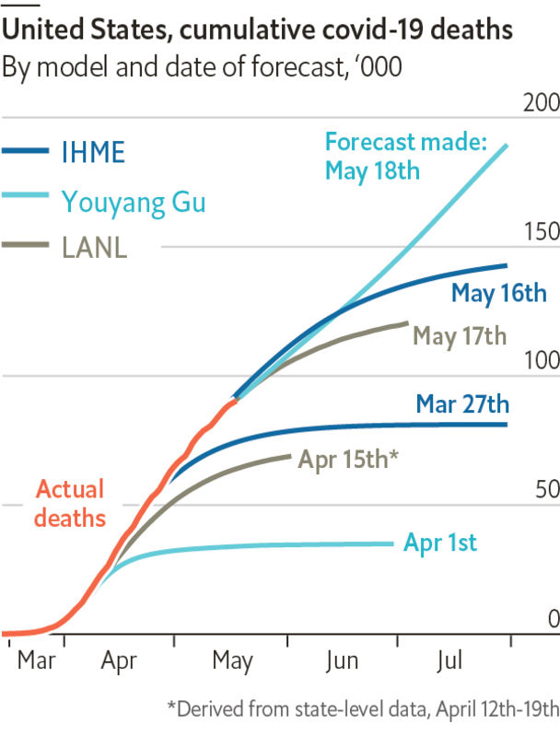

Although long-run forecasts will always be subject to larger errors than short-run projections, they have been getting smaller. An analysis by The Economist finds that all models succumbed to large forecast errors in their early stages. Across the three models, projections made on April 12th for the death toll two weeks ahead had an average absolute error of 17%. Those made at the beginning of May for the next two weeks had an average error of just 4%.

There are several reasons why forecasts got off to a bad start. First, the early models suffered from an absence of good historical numbers. The first models extrapolated patterns from the virus’s path through Wuhan and Italy, where the transmission rate was lower than in America. Second, the stabilisation of the death rate, which is now falling gradually, has made forecasting easier. Finally, predicting the future behaviour of individuals, such as their adherence to lockdowns, is guesswork at best. Some new models are attempting to fill this gap with real-time location information.

With better data and improved models, the forecasts made today should prove more accurate—either by luck or design—than earlier ones. Yet future estimates remain widely divergent. The IHME expects total deaths to stabilise in July at 140,000, whereas Mr Gu expects the virus to persist into August, at which time there will have been nearly 200,000 deaths. Either total would mean that covid-19 would have exacted a truly terrible toll. ■

Sources: Covid19-Projections.com; Institute for Health Metrics and Evaluation; Los Alamos National Laboratory; New York Times; Reich Lab, University of Massachusetts Amherst;The Economist

This article was downloaded by calibre from <https://www.economist.com/graphic-detail/2020/05/23/early-projections-of-covid-19-in-america-underestimated-its-severity>

|  |  |  |  |
| --- | --- | --- | --- |
|  | Articles | Sections | Next |

|  |  |  |
| --- | --- | --- |
| Graphic detail | Sections |  |

Obituary

Little Richard: Gonna have some fun tonight

.

|  |  |  |
| --- | --- | --- |
| Graphic detail | Sections |  |

|  |  |  |  |
| --- | --- | --- | --- |
|  | Articles | Sections | Next |

#### Gonna have some fun tonight

# Little Richard died on May 9th

The king of rock & roll and hero for a generation of musicians was 87

May 23rd 2020 |

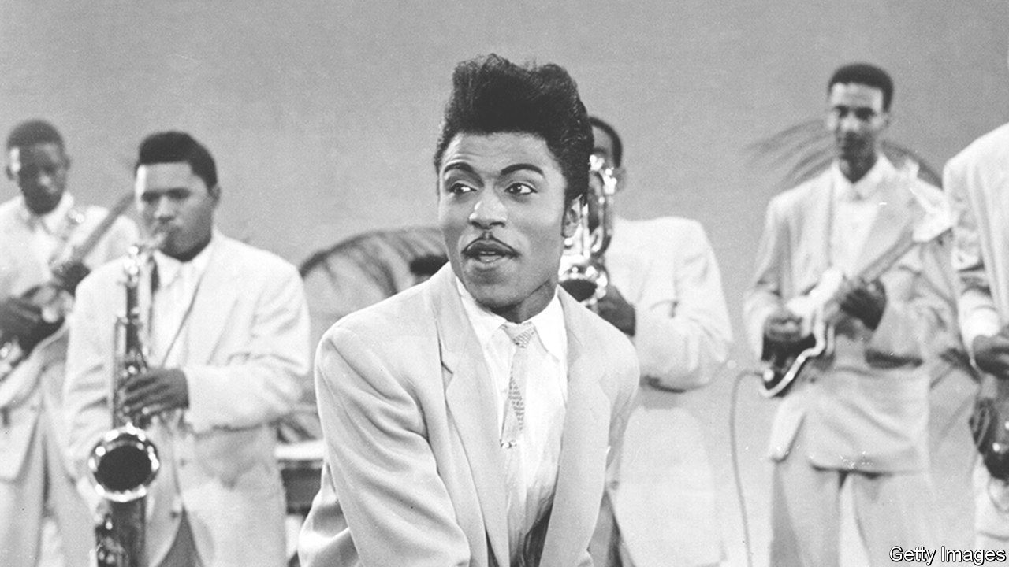

WHAT WAS it, that thing he had? What was it that propelled him in 1955 from washing pots at the Greyhound bus station in Macon, Georgia, to being such a star that girls fainted to see him and he was paid $10,000 an hour? And from a cat that everyone laughed at, never good for anything but scrubbing dishes, into the inventor of the sound that formed a whole generation of music-makers, from the Beatles to James Brown to Elton John to the Rolling Stones? Because almost everybody agreed: he was the one.

It was partly the look that got him noticed, the pancake make-up and mascara round those wildly staring eyes, the pencil moustache, the pompadour rearing up on his head. He’d borrowed all that from doing drag acts in local vaudeville shows, together with his ever-growing dazzle of sequins, glass beads and neon-bright colours to catch whatever spotlight there was. Then came the crazy antics: jumping around, sticking one leg up on the piano as he played, pretending to shove his lead saxophonist off the stage, until by the end of the show he’d be a pool of water, dabbing his face with a hanky and asking, “Am I still pretty?” (His band, the Upsetters, also in make-up, would be fairly sweating, too.) But all that came second to the electrifying rhythm of his pounding hands, the right hand especially, the piano roaring and reverberating like a train, and the voice that roared with it, throat-scraping hoarse, rising time after time to a yelp like a whistle: “Lu-cille-uh! Please come back where you belong!”

The words often made no sense, but that didn’t matter. Rhythm ripped it all up, so fast and wild that you just had to dance. As he whooped in “Tutti Frutti”, the record that made his name, Whop bop b-luma b-lop bam bom! That was his thing, right there: mix boogie-woogie with rhythm & blues and a shot of gospel, add those yips and shouts (it was tricky at first to sing so hard, but he got used to it), crank the volume, speed it way up. Other singers had done pieces of this. He took his woo-ooh-ooh from Marion Williams, his yelps from Ruth Brown, general inspiration from Mahalia Jackson, but it was he who combined them to produce, between 1955 and 1958, a slew of hits—“Good Golly Miss Molly”, “Long Tall Sally”, “Lucille”, “The Girl Can’t Help It”—that defined a new sound for a new age, rock & roll.

Once turned on he never turned off, plugged into that energy 24/7. Inevitably it shook society up, and not just musically. His sexuality did that, too. He swerved around on whether he was gay or not, picking “omnisexual” as what came nearest, but he was proud to say that he had worn purple, and eyelashes, when no men were wearing that. He was the bronze Liberace, the Magnificent One; didn’t care two cents what people thought.

The make-up, though, had been partly to show he was no threat to white women, and his stardom challenged views on race even more. When he began, no Top 40 radio station would play black artists; his songs wouldn’t feature there unless they were covered by white singers like Pat Boone who didn’t have the rhythm or the speed, couldn’t get their mouths together. But white audiences accepted his music from the start, and he was the first to get played. At his shows in the South, still segregated, the white kids were so keen to get close to him that they would jump down from their balcony seats to dance with the blacks below.

The seeds of this liberating music had been in him a long time. “Tutti Frutti” had jumped around in his head since his boyhood in the slums of Macon, together with the songs of the washboard man (“Bam-a-lam-bam/You shall be free) and the high cries of the travelling grocer (“Blackeyed peas and a barrel of beans”). His songs were his experiences: “Good Golly Miss Molly” was something his old toothless Aunt Lulu said, when they put marijuana in her tobacco pipe. Rhythm & blues, “devil music”, was not allowed at home, but whatever music he seized on, he liked loud. At church he was barred once for hollering, and he liked to try out zippy interjections when he led the hymns. Crazy-noise-making, and his love of flouncing in curtains, led his father to kick him out of the house when he was 16 or so. He hadn’t yet dared try his music on the public, but he was already sure he had that little thing, his own thing, which he wanted the world to hear. It would get him the Cadillac he yearned for, at least. He did better than that; at 19 he had a record contract, and at 23 national fame.

In the event the stardom road zigged and zagged all over the place. The Spirit of the Lord kept butting in, sending dreams in which he was saved from crashing aeroplanes or warned of coming damnation. In 1957, while everyone was fawning over him, he suddenly threw it all up and went off to Alabama to become a minister. Four years later he was enticed back to showbiz and feted all over again, mobbed by 40,000 fans when he flew to Europe, and on later visits offering slots in his triumphant tours to both the fledgling Beatles and the fledgling Rolling Stones. (When he read the Bible backstage, the irreverent Beatles would sit reverently round just to enjoy the sound of the master’s voice.) By 1975, though, when he was spending $10,000 a month on cocaine, eating it, snorting it, freezing it, he returned to sobriety and travelled round preaching. Between the two pillars of his life, God and the half-dozen huge hits of his early career—which audiences never tired of—he bounced like a ball on a string.

But why, he thought more and more, should these be separate? God brought joy to the human race, but so did rock & roll. His music was a healer; it could make the blind see and the lame walk. When he put on vests of mirrors and billowing shirts, as he went on doing into the next century, he was winged like an angel, a beautiful Living Flame. He hardly needed an electric suit, though he had one. He could light the world fine as it was. Because the real secret, the real thing he had, was a magic power that made you dance yourself to glory. Whop bop b-luma b-lop bam bom! ■

This article was downloaded by calibre from <https://www.economist.com/obituary/2020/05/23/little-richard-died-on-may-9th>

|  |  |  |  |
| --- | --- | --- | --- |
|  | Articles | Sections | Next |